

Modul Profile Manager

MicroStep HDO s.r.o

august 2025

Pracovné postupy

Contents

Obsah 5

1. Aplikácia Profile Manager 11

1.1. Ako sa prihlásiť do aplikácie 11

1.2. Horná lišta aplikácie 12

1.3. Zmena farby hornej lišty aplikácie 16

1.4. Ako pridať na plochu okná prieskumník, tabuľka a graf 16

1.4.1. Pravidlá pre názvy okien 17

1.5. Ako sa odhlásiť z aplikácie 18

1.6. Ako zmeniť jazykovú verziu 19

1.7. Ako zmeniť predvolené nastavenia 19

1.8. Ako zobraziť profil prihláseného užívateľa 20

1.9. Globálny dátumový rozsah 21

1.9.1. Ako aplikovať dátumový filter vo vybranom okne 22

1.9.2. Ako aplikovať dátumový filter vo všetkých oknách naraz 23

1.10. Ako obnoviť viditeľné dáta 23

1.11. Všeobecné nastavenia 23

1.11.1. Globálne všeobecné nastavenia 23

1.11.2. Všeobecné nastavenia pre tabuľku 28

1.11.3. Všeobecné nastavenia pre graf 31

1.11.4. Všeobecné nastavenia pre prieskumník 33

1.12. Nastavenia pre sviatky 35

1.12.1. Ako vytvoriť profil pre sviatky 35

1.12.2. Ako vybrať profil pre sviatky 39

1.12.3. Ako odstrániť profil pre sviatky 40

1.13. Ako zobraziť informácie o statuse 40

1.14. Ako zobraziť upozornenia 41

1.15. Ako zväčšiť okno stromovej štruktúry 42

1.16. Synchronizácia panelov 44

1.16.1. Zarovnať časové rozsahy 44

1.16.2. Ako synchronizovať tabuľky 45

1.16.3. Ako synchronizovať grafy 47

1.17. Ako importovať, exportovať a ukladať zostavy 47

1.17.1. Ako importovať zostavu 48

1.17.2. Ako exportovať zostavu 50

1.17.3. Ako aktualizovať zostavu 50

1.17.4. Ako uložiť novú zostavu 52

1.17.5. Ako zarovnať zostavu do stĺpcov 54

1.17.6. Ako zarovnať zostavu do riadkov 56

1.17.7. Ako zarovnať všetko do jedného panelu 58

1.17.8. Ako rozdeliť zostavu do samostatných panelov 58

1.17.9. Ako nastaviť globálny časový rozsah pri zobrazení zostavy 59

1.17.10. Ako zatvoriť zostavu 61

1.18. Ako horizontálne zarovnať okná 62

1.19. Ako vertikálne zarovnať okná 63

1.20. Ako zobraziť a stiahnuť exporty 63

1.21. Ako zobraziť importy 65

1.22. Klávesové skratky 67

1.23. Ako vyhľadať profil v aplikácii 71

1.24. Informovanie užívateľa o odhlásení 71

1.25. Ako zobraziť čas, ktorý ostáva užívateľovi do odhlásenia 72

2. Práca s adresármi a profilmi 74

2.1. Ako pridať nový adresár 74

2.2. Ako premenovať adresár 76

2.3. Ako editovať adresár 77

2.4. Ako zmazať adresár 78

2.5. Ako kopírovať adresár 78

2.6. Ako vystrihnúť/presunúť adresár 79

2.7. Ako nahrať súbor 79

2.8. Ako zmazať dáta profilov 81

2.9. Ako filtrovať adresáre a profily 84

2.10. Ako zrušiť filter adresárov a profilov 85

2.11. Ako zobraziť komentáre 85

2.12. Ako zobraziť tooltip 86

2.13. Ako zobraziť charakter 88

2.14. Ako obnoviť zoznam 89

2.15. Ako nastaviť práva používateľov a skupín 89

2.16. Ako vytvoriť export 94

2.17. Ako vytvoriť import 98

2.18. Ako pridať nový profil 101

2.18.1. Ako zadať definíciu pre počítaný typ profilu 105

2.19. Ako pridať novú zostavu 112

2.20. Ako premenovať profil 113

2.21. Ako editovať profil 113

2.22. Ako zmazať profil 114

2.23. Ako zobraziť závislosti profilu 114

2.24. Ako vytvoriť nový profil 116

2.25. Ako nastaviť Politiku profilu 116

2.26. Ako zobraziť informácie o profile 117

2.27. Ako skopírovať profil 118

2.28. Ako vystrihnúť/presunúť profil 121

2.29. Ako zobraziť náhľad časovej rady v strome 122

2.30. Ako zväčšiť okno pre vytvorenie a úpravu počítaného profilu 123

2.31. Ako premiestniť okná 123

2.32. Ako premenovať dokument 124

3. Spoločné ovládacie prvky pre prieskumník, tabuľku a graf 125

3.1. Ako obnoviť dáta v oknách 125

3.2. Ako zmeniť dátumový rozsah 125

3.3. Ako zväčšiť okno cez celú plochu aplikácie 126

3.4. Ako zatvoriť okno 127

3.5. Nastavenie názvu a farby panelu 127

3.6. Ako exportovať zobrazené dáta z okna Prieskumník 129

3.7. Ako skryť horný panel s tlačidlami v okne prieskumník, tabuľka a graf 129

3.8. Ako pridať profil do grafu a tabuľky 130

4. Práca s oknom Prieskumník 132

4.1. Ako zobraziť profily z vybraného adresára v okne Prieskumník 132

4.2. Ako vytvoriť nový adresár 132

4.3. Ako synchronizovať prieskumník so stromom 132

4.4. Ako filtrovať profil 133

4.5. Ako zoradiť dáta v stĺpcoch 134

4.6. Ako vypočítať hodnoty v stĺpcoch Min, Max, Sum, Avg a Count v okne Prieskumník 134

4.7. Náhľad časovej rady 135

4.8. Ako presunúť profil z okna Prieskumník do okna Graf alebo Tabuľka 138

4.9. Ako upraviť pridať alebo odobrať stĺpce v okne Prieskumník 139

4.10. Ako upraviť polia Názov a Komentár 141

4.11. Funkcie pre prácu s adresármi v okne Prieskumník 141

4.12. Funkcie pre prácu s filtrami v okne Prieskumník 142

4.13. Tlačidlo Branch view 143

4.14. Ako zobraziť vymazané položky v okne Prieskumník 145

4.15. Ako skopírovať zobrazené dáta 146

4.16. Použiť ako východzie nastavenie Prieskumníka 148

4.17. Ako filtrovať v stĺpcoch pomocou * wildcard 149

5. Práca s grafom 152

5.1. Ako zobraziť profil v grafe 152

5.2. Ako zobraziť informačné okno s hodnotami pre konkrétne miesto v grafe 153

5.3. Ako zmeniť v grafe dátum od-do 155

5.4. Ako uložiť graf vo formáte JPG 155

5.5. Ako skopírovať celý graf do nového okna 155

5.6. Ako nastaviť parametre grafu 156

5.6.1. Ako nastaviť počet desatinných miest pre každú z Y-ových osí 158

5.6.2. Ako vypnúť vodorovné čiary 159

5.7. Funkcie pre prácu nad označenými profilmi 160

5.7.1. Ako vybrať profily 161

5.7.2. Ako zobraziť vlastnosti profilu 161

5.7.3. Ako zmeniť nastavenia označeným 162

5.7.4. Ako označiť všetky profily 164

5.7.5. Ako odznačiť všetky profily 165

5.7.6. Ako invertovať označené profily 166

5.7.7. Ako zobraziť len označené profily 167

5.7.8. Ako označené profily nezobrazovať 167

5.7.9. Ako odstrániť označené, všetky alebo chybné profily 168

5.7.10. Ako nastaviť koeficient označeným profilom 169

5.7.11. Ako nastaviť offset 171

5.7.12. Ako zobraziť štatistické čiary 172

5.7.13. Ako nahradiť text označeným 174

5.8. Funkcie pre prácu s jedným profilom 175

5.8.1. Ako upraviť nastavenia 176

5.8.2. Ako odstrániť profil 178

5.8.3. Ako presunúť profil na začiatok 179

5.8.4. Ako posunúť profil hore 180

5.8.5. Ako posunúť profil dole 181

5.8.6. Ako presunúť profil na koniec 181

5.8.7. Ako zobraziť komentár 182

5.8.8. Ako nájsť prvú hodnotu 183

5.8.9. Ako nájsť poslednú hodnotu 183

5.8.10. Ako zobraziť subprofily 184

5.8.11. Ako otvoriť umiestnenie profilu 185

5.8.12. Ako otvoriť info okno 187

5.8.13. Ako nastaviť koeficient 189

5.8.14. Ako zadať offset 190

5.8.15. Ako vymeniť profil 193

5.8.16. Ako editovať profil 194

5.8.17. Ako nastaviť farbu pre profil 196

5.8.18. Ako nastaviť veľkosť bodu 197

5.8.19. Ako zobraziť profil v tabuľke 201

5.9. Rýchla zmena typu grafu 203

5.10. Ako priblížiť vybranú časť grafu 205

5.11. Ako posúvať graf 206

5.12. Ako zrušiť zoom 207

5.13. Ako zobraziť/skryť legendu 207

5.14. Ako zobraziť/skryť tooltip 208

5.15. Ako nastaviť y-ovú os, aby bolo vidieť hodnoty 209

5.16. Ako vymeniť profil 211

6. Práca s tabuľkou 215

6.1. Ako zobraziť profil v tabuľke 215

6.2. Ako nastaviť stĺpcové zobrazenie 216

6.3. Ako prepnúť na jednoprofilové zobrazenie 217

6.4. Ako zmeniť časový formát zobrazenia 219

6.5. Ako nastaviť počet stĺpcov 219

6.6. Ako vybrať spôsob prevzorkovávania 221

6.7. Ako zobraziť prvú hodnotu 222

6.8. Ako zobraziť poslednú hodnotu 222

6.9. Ako zobraziť aktuálny deň 222

6.10. Ako zobraziť konkrétny dátum 223

6.11. Ako posúvať dátum o deň, týždeň, mesiac 224

6.12. Ako pridať stĺpec Suma, Priemer, Min, Max 225

6.13. Ako zapnúť/vypnúť tooltip 226

6.14. Ako zapnúť/vypnúť zvýraznenie riadku 227

6.15. Ako upraviť hodnotu profilu v tabuľke 228

6.16. Ako zmeniť definíciu profilu 229

6.17. Ako odstrániť profil z tabuľky 230

6.18. Ako zapnúť automatické nastavenie šírky stĺpcov 230

6.19. Ako otvoriť umiestnenie profilu 231

6.20. Ako pridať profil 232

6.21. Ako exportovať zobrazené dáta do CSV 235

6.22. Ako zmeniť definíciu 236

6.23. Ako zmeniť metadáta profilu 236

6.24. Ako odstrániť profil zo zobrazenia 238

6.25. Ako zobraziť profil v grafe 239

6.26. Ako nájsť pozíciu v grafe 240

6.27. Ako otvoriť profil v strome 241

6.28. Označiť blok pomocou ľavého tlačidla myši 241

6.29. Ako nastaviť, aby sa kurzor posúval v tabuľke pomocou kolieska myši 242

6.30. Ako zmeniť poradie profilov v tabuľke 244

7. Aritmetika počítaných profilov 247

7.1. Pravidlá prevzorkovávania 247

7.1.1. Pravidlá prevzorkovávania vstupného profilu na výstupný so zohľadnením charakteru 247

7.2. Počítaný profil 248

7.2.1. Spôsob zápisu výrazu 250

7.2.2. Vyčíslenie výrazu 250

7.2.3. Aritmetické operácie: 250

7.2.4. Funkcie 251

8. Príplatkové/doplnkové funkcie 262

8.1. Monitorovanie profilov 262

8.1.1. Ako vytvoriť nový monitorovací job 262

8.1.2. Ako editovať job v JMW 268

8.1.3. Ako zmazať job 269

8.1.4. Ako exportovať monitorovacie joby a výsledky jobov 269

8.1.5. Ako zobraziť všetky monitorovacie joby 270

8.1.6. Ako obnoviť zoznam jobov v okne „Monitoring“ 270

8.1.7. Ako zobraziť prehľad výsledkov monitorovacieho jobu 270

8.2. Analýza profilov 270

8.2.1. Ako vytvoriť analýzu profilov 271

8.2.2. Ako zobraziť existujúcu analýzu profilov 274

8.2.3. Ako zmeniť platnosť vytvorenej analýzy profilov 275

8.2.4. Ako exportovať zobrazené dáta v analýze profilov 275

8.3. Report Manager 276

8.3.1. Ako vytvoriť nový report 276

8.3.2. Práva pre Report Manager 283

8.4. Ako obnoviť vymazané položky z koša 284

# Profile Manager Application

The “Profile Manager” application is a tool used for presenting profiles (time series) in graphical or tabular form, as well as their basic management. A profile is a time-unlimited series of values with varying significance. This documentation applies to version 4.3.301.

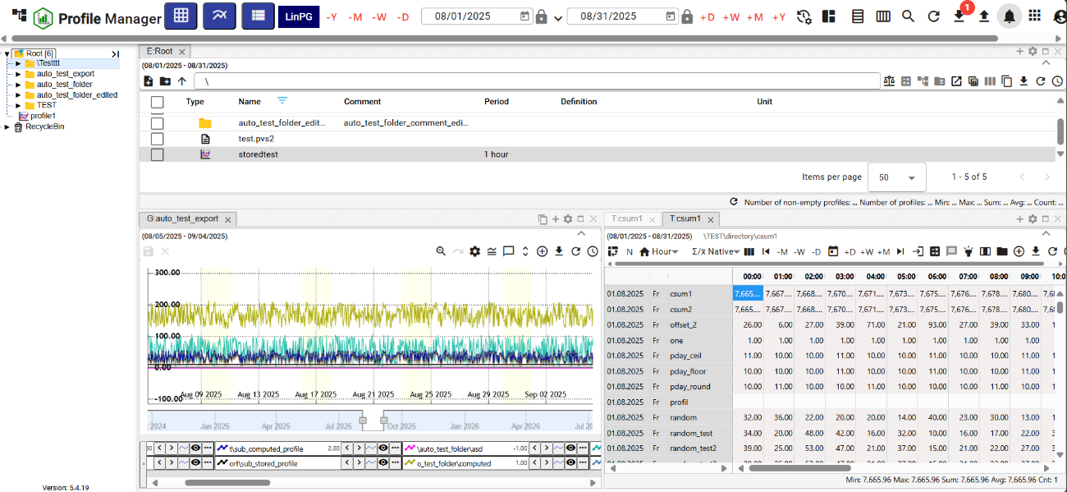

Figure 1: "Profile Manager" Application

## How to log in to the application

When you start the “Profile Manager” application, the login screen appears. You need to enter a username and password. Checking the “Remember me” checkbox will cause the login details not to be required again upon the next login. The application will remember them. To log in, press the “Log in” button.

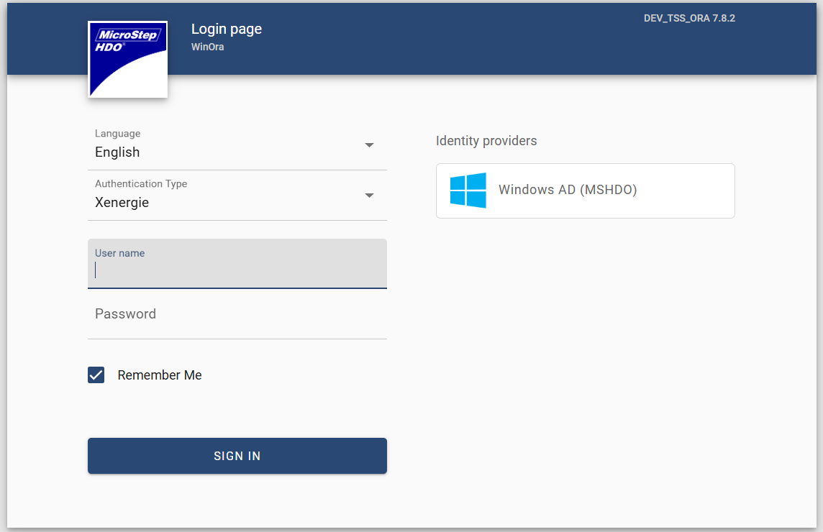

Figure 2: Logging in to the “Profile Manager” Application

## Application top bar

In the application top bar you will find:

* a button that allows you to minimize and maximize the application menu

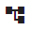

Figure 3: Button to hide and show the application menu

* Application name "Profile Manager" - clicking the button reloads the "Profile Manager" application.

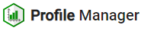

Figure 4: "Profile Manager" button

* “Add Table” button - dragging the button onto the screen adds the “Table” window.

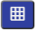

Figure 5: "Add Table" button

* “Add Chart” button - used to add the “Chart” window to the application workspace.

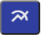

Figure 6: "Add Chart" button

* “Add Explorer” button - dragging the button onto the application screen adds the “Explorer” window.

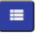

Figure 7: “Add Explorer” button

* a button representing the environment name – both text and color can be set for the button.



Figure 8: Environment Name

* global data range - represents a data filter, chapter 1.9



Figure 9: Global Data Range

* Synchronize Panels button – allows aligning time ranges (1.16.1) and synchronizing tables (1.16.2)



Figure 10: Synchronize Panels button

* button for importing and downloading reports – procedures are detailed in chapter 1.17



Figure 11: “Reports” button

* button for searching a profile – searching for a profile is described in chapter 1.23



Figure 12: “Search Profile” button

* “Refresh Visible Data” button - used to refresh data in the application, chapter 1.10



Figure 13: “Refresh Visible Data” button

* “Export” button – contains a list of exports, chapter 1.20.



Figure 14: “Export” button

* “Import” button – contains a list of imports, chapter 1.21.



Figure 15: “Import” button

* “Notifications” button – indicates changes made in the application, chapter 1.14



Figure 16: “Notifications” button

* Button to display the list of applications. Here you can find the list of applications for the given environment. Clicking on an application in the list will open it in a new browser tab.



Figure 17: Button to display the list of applications

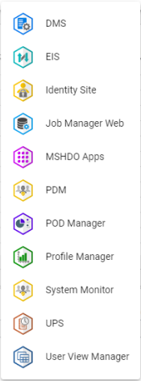

Figure 18: List of applications

* button displaying the name of the logged-in user, which allows:
  + changing the language version of the application, chapter 1.6,
  + restoring the default settings, chapter 1.7,
  + display keyboard shortcuts
  + displaying the profile, 1.8,
  + displaying application and service status information, chapter 1.13
  + logging out of the application, chapter 1.5.

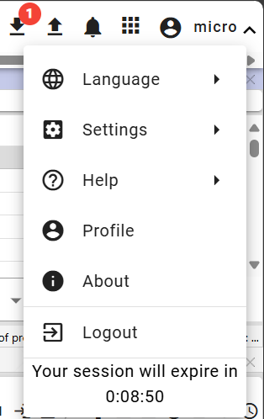

Figure 19: Button with the logged-in user's name

* The "Hide Top Toolbar" button is used to hide the top toolbar; subsequently, the button's appearance changes and it is used to display the top toolbar, Figure 21.

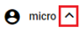

Figure 20: "Hide Top Toolbar" button

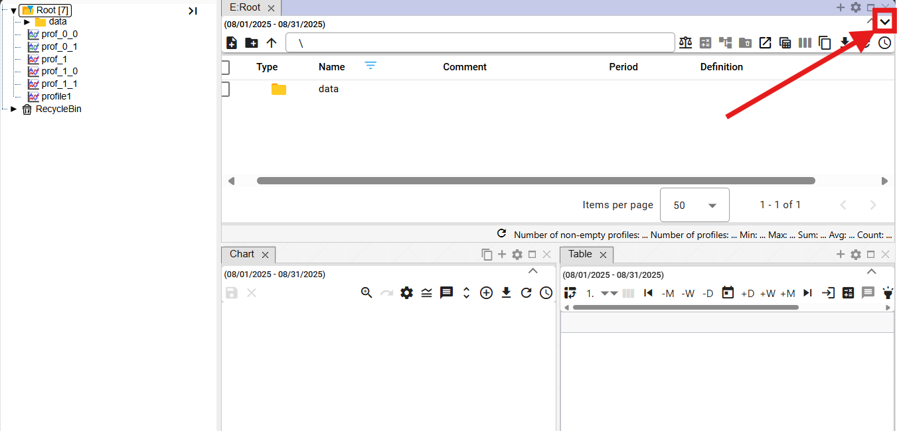

Figure 21: Button for displaying the top toolbar



Figure 22: Application top toolbar

## Changing the color of the application top toolbar

The customer can request a change to the color of the top toolbar. Changing the color of the top toolbar serves to differentiate the Development, Testing, and Production environments.



Figure 23: Application top toolbar

## How to add Explorer windows, tables, and charts to the dashboard.

You can add any number of Explorer windows, tables, and charts to the "Profile Manager" application dashboard. Proceed as follows:

1. Click and drag the button to the application canvas.
2. Hold the button over the canvas and move to the location where you want to add the window.
3. Choose the shape the window should have.

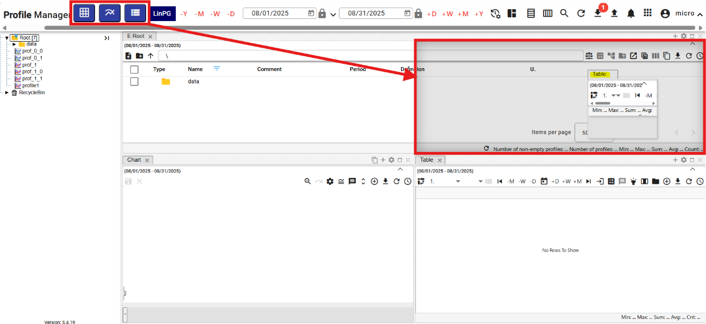

Figure 24: Selecting the shape and location of the window

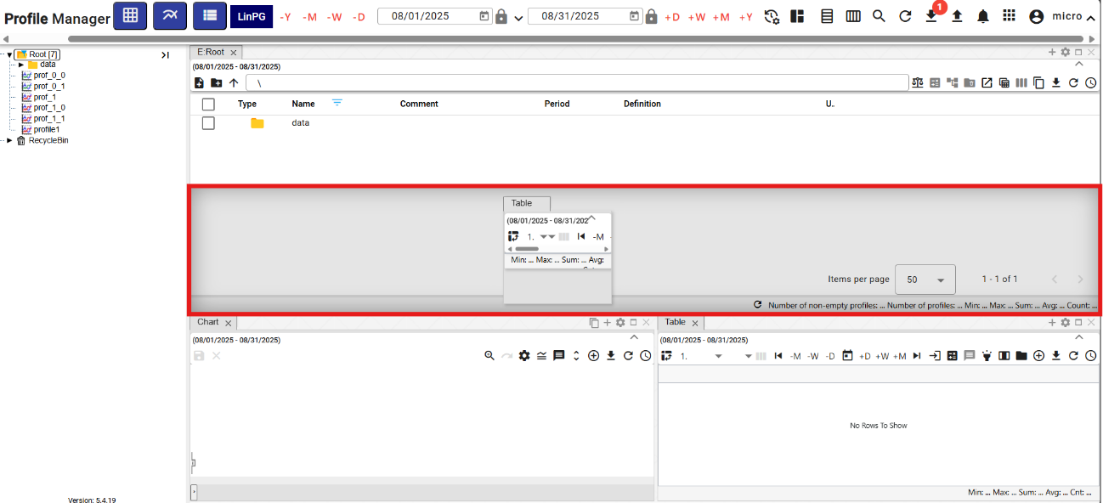

Figure 25: Shape and location of the window table

1. Releasing the button adds the window to the selected location.

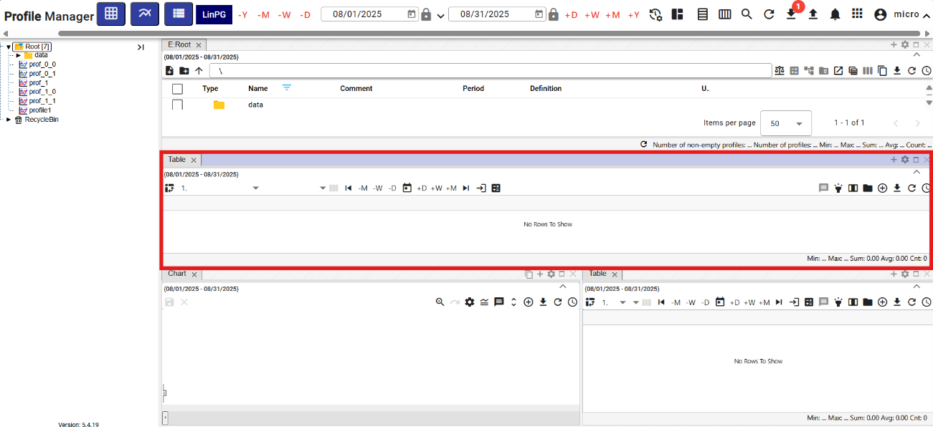

Figure 26: Window table added

### Window Naming Rules

Explorer, Chart and Table windows are automatically named according to the following rules:

Table

The name for the table is “T: <name of the 1st profile in the table>”.

Example: "T:ProfilHPFC".

Chart

The name for the chart is “G: <name of the 1st profile in the chart>”.

Example: "G:ProfilHPFC"

Explorer

The name for the explorer in Slovak and Czech is “P: <name of the directory I am in>”.

Example: "P: AdresarTEST"

In the case of the root directory, the word will be “P:Root”.

In English, the explorer is named “E: <name of the directory I am in>”.

Example: “E:AdresarTEST”

In the case of the root directory, the word will be “E:Root”.

Explorer – Branch view

Explorer – Branch view is named “B: <directory name where the branch view was launched>”

Example: “B:AdresarTEST”. In the case of the root directory, the name will be “B:Root”.

The window title is updated accordingly with each profile or directory change. If the user enters a window title using the button, automatic setting will be disabled from that point on and will no longer be applied.

## How to log out of the application

You log out of the application by pressing the button with the logged-in user's name. A window will appear where you press "Log Out".

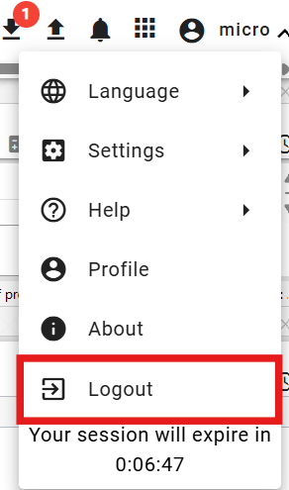

Figure 27: "Log Out" item

## How to change the language version

To change the language version, press the button with the logged-in user's name and then use the mouse cursor to select the "Language" item. In the window that appears, select the language version.

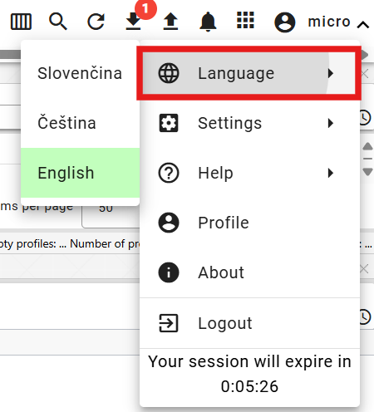

Figure 28: Change Language Version

## How to change default settings

To restore the default settings in the "Profile Manager" application, follow these steps:

1. Click the button with the logged-in user's name.
2. Move the mouse cursor to the "Settings" item.
3. Click the "Set Default Settings" button.

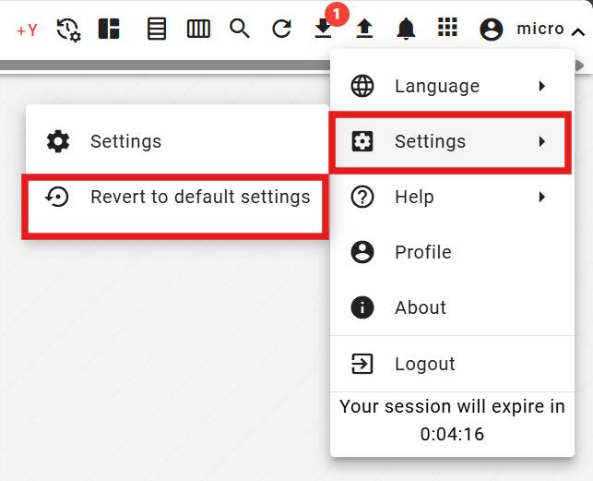

Figure 29: "Settings" item

1. A confirmation window will appear; press the "Yes" button.

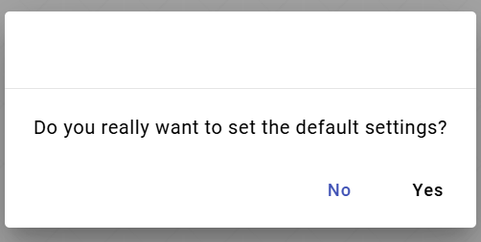

Figure 30: Confirmation for setting default settings

## How to display the logged-in user's profile

You can display the logged-in user's profile:

1. Click the button labeled with the logged-in user's name.
2. Click the "Profile" item.

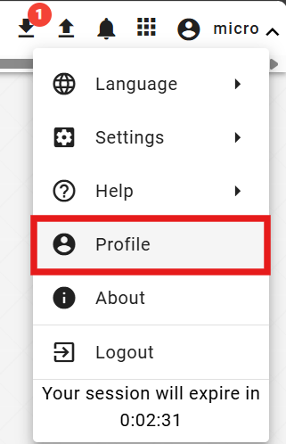

Figure 31: “Profile” item

1. The profile of the logged-in user in the “IdentitySite” application will be displayed in a new browser tab.

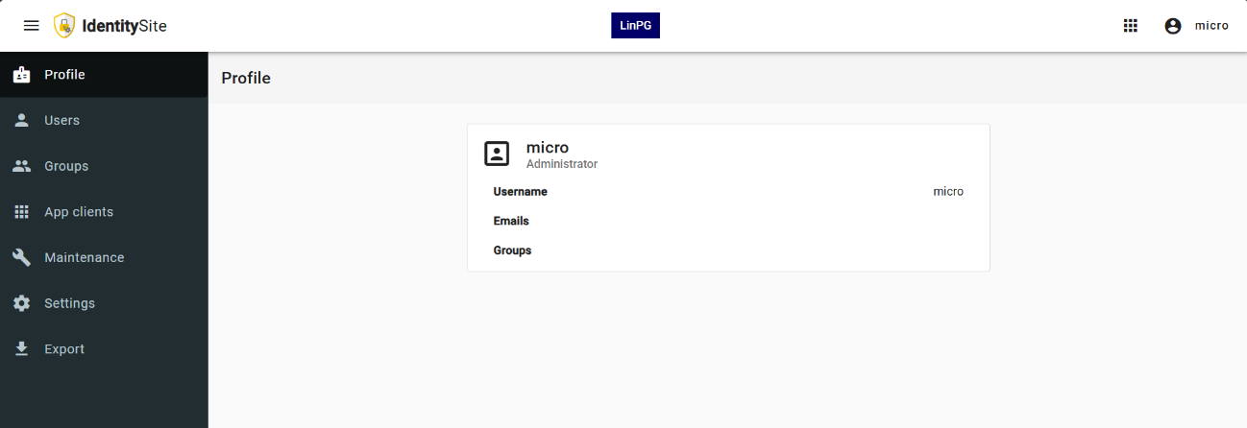

Figure 32: Profile of the logged-in user in the “IdentitySite” application

## Global date range

By default, the date filter is set to the current date.



Figure 33: Global date range

Clicking the button displays the default date range options, Figure 34.

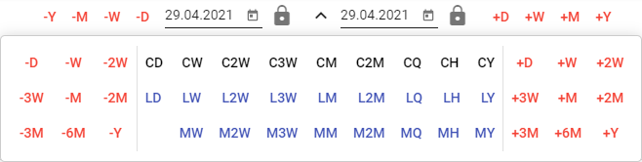

Figure 34: Default date range options

You can lock dates. When changing the date range, the locked date will not change.



Figure 35: Locking the date

### How to apply a date filter in the selected window

The date range in the application's top bar is linked to the selected window. If the date range is changed in the selected window, it will also change in the application's top bar. If the date range is changed in the application’s top bar, it will be applied to the selected window.

Proceed:

1. Select the window where you want to apply the filter by clicking in the top part of the window, Figure 36.

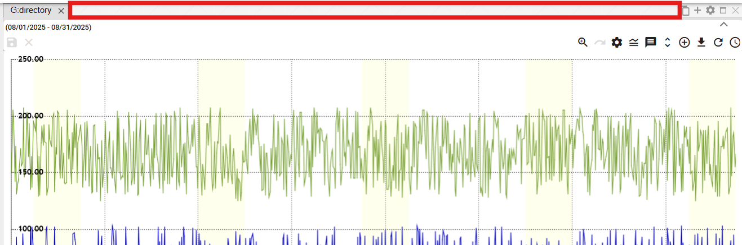

Figure 36: Area for window selection

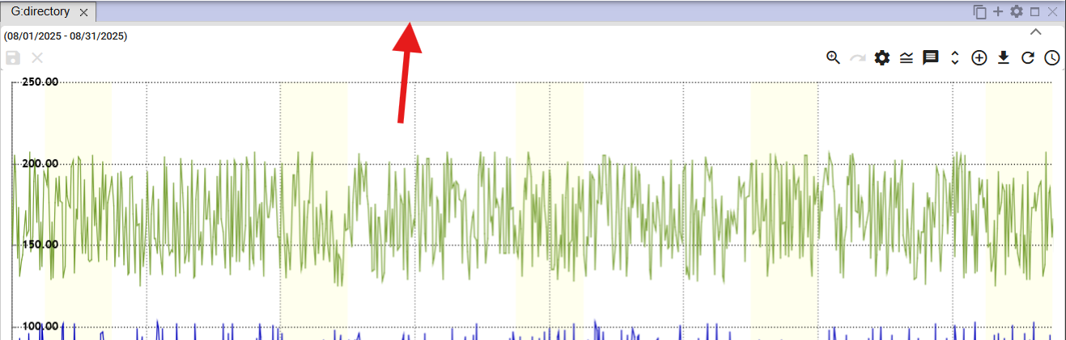

Figure 37: Selected window for the filter

1. Select the date filter from the top bar of the application.



Figure 38: Global Date Range

1. The data will be displayed in the selected window according to the chosen date filter.

### How to apply the date filter to all windows at once

Proceed:

1. Select one of the Explorer, Table, or Chart windows by clicking in the top part of the window, Figure 36 and Figure 37.
2. Then, enter the date filter in the top bar of the application.



Figure 40: Global Date Range

1. Check "align time ranges".

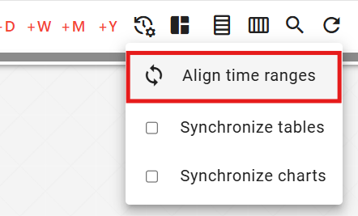

Figure 39: “align time ranges” Checkbox

1. The date filter is applied to all windows in the application.

## How to restore visible data

To restore data in the "Profile Manager" application, press the "Restore Visible Data" button, located in the application's top bar.



Figure 41: "Restore Visible Data" button

## General Settings

The "General" tab in the "Settings" window is divided into sections:

* Global – general settings for the "Profile Manager" application,
* Table – general settings for the table,
* Graph – general settings for the graph,
* Explorer – general settings for the Explorer.

Individual settings are described in the following subchapters.

### Global general settings

#### How to enable automatic refresh after profile modification

If you want to refresh the data after saving, proceed as follows:

1. Click the button with the logged-in user's name, located in the top bar of the application. Hover the mouse cursor over “Settings” and click “Settings” in the displayed window.

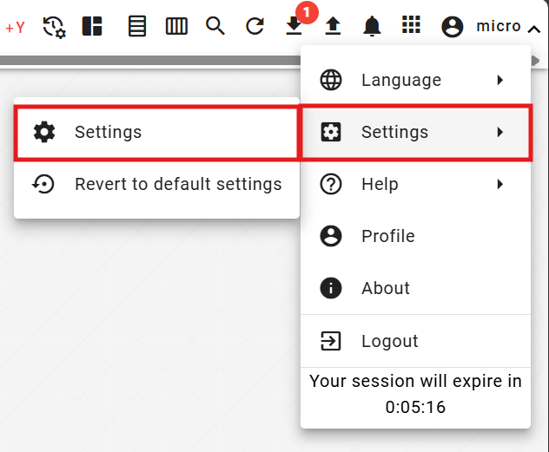

Figure 42: “Settings” item

1. A “Settings” window will appear.
2. In the "General" section, check the "Refresh displayed data after saving" box.

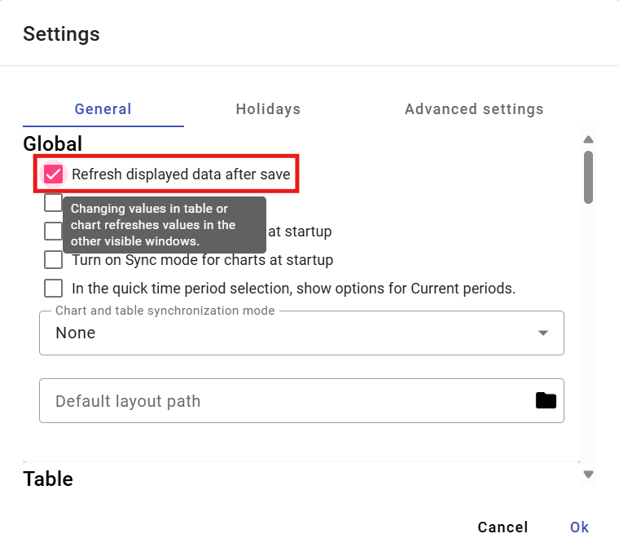

Figure 43: “Refresh displayed data after saving” item

1. Save the changes by clicking the "OK" button.

#### How to display new windows in the current day

To display new Explorer, Table, and Chart windows in the current day, proceed as follows:

1. In the "Settings" window, on the "General" tab, in the "Global" section, check the "Show current day" box, Figure 43.
2. Save the changes by clicking the "Ok" button.

#### How to synchronize time for tables

To synchronize time for tables, proceed as follows:

1. In the "Settings" window, on the "General" tab, in the "Global" section, check the "Synchronize for tables on startup" box, Figure 43.
2. Save the changes by clicking the "OK" button.
3. Subsequently, restart the application.
4. If you check the "Synchronize for tables on startup" box, the "Synchronize tables" button will also be checked, 1.16.2.

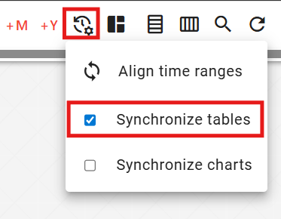

Figure 44: "Synchronize tables" field

1. The text "SYNC" will be displayed in the table window.

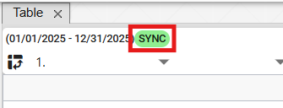

Figure 45: The text "SYNC" will be displayed in the table window.

#### How to synchronize time for charts

To synchronize time for tables, proceed as follows:

1. In the "Settings" window, on the "General" tab, in the "Global" section, check the "Synchronize for charts on startup" box, Figure 43.
2. Save the changes by pressing the "OK" button.
3. Subsequently, restart the application.
4. If you check the "Synchronize for charts on startup" box, the "Synchronize charts" button will also be checked, 1.16.3

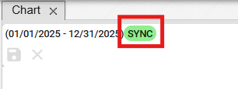

Figure 46: The text "SYNC" will be displayed in the chart.

#### How to enable synchronization between the chart and the table

To enable synchronization between the chart and the table, proceed as follows:

1. In the "Settings" window, in the "General" tab, in the "Global" section, select the item in the "Chart and Table Synchronization Mode" field. You can choose:
   1. none - synchronization between the chart and the table is disabled.
   2. start - the beginning of the chart is synchronized,
   3. middle - synchronizes the middle of the chart.

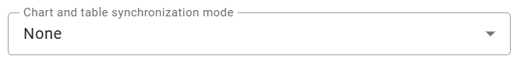

Figure 47: Chart and Table Synchronization Mode

1. You save changes by pressing the "OK" button.
2. Subsequently, restart the application.

#### How to display Current Period options in the Quick Time Period Selection.

In the Quick Time Period Selection, AR, AM, AT, AD options will be displayed instead of +R, +M, +T, +D. MR, MM, MT, MD will be displayed instead of -R, -M, -T, -D.

Proceed:

1. Check the "Display Current Period options in Quick Time Period Selection" box.
2. Save the changes by pressing the "OK" button in the "Settings" window.
3. Restart the application. The changes will then appear in the application.



Figure 48: Quick Time Period Selection

#### How to set the path to the default layout

The "Default layout path" field is used to set the path to the saved "Profile Manager" application layout. When opening the "Profile Manager" application, the specified layout will be displayed.

Proceed:

1. In the "Settings" window, in the "General" tab, in the "Global" section, in the "Default layout path" field, enter the path to the saved layout or click the button to display the "Select Layout" window, where you can search for the saved layout.

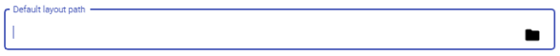

Figure 49: "Default layout path" field

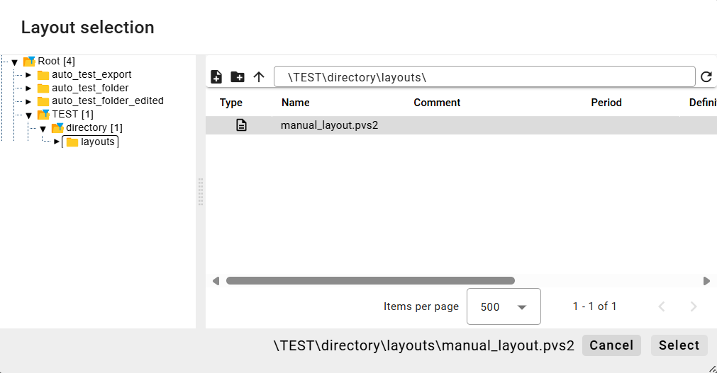

Figure 50: Select Report

1. In the "Select Report" window, click the "Select" button.
2. In the "Default layout path" field, you will find the path to your selected report.

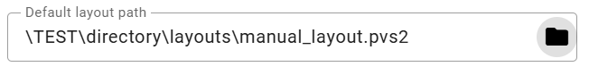

Figure 51: Selected Report

1. To save the changes, click the "OK" button in the "Settings" window.

### General settings for the table

#### How to set up automatic saving of changes in the table

By enabling automatic saving in the table, changes made to the table will be saved immediately. Proceed as follows:

1. In the "Settings" window, in the "General" tab, in the "Table" section, check "Automatic saving during editing".

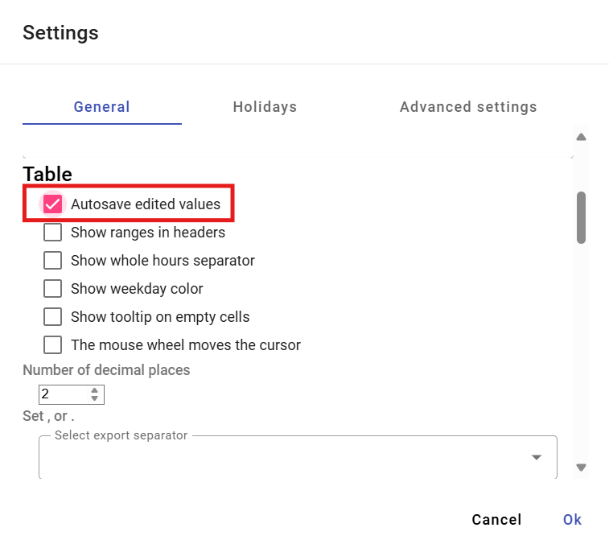

Figure 52: Settings for the table

1. Save the changes by clicking the "OK" button.

#### How to display ranges in the header for the table

You set the ranges for the header for the Table window:

1. In the "Settings" window, on the "General" tab, in the "Table" section, check "Display ranges in the header", Figure 52.
2. Save the changes by clicking the "OK" button.

#### How to set the display of the whole hour separator for the table

You set the display of the whole hour separator in the Table window:

1. In the "Settings" window, in the "General" tab, in the "Table" section, check "Show whole hour separator", Figure 52.
2. Save the changes by clicking the "OK" button.

#### How to set the cell color display for days of the week in the table

You set the cell color display for days of the week:

1. In the "Settings" window, on the "General" tab, in the "Table" section, check "Display cell colors for days of the week", Figure 52.
2. Save the changes by clicking the "OK" button.

#### How to display tooltips also over empty cells in the table

To configure the display of tooltips also over empty cells in the table, proceed as follows:

1. In the "Settings" window, in the "General" tab, in the "Table" section, check "Show tooltip also over empty cells", Figure 52.
2. Save the changes by clicking the "OK" button.

#### How to configure the mouse wheel to scroll the cursor.

You configure cursor scrolling via the mouse wheel:

1. In the “Settings” window, in the “General” tab, in the “Table” section, check “Mouse wheel scrolls cursor”, Figure 52.
2. Save the changes by pressing the "OK" button.

#### How to set the number of decimal places in the table

To set the number of decimal places in the Table window, proceed as follows:

1. In the "Settings" window, in the "General" tab, in the "Table" section, set the "Number of decimal places" item, Figure 52.
2. Save the changes by clicking the "OK" button.

#### How to set the export separator for the table

To set the export separator for the table, proceed as follows:

1. In the "Settings" window, in the "General" tab, in the "Table" section, in the "Select export separator" field, choose the separator.
2. Save the changes by clicking the "OK" button.

#### How to set the used statistical columns in the table

To set which statistical columns to use in the table, proceed as follows:

1. In the "Settings" window, in the "General" tab, in the "Table" section, select the statistical columns to use. You can select the Sum, Average, Min, and Max columns.

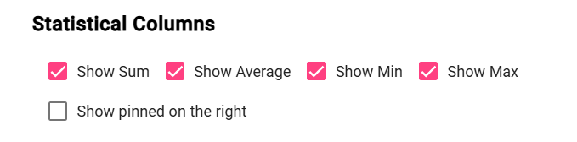

Figure 53: Statistical Columns

1. Save the changes by clicking the "OK" button.

#### How to set right alignment

To set right alignment in the table, follow these steps:

1. In the "Settings" window, in the "General" tab, in the "Table" section, check the "Show pinning on the right" box.

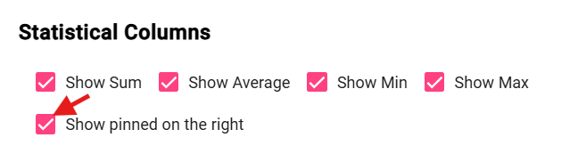

Figure 54: "Show pinning on the right" item

1. Save the changes by clicking the "OK" button.

#### How to set default column widths for the table

To set the default column widths for the table, proceed as follows:

1. To set default values for the column widths, check the "Apply Default Values" box, located in the "General" tab within the "Table" section, in the "Settings" window.

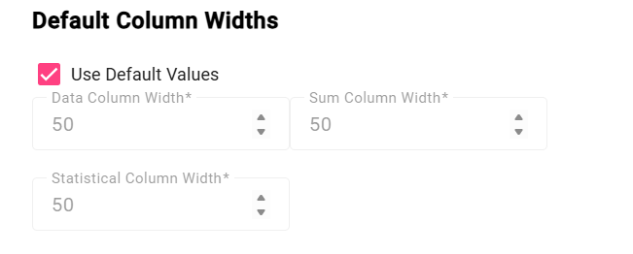

Figure 55: "Apply Default Values" item

1. To set custom values for the column widths, leave the "Apply Default Values" box unchecked. This will enable the fields for setting the column widths.

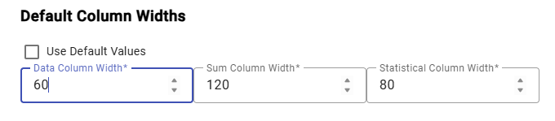

Figure 56: Setting Custom Values for Column Widths

1. Enter the column widths and save the changes by clicking the "OK" button.

### General Settings for the Chart

#### How to set the default line type for the chart

The default line type for the chart can be "Line" or "Step line". To set the default line type, proceed as follows:

1. In the "Settings" window, in the "General" tab, in the "Chart" section, you can select the default line type.
2. By clicking in the "Default line type" field, you can select "Line" or "Step line".

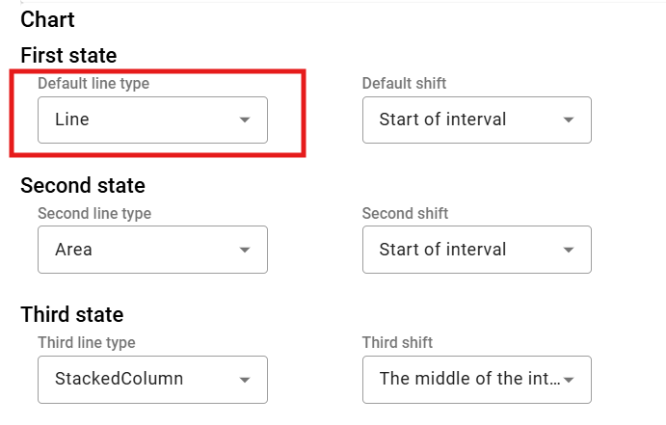

Figure 57: Selecting the default line type for the chart

1. You save the changes by clicking the "OK" button.

#### How to set the second and third line type for the chart

To set the second and third line type, proceed as follows:

1. In the "Settings" window, in the "General" tab, in the "Chart" section, click in the "Second Line Type" field to display a window where you can select the line type.
2. To select the third line type, click in the "Third Line Type" field to display a window where you can select the line type.
3. Save the changes by pressing the "OK" button.

#### How to set the default offset, second and third offset for the chart.

Proceed:

1. In the "Settings" window, in the "General" tab, in the "Chart" section, click in the "Default offset" field and select one of the displayed options.
2. In the "Second offset" field, select an item for the second offset.
3. In the "Third offset" field, select an item for the third offset.
4. Save the changes by clicking the "OK" button.

#### How to set the number of decimal places for the chart

Proceed:

1. In the "Settings" window, in the "General" tab, in the "Chart" section, in the "Number of decimal places" field, enter the number of decimal places.
2. Save the changes by pressing the "OK" button.

#### How to set the display of the chart start date.

Proceed:

1. In the "Settings" window, on the "General" tab, in the "Chart" section, check the "Show chart start date" box.
2. Save the changes by clicking the "Ok" button.

#### How to display the current time

Proceed:

1. In the "Settings" window, in the "General" tab, in the "Graph" section, check the "Display current time" box.
2. Save the changes by pressing the "Ok" button.

#### How to zoom out by dragging to the left

The "zoom" function is used to magnify a selected area in the graph. The "zoom out" function will distance the selected area in the graph. To zoom in on a specific area in the graph, left-click in the graph and use the mouse cursor to mark the area in the graph by dragging from left to right. To distance an area in the graph, do the opposite: mark the area in the graph from right to left, moving upwards.

Proceed:

1. In the "Settings" window, in the "General" tab, in the "Graph" section, check the box "Zoom out by dragging to the left".
2. You save the changes by pressing the "OK" button.

#### How to set it up so that after zooming in, it automatically switches to panning.

The "Automatically switch to panning after zoom" field means that if you click the "Switch to zoom" button in the graph window, after zooming in on the selected area in the graph, panning will be automatically activated. If the "Automatically switch to panning after zoom" field is not checked, activating the "zoom" function would start the zoom and continue until you cancel it.

Proceed:

1. In the "Settings" window, in the "General" tab, in the "Graph" section, check the "Automatically switch to panning after zoom" box.
2. Save the changes by pressing the "Ok" button.

### General settings for the explorer

#### How to set decimal places in the Explorer window

To set the number of decimal places for statistics in the Explorer window, follow these steps:

1. In the "Settings" window, in the "General" tab, at the bottom of the "Settings" window, in the "Explorer" section, set the number of decimal places.

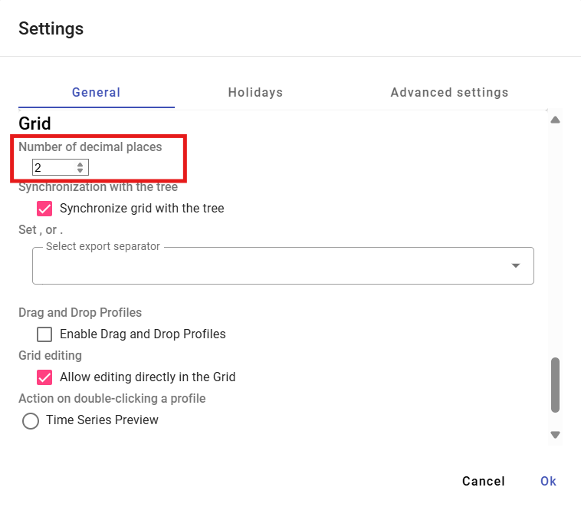

Figure 58: Setting the number of decimal places in the Explorer window

1. Save the changes by clicking the "OK" button.
2. In the Explorer window, the statistics will be displayed with the specified number of decimal places.

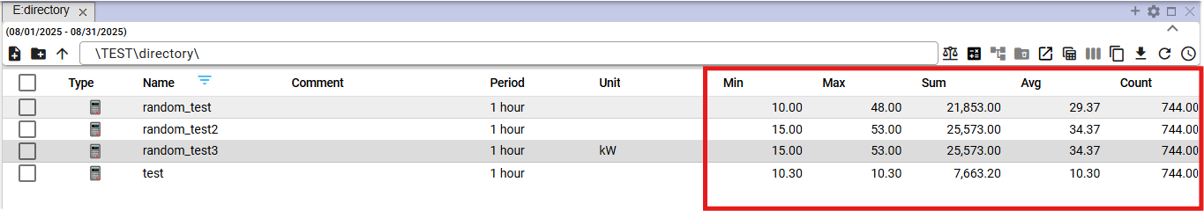

Figure 59: Selected number of decimal places in the Explorer window

#### How to synchronize the Explorer window with the tree view

To synchronize the Explorer window with the tree view, proceed as follows:

1. In the bottom part of the "Settings" window, in the "General" tab, in the "Explorer" section, check the "Synchronize grid with tree view" box.
2. Save the changes by clicking the "OK" button.

#### How to set the export separator for Explorer

To set the export separator for Explorer, proceed as follows:

1. At the bottom of the "Settings" window, in the "General" tab, in the "Explorer" section, there is a field called "Select export separator", where you can choose a period or a comma as the separator.
2. Save the changes by pressing the "OK" button.

#### How to enable Drag and drop functionality for profiles

To enable the "Drag and drop profiles" functionality, proceed as follows:

1. In the bottom part of the “Settings” window, in the “General” tab, in the “Explorer” section, check the “Drag and drop profiles” box.
2. Save the changes by pressing the "Ok" button.

#### How to enable editing directly in the Explorer window

The “Enable editing directly in Explorer” item is active by default. It allows you to edit the “Name”, “Comment”, and “Definition” fields directly in the Explorer window.

To disable the function, proceed as follows:

1. Uncheck the "Enable editing directly in Explorer" box.
2. Save the changes by pressing the “OK” button.

#### How to select an action for double-clicking a profile

You can select an action to be triggered when double-clicking a profile. Proceed as follows:

1. In the bottom part of the “Settings” window, in the “General” tab, in the “Explorer” section, select one of the three actions.

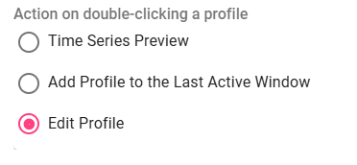

Figure 60: Selecting an action for double-clicking a profile

1. Save the changes by clicking the "OK" button.

## Holiday Settings

### How to create a holiday profile

A holiday profile allows displaying holidays in all profiles. To create a holiday, you need to have a holiday profile created, Figure 61, where you enter a value of 1 for the days when the holiday is and a value of NaN for the days when it is not. Create the holiday profile with a period of DAY.

The advantage of a holiday profile is that you decide which holidays you want to display – Slovak or from another country, or from multiple countries at once. A created holiday profile can also be shared for other applications.

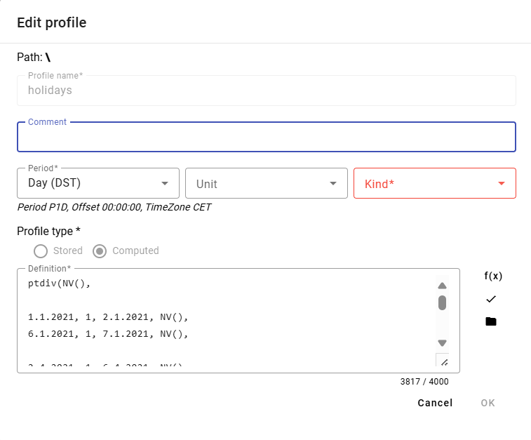

Figure 61: Example of a holiday profile definition

You create a holiday profile:

1. Click the button with the logged-in user’s name, which is located in the top application bar. Position the mouse cursor over “Settings” and click “Settings” in the displayed window, Figure 42.
2. A window “Settings” will appear, in which click the “Holidays” tab.

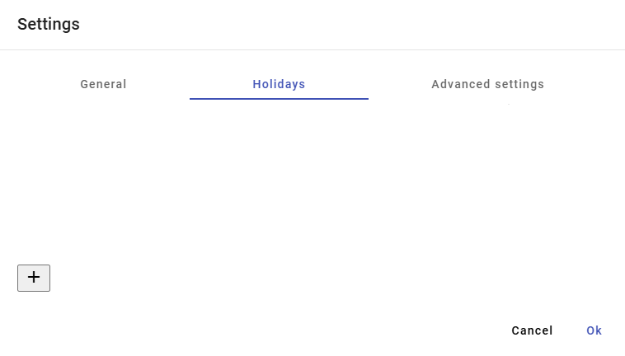

Figure 62: “Holidays” tab

1. Click the button to create a profile.

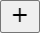

Figure 63: Button to create a profile

1. A "Holidays" window will appear, which is used to create a profile.

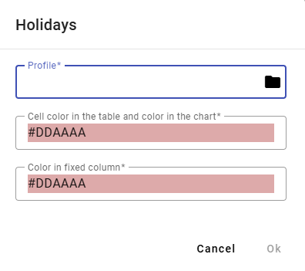

Figure 64: Creating a profile

1. In the "Profile" field, enter a profile or click the button to select a profile.
2. After clicking the button, a window for profile selection will appear.

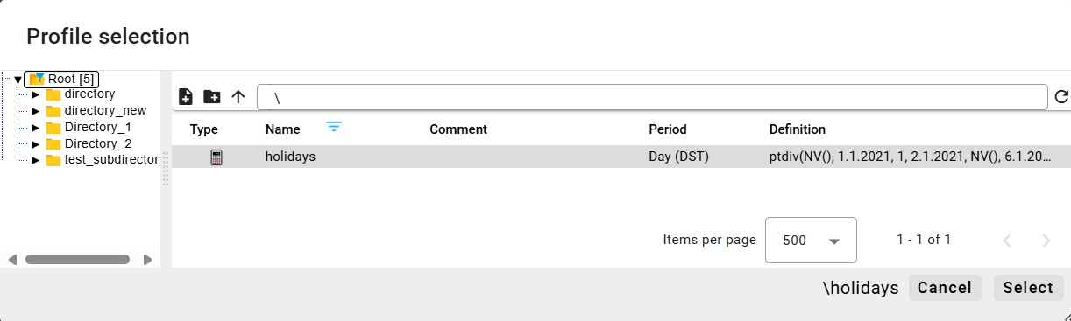

Figure 65: Profile Selection Window

1. Select a holiday profile and click the "Select" button.
2. Select a color for the "Cell color in table" and "Color in chart" fields, and for the "Color in fixed column" field.

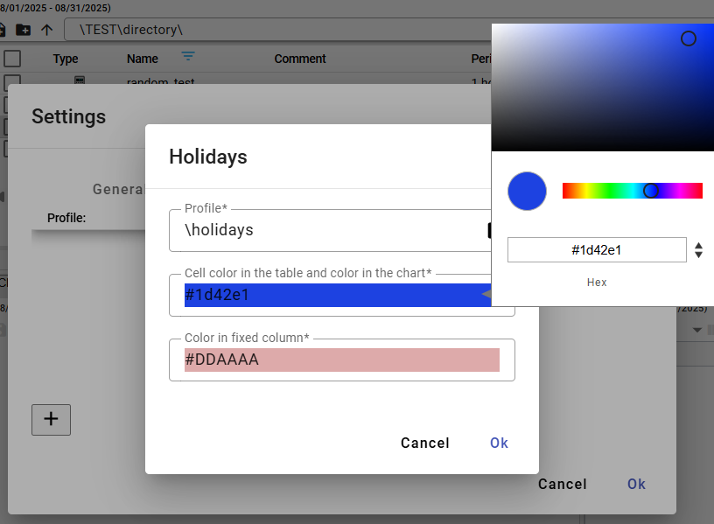

Figure 66: Color Selection

1. You create a profile by clicking the "OK" button.
2. A created holiday profile is displayed in the "Holidays" window.

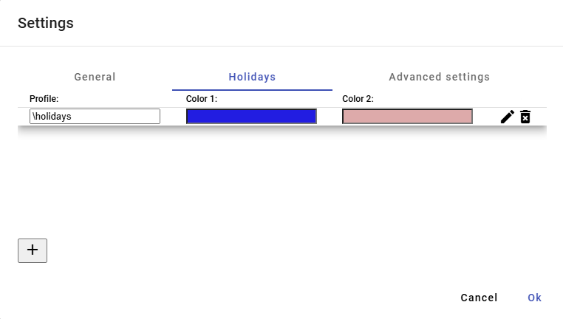

Figure 67: Created Holiday Profile

1. You save the created profile by clicking the "OK" button.

### How to select a holiday profile

You edit the holiday profile:

1. Click the button with the logged-in user's name, located in the top bar of the application. Position the mouse cursor over "Settings" and click "Settings" in the displayed window, Figure 42.
2. A window "Settings" will appear, in which click on the "Holidays" tab.
3. Click the edit button next to the profile you want to modify.



Figure 68: Edit profile button

1. A "Holidays" window will appear for editing the profile.

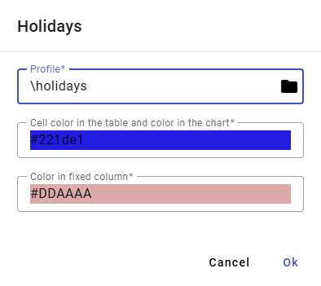

Figure 69: Editing profile for holidays

1. Edit details.
2. Save changes by pressing the "OK" button.
3. In the "Settings" window, press the "OK" button.

### How to delete a holiday profile

You edit the holiday profile:

1. Press the button with the logged-in user's name, located in the top bar of the application. Move the mouse cursor to "Settings" and click "Settings" in the displayed window, Figure 42.
2. A "Settings" window will appear, in which click on the "Holidays" tab.
3. Press the delete button next to the profile you want to remove.



Figure 70: Delete profile button

1. A confirmation window for deleting the profile will appear, in which press the "Yes" button.

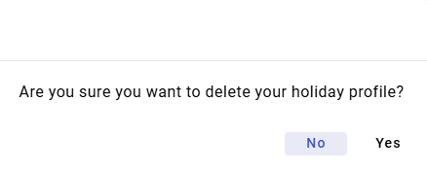

Figure 71: Profile Deletion Confirmation

1. The profile will be deleted from the list of holiday profiles.
2. Confirm the profile deletion in the "Settings" window by pressing the "OK" button.

## How to display status information

To display status information, press the button labeled with the logged-in user's name. A menu will appear where you select the "Info" item. Subsequently, the "Status Information" window will appear, providing information about the status of the "Profile Manager Web" application and the status of the TSS Service, TSS Core, MSHDO.DMST.API, DMS, and MSHDO.Xenergy.UTS.Api services.

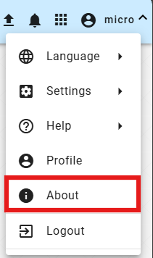

Figure 72: "Info" item

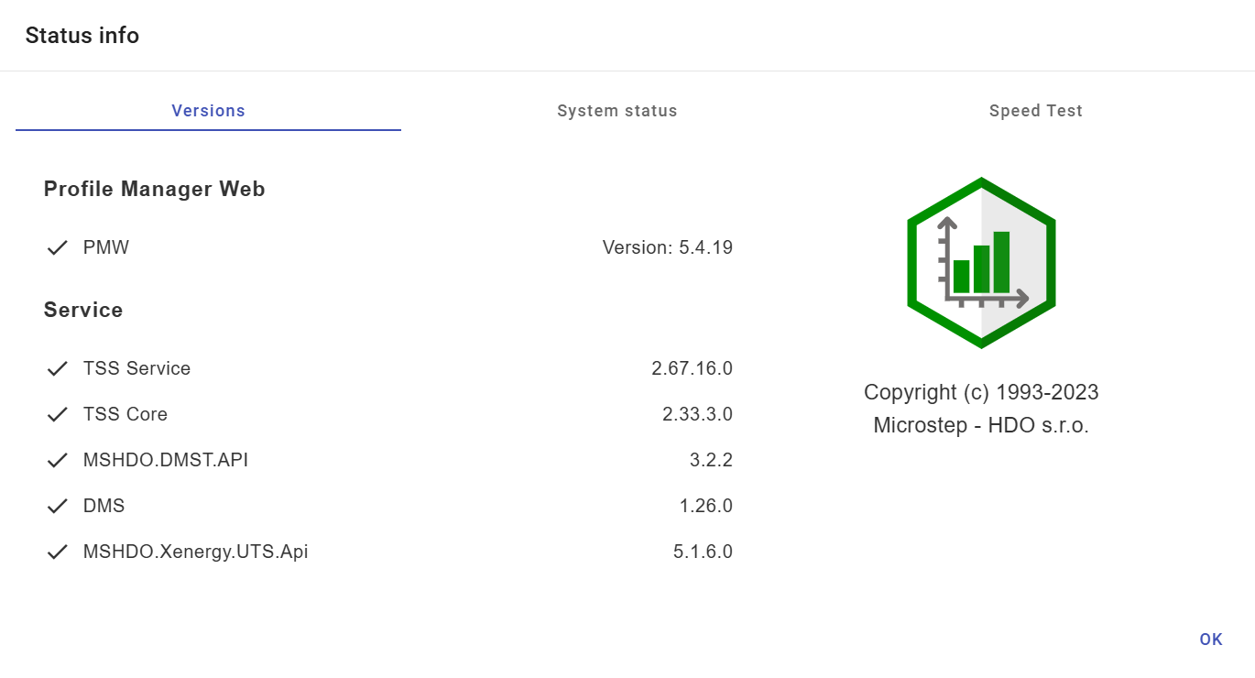

Figure 73: "Status Information" window

## How to display notifications

The "Notifications" button indicates changes made in the system. For example, creating a directory, and so on. If there are notifications in the application, the number of notifications is displayed in a red circle in the top right corner of the "Notifications" button.



Figure 74: "Notifications" button

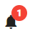

Figure 75: New notification

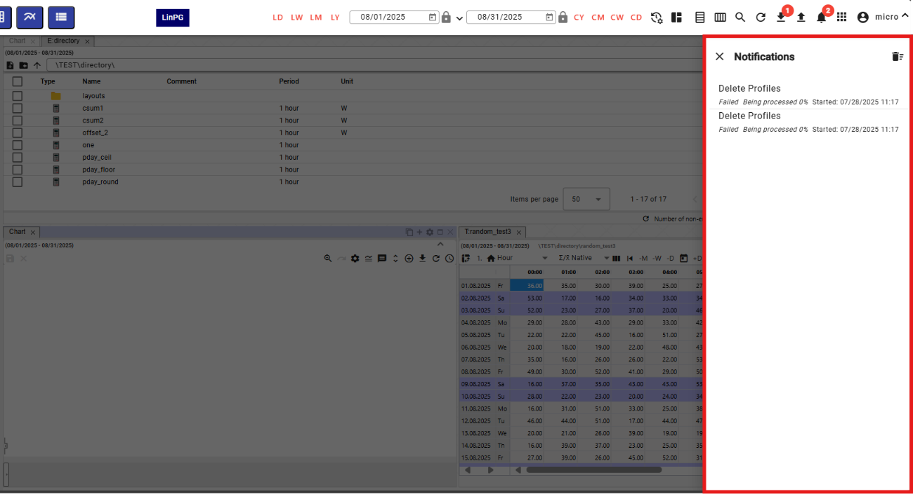

Figure 76: Notification Block

To delete notifications, press the button with the trash can icon, located in the upper right corner of the "Notifications" block. A confirmation window will appear, where press the "Yes" button.



Figure 77: Confirmation Window for Deleting Notifications

## How to resize the tree structure window

To resize the tree structure window, press the button, Figure 78, located in the upper right corner of the tree structure. The tree structure window will then resize, Figure 80. To return the tree structure to its standard width, press the button in the upper right corner again, Figure 79.

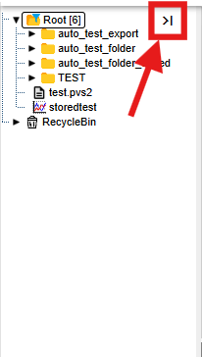

Figure 78: Button for resizing the tree structure

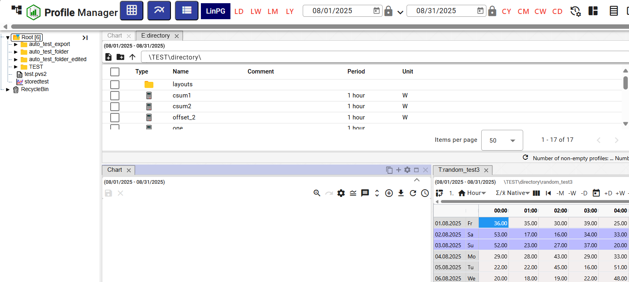

Figure 79: Standard width of the tree structure window

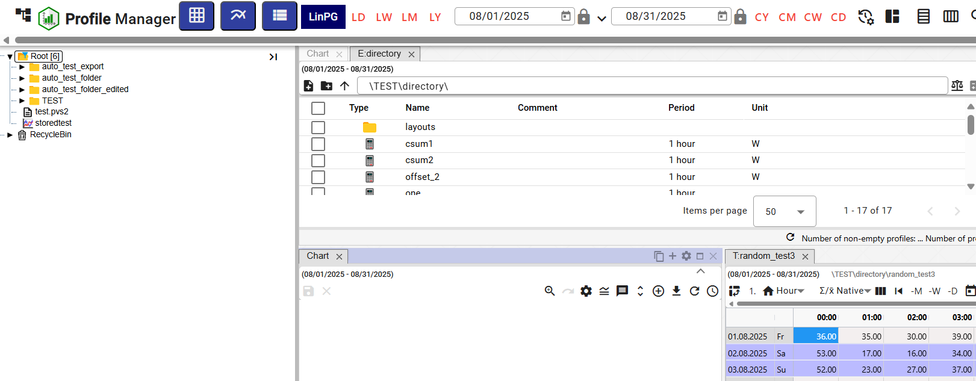

Figure 80: Resized tree structure window

## Panel Synchronization

The "Panel Synchronization" button is used to synchronize open windows in the "Profile Manager" application. It allows aligning time ranges (chapter 1.16.1) and synchronizing tables (chapter 1.16.2).

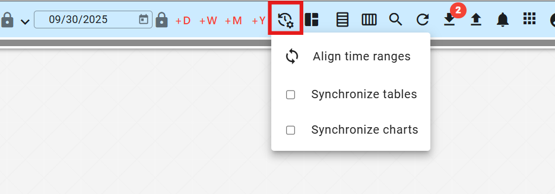

Figure 81: "Panel Synchronization" button

### Align time ranges

If different date ranges are set in the windows and you want to set a uniform date range in all open windows, proceed as follows:

1. Click on the header of the window whose date range you want to set in the other windows.

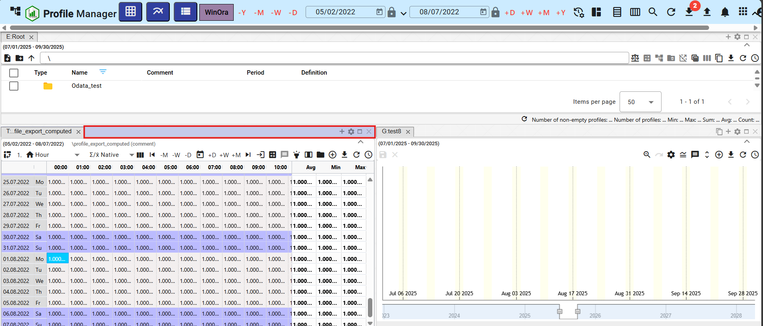

Figure 82: Active window

1. Press the "Synchronize Panels" button and click on "Align Time Ranges".

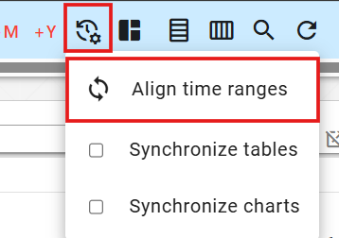

Figure 83: "Align Time Ranges" item

1. The date range will be set in all windows to match the one set in the active window.

### How to synchronize panels

The "Synchronize Panels" item means that the start of the range and the cursor are synchronized to all open panels.

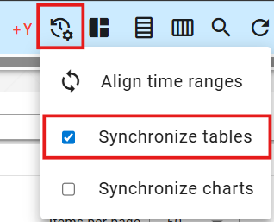

Figure 84: "Synchronize Tables" item

To have tables synchronize on every launch, check the "Synchronize for tables on launch" box in the "Settings" window under the "General" tab in the "Global" section (Figure 85). If table synchronization is enabled, the text "SYNC" will appear in the table window (Figure 86).

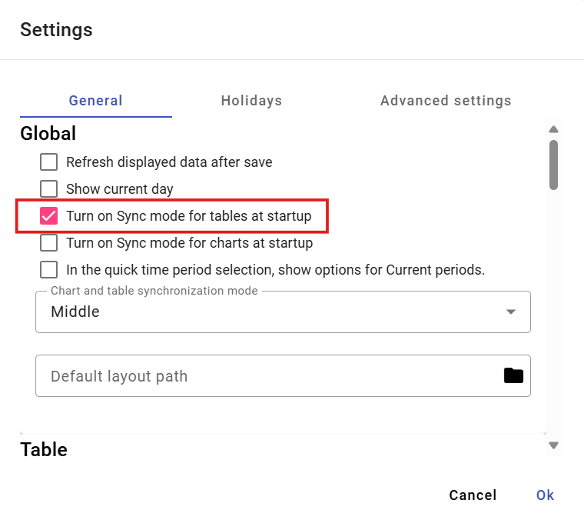

Figure 85: "Synchronize for tables on launch" box

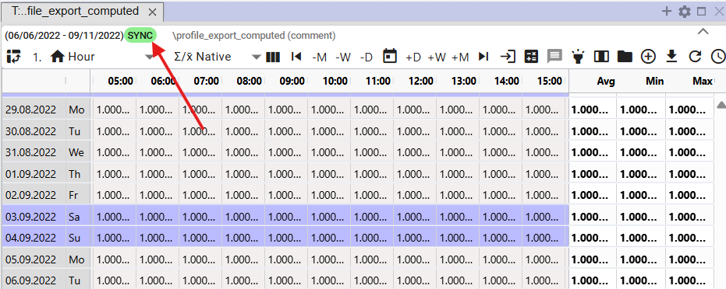

Figure 86: The text "SYNC" will appear if table synchronization is enabled.

### How to synchronize charts

To synchronize charts each time you launch the application, check the "Synchronize for charts on launch" box in the "Settings" window, under the "General" tab, in the "Global" section (Figure 85). If you set chart synchronization in the "Settings" window, the "Synchronize charts" box will be checked in the "Synchronize Panels" button (Figure 87), and the text "SYNC" will appear in the chart window (Figure 88).

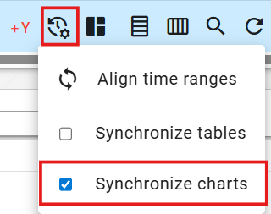

Figure 87: "Synchronize charts" item

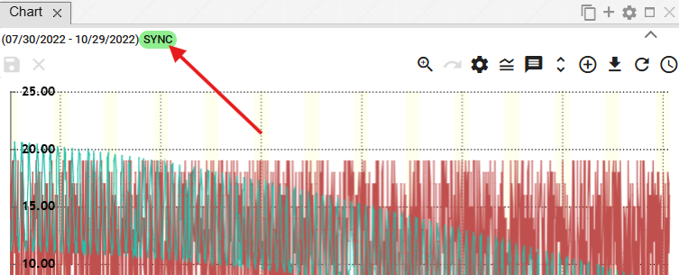

Figure 88: The text “SYNC” will appear if chart synchronization is enabled.

## How to import, export, and save reports

The button, Figure 89, is used for importing, saving and downloading reports. Importing reports is detailed in the following chapter 1.17.1 and downloading reports is described in chapter 1.17.2.

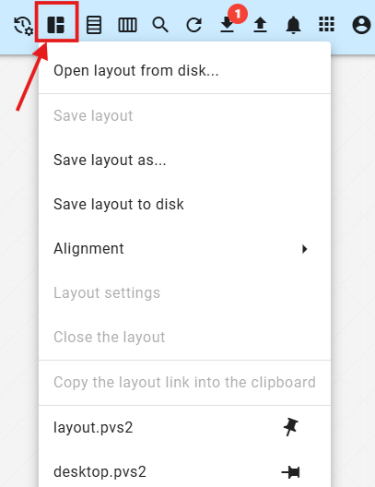

Figure 89: "Report Management" button

### How to import a report

To import a report, proceed as follows:

1. Click the "Report Management" button to display a window where you select "Open Report from Disk..."

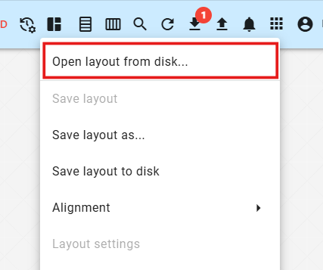

Figure 90: "Open Report from Disk..." item

1. A window will appear where you select the report you want to import.

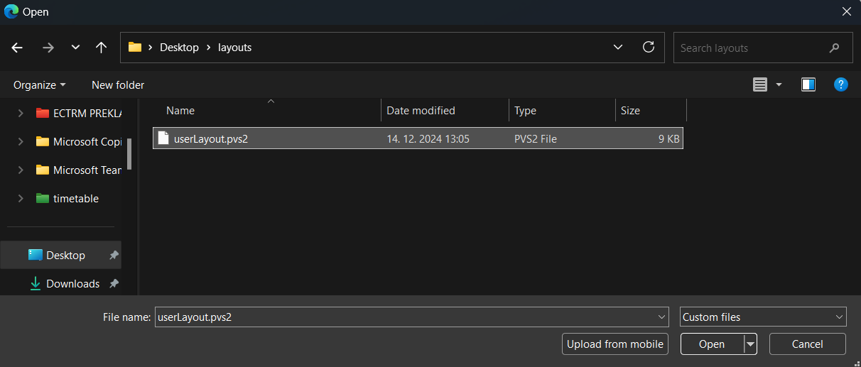

Figure 91: Selecting a Report for Import

1. Confirm the selected report for import by clicking the "Open" button.
2. The selected report is being imported, and the appearance of the “Profile Manager” application will change according to the settings of the selected report – the number and size of windows, the data displayed in the windows, and so on.
3. Next to the "Report Management" button, the name of the imported report will be displayed.



Figure 92: Name of the imported report

### How to export a report

You export the report as follows:

1. Press the "Report Management" button.
2. Select "Save Report to Disk".

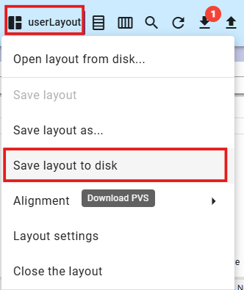

Figure 93: "Save Report to Disk" item

1. Subsequently, the report will be downloaded.

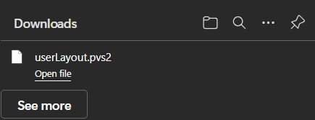

Figure 94: Downloaded Report

### How to update the report

To update the report, proceed as follows:

1. In the profile tree, open the report you want to update. To open the report, double-click the report name in the profile tree.

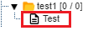

Figure 95: Report in the profile tree

1. Subsequently, the name of the open report will be displayed next to the “Report Management” button.

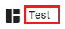

Figure 96: Name of the open report

1. Make the changes to the report that you want to save.
2. You save the changes by pressing the “Report Management” button and subsequently selecting the “Save Report” item.

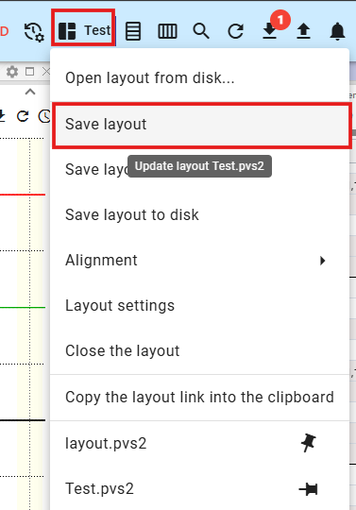

Figure 97: "Save Report" item

1. A confirmation window will appear, in which press the “Yes” button.

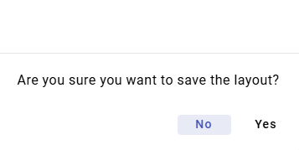

Figure 98: Report Save Confirmation Window

1. The report will be updated.

### How to Save a New Report

You can save the appearance of the “Profile Manager” application – the number and size of displayed windows, the data displayed in the windows – as a report.

You save a new report in the profile tree as follows:

1. Make the settings in the application that you want to save as a report.
2. Click the "Report Management" button and select "Save Report As..." in the displayed window.

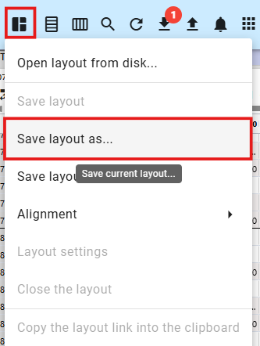

Figure 99: "Save Report As..." item

1. A "New Report" window will appear.

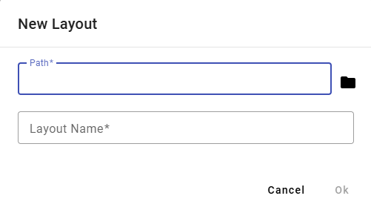

Figure 100: "New Report" window

1. In the "Path" field, enter the path where you want to save the report in the profile tree. You can also enter the path by clicking the button and selecting a directory in the profile tree where the report should be saved.

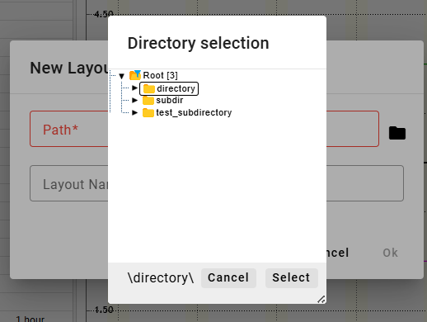

Figure 101: Selecting a directory to save the report

1. Enter the report name.

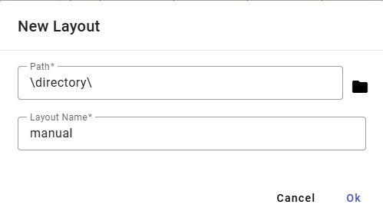

Figure 102: Data entered

1. Save the new report by pressing the "OK" button.
2. To display the report in the profile tree, click on the directory in the profile tree and select "Refresh".

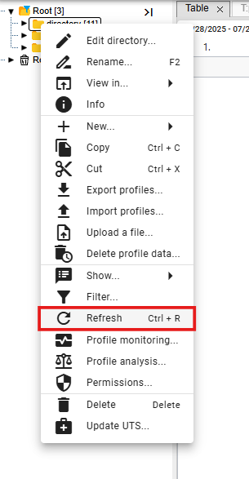

Figure 103: "Refresh" item

### How to align the report into columns

Proceed:

1. Click the "Report Management" button located in the top application bar.
2. A menu will appear. Use your mouse cursor to select the "Alignment" item and then select the "Into Columns..." item.
3. A menu will appear, in which select the number of columns.

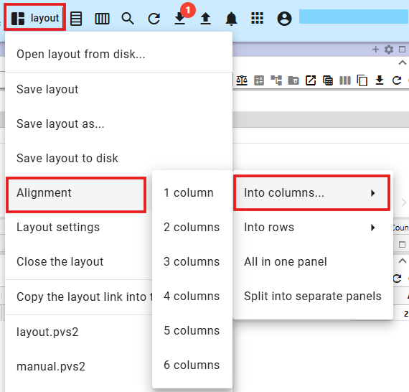

Figure 104: "Into Columns..." item

1. The windows in the "Profile Manager" application will align into the selected number of columns.

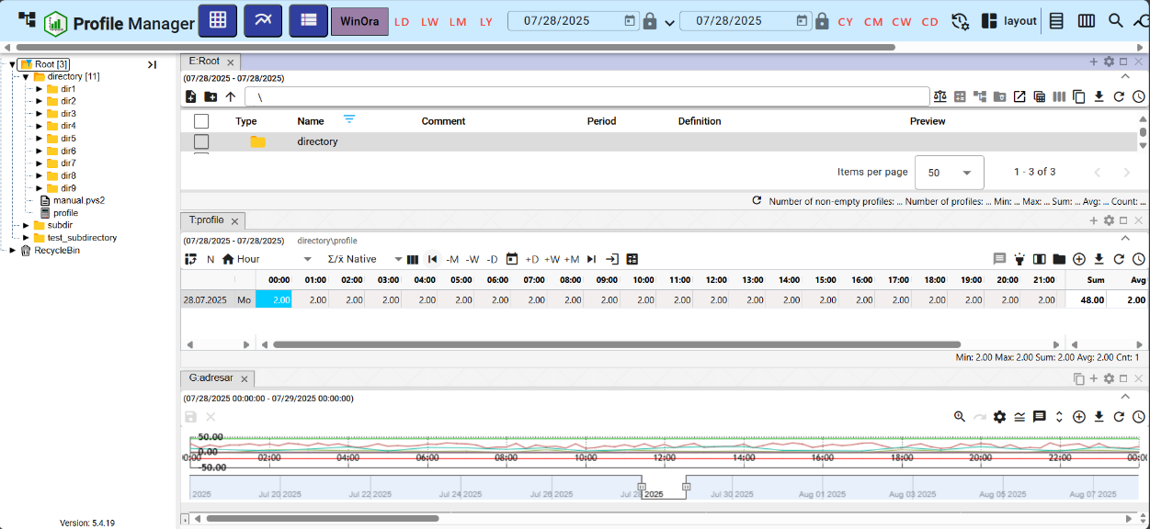

Figure 105: Aligning windows into one column

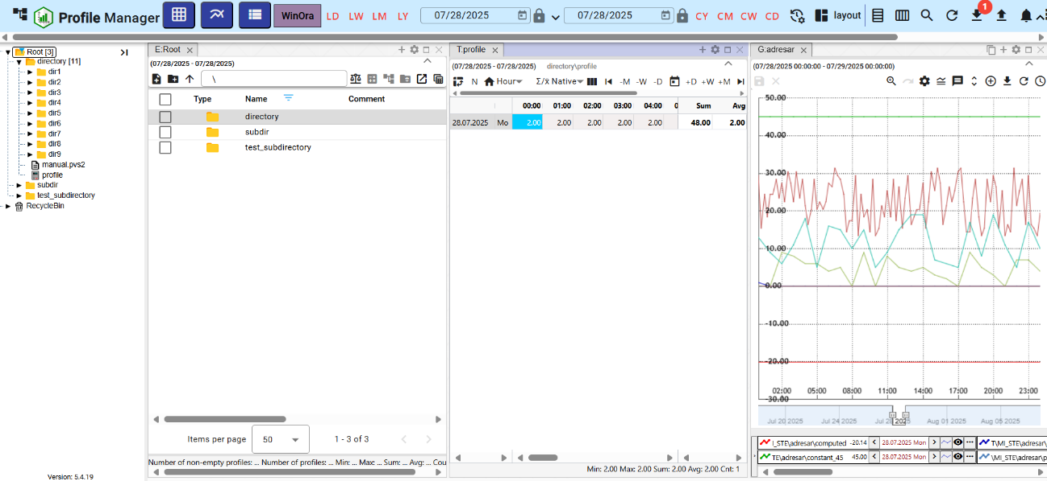

Figure 106: Aligning into three columns

### Aligning into rows

Proceed:

1. Click the "Report Management" button, located in the application's top bar.
2. A menu will appear; then, use your mouse cursor to select "Alignment" and then select "Into Rows."
3. A menu will appear, in which select the number of rows.

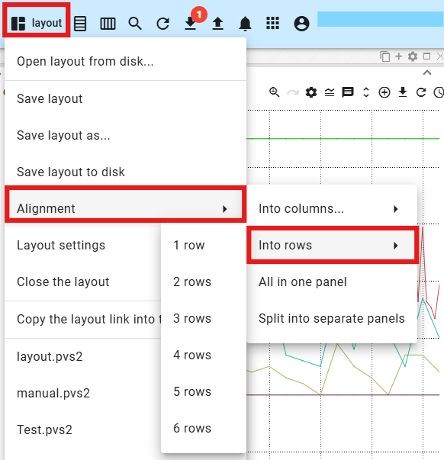

Figure 107: "Into Rows" item

1. The windows in the application will align into the selected number of rows.

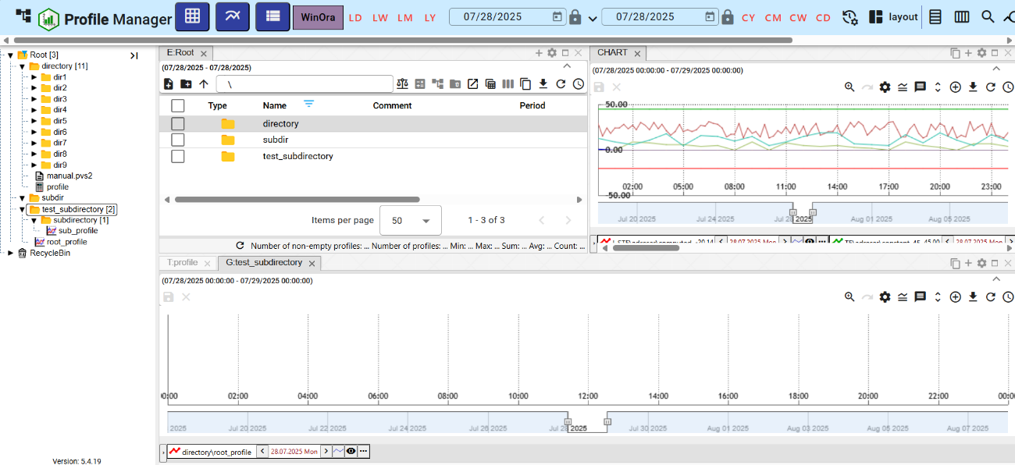

Figure 108: Aligning into two rows

### How to align everything into one panel

Proceed:

1. Click the "Manage Reports" button.
2. A menu will appear; use your mouse cursor to select "Alignment" and then select "All to One Panel".
3. All windows will appear in one panel.

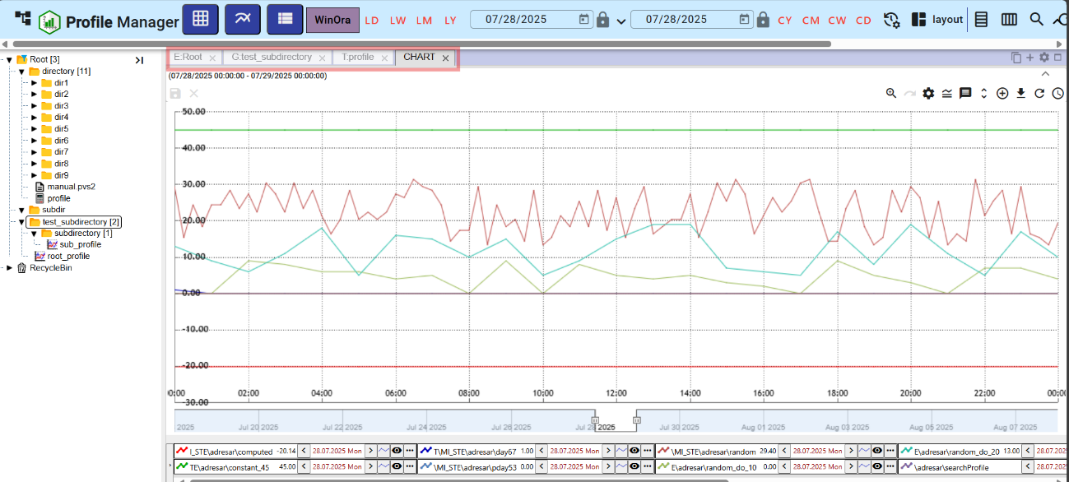

Figure 109: Alignment to One Panel

### How to split the layout into separate panels

Proceed:

1. Click the "Manage Reports" button.
2. A menu will appear; use your mouse cursor to select "Alignment" and then select "Split into separate panels".
3. Each open window will appear in a separate panel.

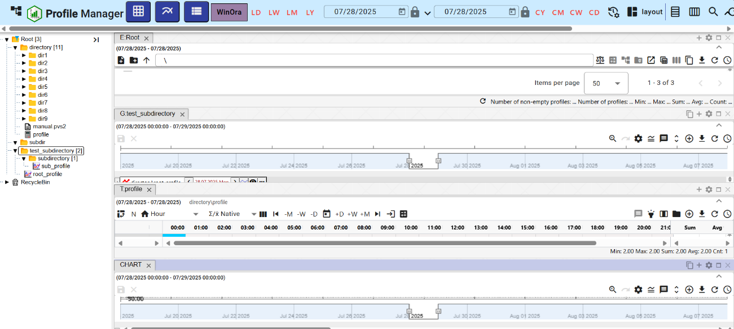

Figure 110: Split into separate panels

### How to set the global time range when displaying a report

To change the global time range for a saved report, proceed as follows:

1. Click the "Report Management" button.
2. Select "Report Settings".

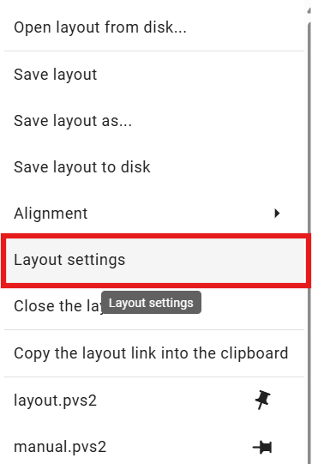

Figure 111: "Report Settings" item

1. The "Report Settings" window will appear.

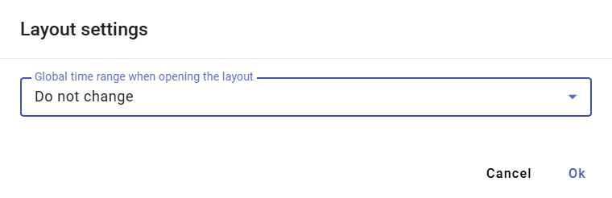

Figure 112: "Report Settings" window

1. Click in the "Global Time Range on Report Open" field.
2. A menu will appear where you select a date range.

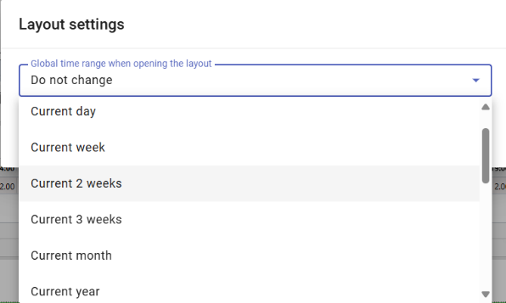

Figure 113: Menu for setting the global time range

1. Save by clicking the "OK" button.
2. A confirmation window will appear where you click the "Yes" button.

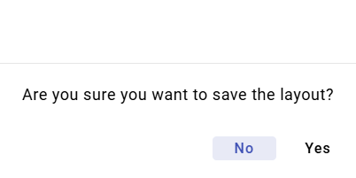

Figure 114: Confirmation window for saving

### How to close the report

To close the report, press the "Report Management" button and select "Close Report". The report will then close.

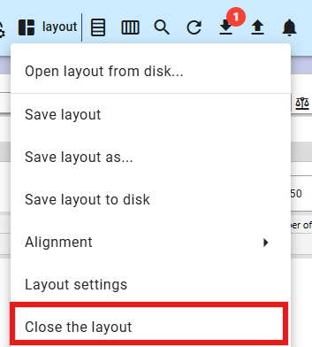

Figure 115: "Close Report" item

## How to horizontally align windows

To horizontally align windows, press the "Horizontal Alignment" button located in the application's top bar. The open windows in the "Profile Manager" application will be horizontally aligned, Figure 117.



Figure 116: "Horizontal Alignment" button

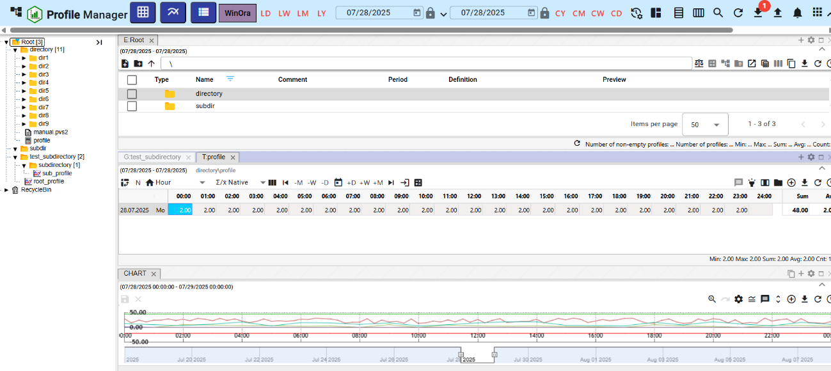

Figure 117: Horizontal Alignment of Windows

## How to vertically align windows

To vertically align windows, press the "Vertical Alignment" button, located in the application's top bar. The open windows in the "Profile Manager" application will be vertically aligned, Figure 119.



Figure 118: "Vertical Alignment" Button

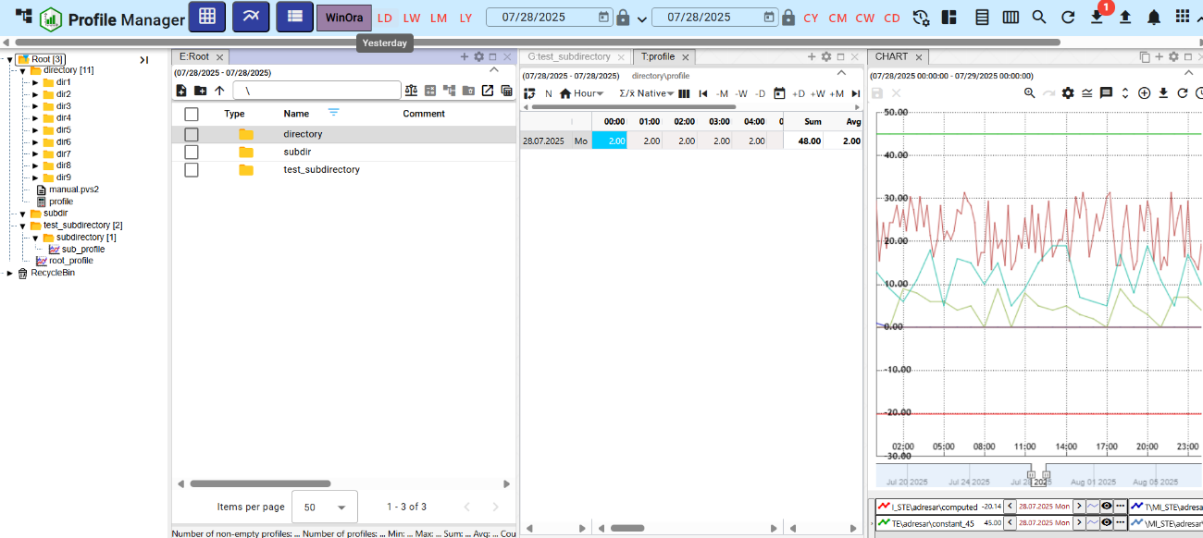

Figure 119: Vertical Alignment of Windows

## How to view and download exports

In the top bar of the "Profile Manager" application, there is an "Export" button, which is used to display a list of exports in the "Exports" window. If the export is successful, it can be downloaded by pressing the green "Download" button. The procedure for creating an export is described in chapter 2.16.



Figure 120: "Export" Button

The number of downloaded exports is displayed as a number in a red circle next to the "Export" button, Figure 121. An undownloaded export in the "Exports" window has a red "N" next to the "Download" button, Figure 122.

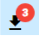

Figure 121: Three undownloaded exports

Exports can be in the following states:

* IN PROGRESS – export in progress.
* COMPLETED – successfully finished export, it can be downloaded by pressing the “Download” button.
* ERROR – an error occurred during export.
* DELETED – the export was deleted. Information about the export deletion came from the Export Service application.

Export statuses come from the Export Service and are only used for display in the “Profile Manager” application. Close the “Exports” window by pressing the “Cancel” button.

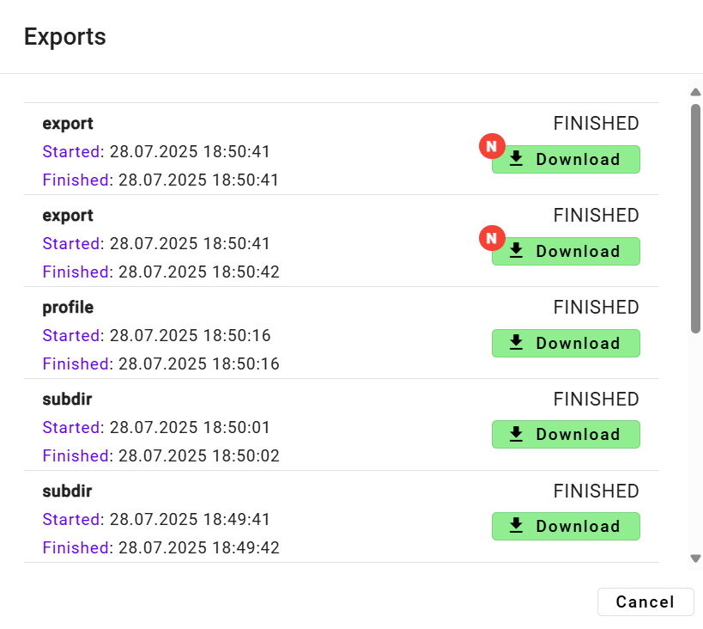

Figure 122: “Exports” window

## How to display imports

The “Import” button is located in the top bar of the “Profile Manager” application and is used to display the list of imports in the “Imports” window. The procedure for creating an import can be found in Chapter 2.17.



Figure 123: “Import” button

After clicking the “Import” button, the “Imports” window is displayed, where it is possible to view the details of imports, Figure 125.

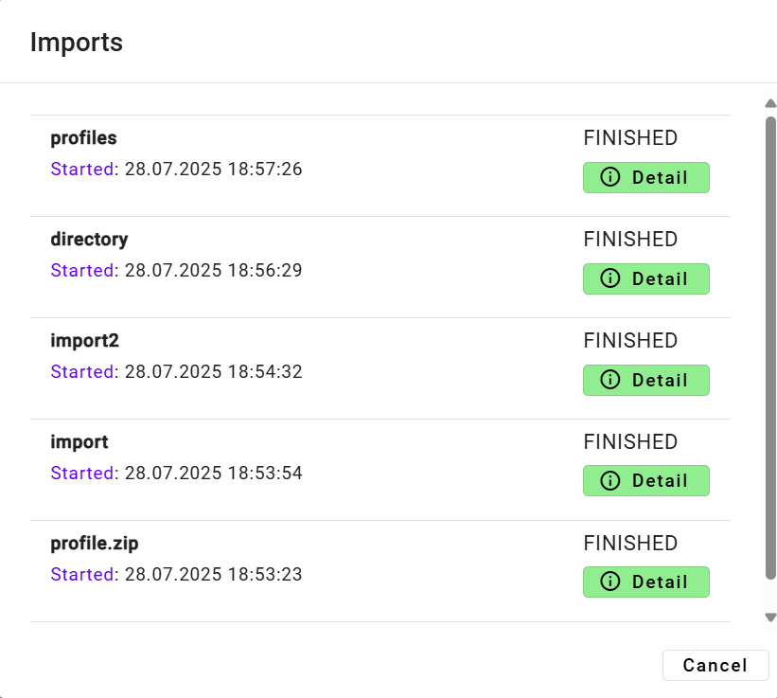

Figure 124: “Imports” window

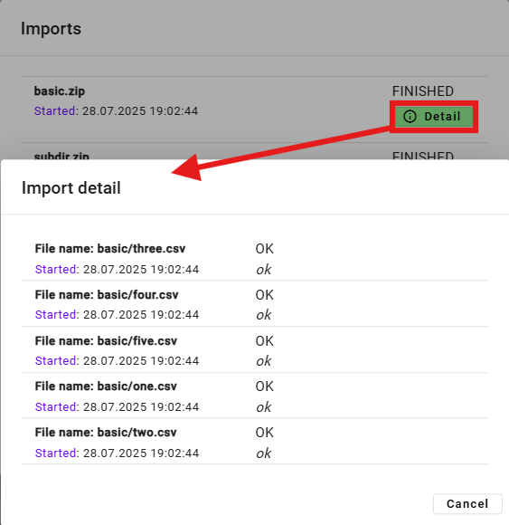

Figure 125: Displaying import details

## Keyboard shortcuts

You can display the list of keyboard shortcuts in the “Profile Manager” application:

1. Click the button with the logged-in user’s name, located in the application's top bar.
2. Select the “Help” item from the menu that appears.
3. Click the “Keyboard shortcuts” item.

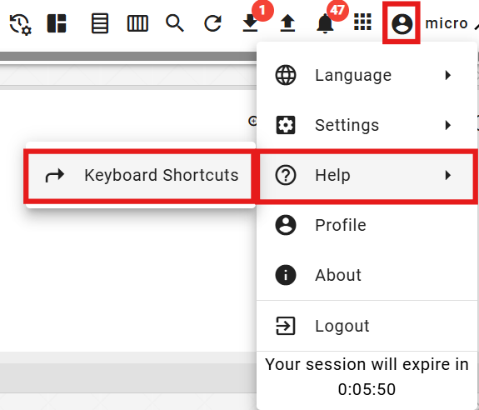

Figure 126: “Keyboard shortcuts” item

1. The “Keyboard shortcuts” window appears.

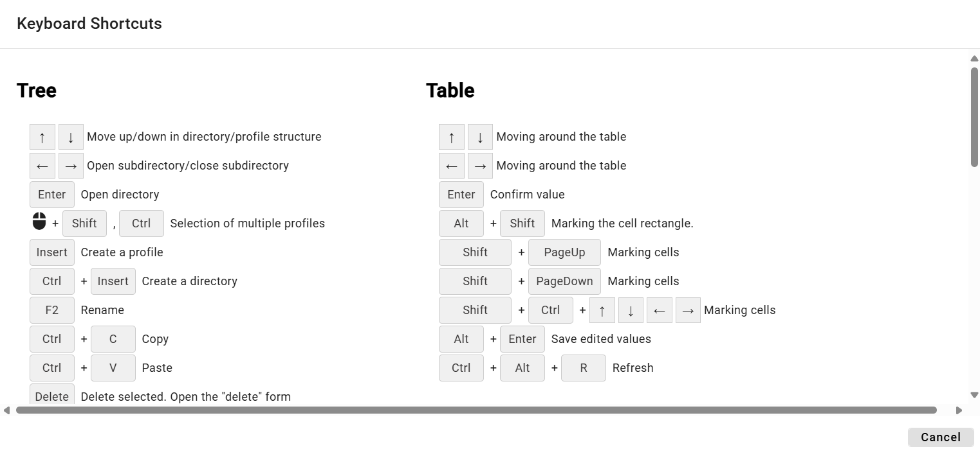

Figure 127: “Keyboard shortcuts” window

1. You can search for keyboard shortcuts by entering text into the “Search” field located in the top-left corner of the window. A list of keyboard shortcuts matching the entered text will appear automatically.
2. Close the window by clicking the “Cancel” button.

In the “Profile Manager” application, you can use the keyboard shortcuts listed in the following table.

|  |  |  |
| --- | --- | --- |
| Klávesová skratka | Časť aplikácie | Popis |
| šípky HORE/DOLE | strom | Posun hore/dole v štruktúre adresárov/profilov |
| šípky HORE/DOLE | prieskumník | Posun hore/dole v štruktúre adresárov/profilov |
| šípky HORE/DOLE | tabuľka | Pohyb po bunkách tabuľky |
| šípky HORE/DOLE | graf | Hore zoom OUT, dole zoom IN |
| šípky Doprava a doľava | strom | Otvorenie podadresára/zatvorenie podadresára |
| šípky Doprava a doľava | prieskumník | Posun celej tabuľky doľava a doprava, aby bolo možné vidieť schované stĺpce |
| šípky Doprava a doľava | tabuľka | Pohyb po bunkách tabuľky |
| šípky Doprava a doľava | graf | Posun grafu o jedno zobrazené časové okno doľava a doprava |
| ENTER | strom | Otvorenie adresára |
| ENTER | prieskumník | Otvorenie adresára/Otvorenie editačného okna profilu |
| ENTER | tabuľka | Potvrdenie hodnoty |
| ENTER | graf | Bez akcie |
| Výber myšou pomocou Shift, Ctrl | strom | Výber viacero adresárov/profilov |
| Výber myšou pomocou Shift | prieskumník | Výber viacero adresárov/profilov |
| Výber myšou pomocou Shift, Ctrl | graf | Výber viacero profilov |
| Alt + Shift | tabuľka | Označenie obdĺžnika buniek |
| Insert | prieskumník | Založí profil |
| Ctrl + Insert | prieskumník | Založí adresár |
| Insert | strom | Založí profil |
| Ctrl + Insert | strom | Založí adresár |
| Ctrl + ALT + K | graf | Zmena koeficientu označeného profilu / označených profilov |
| Ctrl + ALT + W | graf | Skryje označený profil / označené profily |
| Ctrl + ALT + Q | graf | Odkryje označený profil / označené profily |
| Ctrl + ALT + T | PMW | Nové okno Tabuľka |
| Ctrl + ALT + G | PMW | Nové okno Graf |
| Ctrl + ALT + E | PMW | Nové okno Prieskumník |
| Ctrl + C | strom/ prieskumník | Kopírovať |
| Ctrl + ALT + C | prieskumník | Export prieskumníka do clipboardu |
| Ctrl + V | strom/ prieskumník | Paste |
| Ctrl + S | PMW | Uloženie zostavy. Ak nie je žiadna otvorená ponúkne formulár na uloženie do stromu. |
| Ctrl + O | PMW | Otvorenie zostavy z disku |
| Ctrl + ALT + F4 | PMW | Zavretie grafu/tabuľky |
| Ctrl + šípka NAHORU/DOLŮ | graf | Posun/radenie zobrazovaných profilov pod grafom |
| Alt + ENTER | graf | Uloží rozkreslenú čiaru |
| Alt + ENTER | tabuľka | Uloží zeditované hodnoty |
| Delete | graf | odoberie z grafu vybrané profily |
| Delete | strom/prieskumník | Zmazať vybrané. Otvoriť formulár "Delete" |
| CTRL+ R | strom/prieskumník | Refresh |
| CTRL+ ALT + R | graf/tabuľka | Refresh |
| Koliesko myši | graf | Zmena rozsahu časovej osi |
| Koliesko myši + CTRL | graf | Zmena rozsahu ľavej osi |
| Koliesko myši + CTRL + ALT | graf | Zmena rozsahu pravej osi |
| SHIFT + šípka NAHORU/DOLŮ | prieskumník | Výber adresárov/profilov |
| SHIFT + HOME | prieskumník | Výber viacero adresárov/profilov |
| SHIFT + END | prieskumník | Výber viacero adresárov/profilov |
| CTRL + X | prieskumník /strom | Presun adresárov/profilov |

## How to search for a profile in the application

To search for a profile, proceed as follows:

1. Press the button located in the application's top bar.
2. A "search profile" field will appear, into which you can type the profile name.

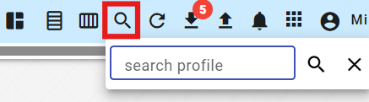

Figure 128: Search profile field

1. Enter text by which you want to search for profiles.
2. Press Enter or the search button.

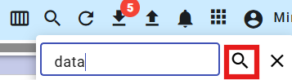

Figure 129: Search button

1. In the active window, the "B:Root" tab will appear, displaying profiles matching the entered text.

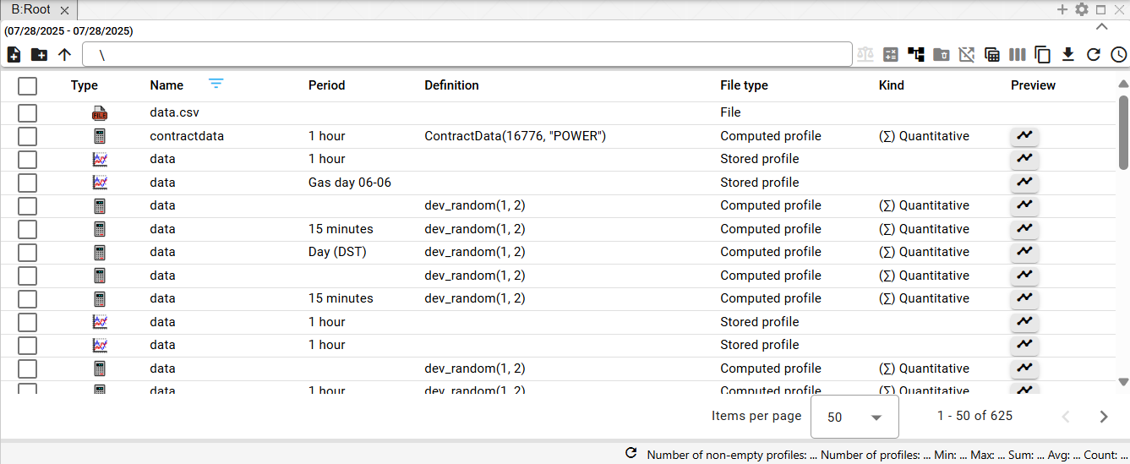

Figure 130: Search Results

## Informing the user about logout

If the user has the "Profile Manager" application open in multiple browser tabs and logs out in one of the tabs, a window informing the user about the logout will appear, as shown in Figure 131. To log in, press the "Log In" button. The login screen will appear, where you can enter your username and password to log in, as shown in Figure 2. After logging in, the "Profile Manager" application will be in the state it was in before the logout.

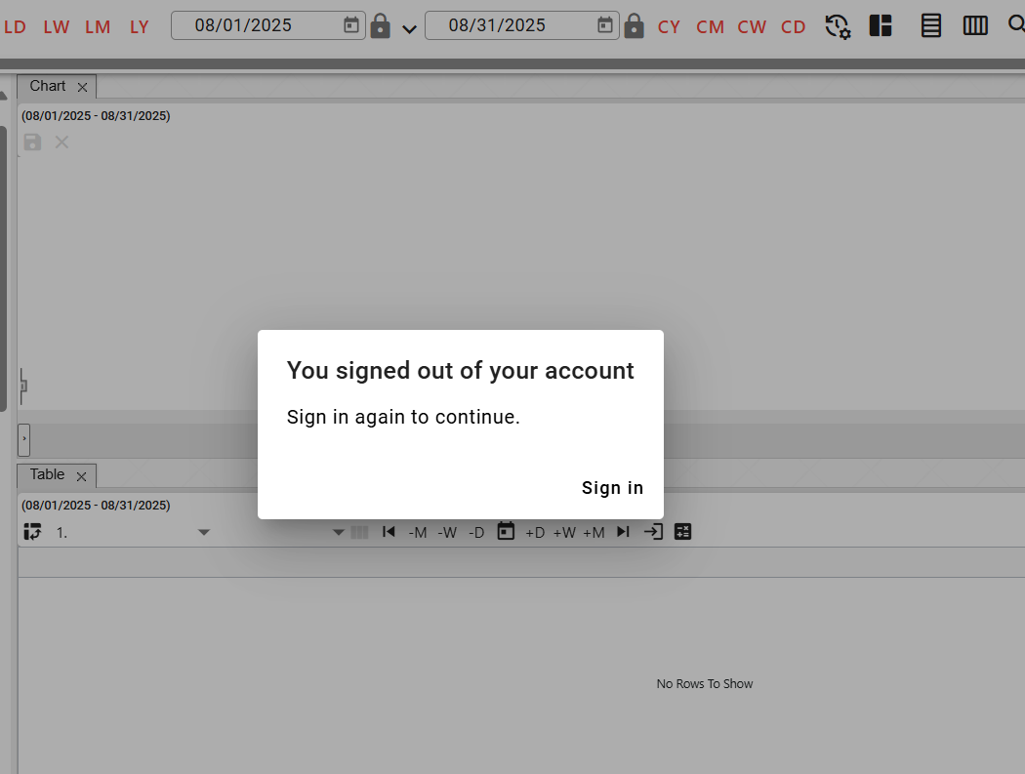

Figure 131: "You have been logged out of your account"

## How to display the time remaining until the user is logged out

If you are not actively using the "Profile Manager" application, the time remaining until the user is logged out of the "Profile Manager" application is counted down. If you are using the application, the time is reset.

You can check how much time remains until logout:

1. Click on the button with the logged-in user's name.
2. A menu will appear, displaying information about the remaining time until the login session expires, Figure 132.

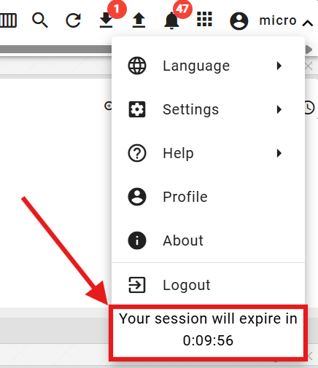

Figure 132: Information about the remaining time until user logout

If the user has not actively worked with the "Profile Manager" application and the login session expires, the user is logged out of the application. A "Login Session Expired" window will appear. To log in again, press the "Log In" button.

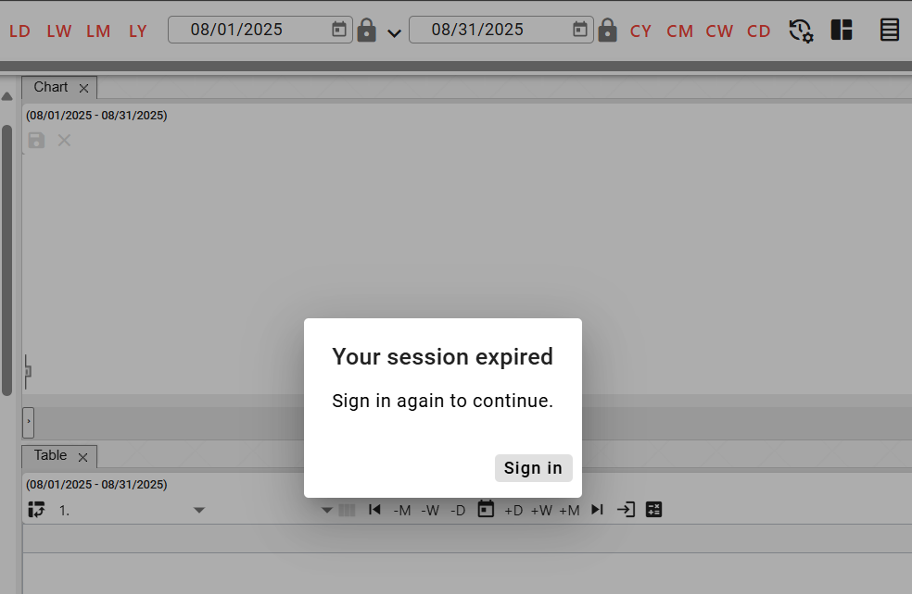

Figure 133: Login Session Expired Notification

# Working with directories and profiles

You can create, rename, edit, and delete directories and profiles within the tree structure. You can also filter directories.

A directory allows for the logical grouping of data into a single group. Each directory can contain further directories or profiles.

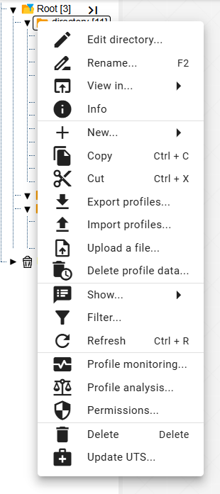

Figure 134: Window with functions for directories and profiles

## How to add a new directory

To add a new directory, proceed as follows:

1. Right-click on the directory in the tree structure where you want to add the new directory.
2. In the menu, select "New" and then "Folder".

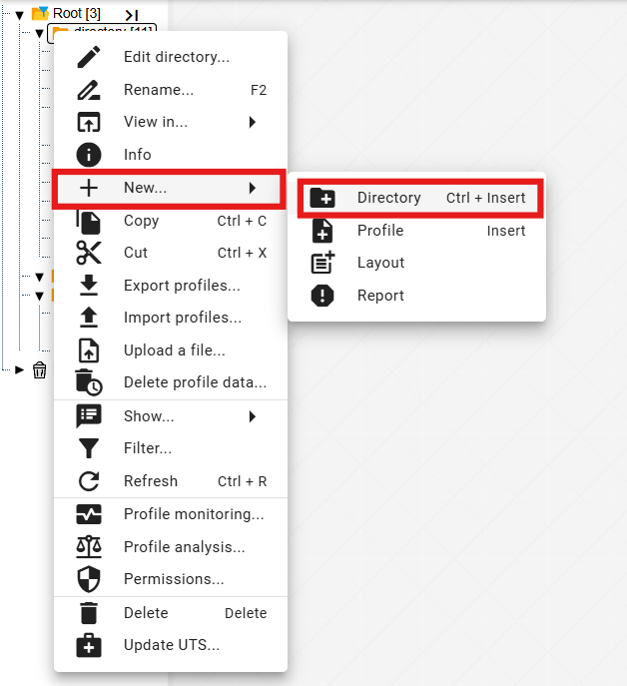

Figure 135: "Folder" item

1. A window for creating a directory will appear.

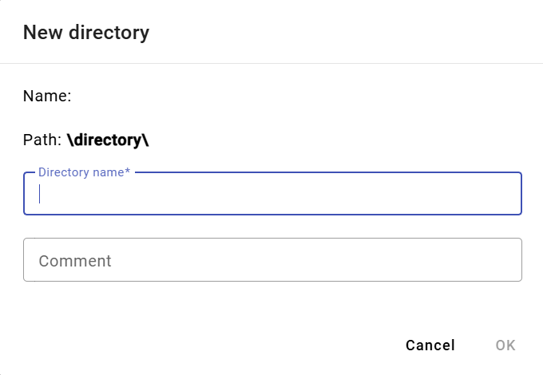

Figure 136: Window for creating a directory

1. Enter the details. The "Directory Name" field is required. The directory name cannot start with a number. It may contain letters, numbers, and underscores. The name must be at least 3 characters and a maximum of 50 characters long. If you do not enter a name or enter an invalid name, information about the directory name will be displayed, see Figure 137. The rules for entering the directory name may vary depending on the configuration of the environment.

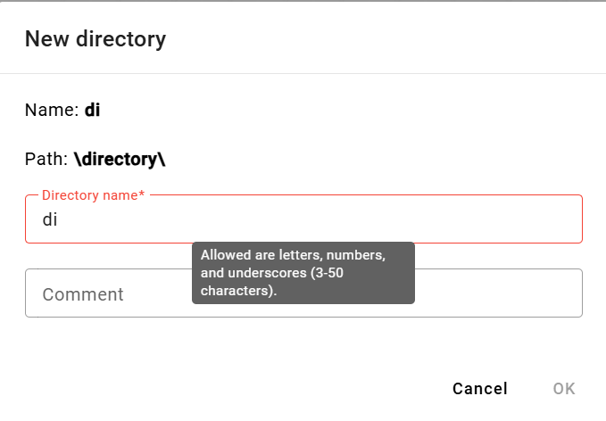

Figure 137: Information about the rules for entering the directory name

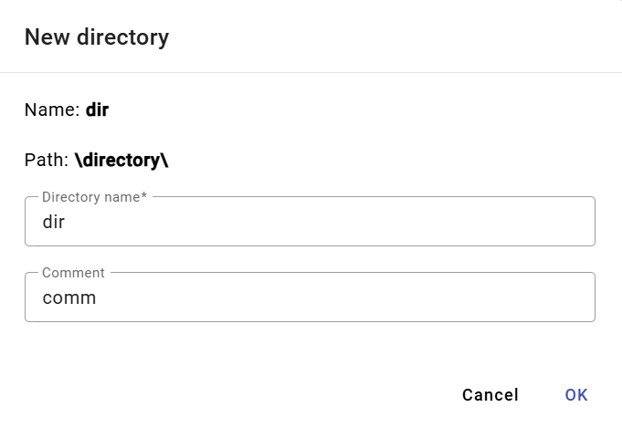

Figure 138: Entering Name and Comment

1. You create the directory by clicking the "OK" button.

## How to rename a directory

How to rename a directory:

1. Click the left mouse button on the directory name and press the "F2" key, or right-click on the directory you want to rename and select "Rename".

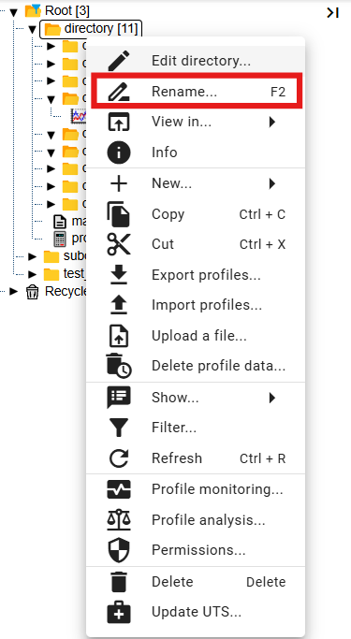

Figure 139: "Rename" item

1. A window will appear where you can enter the new directory name. The directory name must not begin with a number. It may contain letters, digits and underscores. The name must be at least 3 characters and a maximum of 50 characters long. If you do not enter a name or enter an invalid name, an information message about the directory name will be displayed. The rules for entering a directory name may vary depending on the configuration of the environment.

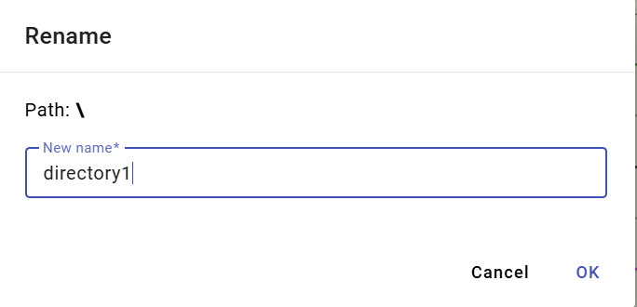

Figure 140: Rename Directory Window

1. You save the changes by pressing the "OK" button.

## How to rename a directory

To edit the directory, proceed as follows:

1. Right-click on the directory you want to edit.
2. In the menu, select "Edit".
3. A window will appear where you can edit the "Comment" field.

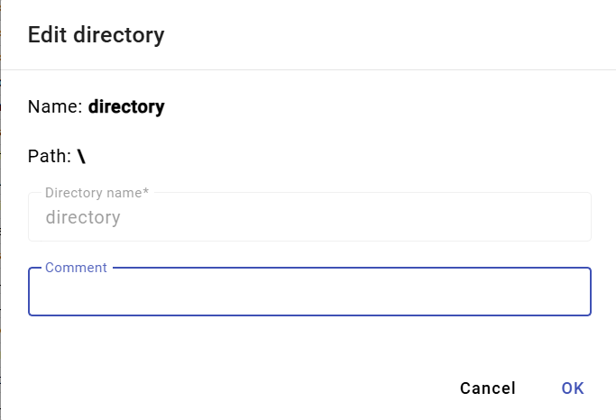

Figure 141: Directory Editing Window

1. You save the changes by pressing the "OK" button.

## How to delete a directory

You delete the directory:

1. Right-click on the directory you want to delete.
2. A menu will appear, in which select "Delete".
3. In the confirmation window, click the "Yes" button.

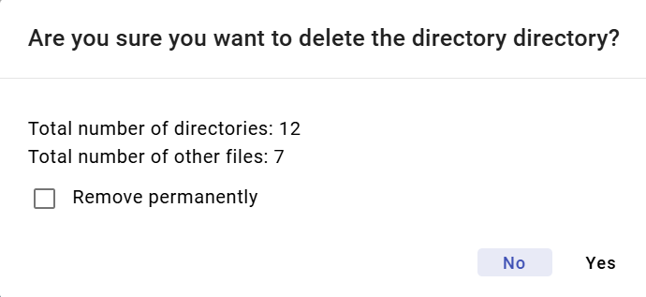

Figure 142: Confirmation Delete Window

## How to Copy a Directory

To copy a directory, proceed as follows:

1. Right-click on the directory you want to copy.
2. In the menu, select "Copy".
3. Right-click on the directory where you want to paste the copied directory and select "Paste".
4. A "Copy" window will appear.

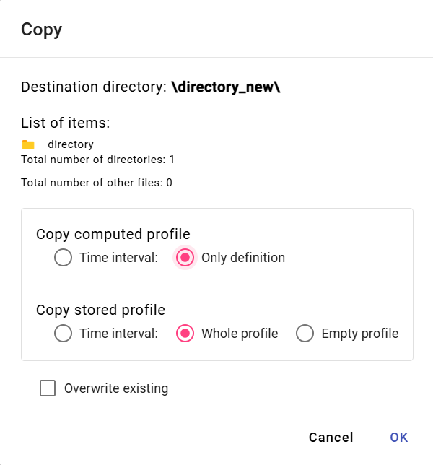

Figure 143: Directory Copy Window

1. Click the "OK" button.

## How to cut/move a directory

To move a directory from one location to another in the tree structure, use the "Cut" item. To cut a directory, proceed as follows:

1. Right-click on the directory you want to cut.
2. In the menu, select the "Cut" item.
3. Right-click on the directory where you want to paste the directory.
4. Select the "Paste" item.
5. A confirmation window will appear, in which click the "OK" button.

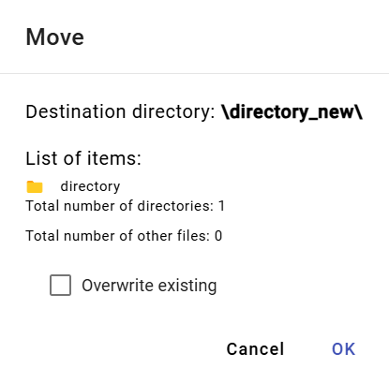

Figure 144: "Move/Copy" Window

## How to upload a file

To upload a file, proceed as follows:

1. Right-click on the location in the tree structure where you want to upload the file.
2. A window will appear where you select "Upload File...".

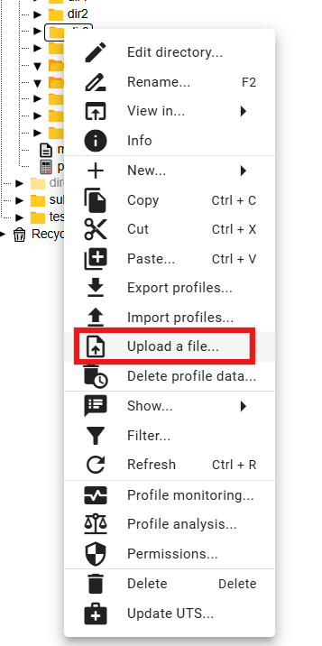

Figure 145: "Upload File..." item.

1. A window will appear where you select “Upload”, click it, and choose the file you want to upload. You can also upload the file by dragging and dropping it into the “Upload” window.

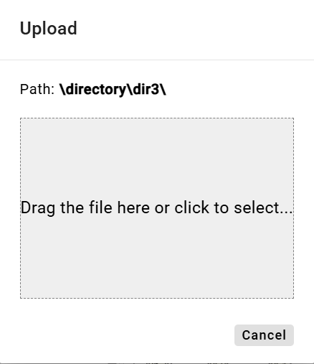

Figure 146: "Upload" window

1. The window will close and a notification will appear at the bottom of the screen: “Upload request has been sent.”



Figure 147: "Upload request has been sent" notification.

Recognized document file types:

* pgz2 - reports
* pvs2 - reports
* xlsx - report template

## How to delete profile data

The "Profile Data Deletion" function will delete data in all profiles within the selected folder(s) based on the specified time interval. You can also select multiple folders or multiple profiles at once. Data can also be deleted in subdirectories.

To delete profile data, proceed as follows:

1. To delete data in only one selected folder (including its subdirectories) or in one profile, right-click on the selected folder or profile. A window will appear where you can select "Profile Data Deletion...".

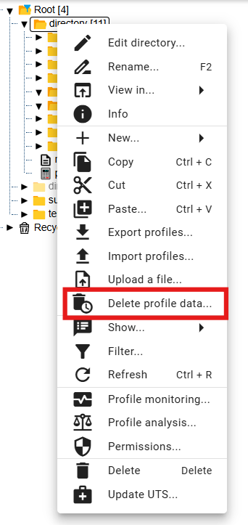

Figure 148: "Profile Data Deletion..." item

1. To delete data in multiple folders or profiles simultaneously, proceed as follows:
   1. Select the folders or profiles in which you want to delete data.
   2. If the folders you want to select are consecutive, click the left mouse button on the first folder, hold down the SHIFT key, and then click on the last folder you want to select. All folders in between will be highlighted.

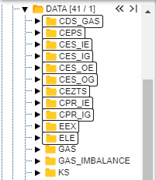

Figure 149: Selecting Multiple Folders

* 1. If the folders you want to select are not consecutive, click the left mouse button on the first folder, hold down the CTRL key, and then click with the left mouse button to select the other folders you want to select.

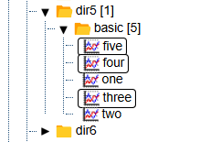

Figure 150: Selecting Multiple Profiles

* 1. Right-click on the selected folders or profiles and select "Delete Profile Data...".

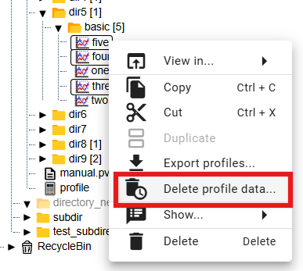

Figure 151: "Delete Profile Data..." Item

1. The "Delete Data Range" window appears, where you select a daily or minute time interval. The minute time interval is selected by default.

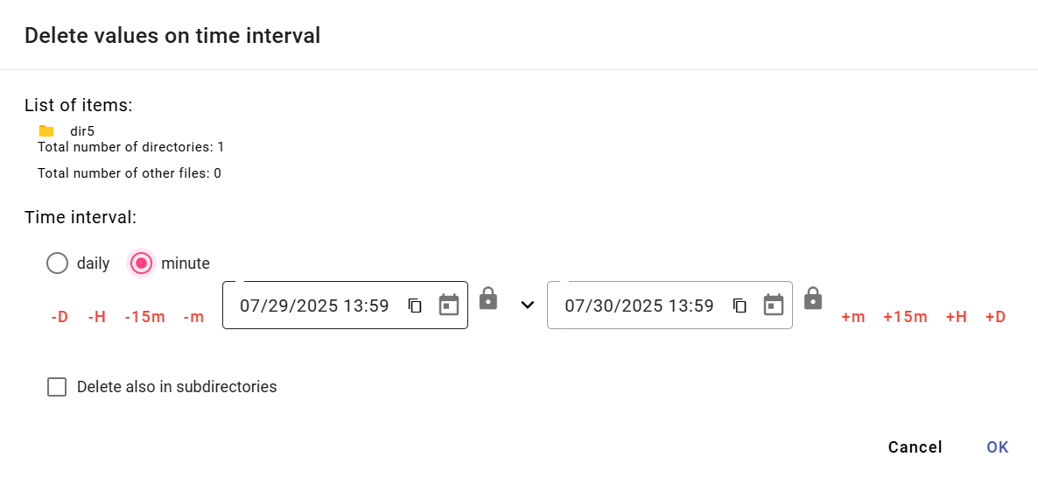

Figure 152: "Delete Data Range" Window for a Single Selected Folder

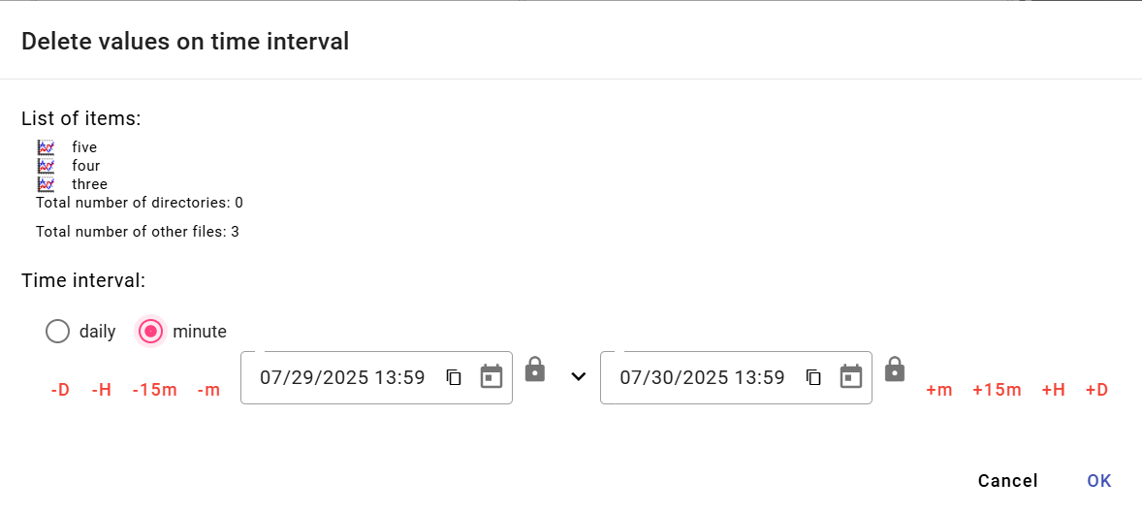

Figure 153: "Delete Data Range" Window for Multiple Selected Profiles

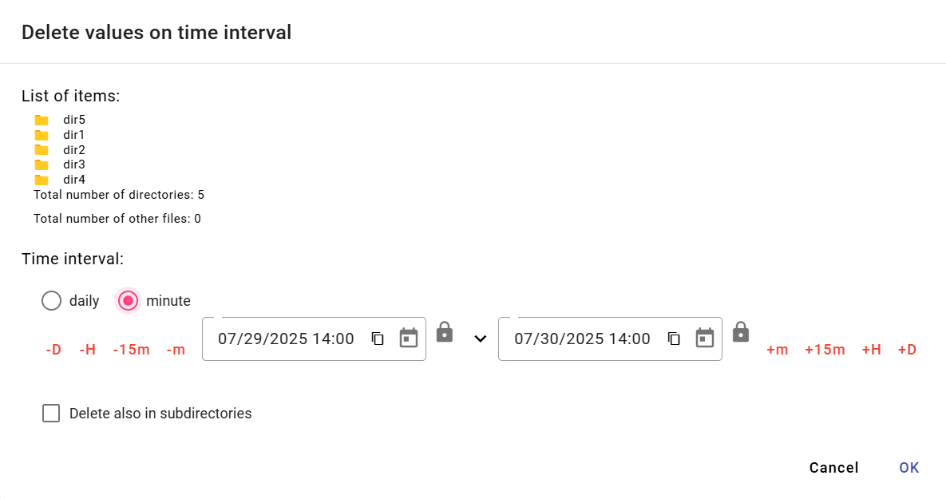

Figure 154: "Delete Data Range" Window for Multiple Selected Folders

1. Next, enter the time interval within which the data should be deleted.
2. If you check the "Delete also in subfolders" checkbox, the subfolders will also be traversed and data in the profiles will be deleted according to the selected time interval.
3. Confirm by clicking the "OK" button.

## How to filter directories and profiles

To filter directories and profiles, proceed as follows:

1. Right-click on the directory.
2. Select "Filter" from the menu.
3. A window for filtering will appear. To filter directories, enter the name or part of the directory name in the "Filter directories" field. To filter profiles, enter the name or part of the profile name in the "Filter profiles" field. Wildcards are not supported here; it searches for any substring. Filtering is also “case sensitive”.

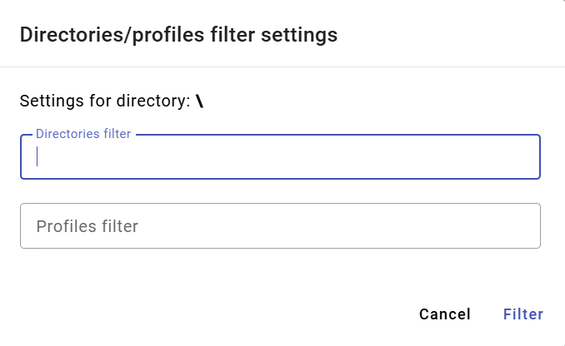

Figure 155: "Directory and Profile Filter Settings" window

1. Confirm the filter by pressing the "OK" button.

## How to cancel the directory and profile filter

To cancel the filter, proceed as follows:

1. Right-click on the directory where the filter is set.
2. Select "Filter".
3. Cancel the selected filter.
4. Save the changes by clicking the "OK" button.
5. After cancelling the filter, all directories and profiles will be displayed in the tree structure.

## How to display comments

When creating directories and profiles, you can enter a comment. To enable the display of comments in the tree structure:

1. Right-click on any directory or profile in the tree structure.
2. A window will appear, in which use your mouse cursor to select the "View" item and choose "Show Comments".
3. When comments are enabled, directory and profile names are displayed in parentheses, and comments appear before the names, Figure 156. If no comment was entered, directory or profile names are displayed only in parentheses, Figure 157.

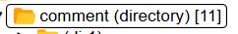

Figure 156: Directory with comments enabled



Figure 157: Directory not containing a comment

1. To disable comments, right-click on any directory or profile in the tree. In the window that appears, use the mouse cursor to select "View" and then choose "Hide comments."

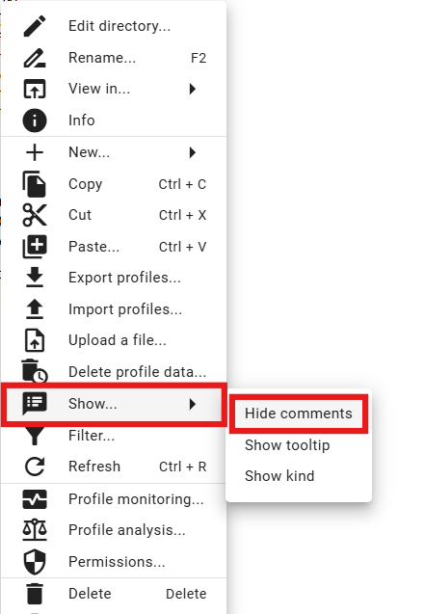

Figure 158: "Hide comments" item

1. Comments are then hidden and directory or profile names are displayed without parentheses.



Figure 159: Directory with hidden comments

## How to display a tooltip

To display a tooltip for profiles in the tree structure, proceed as follows:

1. Right-click on any directory or profile in the tree structure.
2. A window will appear, in which use the mouse cursor to select the "View..." item and click on the "View Tooltip" item.

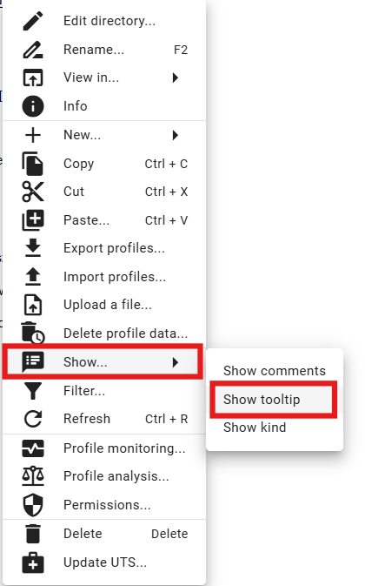

Figure 160: "View Tooltip" item

1. The tooltip will appear when you hover the mouse cursor over the profile name.

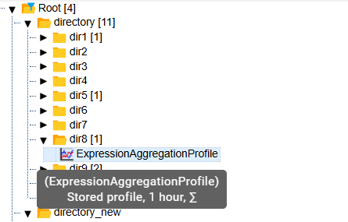

Figure 161: Displayed tooltip

1. To disable the tooltip display, right-click on any directory or profile in the tree. In the window that appears, use the cursor to select "View" and then choose "Hide Tooltip".

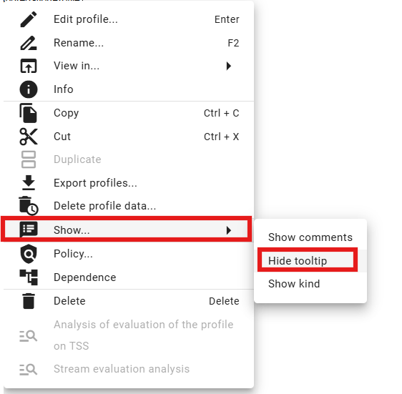

Figure 162: "Hide Tooltip" item

## How to display the character

The profile character can be either "Quantitative" or "Progressive", which are represented by labels.

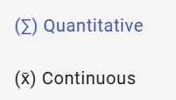

Figure 163: Labels representing quantitative and progressive character

To display the character for profiles in the tree structure, proceed as follows:

1. Right-click on any directory or profile in the tree structure.
2. A window will appear. Use your mouse cursor to select the "Display..." item and click on the "Display Character" item, Figure 160.
3. If a character was entered, the character mark will be displayed before the profile name.

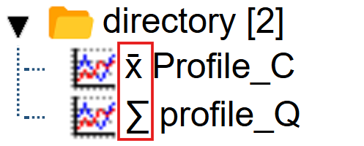

Figure 164: Character displayed next to profiles

1. To disable character display, right-click on any directory or profile in the tree. In the window that appears, use your cursor to select the "View" item and select "Hide Character".

## How to restore the list

To restore the list of profiles and directories, right-click on a directory in the tree and press the "Refresh" button.

## How to set user and group permissions

You set permissions for users and user groups:

1. Right-click on the directory for which you want to set permissions.
2. Select "Permissions Definition".

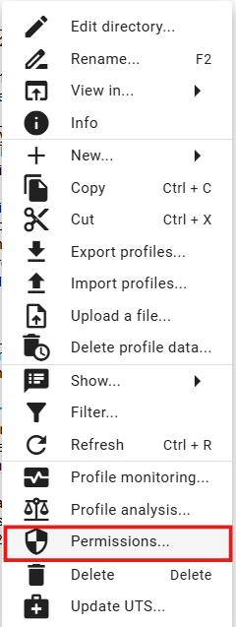

Figure 165: "Permissions Definition" item

1. The "Permissions Definition" window will appear.

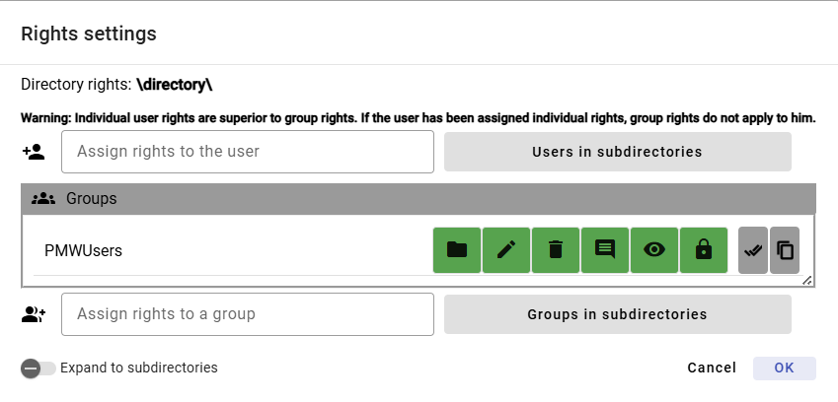

Figure 166: Permissions Definition Window

1. To add user permissions, click in the "Assign Permissions to User" field and start typing the user's name. A list matching the entered text will appear automatically.

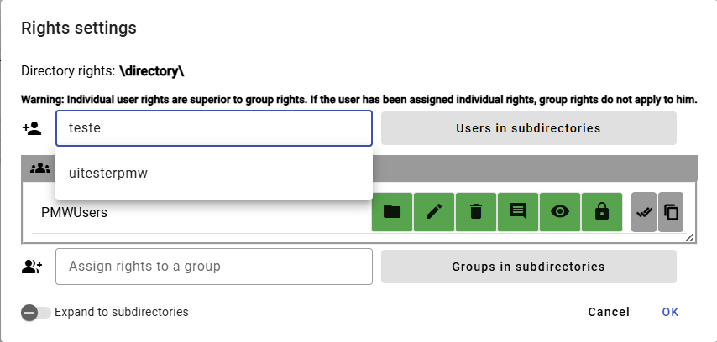

Figure 167: Start typing the user's name in the "Assign Permissions to User" field.

1. Select a user to display the "Users" table containing the selected user.

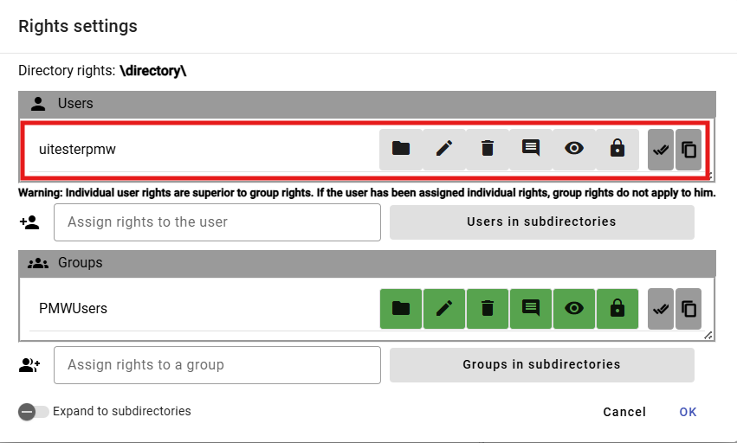

Figure 168: Selected User

1. Click the buttons to add permissions to the user.

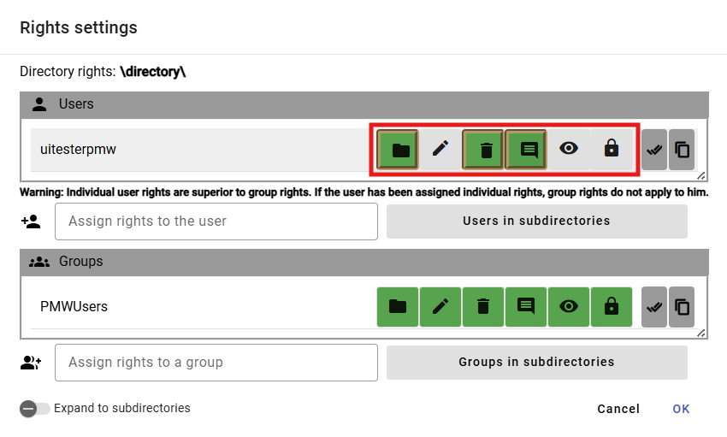

Figure 169: Assigning Permissions to User

1. To assign permissions to a group, select the group in the "Assign permissions to group" field.

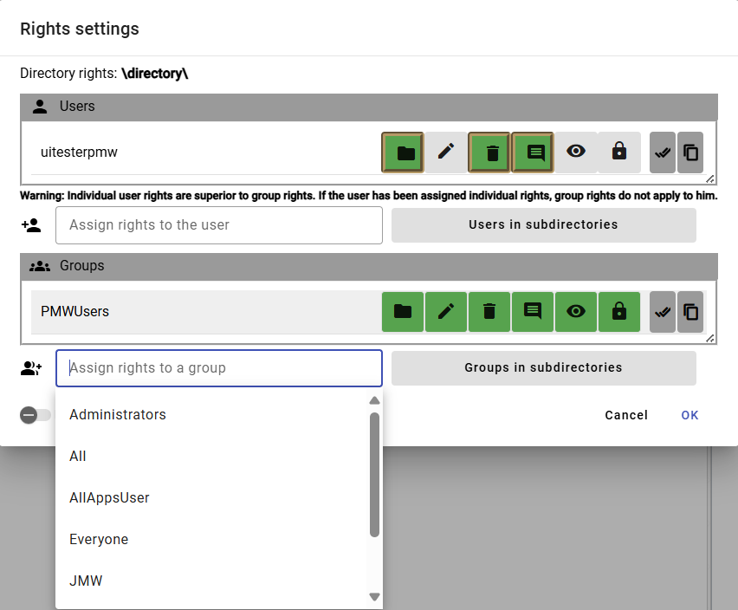

Figure 170: Selecting a Group

1. The selected group will appear in the "Groups" table.

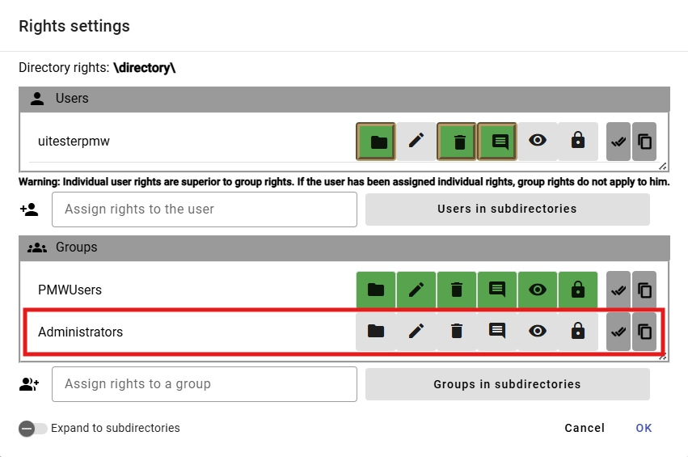

Figure 171: Selected Group

1. Click the buttons to set permissions for the selected group.

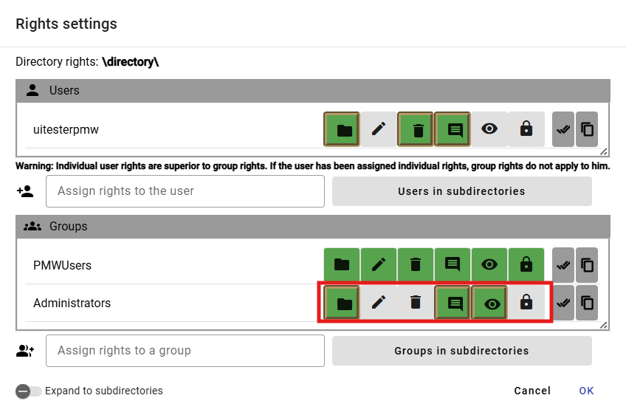

Figure 172: Assigning Rights to Group

1. To set rules for subdirectories as well, check the "Apply to Subdirectories" button.

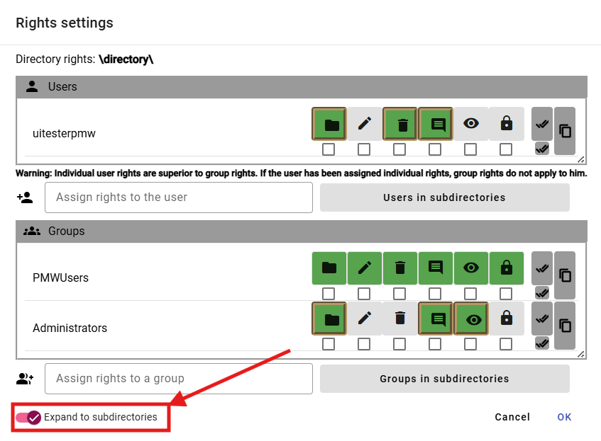

Figure 173: "Apply to Subdirectories" Permission

1. Checkboxes will appear below the buttons representing permissions for users and groups. Check the boxes below the buttons for which you want the permission to apply to subdirectories.

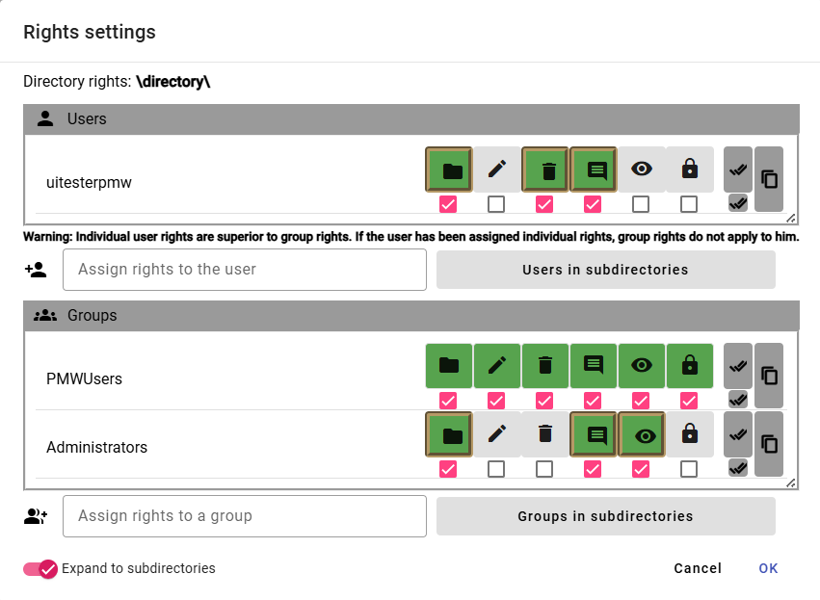

Figure 174: User and Group Permissions for Subdirectories

1. Save the changes by clicking the "OK" button.

## How to create an export

To export profiles, proceed as follows:

1. In the tree structure, right-click on a directory, or in the explorer window, right-click on the row with the directory from which you want to export profiles.
2. Select "Export Profiles..."

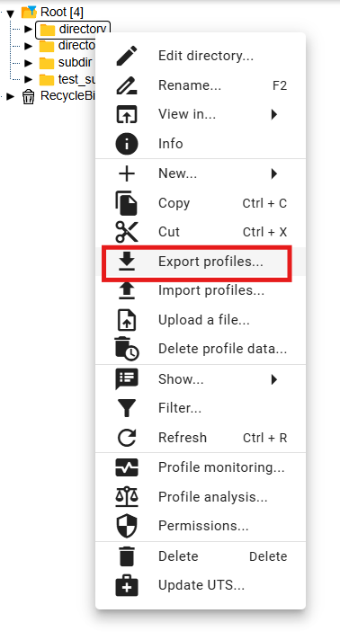

Figure 175: "Export Profiles..." item

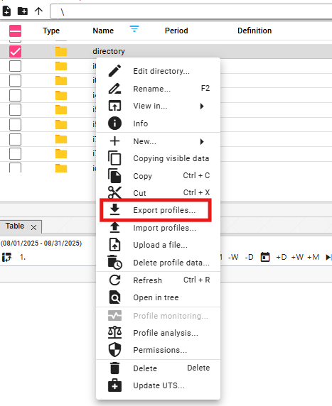

Figure 176: "Export" item in the Explorer window

1. The "Export" window appears, containing two tabs: "All" and "Profiles (CSV)". The "All" tab is displayed by default. The "All" tab allows you to export calculated profiles as an expression. The "Profiles (CSV)" tab exports only the data.

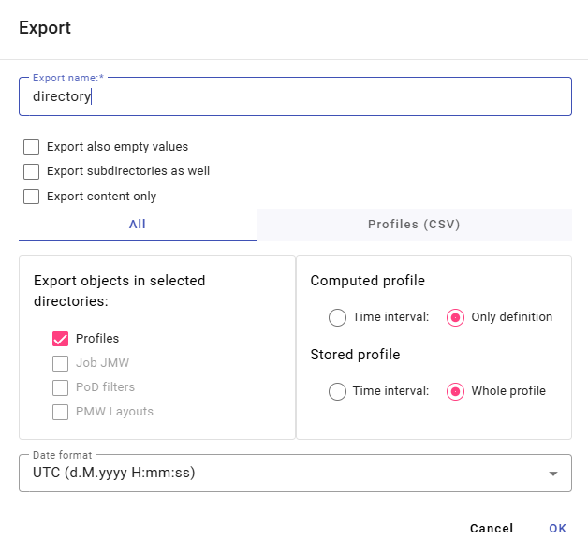

Figure 177: "Export" window, "All" tab

1. The "Export Name" field is populated by default with the name of the directory from which you want to export the profiles. You can change the name for the export.
2. In the top part of the window, select what should be exported (including subdirectories, including empty values, only content).
3. In the "All" tab, in the "Export Objects in Selected Directories" section, select which objects should be exported.
4. For "Calculated Profile", select whether to export "Time Interval" or "Definition Only".
5. For "Saved Profile", select whether to export "Time Interval" or "Full Profile".
6. In the "Time Format" field, select the time format.
7. To export profiles in CSV format, click the "Profiles (CSV)" tab.
8. In the "Time Interval (mm/dd/yyyy)" section, select the dates in the "Start Date" and "End Date" fields.
9. Click in the "Column Separator" field and select a separator.
10. Click in the "Decimal Separator" field and select a separator.
11. In the "Time Format" field, select a time format.

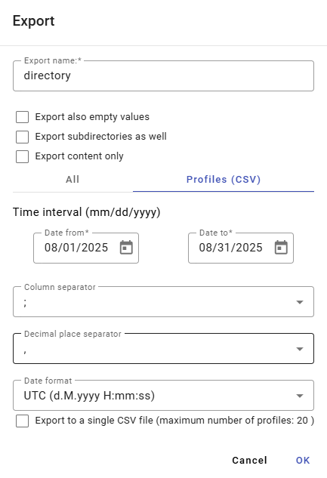

Figure 178: "Export" window, "Profiles (CSV)" tab

1. You start the export by pressing the "OK" button.
2. Information about the export status is displayed in the "Exports" window, which is covered in chapter 1.20. In the "Exports" window, it is then possible to download the completed export.

## How to create an import

To create an import, proceed as follows:

1. Right-click in the tree structure on the directory into which you want to import the file.
2. Select "Import Profiles..."

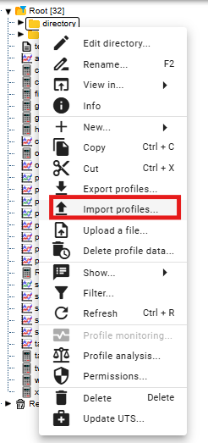

Figure 179: "Import Profiles..." item

1. The "Import" window appears.

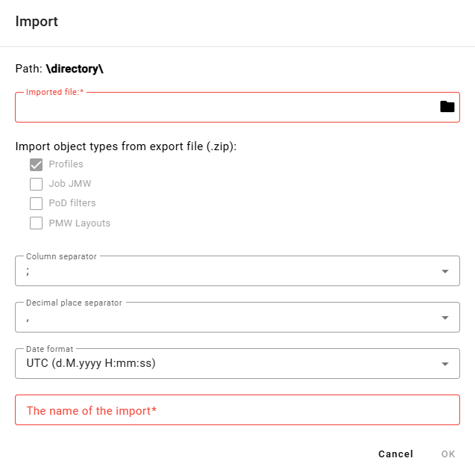

Figure 180: "Import" window

1. In the "Imported File" section, click the black file icon and select the file you want to import.
2. In the "Import object types from export (.zip)" section, select what you want to import. "Profiles" is selected by default.
3. Click in the "Column Separator" field and select the separator.

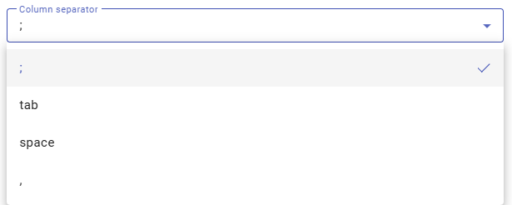

Figure 181: Menu for the "Column Separator" item

1. Click in the "Decimal Separator" field and select the separator.
2. In the "Import Name" field, enter a name for the imported file.
3. You import the file by pressing the "OK" button.
4. The imported file appears in the selected directory.



Figure 182: Imported file

Information about the import status is displayed in the "Imports" window, which is covered in chapter 1.21.

## How to add a new profile

To add a profile, proceed as follows:

1. Right-click on the directory where you want to add the profile.
2. In the menu, select "New" and then "Profile".

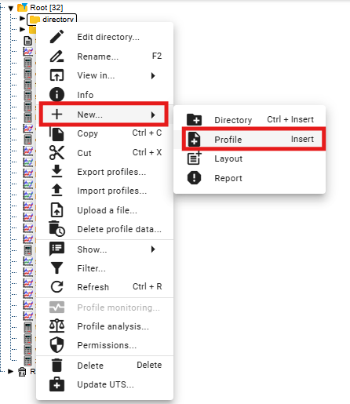

Figure 183: Creating a profile

1. A window for creating a profile will appear.

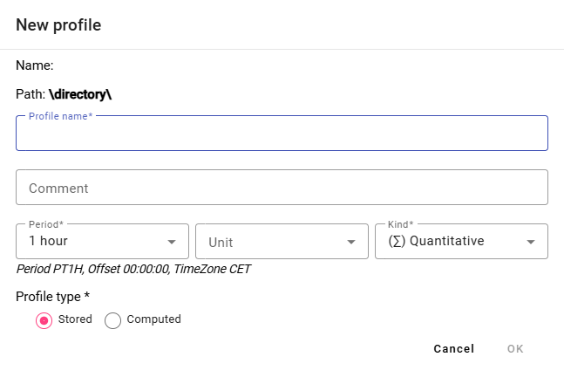

Figure 184: Window for creating a profile

1. Enter the details.
2. The "Profile Name", "Period", and "Profile Type" fields are required.
3. The profile name must not start with a number. It may contain letters, numbers and underscores. The name must be at least 3 characters and a maximum of 50 characters long. If you do not enter a name or enter an invalid name, information regarding the profile name will be displayed. The rules for entering the profile name may vary depending on the configuration of the given environment.

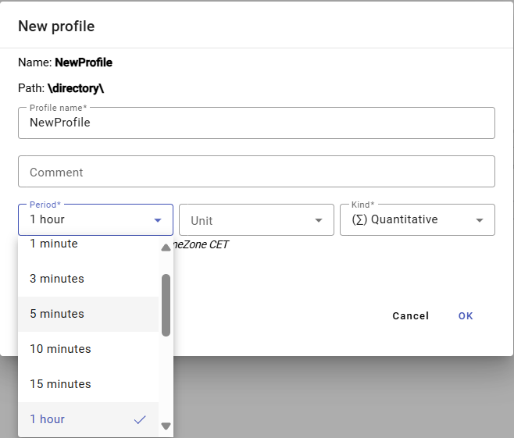

Figure 185: Period Selection

1. If you select a calculated profile type, enter the definition. For example, profilA+2*(profilC-2). The arithmetic options are described in the document “Xenergie TSS Kompl_prehl_fnc_G2 R12.xlsx”. Chapter 2.18.1 deals with creating definitions for calculated profiles.

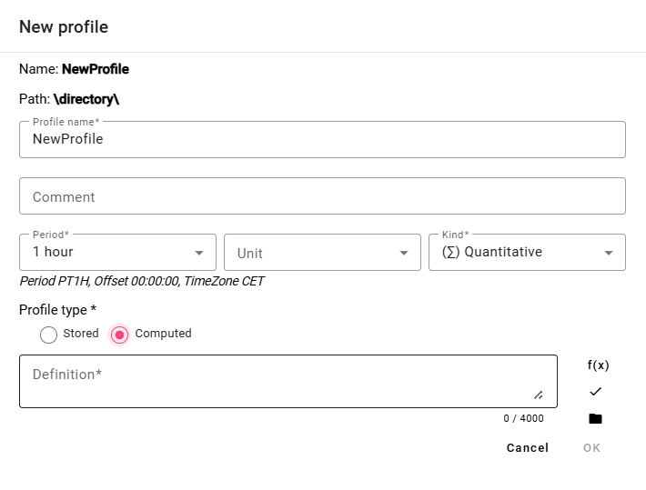

Figure 186: Calculated Profile Type

1. You create a profile by pressing the “OK” button.

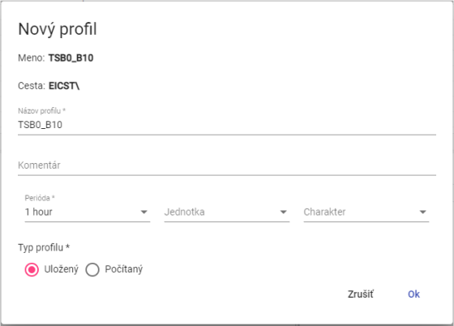

Figure 187: Saved Profile Type

Profile Character:

• Quantitative – represents the amount, for example, energy consumed over a certain period.

• Transient – represents the state of a certain quantity at a specific time. For example, the temperature profile.

• Undefined – If a profile does not have explicitly defined one of the two characteristics above, the system treats it as Transient. This behavior was chosen with regard to maintaining backward compatibility with older versions of the Xenergie system and allows for a seamless transition to newer versions of the system.

The profile characteristic serves to identify the method by which values in the profile should be resampled to a finer or coarser sampling rate. For example, ¼-hour energy values in MWh should be summed when converting to hourly values, while ¼-hour power values in MW should be averaged.

The profile characteristic is used solely and only in connection with the need for resampling (recalculating the profile to a different period). When using the profile in its native period, this setting is irrelevant.

### How to define a calculated profile type

To define a calculated profile type, proceed as follows:

1. In the "New Profile" window, click the "Function Wizard" button, which will display the window for entering the function.



Figure 188: "Function Wizard" button

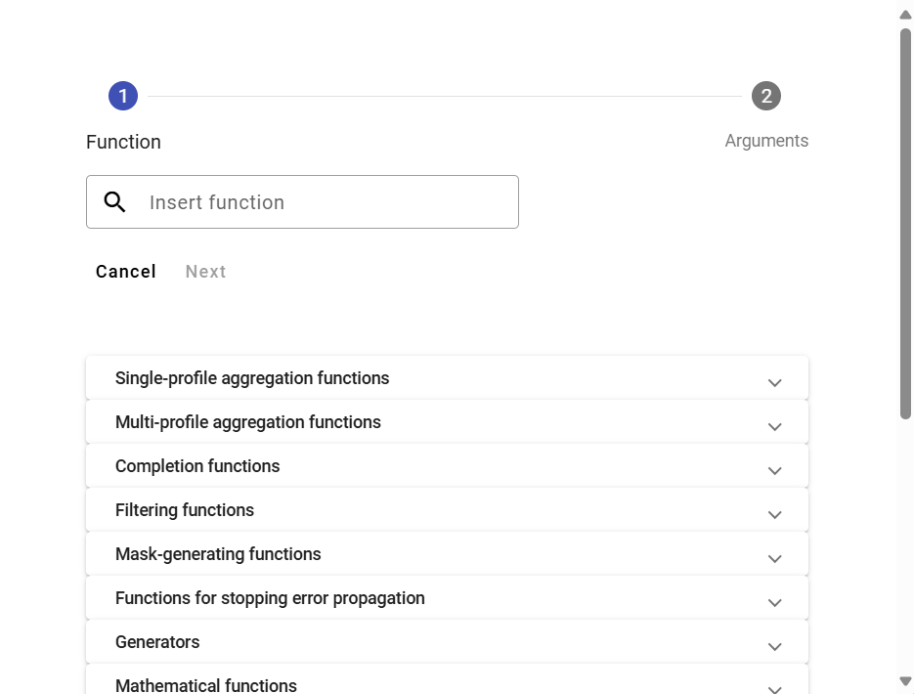

Figure 189: Function Wizard

1. Click in the "Insert Function" box.

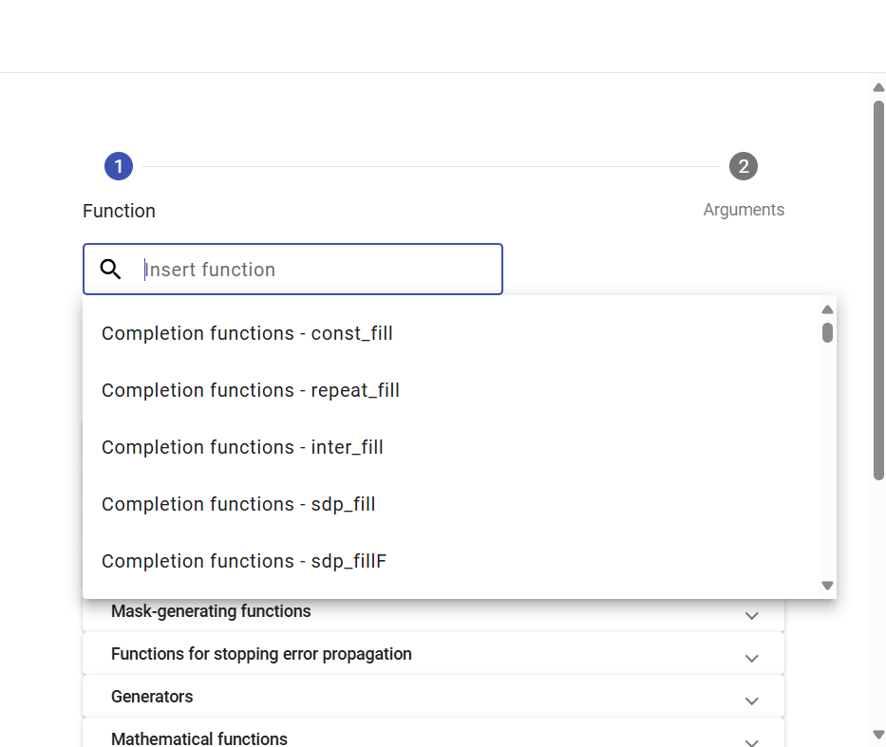

Figure 190: Function Selection

1. A list of functions will appear, from which you select the function.
2. After selecting a function, a description will appear.

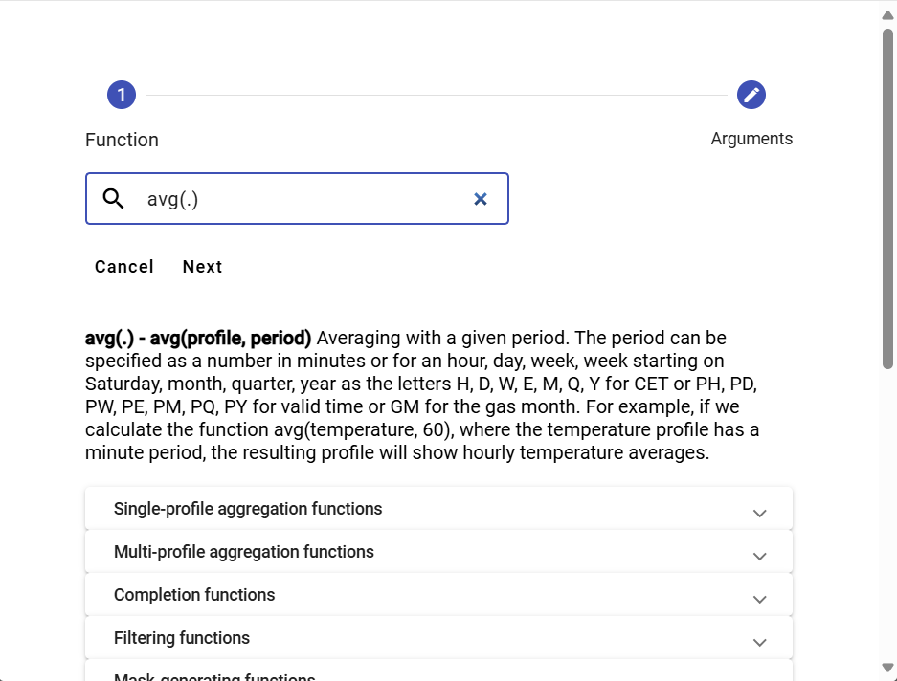

Figure 191: After selecting a function, a description of the function will appear.

1. Clicking on a function group will display a list of functions with descriptions.

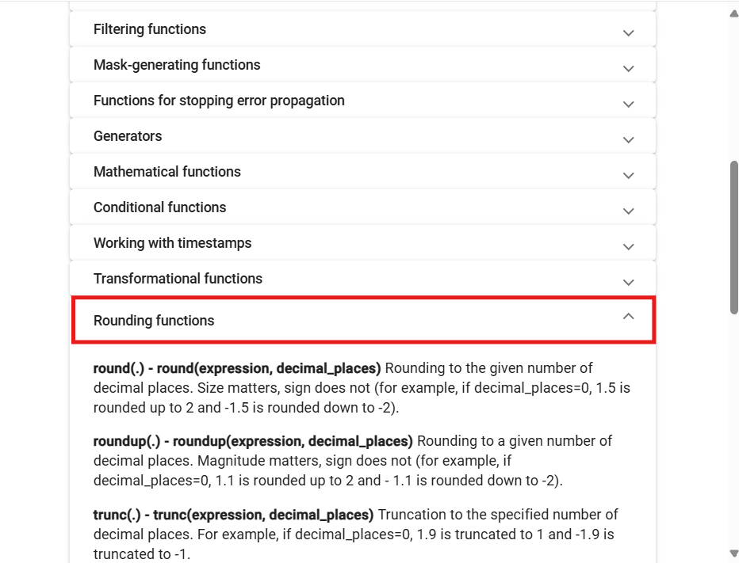

Figure 192: Function Descriptions

1. Enter the profile path or click the button to display the “Profile Selection” window, where you select a profile.
2. Enter the period.

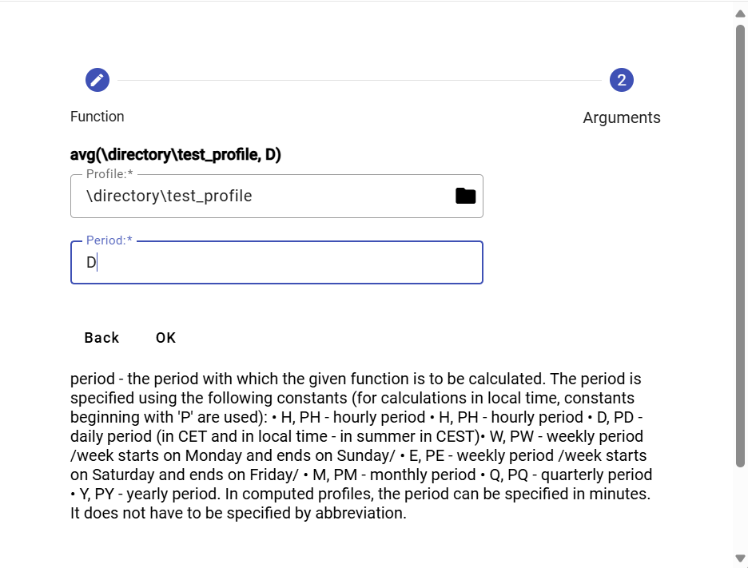

Figure 193: Entering the Period

1. Press the “OK” button.
2. In the "New Profile" window, after entering the definition, press the "Check Definition" button.

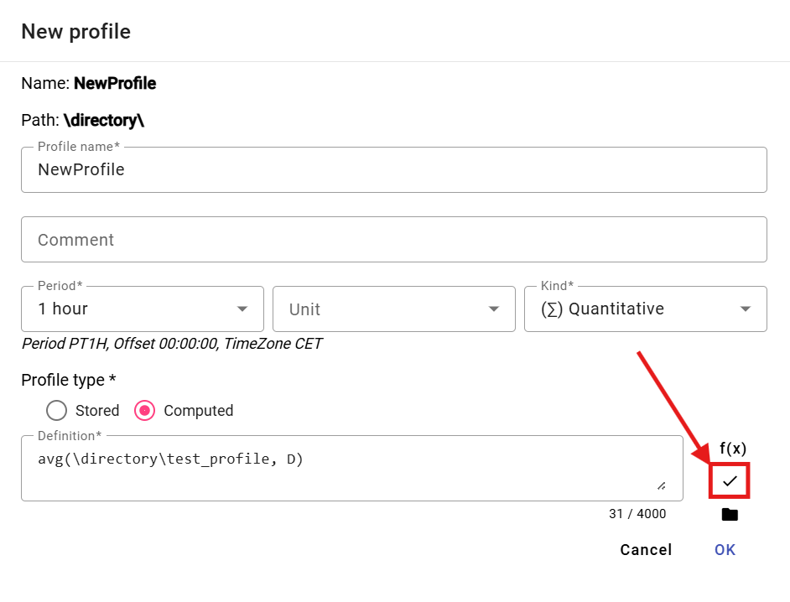

Figure 194: “Check Definition” button

1. A “Status” window will appear, which you close by pressing the “OK” button.

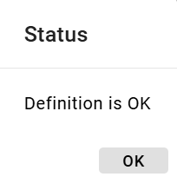

Figure 195: “Status” window

1. The button is used to add a profile.
2. You save the profile by pressing the “OK” button.

## How to add a new report

You create a new report:

1. Right-click on the folder where you want to add the new report.
2. Select "New..." and then "Report".

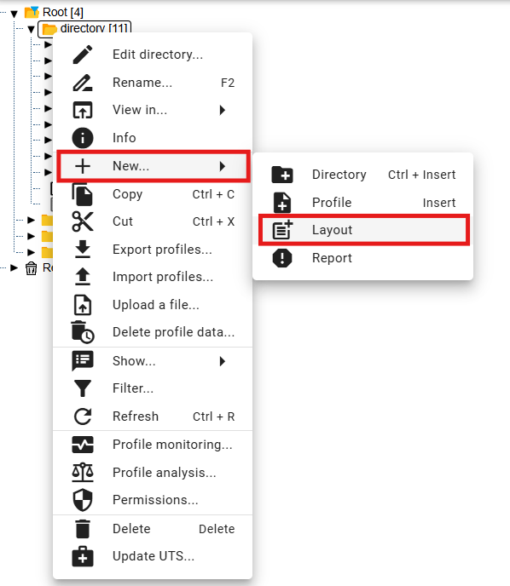

Figure 196: "Report" item

1. A "Report Name" window will appear.

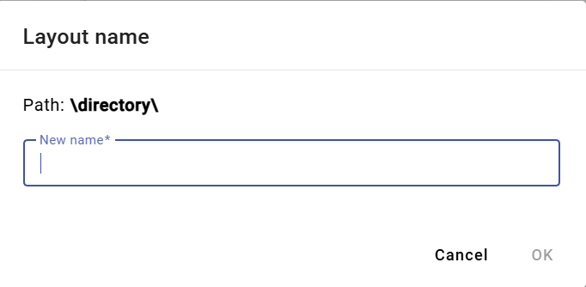

Figure 197: "Report Name" window

1. Enter a name for the new report. The report name must not begin with a number. It may contain letters, numbers, and underscores. The name must be at least 3 characters and a maximum of 50 characters long. If you do not enter a name or enter an invalid name, a message with the rules for the name will be displayed. The rules for entering the name may vary depending on the configuration of the environment.

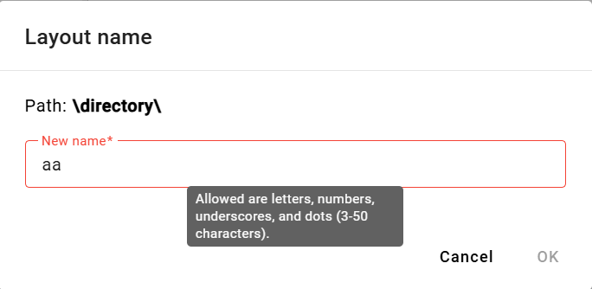

Figure 198: A message with the rules for the name will be displayed if the name is invalid.

1. Confirm by clicking the "OK" button.
2. A new report will be added to the selected folder.

## How to rename a profile

Rename profile:

1. Right-click on the profile you want to rename.
2. In the menu, select "Rename".
3. A window will appear where you enter the new name. The profile name cannot start with a number. It may contain letters, numbers, and underscores. The name must be at least 3 characters and a maximum of 50 characters long. If you do not enter a name or enter an invalid name, information about the profile name will be displayed. The rules for entering the profile name may vary depending on the configuration of the given environment.

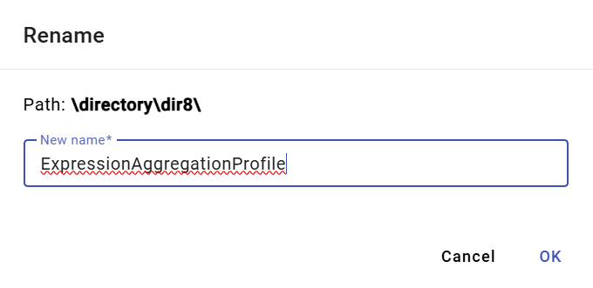

Figure 199: Renaming the profile

1. You save the changes by clicking the "OK" button.

## How to edit a profile

To edit a profile, proceed as follows:

1. Right-click on the profile you want to edit.
2. In the menu, select "Edit".
3. A window will appear where you can edit the details.

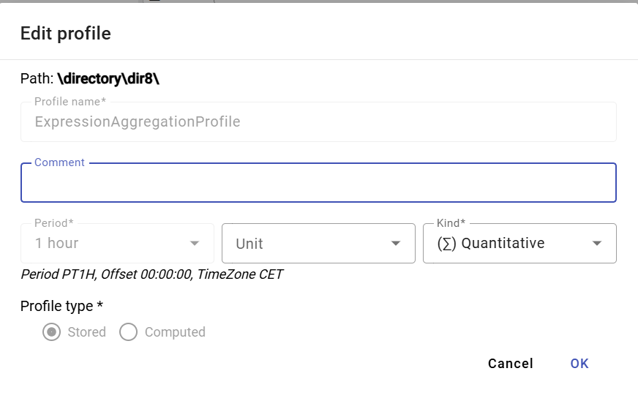

Figure 200: Window for editing the profile

1. Save the changes by pressing the "OK" button.

## How to delete a profile

Procedure for deleting a profile:

1. Right-click on the profile you want to delete.
2. In the menu, select "Delete".
3. A window will appear, in which confirm the deletion of the profile by pressing the "Yes" button.

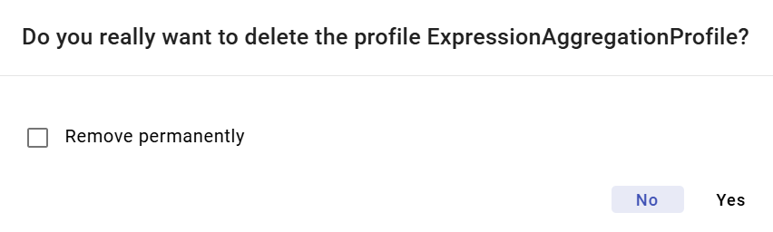

Figure 201: Confirmation of deletion window

## How to display profile dependencies

You will display profile dependencies:

1. Right-click on the profile in the tree structure.
2. Select "Dependencies".
3. A window will appear with three tabs: “Used Profiles”, “Complete Definition”, and “Dependent Profiles”. The first tab contains a list of used profiles.

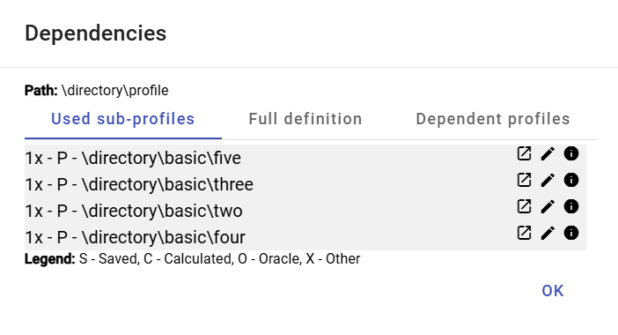

Figure 202: “Used Profiles” tab

1. The second tab “Complete Definition” contains the profile definition entered when creating the profile.

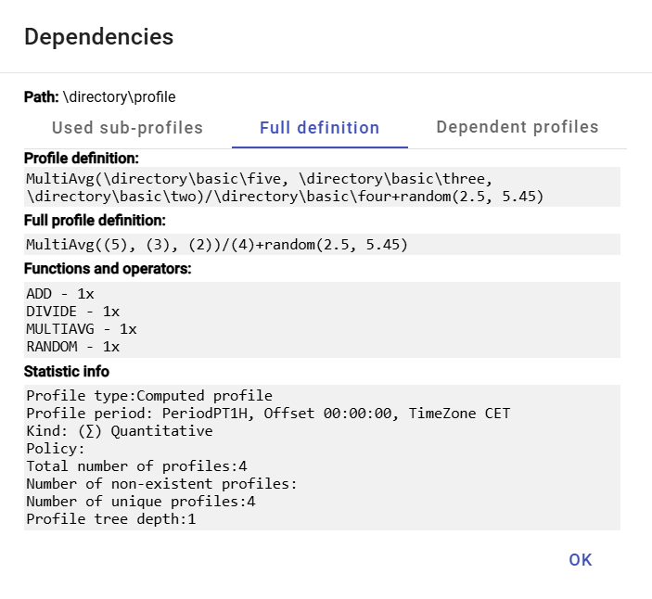

Figure 203: “Complete Definition” tab

1. The third tab “Dependent Profiles” contains a list of dependent profiles.

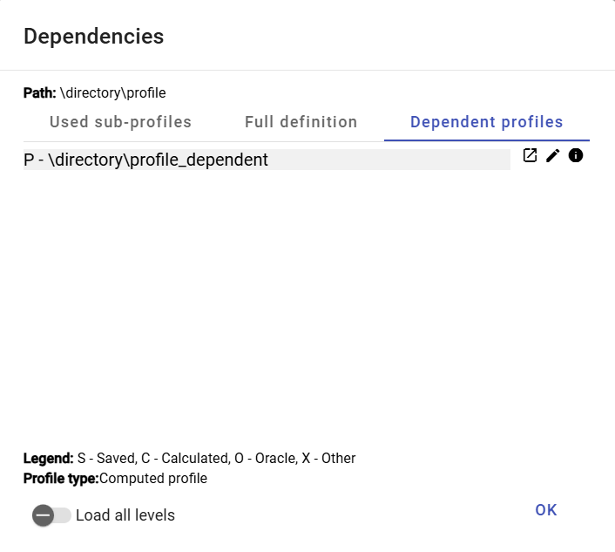

Figure 204: “Dependent Profiles” tab

## How to create a new profile

In the Explorer window, you create a new profile by clicking the “Create New Profile” button, which is located in the upper left corner of the Explorer window. The “New Profile” window will appear. The procedure for creating a profile is detailed in chapter 2.18.

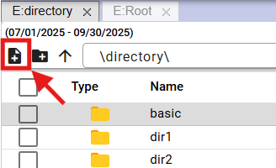

Figure 205: “Create New Profile” button

## How to Set Profile Policy

The policy defines special profile behavior. Policies are added to the system based on specific customer requirements.

Profile Time Policy:

Profile Time Policy is a profile property that enables handling very specific data transformation cases in profiles.

One use of the policy is the ability to change the period of a stored profile from 1h to 15 minutes without the need for lengthy and slow data transformation. After applying the policy “1h to 15min”, the originally hourly stored profile becomes a 15-minute profile across the entire range. All applications using the profile will see it only as a 15-minute profile from the moment of transformation. Therefore, the policy is fully transparent to other applications outside of TSS.

The “1h to 15min” policy, however, must have a firmly defined change date, from which the profile should be used as a fully-fledged 15-minute profile. Before this date, the profile will appear as a 15-minute profile, but all 4 values within the hour will always be the same. Their value will depend on the specified character of the profile.

Example:

The originally hourly stored profile contained a value of 100 MWh. If the profile character is set to “Quantitative”, the 15-minute profile will return a value of 25 MWh in each 15-minute interval.

If the same profile had the character set to “Continuous”, then the 15-minute profile would return a value of 100 MWh in each 15-minute interval of that hour after the policy is set.

To set the policy, proceed:

1. Right-click on the profile in the tree structure that you want to set the policy for.
2. Select “Policy”.
3. The “Policy Settings” window will appear.

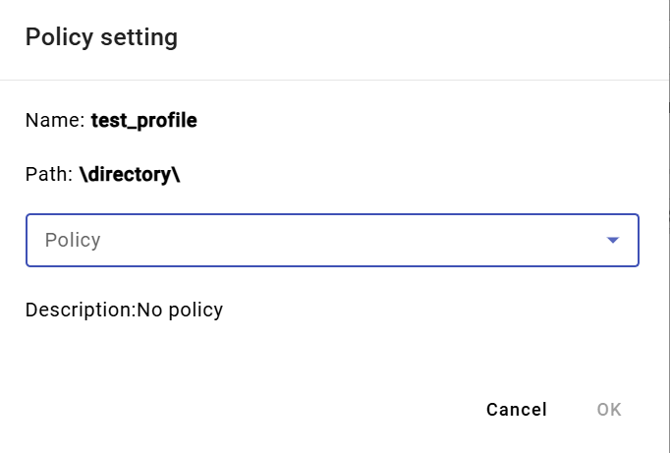

Figure 206: “Policy Settings” Window

1. Currently, two policies are available.

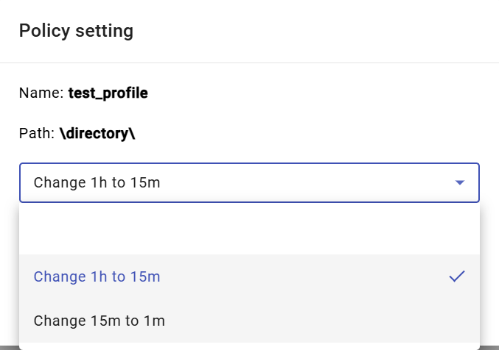

Figure 207: Policy Selection

1. You save changes by pressing the "OK" button.

## How to display profile information

To display profile information, proceed as follows:

1. Right-click on the profile for which you want to display information.
2. Select "Info".
3. A window with information will appear.

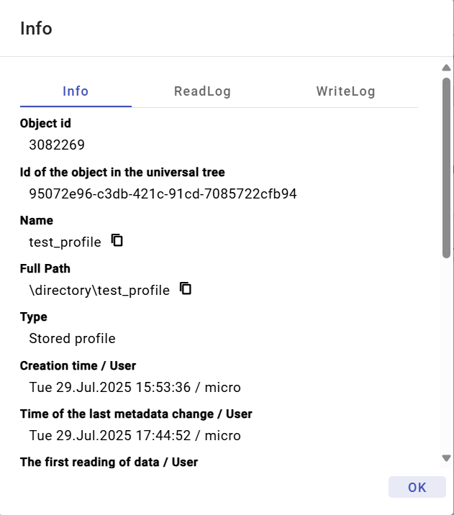

Figure 208: Profile Information

## How to copy a profile

To copy a profile, follow these steps:

1. Right-click on the profile you want to copy.
2. Select "Copy".
3. Right-click on the directory where you want to paste the copied profile and select "Paste".
4. A "Copy" window will appear.

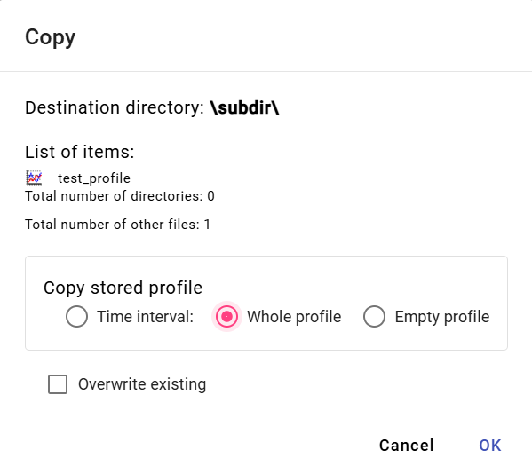

Figure 209: "Copy" window

1. Select whether to copy only the time interval, the entire profile, or an empty profile. "Entire profile" is selected by default.
2. Press the "OK" button.

You can also copy a saved profile from one directory to another by grabbing the profile with the left mouse button and moving it over the directory you want to copy the profile to.

To copy a directory, proceed as follows:

1. Grab the directory and move it over to the directory you want to copy the profile to.
2. Subsequently, release the directory, which will display the "Move/Copy" window.

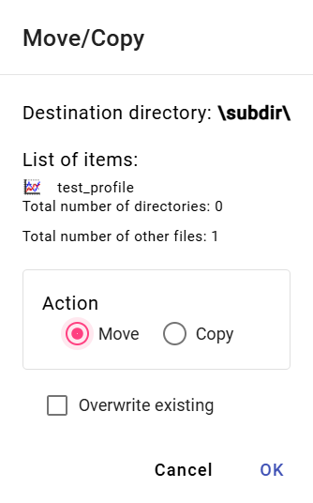

Figure 210: Window for moving the profile

1. Check the "Copy" action.

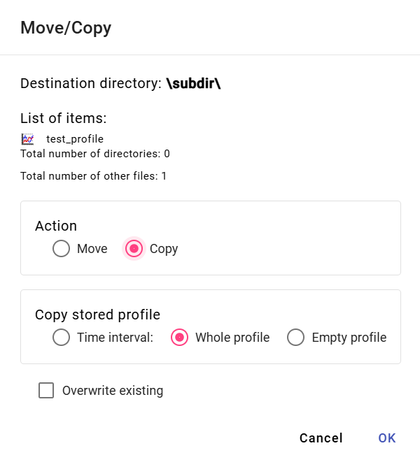

Figure 211: Window for copying the profile

1. In the "Copy Saved Profile" section, select whether to copy the entire profile, a time interval of the profile, or an empty profile.
2. If you select a time interval, enter the time interval to be copied.

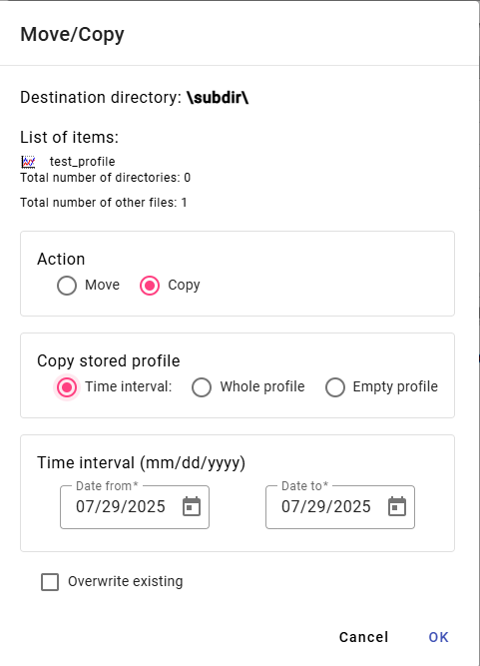

Figure 212: Window for copying a time interval of a saved profile

1. Checking the "Overwrite existing in case of conflict" checkbox means that if a profile with the same name as the profile you want to copy already exists in the directory, the profile will be overwritten. If you do not check the checkbox and a conflict occurs, the original profile will be retained.
2. You copy the profile to the directory by pressing the "OK" button.

## How to cut/move a profile

To cut/move a profile, proceed as follows:

1. Right-click on the profile you want to cut.
2. In the menu, select "Cut".
3. Right-click on the folder where you want to insert the profile.
4. Select "Insert".
5. A confirmation window will appear, in which press the "OK" button.

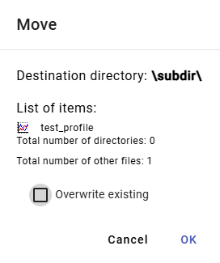

Figure 213: "Move" window

You can also move a saved profile from one directory to another by clicking and dragging the profile to the directory you want to move it to.

To move the directory, proceed as follows:

1. Grab the profile and drag it to the directory you want to move the profile to.
2. Next, release the profile over the directory, which will display the "Move/Copy" window.

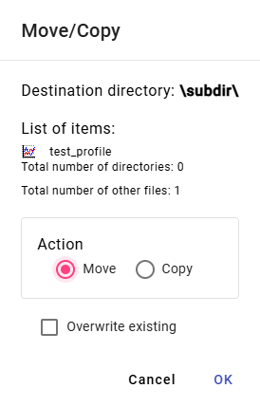

Figure 214: Window for moving the profile

1. Checking the "Overwrite existing in case of conflict" checkbox means that if a profile with the same name as the profile you want to move is found in the directory, the profile will be overwritten. If you do not check the checkbox and a conflict occurs, the original profile will be retained.
2. You save the profile to the directory by clicking the “OK” button.

## How to display the time series preview in the tree

To display the time series preview in the tree, double-click the profile in the tree structure. The “Time Series Preview” window will appear. The “Time Series Preview” window is described in chapter 4.7.

## How to resize the window for creating and editing a calculated profile

You can resize the window for creating and editing a calculated profile. Proceed as follows:

Click and hold the left mouse button – and drag. Resize the window to the desired size and release the left mouse button.

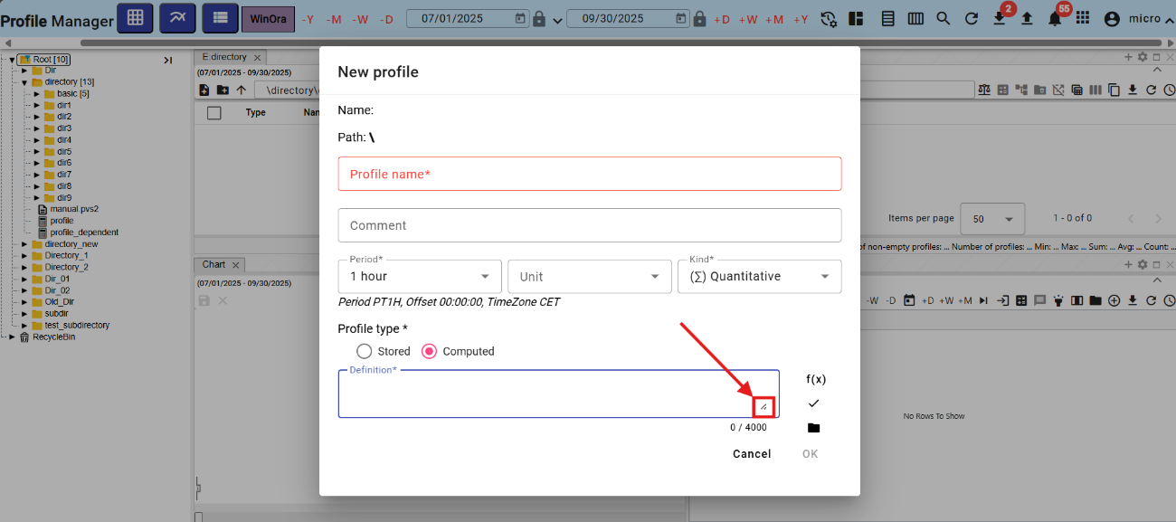

Figure 215: Button for enlarging the "New Profile" window

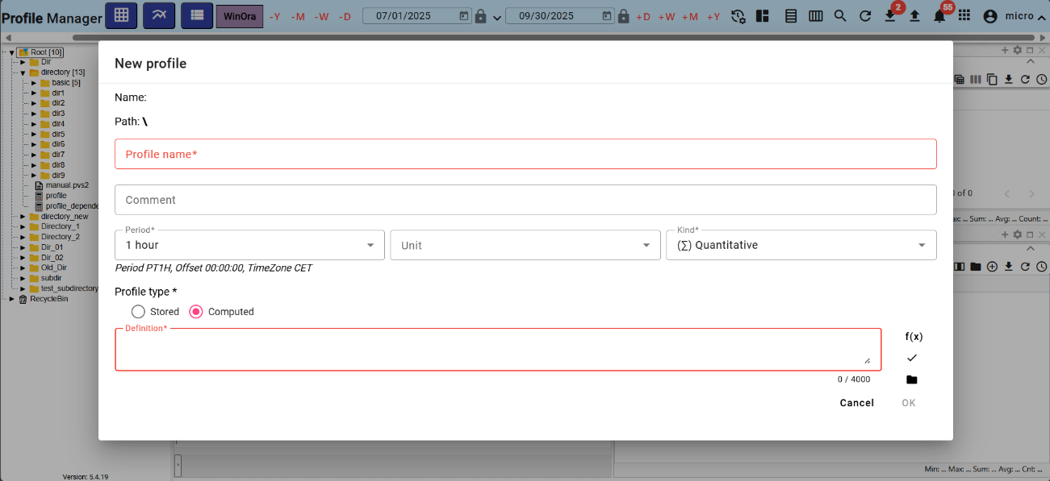

Figure 216: Enlarged "New Profile" window

## How to move windows

To move windows in the "Profile Manager" application, click and drag the top of the window with the left mouse button and move the window to the desired location.

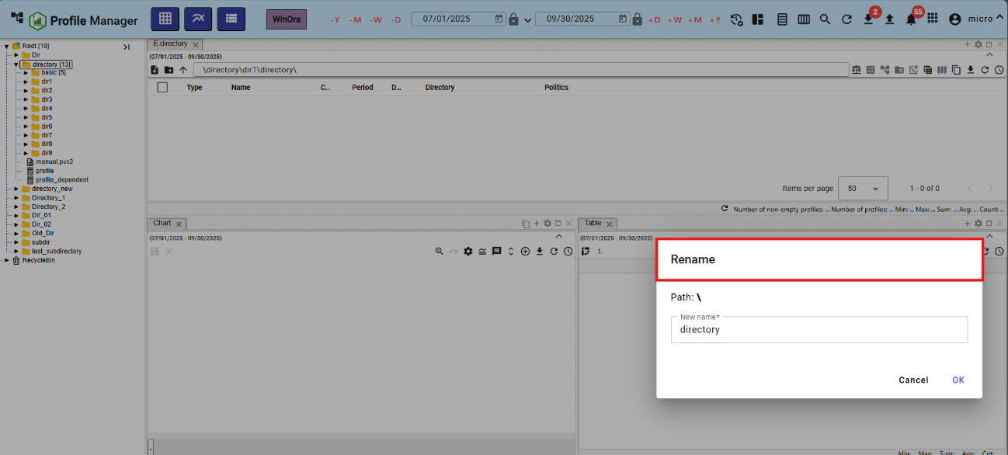

Figure 217: Moving the "Rename" window

## How to rename a document

You rename the document (for example, a report):

1. Right-click on the document you want to rename.
2. In the menu, select "Rename".
3. A "Rename" window will appear.

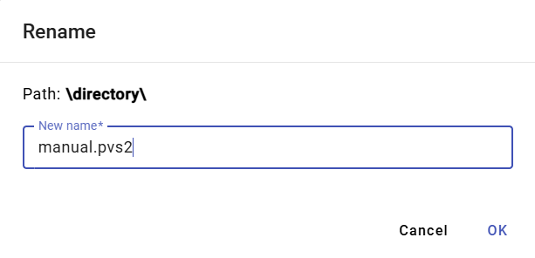

Figure 218: "Rename" window

1. Edit the name.
2. Save by clicking the "OK" button.

# Common controls for Explorer, table, and chart

Window manipulation buttons are located at the top of the Explorer, table, and chart windows. Working with the buttons is detailed in the following subsections.

## How to restore data in windows

To reload data in windows, press the button that displays Figure 219.



Figure 219: Button to reload data in Explorer, table, and chart windows.

## How to change the date range

You change the date range in the Explorer, table, or chart window:

1. Click the "Change Date Range" button, located in the upper-right corner of the window.



Figure 220: "Change Date Range" button

1. A window for setting the date range appears.

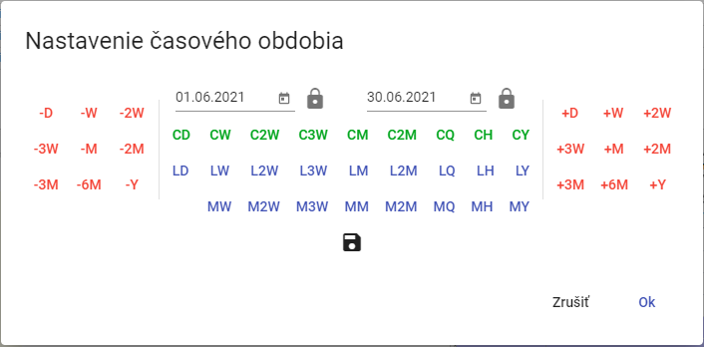

Figure 221: Window for changing the date range

1. You can set the date by pressing the buttons, selecting a date, or directly overwriting the date.
2. You can save the new date range by pressing the floppy disk button. A maximum of 3 date ranges can be saved.



Figure 222: Button for saving the date range

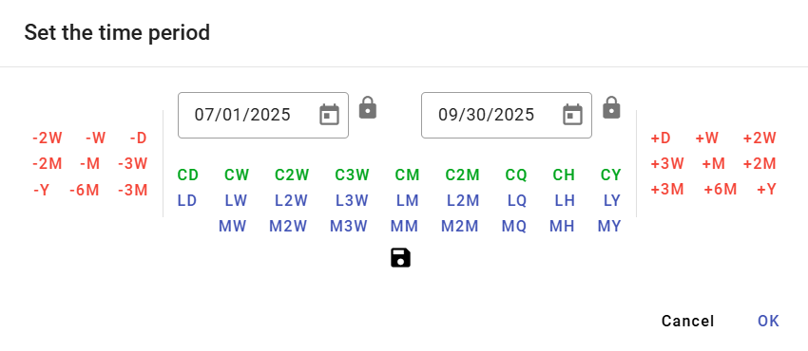

Figure 223: Saved date range

1. You start the date range by pressing the "OK" button.

## How to maximize the window to cover the entire application area

You can maximize the graph, explorer, and table windows by pressing the "Maximize" button (Figure 224) or by double-clicking the top bar of the panel, as shown in Figure 226. The window will then be displayed across the entire application area. After pressing the "Maximize" button, a "Restore Size" button will appear in its place, which is used to return the window to its original size. You can also resize the maximized window by double-clicking the top bar of the panel.



Figure 224: "Maximize" button



Figure 225: "Restore Size" button

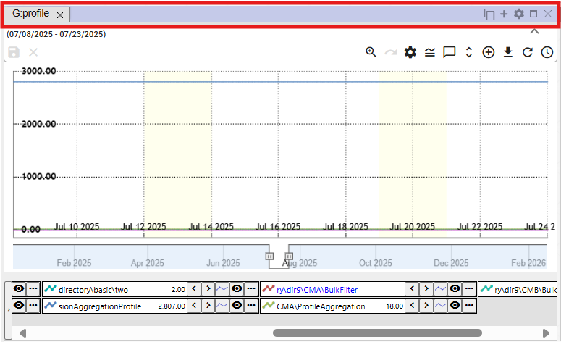

Figure 226: Top bar of the panel

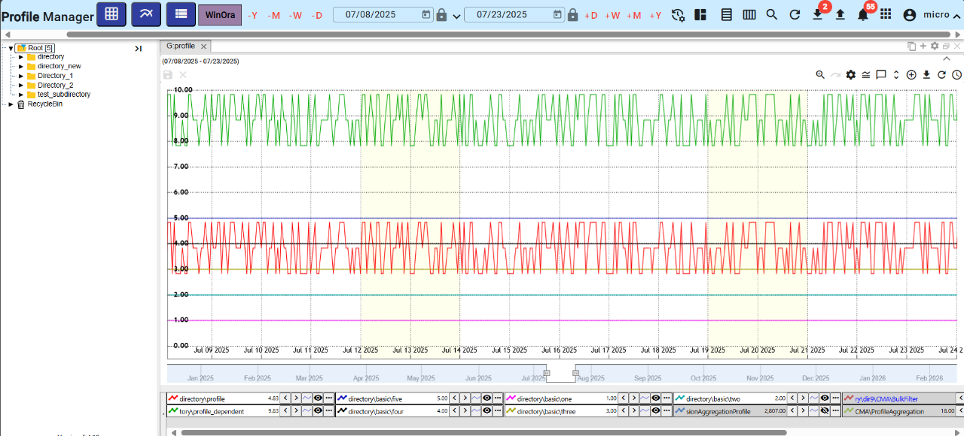

Figure 227: Window Zoom

## How to close the window

You can close the graph, explorer, and table windows by pressing the x button, which is located next to the window title and in the upper right corner of the window.



Figure 228: “Close” Button to Close the Window

## Setting the panel title and color

Panels are named Explorer, Table, and Graph by default. To change the panel name and color, follow these steps:

1. Press the "Panel settings" button, located in the top right corner of the window.



Figure 229: "Panel settings" button

1. The "Panel settings" window will appear.

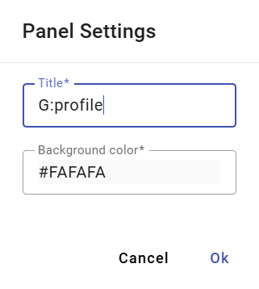

Figure 230: "Panel settings" window

1. In the "Title" field, enter a name.
2. To set the panel color, click in the "Background color" field and select a color.

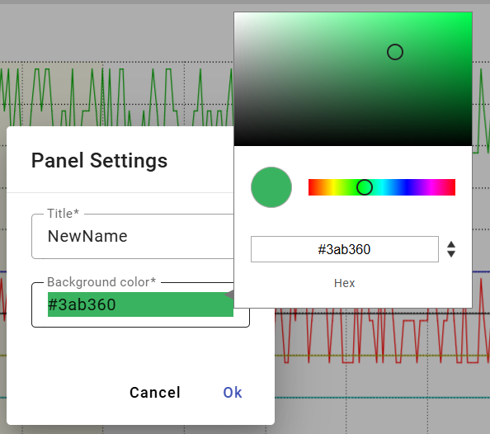

Figure 231: Color selection

1. Save the changes by clicking the "OK" button.

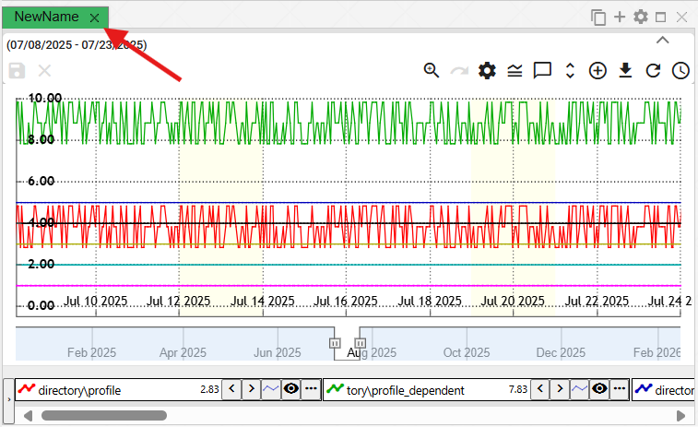

Figure 232: Changed panel color

## How to export displayed data from the Explorer window.

You can export the displayed data from the Explorer window, table, or chart by clicking the export button, Figure 233.



Figure 233: Export button

## How to hide the top button bar in the Explorer window, table, and chart.

The top part in the Explorer window, table, and chart can be hidden using the button shown in Figure 234. To display the top part in the windows again, click the button again, Figure 235.

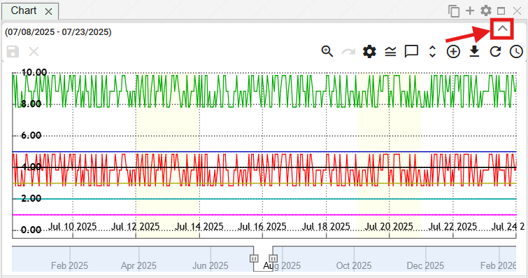

Figure 234: Button to hide the top part in the Explorer window, table, and chart.

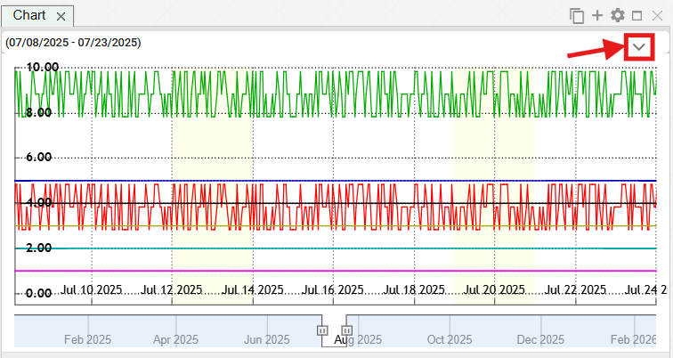

Figure 235: Button to display the top part in the Explorer window, table, and chart.

## How to add a profile to a chart and table

You can add a profile to a chart and table by following these steps:

1. Press the "Add Profile" button, which is located at the top of the chart or table window.



Figure 236: “Add Profile” Button

1. The “Add profile” window will appear.

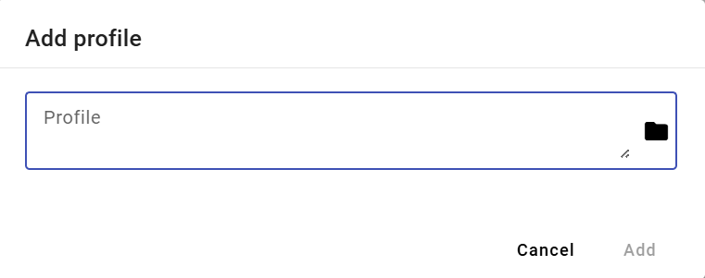

Figure 237: “Add profile” Window

1. Enter the path where the profile is saved.

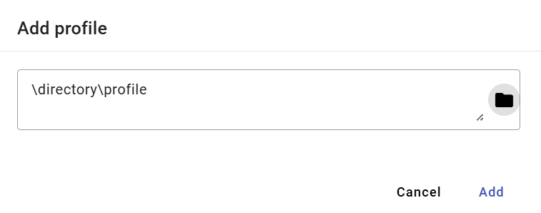

Figure 238: Entering the path to the profile

1. Press the "Add" button.
2. The selected profile will be added in the graph/table window.

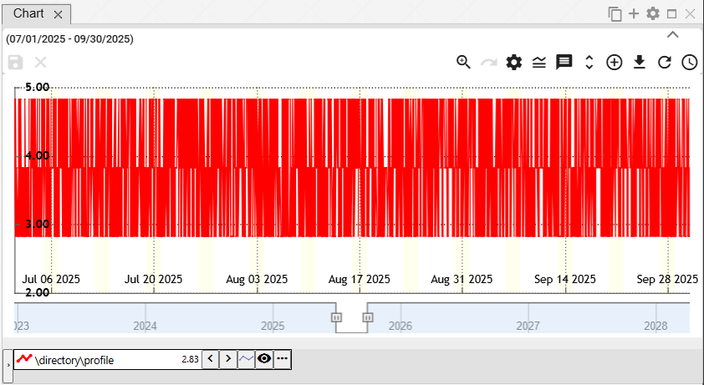

Figure 239: Added profile in the graph window

# Working with the Explorer Window

After launching the “Profile Manager” application, the explorer window is populated with directories and profiles from the tree structure. While working with the application, you can add any number of explorer windows.

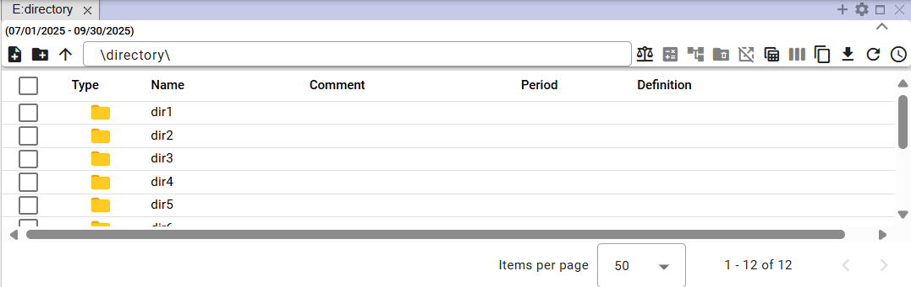

Figure 240: "Explorer" Window

## How to display profiles from the selected directory in the Explorer window.

In the Explorer window, directories and profiles from the tree structure are displayed by default. To display profiles from the selected directory, double-click the left mouse button on the button in the “Type” column.

You can display the list of directories in reverse order by clicking on the arrow.

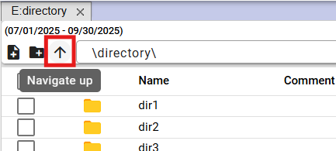

Figure 241: Back step button

## How to create a new directory

In the Explorer window, you can create a new directory by clicking the "Create New Directory" button. The "New Directory" window will appear. The procedure for creating a directory is in chapter 2.1.

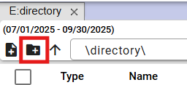

Figure 242: "Create New Directory" button

## How to synchronize Explorer with the tree view

The "Synchronize with Tree" button indicates that Explorer is synchronized with the tree view. A crossed-out "Synchronize with Tree" button indicates that if the directory is changed in the tree view, the change will not be reflected in the Explorer window.



Figure 243: "Synchronize with Tree" button



Figure 244: Synchronization with Tree Disabled

## How to filter a profile

You can filter the profiles displayed in the Explorer window by individual columns. Proceed as follows:

1. Position the mouse cursor on the column header you want to apply the filter to.
2. Click the button to display the filter input window.



Figure 245: Filter button

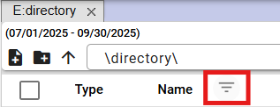

Figure 246: Filter button above the "Name" column

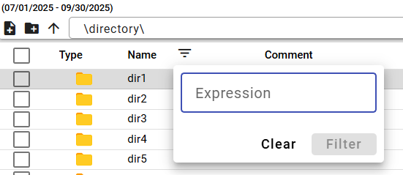

Figure 247: Filter input window

1. Enter filter criteria.

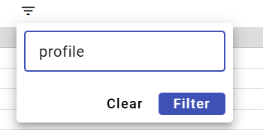

Figure 248: Entering filter criteria

1. Press the "Filter" button or the Enter key.
2. Profiles matching the filter criteria will be displayed.

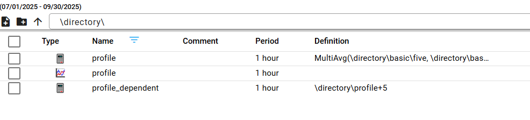

Figure 249: Filter Applied

1. A button is displayed above the column where the filter is applied.
2. You can cancel the filter by clicking the button, which will display a window for filtering and then pressing the "Clear" button.

## How to sort data in columns

To sort data in a column, hover over the column name and click the arrow that appears next to the column name.

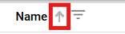

Figure 250: Button for sorting data in a column

## How to calculate Min, Max, Sum, Avg, and Count values in the Explorer window.

To calculate values in columns in the Explorer window, follow these steps:

1. In the Explorer window, display the directory profiles for which you want to calculate summary values.

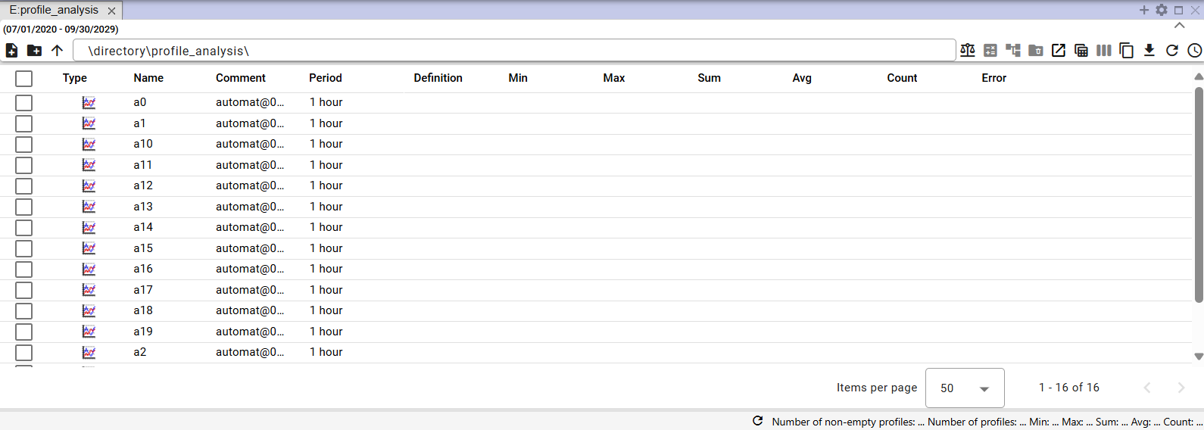

Figure 251: Displaying a directory in the Explorer window

1. Press the "Statistics" button.



Figure 252: The "Statistics" button

1. The values in the "Min", "Max", "Sum", "Avg" and "Count" columns are populated.

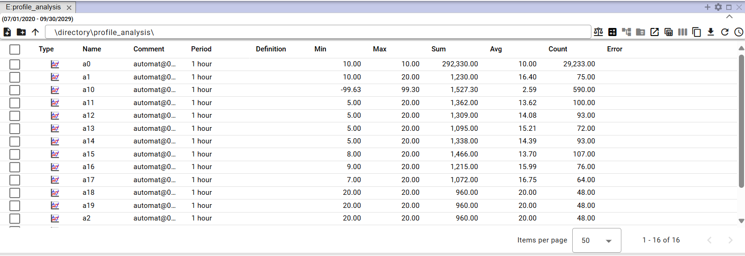

Figure 253: Statistics calculation in the explorer window

## Time series view

To view a time series preview, proceed as follows:

1. In the "Explorer" window, double-click the button next to the profile whose time series preview you want to view in the "Type" column. Or click the button in the "Preview" column.

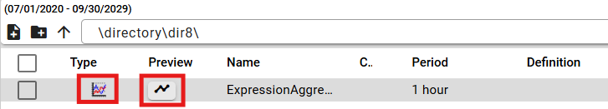

Figure 254: Button to display the "Time Series Preview" window

1. The "Time Series Preview" window will be displayed.

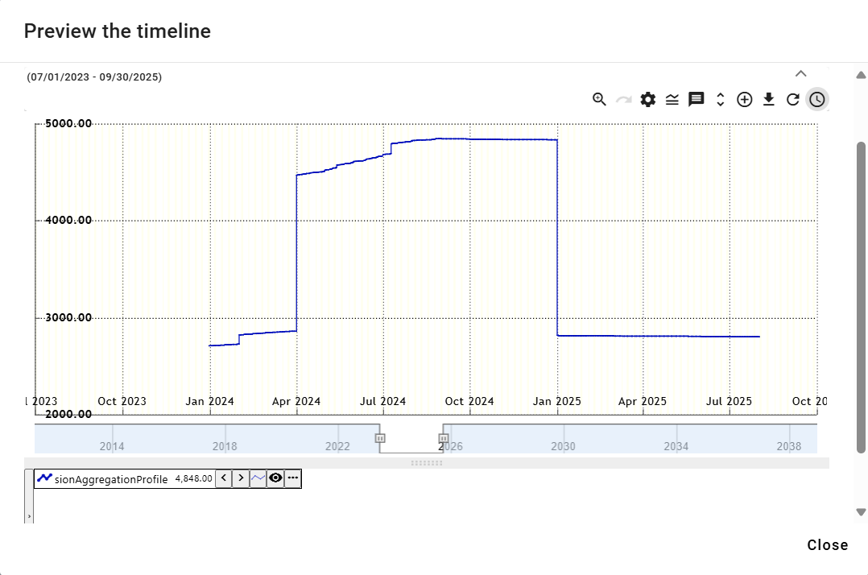

Figure 255: "Time Series Preview" window

1. Subsections in Chapter 5 cover working with the buttons located in the upper right corner of the chart.



Figure 256: Buttons for working with the chart

1. At the bottom of the window is the profile name. Right-clicking on the profile name displays a list of functions for working with the profile. The functions are detailed in Chapter 5.7.

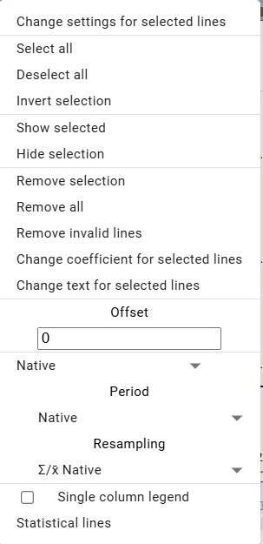

Figure 257: Functions for working with the profile

1. Clicking the arrow next to the profile name displays a window with functions, which are detailed in Chapter 5.8.

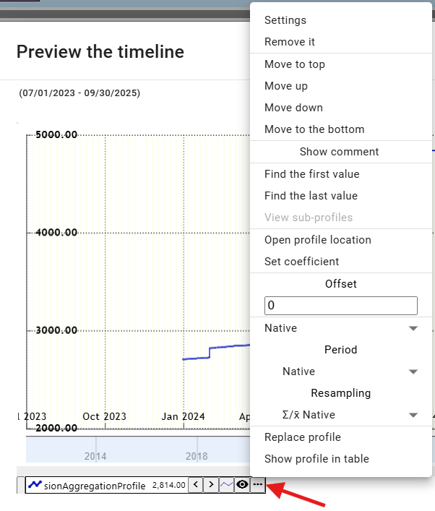

Figure 258: List of functions for working with the profile

## How to move a profile from the Explorer window to the Chart or Table window

You can move a row from the Explorer window to the Chart or Table window. You can move a directory from the Explorer window to the Chart window. You can drag a profile from the Explorer window to the Chart or Table window.

Proceed:

1. In the Explorer window, position the mouse cursor on the directory row or profile you want to move to the Chart or Table window.

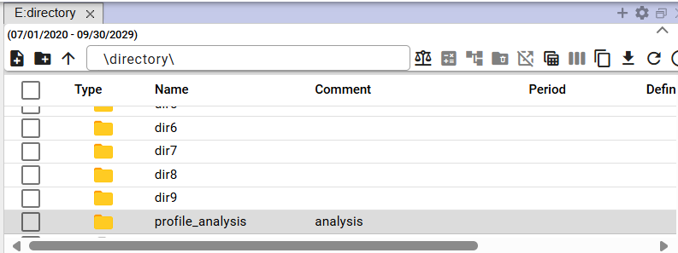

Figure 259: Selected directory

1. Click and hold the left mouse button on the row in the Explorer window, drag the row over the window where you want to display it, and release.

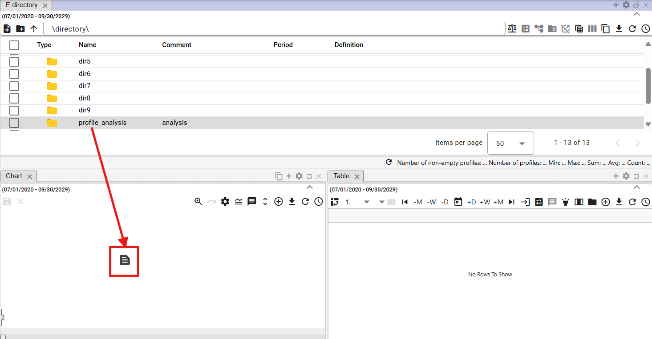

Figure 260: Moving the directory to the Chart window

1. The profile will be displayed in the selected window.

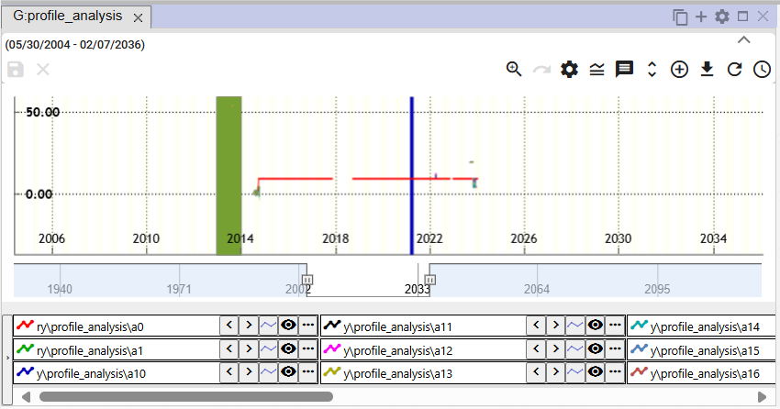

Figure 261: Profiles moved from the Explorer window to the Chart window

## How to edit, add, or remove columns in the Explorer window

You can modify the list of displayed columns in the Explorer window. You can add or remove columns.

To change the displayed columns:

1. Click the "Choose columns" button, located in the upper-right corner of the Explorer window.

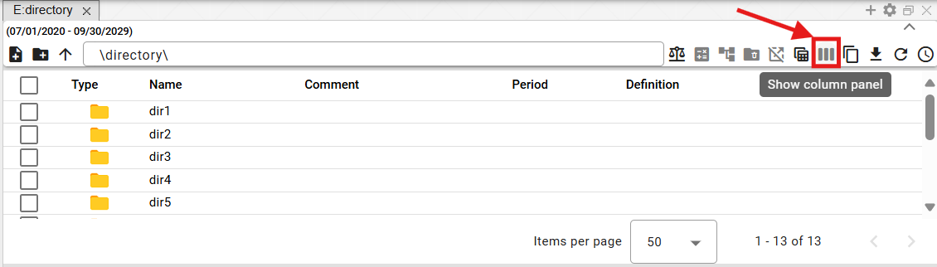

Figure 262: "Choose columns" button

1. A block with a list of columns will appear.

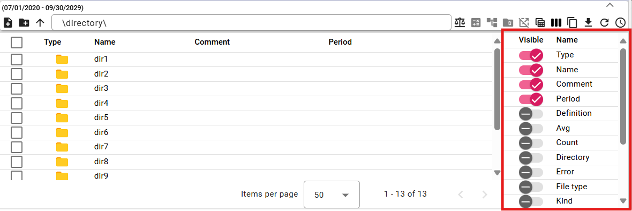

Figure 263: List of columns

1. Add or remove columns to display. Changes to the list of selected columns are automatically reflected in the explorer window.
2. You can change the column order in the explorer window. To change the column order, grab the column move button and drag the column to the desired position in the list.

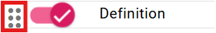

Figure 264: Column move button

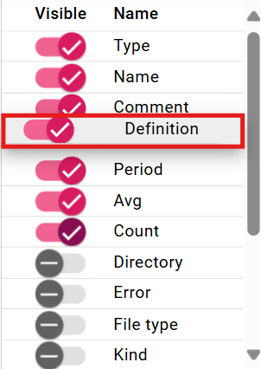

Figure 265: Moving the "Character" column

## How to edit the Name and Comment fields

You can edit the "Name" and "Comment" fields for profiles and directories in the Explorer window.

To edit, proceed as follows:

1. Double-click the field to open it for editing.

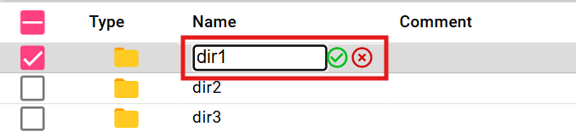

Figure 266: Editing the directory name

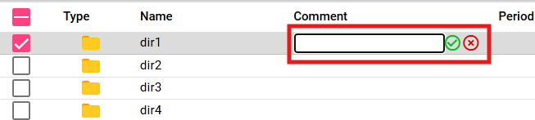

Figure 267: Entering a comment for the directory

1. Edit the text.
2. Save the changes by pressing the button.

## Features for working with directories in the Explorer window

You can display the features for working with a directory by right-clicking on the directory in the Explorer window. Working with the features is detailed in Chapter 2.

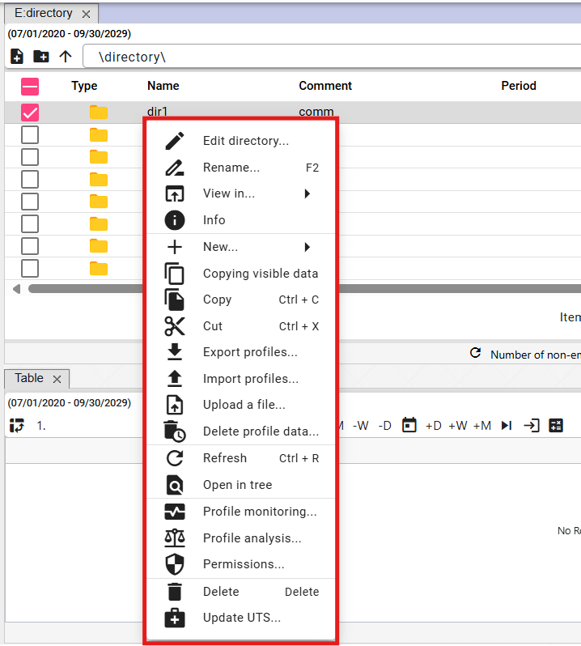

Figure 268: List of features for working with directories

## Features for working with profiles in the Explorer window

You can display the features for working with a profile by right-clicking on the profile in the Explorer window. Working with the features is detailed in Chapter 2.

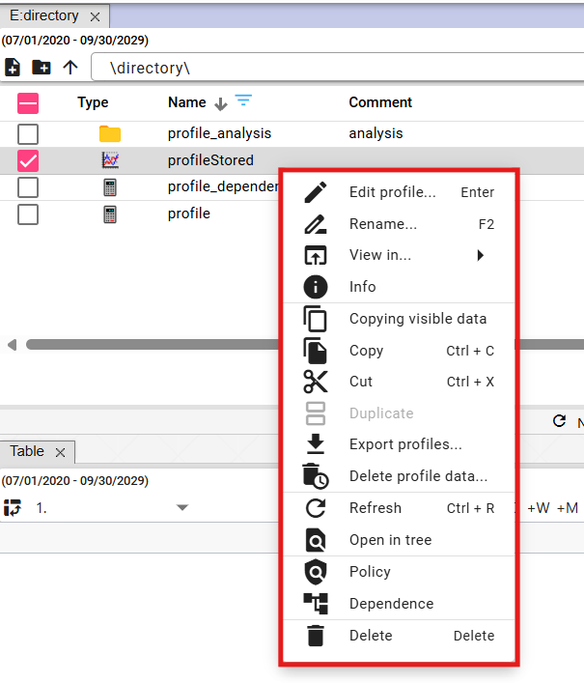

Figure 269: List of features for working with profiles

## Branch View button

The "Branch View" button allows you to perform bulk operations on all profiles in the database, regardless of which directory the profile is located in. You can use "Edit" and "Delete" for bulk operations.

The "Branch View" button displays items from the selected directory without sorting them into nested directories, Figure 271. To return to the standard directory view in the Explorer window, click the "Branch View" button again.

Procedure for bulk editing profiles:

1. Click the "Branch View" button to display a list of profiles without directories.

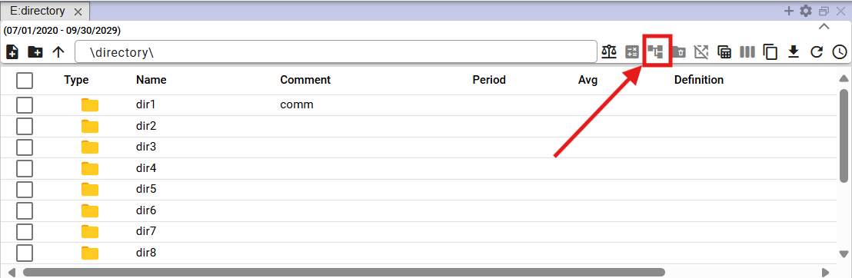

Figure 270: "Branch View" button

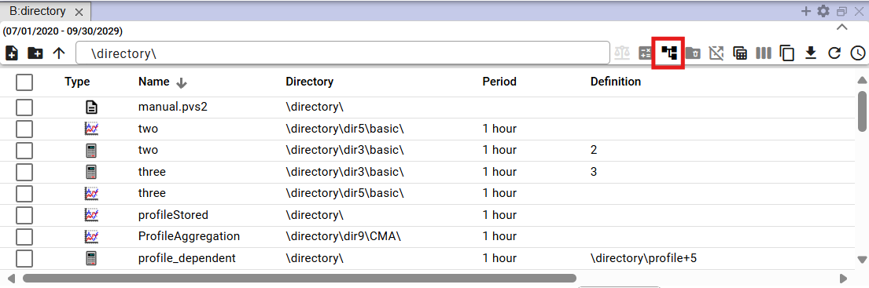

Figure 271: Display of profiles without directories

1. Enter a filter to obtain a list of profiles on which you want to perform bulk operations.

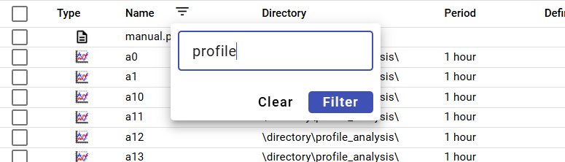

Figure 272: Entering a filter

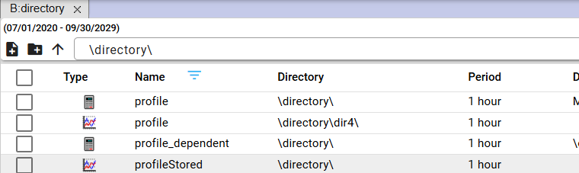

Figure 273: Filtered items

1. Select the profiles on which you want to perform bulk operations by checking the boxes in the first column. To select all profiles, check the first box and the remaining boxes will be automatically checked.

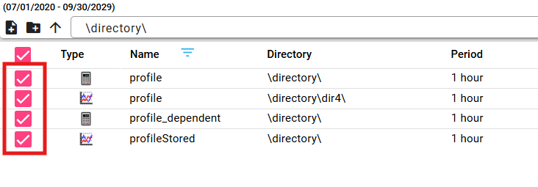

Figure 274: Selected profiles

1. Right-click anywhere on the selected profiles and select “Edit”.

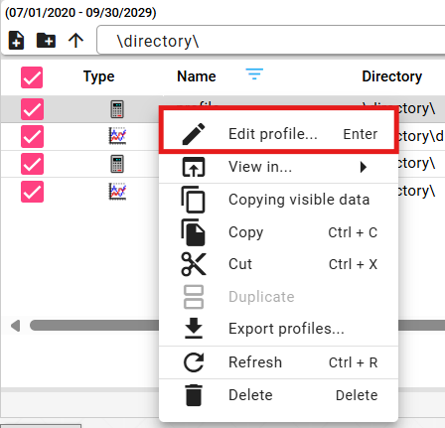

Figure 275: “Edit” item

1. The “Bulk Edit” window will appear.

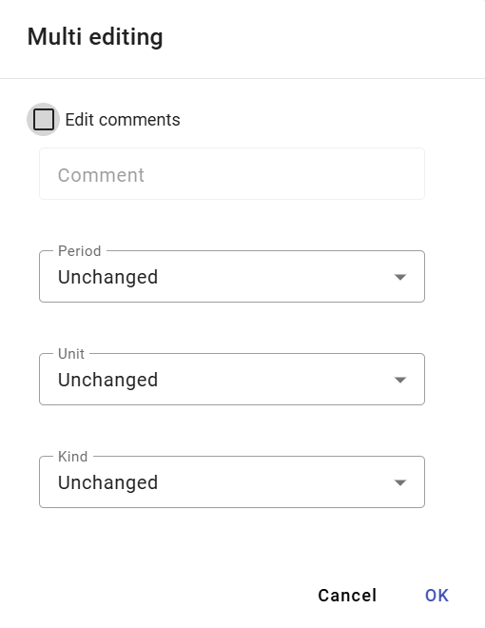

Figure 276: “Bulk Edit” window

1. You can edit the “Comment”, “Period”, “Unit” and “Character” fields.
2. Edit the data and save the changes by clicking the “Ok” button.

## How to display deleted items in the Explorer window

The “Trash” button in the Explorer window is used to display deleted items. The button is inactive – grey – by default. After clicking it, it turns black. To stop displaying deleted items, click the “Trash” button again. Subsequently, the directories and profiles from the tree structure will be displayed in the Explorer window.



Figure 277: "Trash" button – inactive



Figure 278: "Trash" button – active

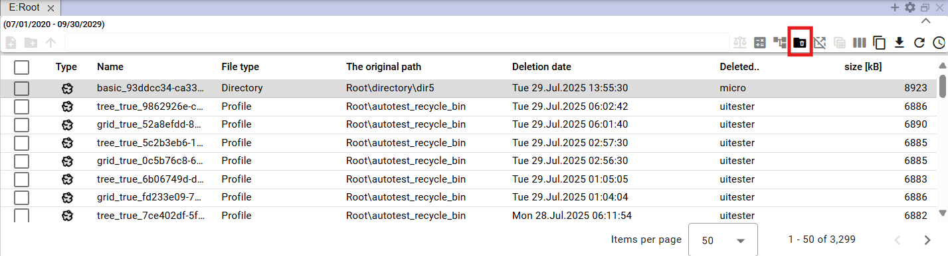

Figure 279: Displaying the contents of the "Trash" button

## How to copy the displayed data

The "Copy Displayed Data" button, Figure 280, is used to copy data from the "Explorer" window. Figure 282 shows the copied data.

Proceed:

1. Display the data you want to copy in the Explorer window.
2. To copy all displayed data, press the "Copy Displayed Data" button.

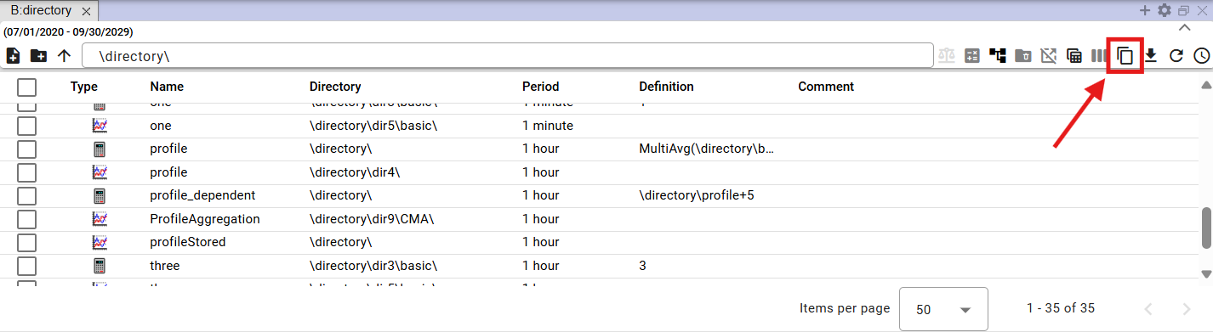

Figure 280: "Copy Displayed Data" button

1. To copy specific files, select them in the Explorer window. Right-click on the selected files and select "Copy Displayed Data".

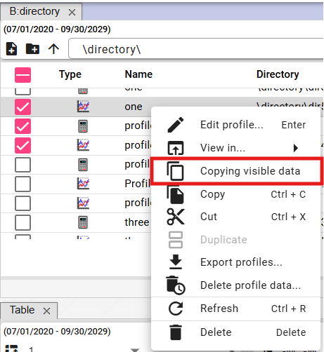

Figure 281: "Copy Displayed Data" item

1. You can paste the copied data into Microsoft Excel.

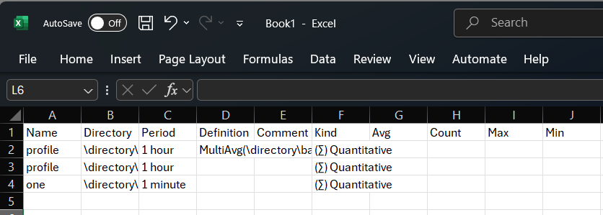

Figure 282: Data copied to MS Excel

## Use as Default Explorer Settings

You can set the current column settings as default. The saved column settings will be displayed each time a new explorer is opened or when the “Profile Manager” application is opened.

To set the current Explorer column settings as default, follow these steps:

1. Click the "Use as Default Explorer Settings" button, located in the upper-right corner of the Explorer window.



Figure 283: "Use as Default Explorer Settings" button

1. A confirmation window will appear, in which click the "Yes" button.

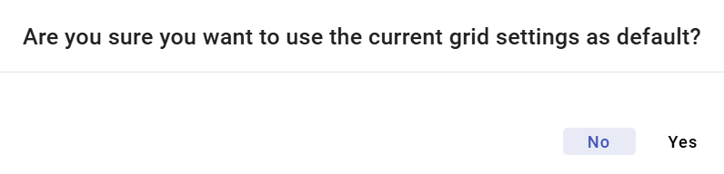

Figure 284: Confirmation window for saving default Explorer settings

## How to filter in columns using the * wildcard

In Explorer, you can filter in columns using wildcards, using *.

Examples:

* Text* - finds everything that starts with the specified text
* *Text - finds everything that ends with the specified text
* *Text* - finds everything that contains the specified text

Example: profile* - finds everything that starts with "profile"

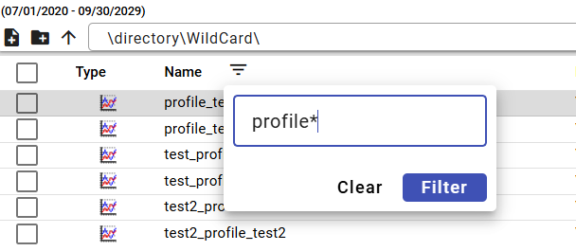

Figure 285: Filter assignment for searching profile names starting with "profile"

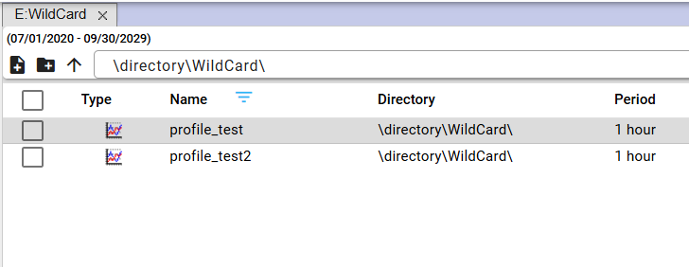

Figure 286: Searching for profiles starting with "profile"

Example: *profile - finds everything that ends with "profile"

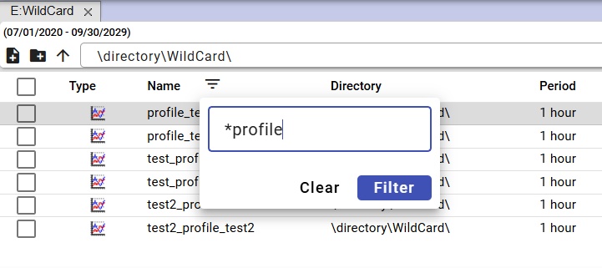

Figure 287: Filter assignment for searching profile names ending with "profile"

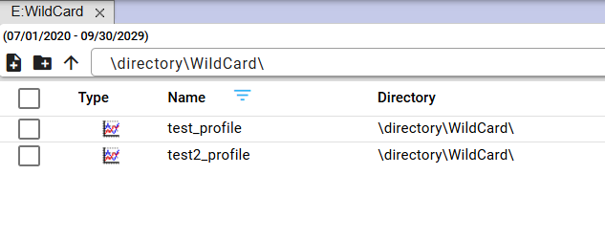

Figure 288: Searching for profiles ending with "profile"

Example: *profile* - finds everything that contains the text "profile"

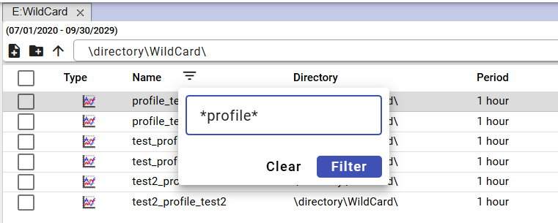

Figure 289: Filter assignment for searching profile names containing the text "profile"

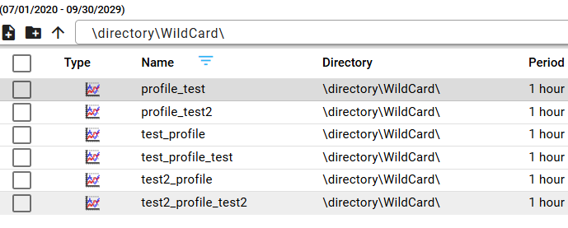

Figure 290: Searching for profile names containing the text "profile"

# Working with the graph

After launching the "Profile Manager" application, a working window with an empty graph area opens. While working with the application, you can add any number of windows for the graph. You can display an optional number of profiles in one graph.

## How to display a profile in the graph

To display a profile in the graph window, proceed as follows:

1. By default, the graph window is empty.

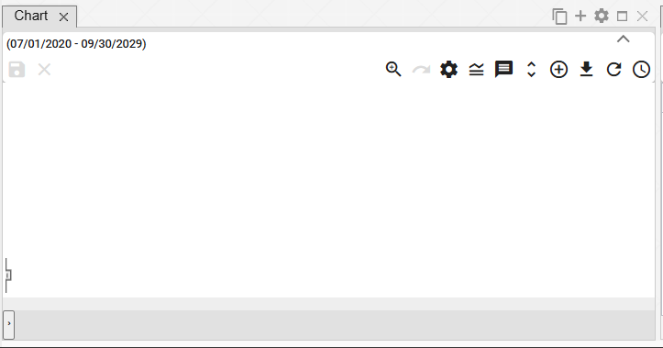

Figure 291: By default, the graph window is empty.

1. To display a profile in the graph window, click and drag a profile or profile directory in the profile tree and drop it into the graph window. Release the profile or profile directory in the graph window.

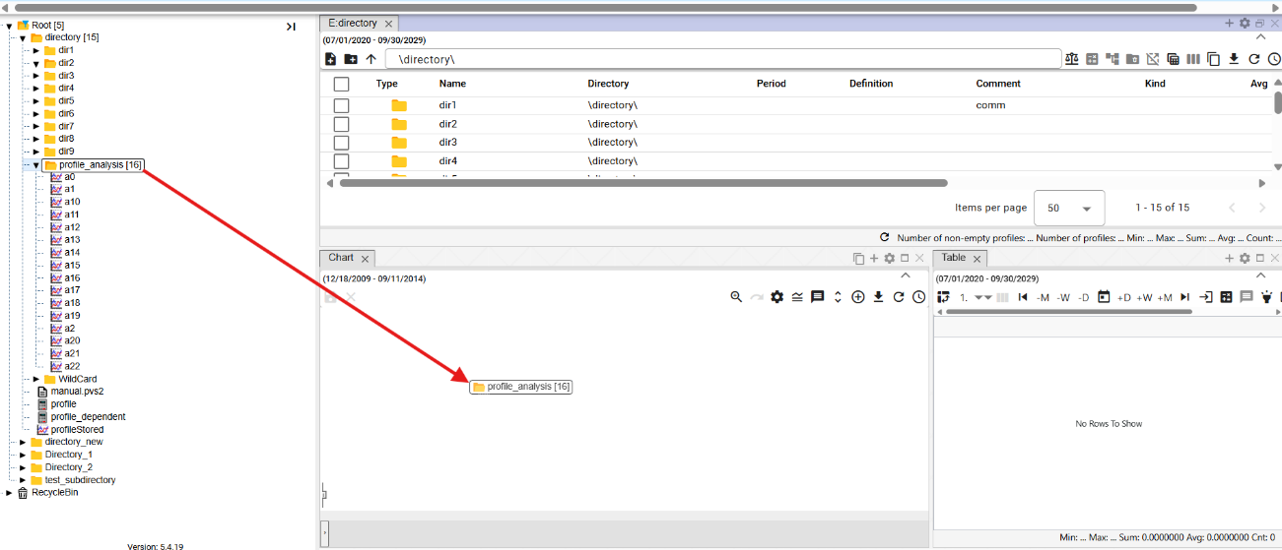

Figure 292: Dragging a directory onto the graph window

1. A graph will be plotted in the graph window from the data.

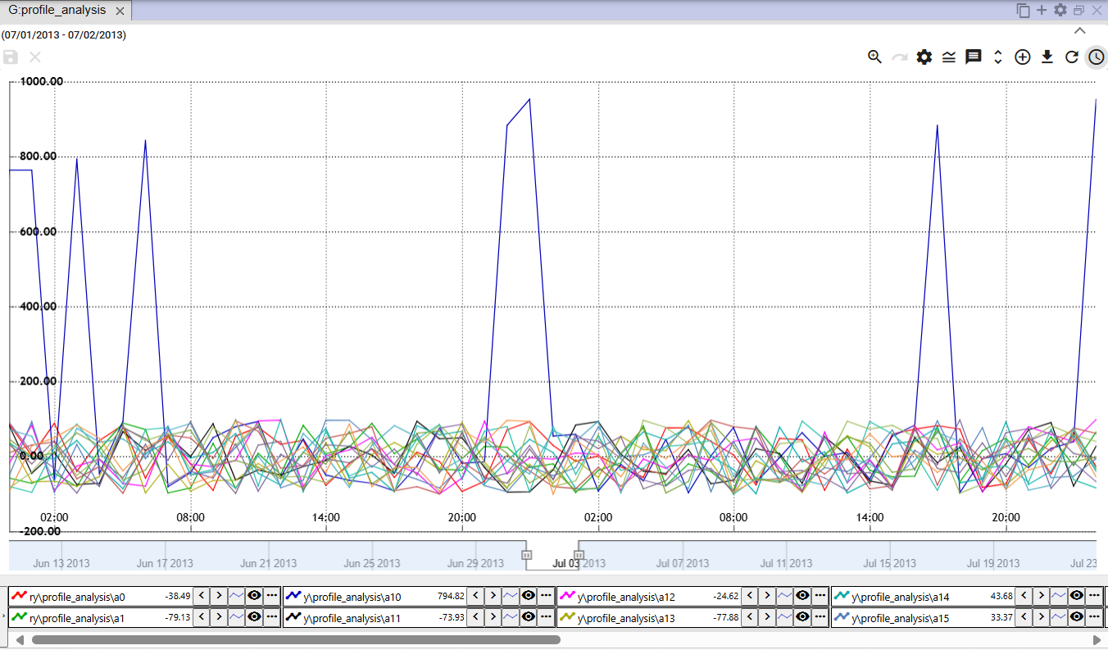

Figure 293: Graphical Display of Profiles

## How to display an information window with values for a specific location in the graph

To display the values for a specific location in the graph, position the mouse cursor at the selected location.

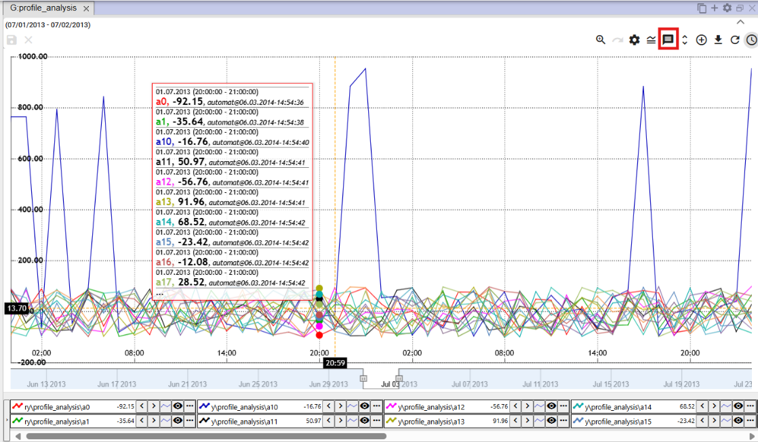

Figure 294: Display of Profile Values at a Specific Location in the Graph

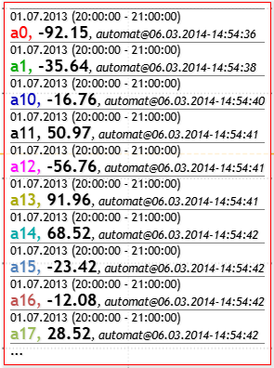

Figure 295: Profile Values at a Selected Location in the Graph

If the data is incomplete within a given range (decimation), a yellow exclamation mark is displayed (Figure 296).

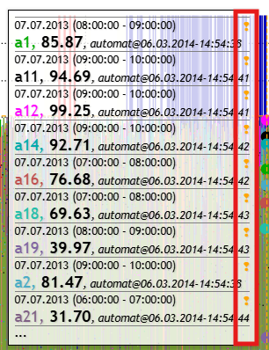

Figure 296: Yellow Exclamation Mark

## How to change the date range in the graph

You can change the time range for which the graph is displayed using the "Change Time Range" button located in the upper right corner of the graph window. The procedure is detailed in Chapter 3.2.



Figure 297: "Change Time Range" Button

## How to save the graph in JPG format

You can save the graph as an image in JPG format. Proceed as follows:

1. Click the "Export Graph to JPG" button, located in the top right corner of the graph window.



Figure 298: "Export Graph to JPG" button

1. The graph image will be created and saved among the downloaded files on your computer.

## How to copy the entire graph to a new window

You can copy the entire graph to a new window:

1. Press the "Copy the entire graph to a new window" button.
2. The graph will be copied and displayed in a new tab in the graph window.

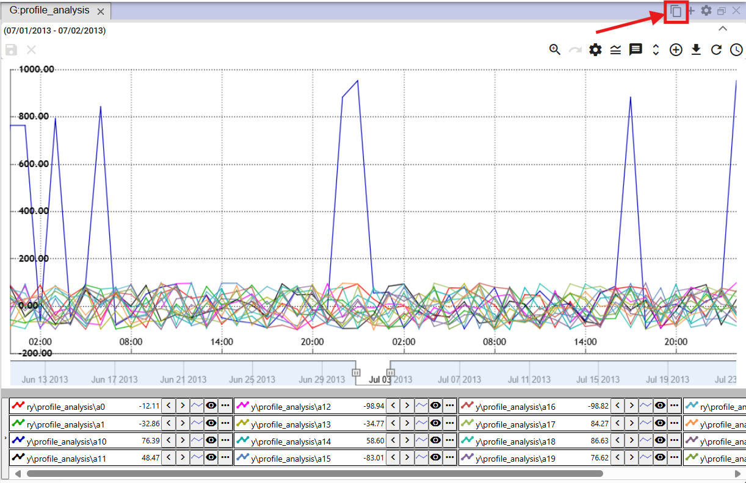

Figure 299: "Copy the entire graph to a new window" button

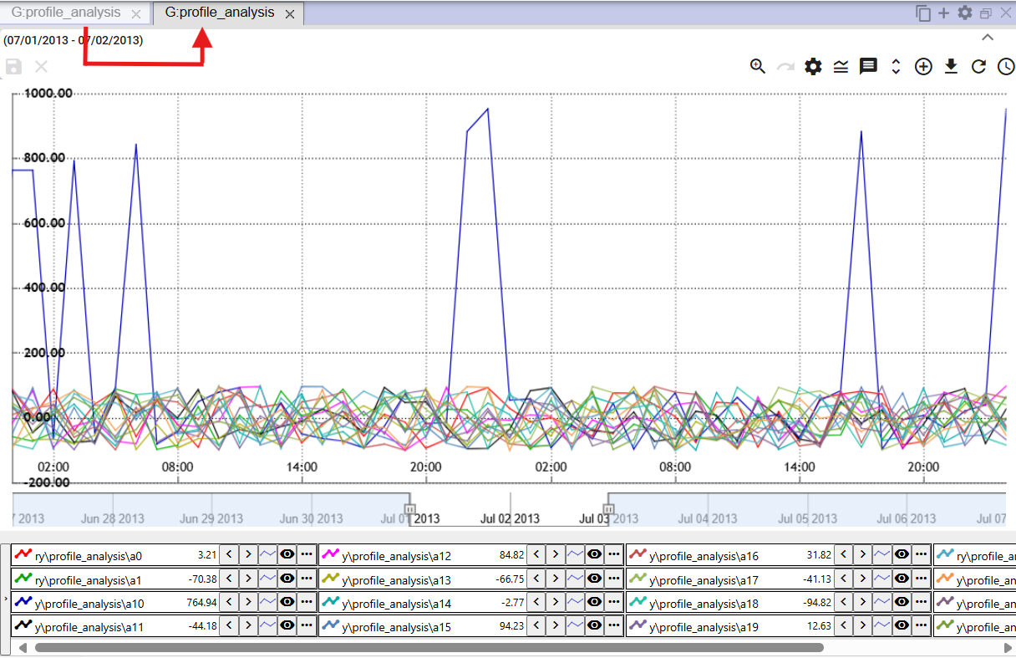

Figure 300: Copied graph in a new tab

## How to set graph parameters

You can set graph parameters, such as the font size for the graph title:

1. Click the “Graph Settings” button, located in the upper right corner of the “Graph” window.



Figure 301: "Graph Settings" button

1. A “Graph Legend” window will appear, where you can set the parameters.

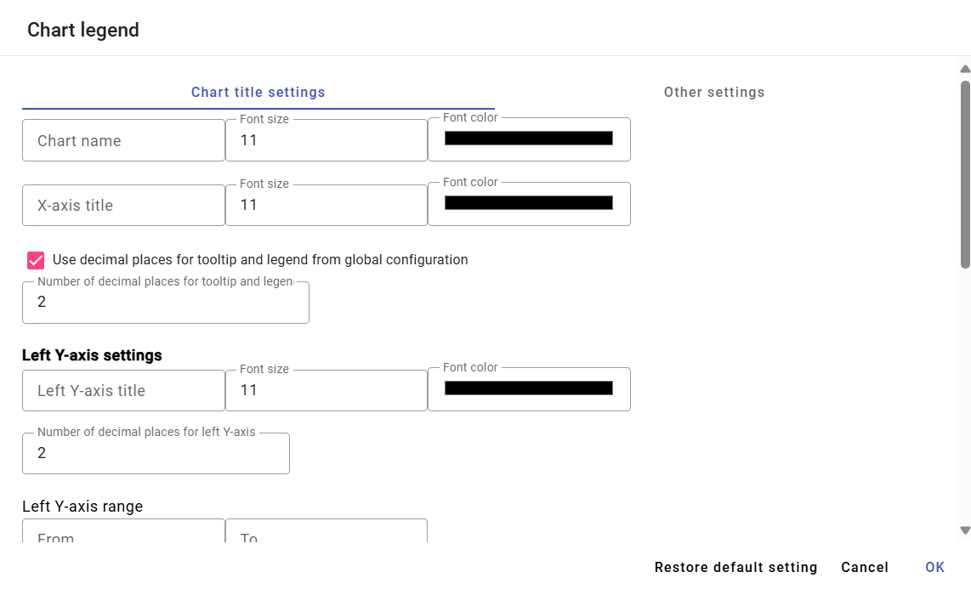

Figure 302: "Graph Legend" window

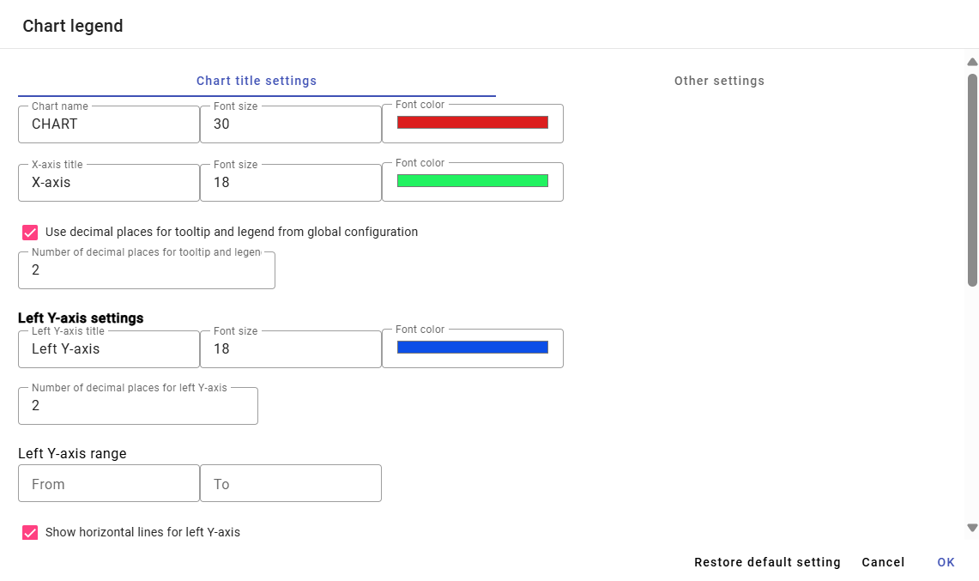

Figure 303: Changes in the “Graph Legend” window

1. You save the changes by pressing the “OK” button.

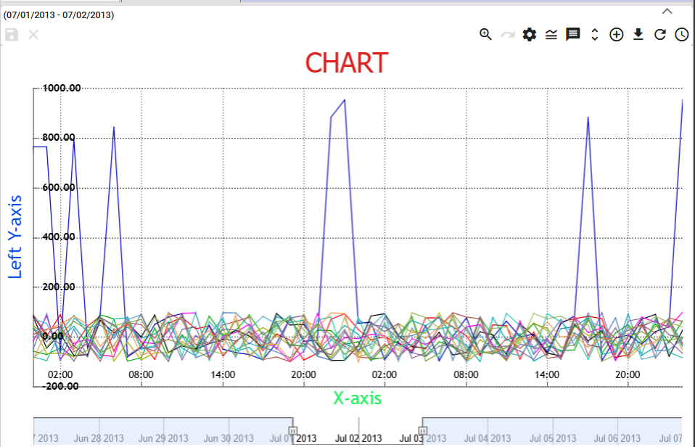

Figure 304: Changes in the “Graph” window

### How to set the number of decimal places for each Y-axis.

Proceed:

1. In the “Graph Legend” window, enter the number of decimal places for the left and right Y-axis.

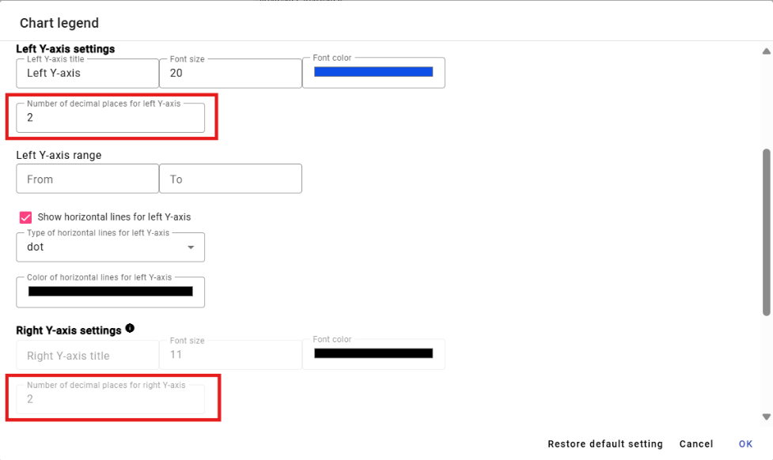

Figure 305: Settings for the Y-axis

1. To enter a value for the "Number of decimal places for tooltip and legend" field, uncheck the "Use decimal places for tooltip and legend from global configuration" box.

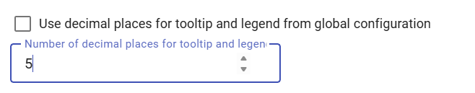

Figure 306: Entering a new value for the "Number of decimal places for tooltip and legend" field

1. Save the changes by clicking the "OK" button.

### How to disable horizontal lines

To disable horizontal lines in the chart, proceed as follows:

1. Click the "Chart Settings" button, Figure 301.
2. In the “Chart Legend” window, uncheck the boxes “Show horizontal lines for the left Y axis” and “Show horizontal lines for the right Y axis”.

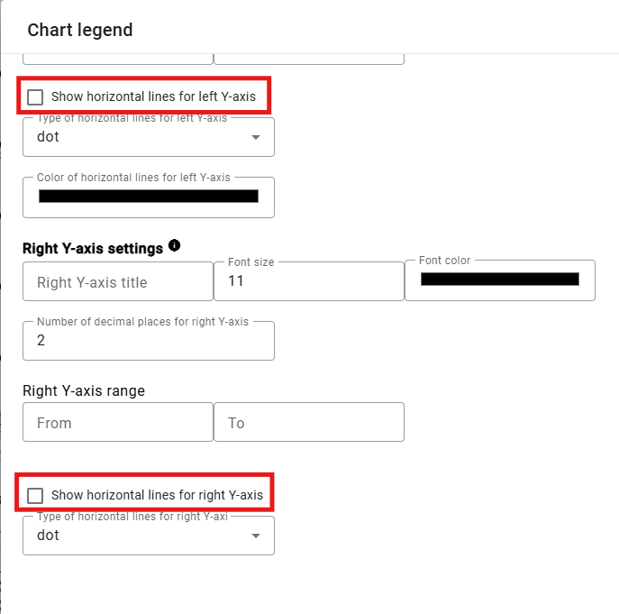

Figure 307: Disabling horizontal lines in the chart

1. Save the changes by clicking the "OK" button.

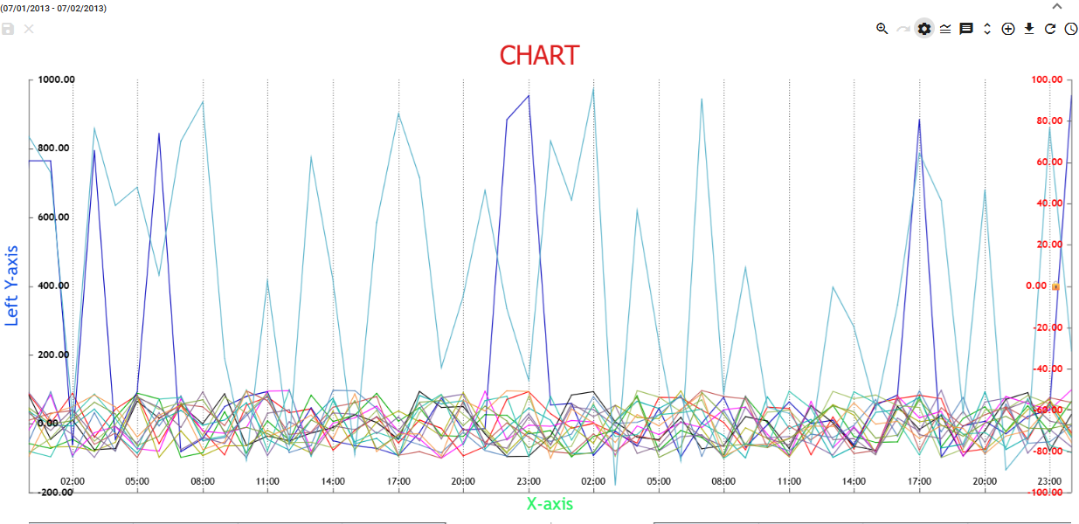

Figure 308: Horizontal lines disabled in the chart

## Functions for working with selected profiles

To display functions across multiple profiles, proceed as follows:

1. Press the Ctrl key and select the desired profiles by clicking the left mouse button on the names of the selected profiles. After selection, the profile name will be highlighted in blue.
2. Press the button located in the lower-left corner of the chart window.

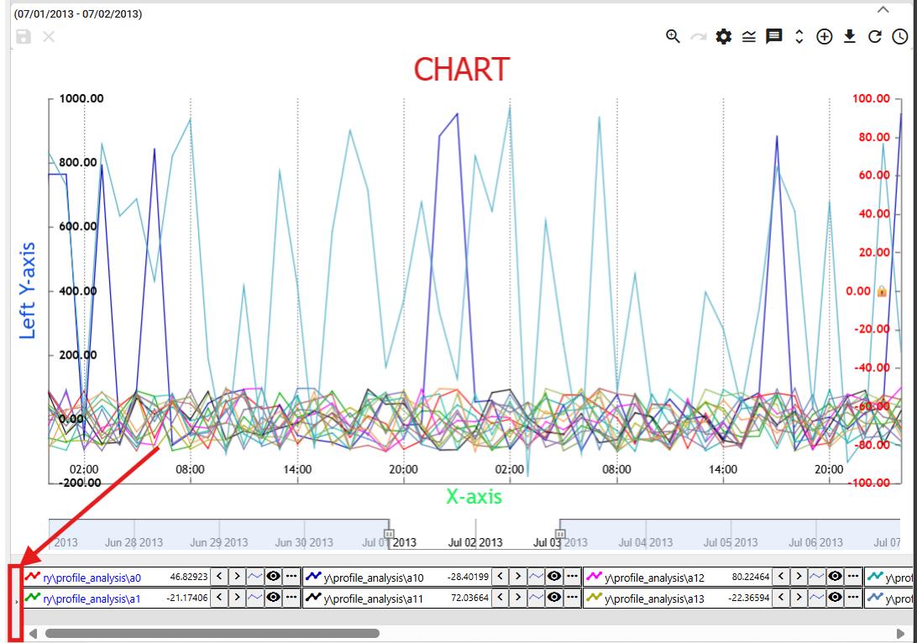

Figure 309: Button for displaying functions for selected profiles

1. A list of functions for selected profiles will be displayed. The functions are detailed in the following chapters.

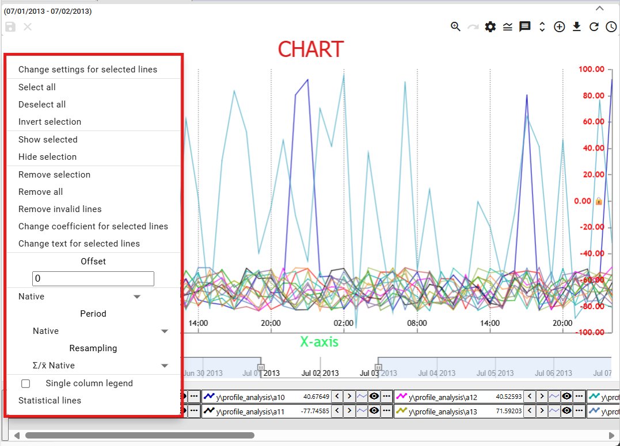

Figure 310: List of functions for selected profiles

### How to select profiles

To select a profile, press the Ctrl key and click on the profile name. You can select multiple profiles at the same time. The font color of the selected profile will change from black to blue.

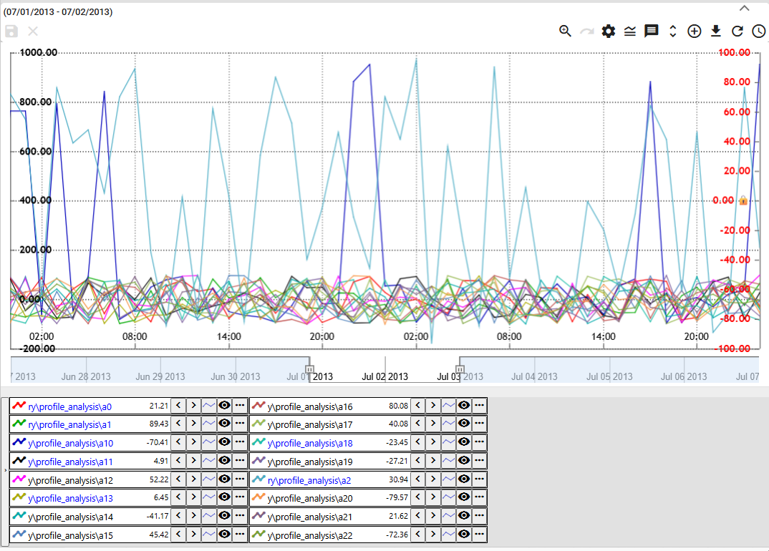

Figure 311: Selecting Multiple Profiles

### How to display profile properties

You display profile properties:

1. Click the button located before the profile name at the bottom of the Graph window.

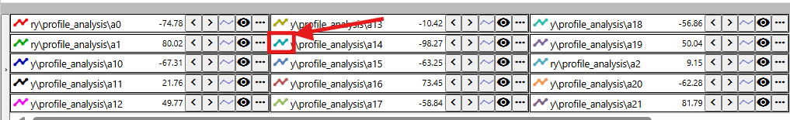

Figure 312: Button to display profile properties

1. The "Line Profile Property" window will be displayed.
2. Edit the data.
3. You save the changes by pressing the "OK" button.

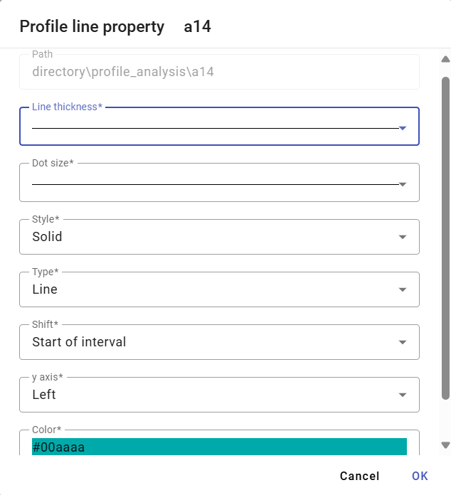

Figure 313: "Line Profile Property" Window

### How to change the settings of the selected item.

You change the settings for multiple selected profiles simultaneously:

1. Select the profiles for which you want to change the settings.
2. Right-click on the name of one of the profiles.
3. In the displayed window, select "Change settings for selected".

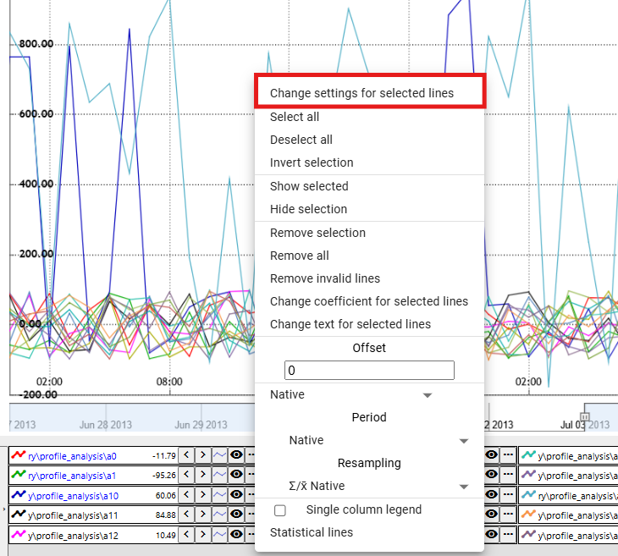

Figure 314: "Change settings for selected" item

1. A window will appear where you change the settings for the selected profiles.

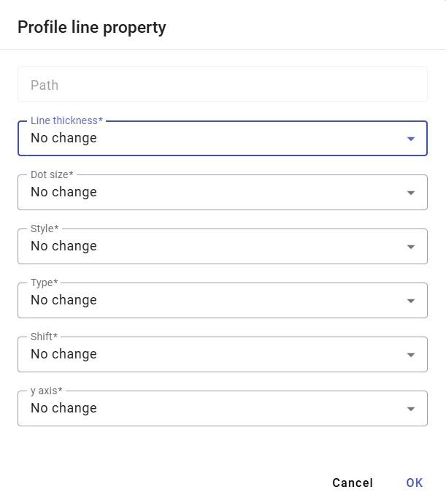

Figure 315: Window for settings of selected profiles

1. You save the changes by clicking the "OK" button.

### How to select all profiles

To select all profiles, right-click on the profile name and select “Select All”, Figure 316. All profiles will be highlighted, Figure 317.

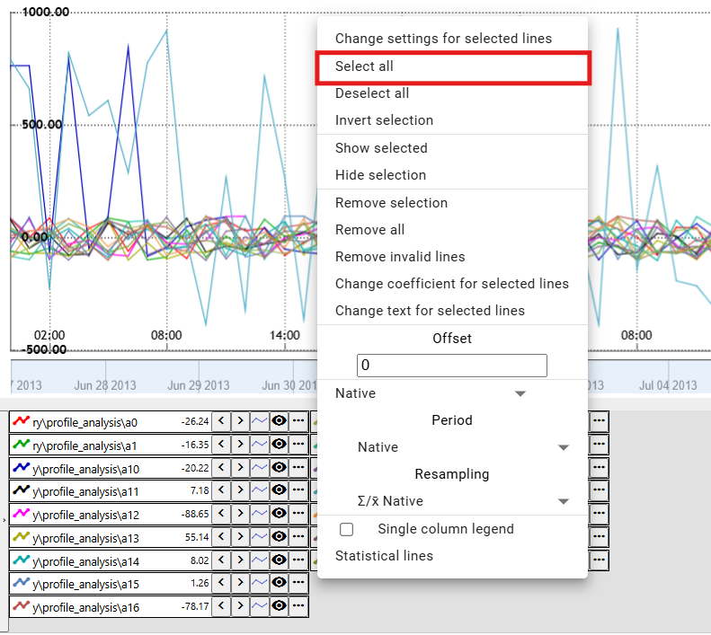

Figure 316: “Select All” item

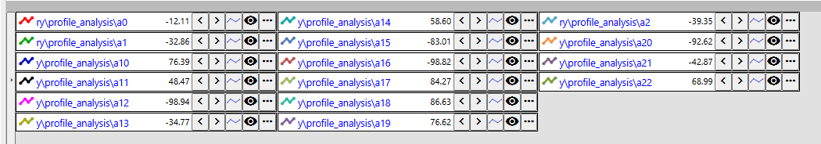

Figure 317: Highlighted Profiles

### How to deselect all profiles

The “Deselect All” item is used to deselect all selected profiles.

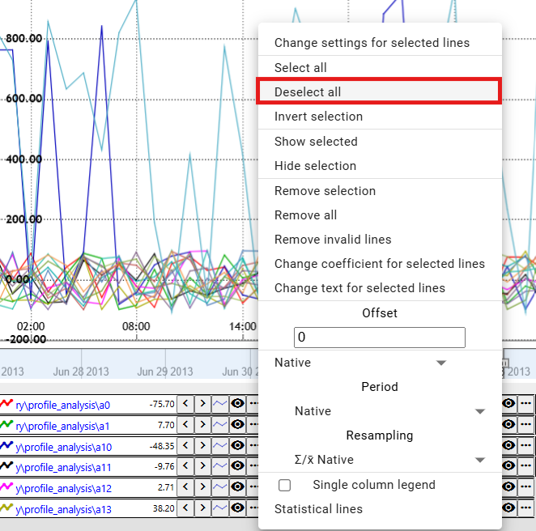

Figure 318: The “Deselect All” item

### How to invert selected profiles

The “Invert Selection” item will swap the selection of profiles. Selected profiles will be deselected and unselected profiles will be selected, Figure 320.

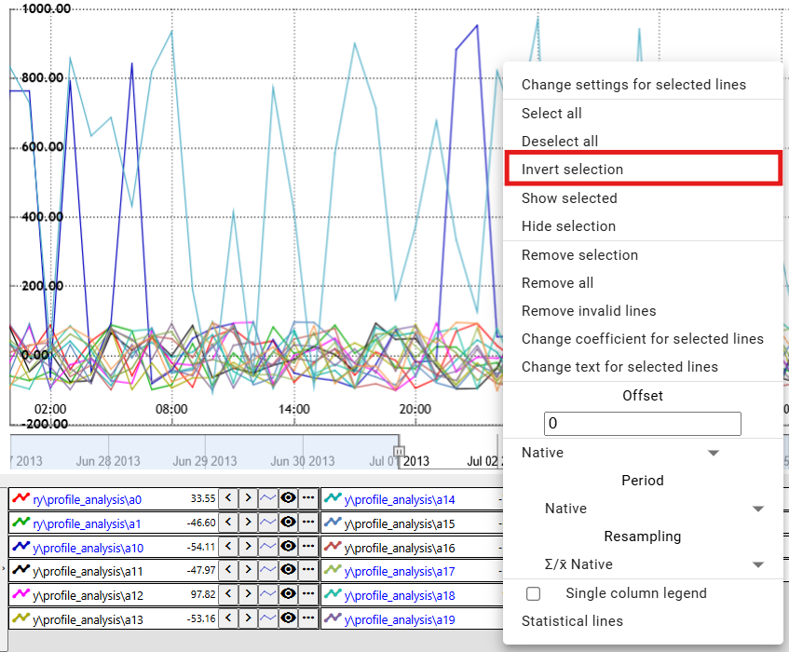

Figure 319: The “Invert Selection” item

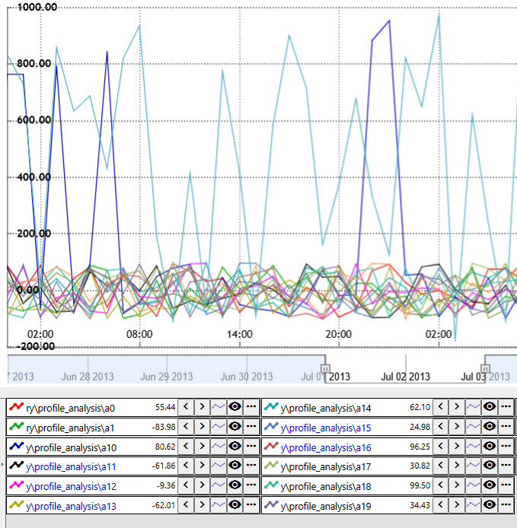

Figure 320: Inverted profile selection

### How to display only selected profiles

The “Show Selected” item is used to display selected profiles.

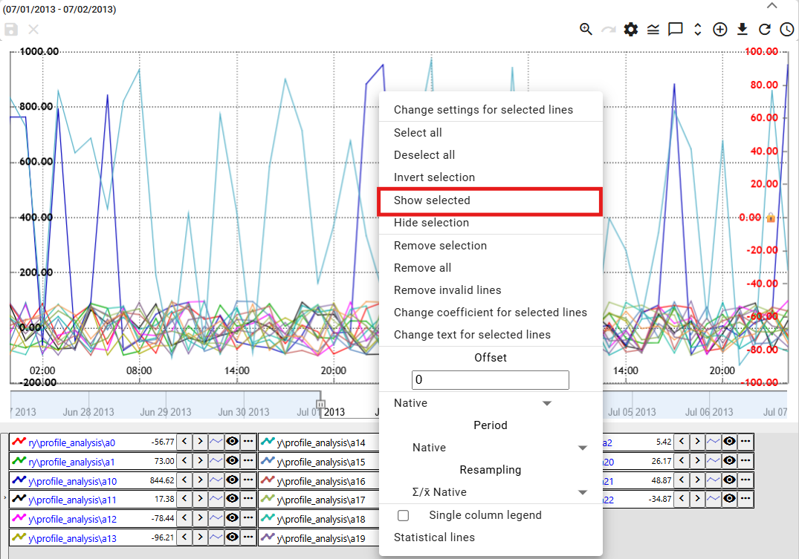

Figure 321: “Show Marked” item

### How to not display marked profiles

To not display marked profiles in the graph, proceed as follows:

1. Mark the profiles you do not want to display.
2. Right-click on the profile name.
3. Select "Do not display marked".

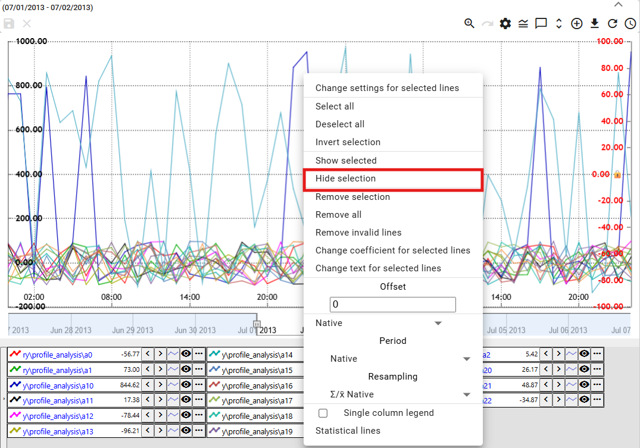

Image 322: "Do not display marked" item

1. Selected profiles will be hidden.

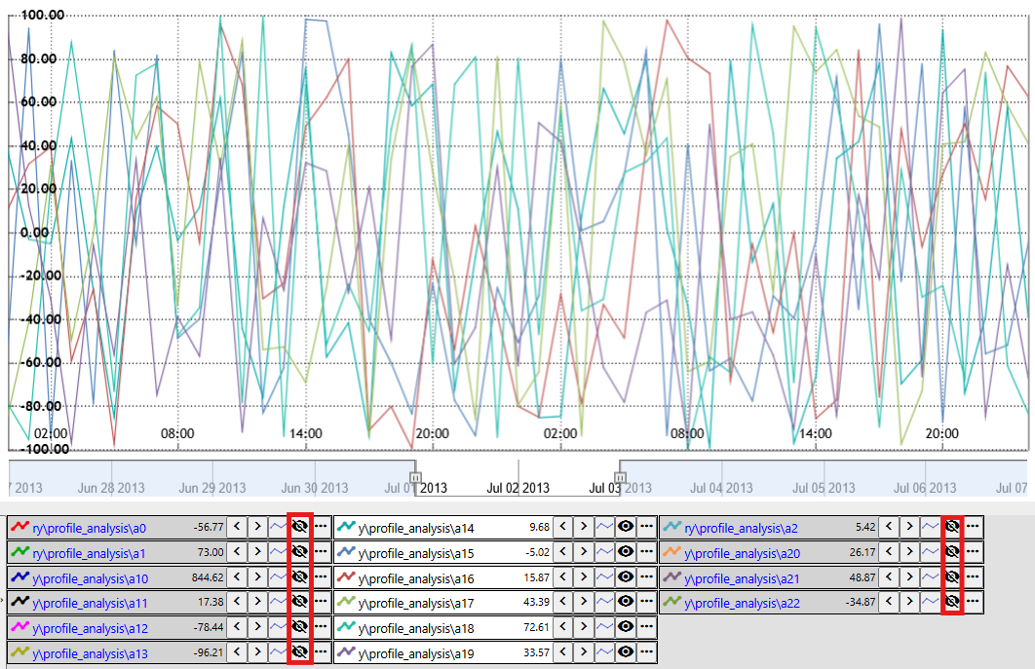

Image 323: Hidden profiles

### How to remove marked, all, or faulty profiles

You can use three functions to remove profiles:

* Remove marked - used to remove marked profiles,
* Remove all - all profiles will be removed.
* Remove faulty - only faulty profiles will be removed.

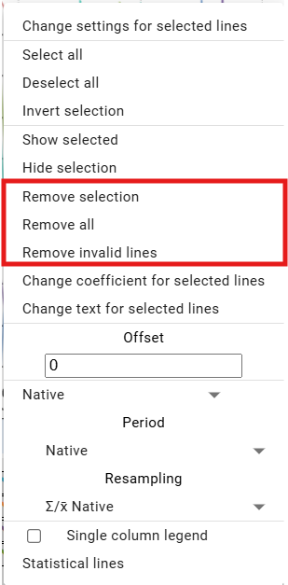

Figure 324: “Remove marked”, “Remove all”, and “Remove faulty” items.

To remove profiles, proceed:

1. To remove marked profiles, select the profiles you want to remove.
2. Right-click on the profile name.
3. Select "Remove Marked", "Remove All", or "Remove Faulty".
4. The profiles will be removed.

### How to set the coefficient for marked profiles

To set the coefficient, proceed:

1. Click on the profile name to select the profiles you want to set the coefficient for.
   1. To mark multiple profiles, click on the profile name, hold down the Ctrl key, and click on the profile names to select the profiles you want to choose.
   2. To select multiple profiles simultaneously, click the left mouse button on the name of the first profile, hold down the Shift key, and click the left mouse button on the last profile. All profiles in between will be selected.
2. Marked profile names will turn blue.
3. Right-click on the name of one of the marked profiles.
4. A window will appear where you select "Set coefficient for marked profiles".

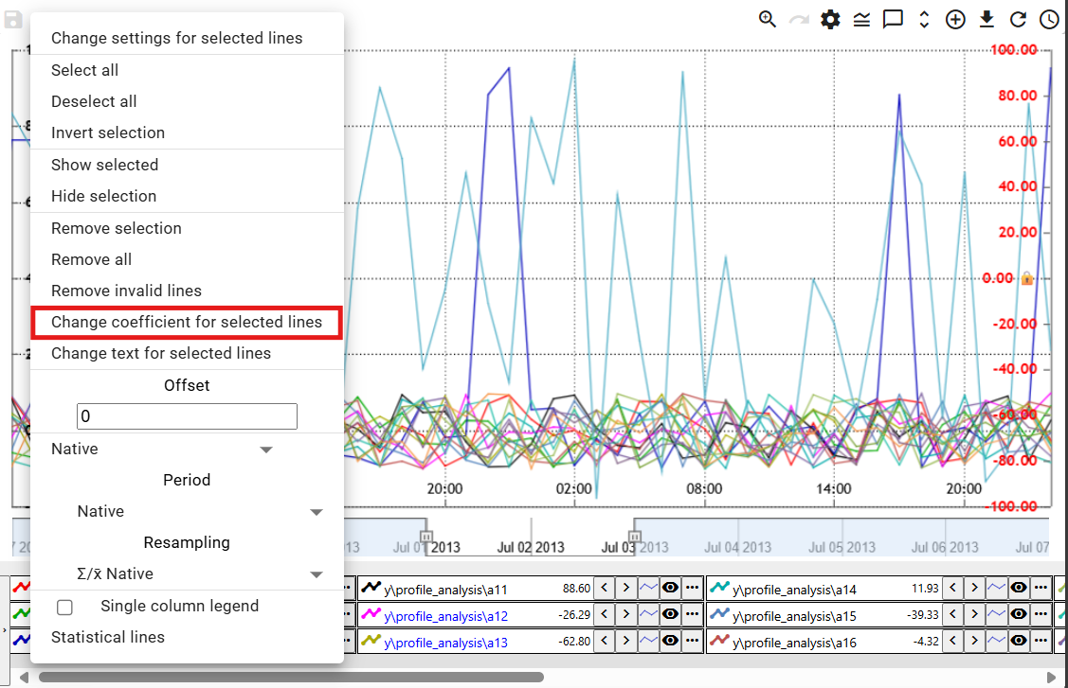

Figure 325: "Set coefficient for marked profiles" item

1. A window will appear where you set the coefficient.
2. Set the coefficient and save by clicking the "OK" button.

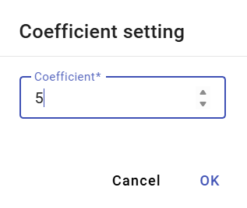

Figure 326: "Coefficient Setting" window

1. The coefficient will be set for the selected profiles. An information about the set coefficient will be displayed next to the profile names.

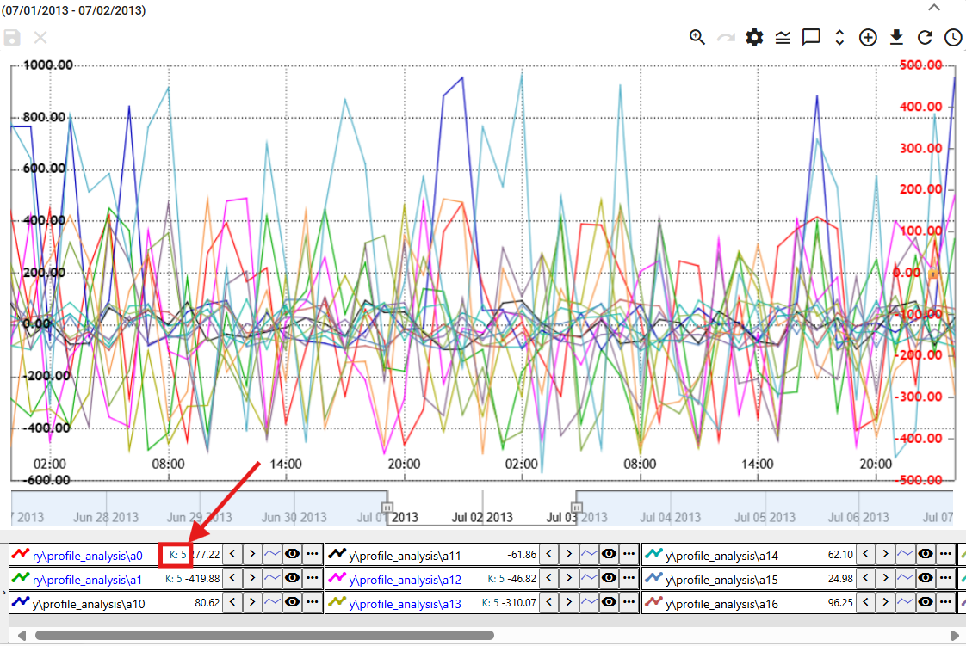

Figure 327: Set Coefficient

### How to set the offset

To set the offset, proceed as follows:

1. Click on the profile names to select the profiles you want to set the offset for.
2. Right-click on the name of one of the selected profiles.
3. A window will appear where you can enter the offset and press Enter.

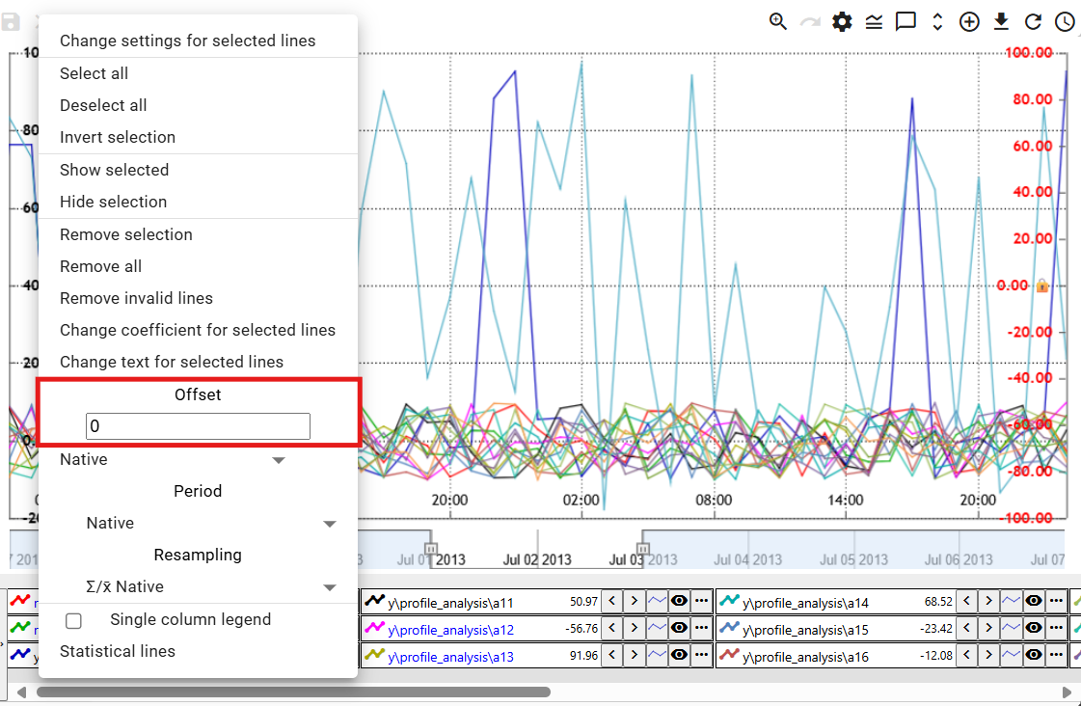

Figure 328: "Offset" field

1. For selected profiles, information about the set offset will be displayed.

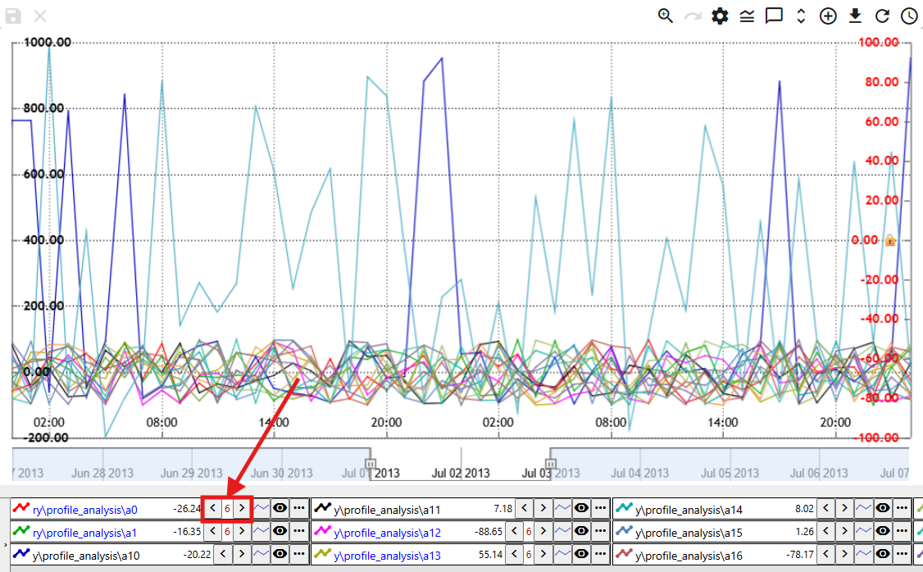

Figure 329: Set offset

### How to display statistical lines

To display statistical lines, proceed as follows:

1. To display statistical lines only for selected profiles, hold down the Ctrl key and click on the profile names to which the statistical lines should be displayed.
2. Right-click on the profile name.
3. Select "Statistical Lines".

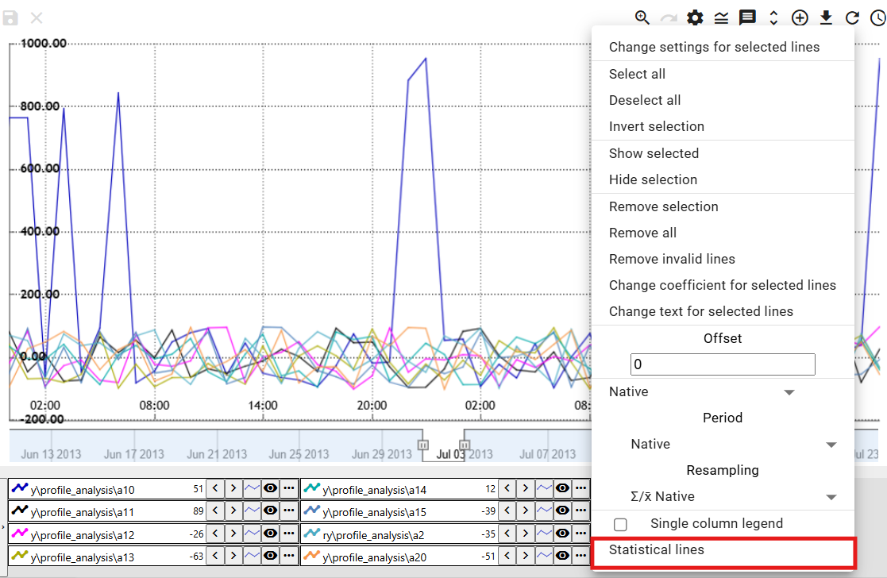

Figure 330: "Statistical Lines" item

1. The "Statistical Lines" window will appear.

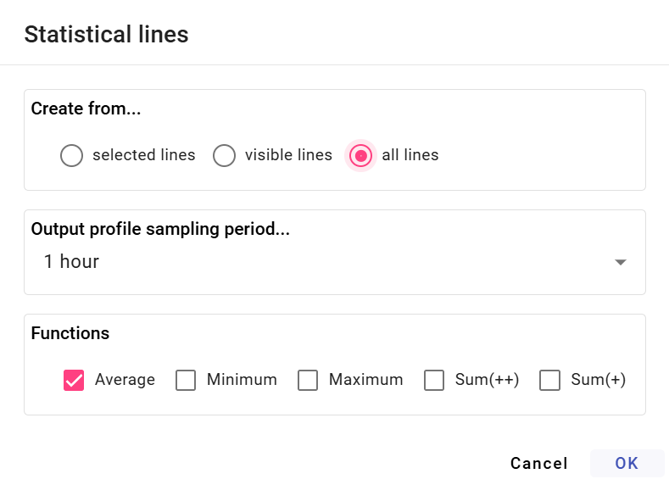

Figure 331: "Statistical Lines" window

1. Select whether the statistical lines should be created from the selected lines, visible lines, or all lines.
2. Select a function. You can select multiple functions simultaneously.
3. Press the "OK" button.

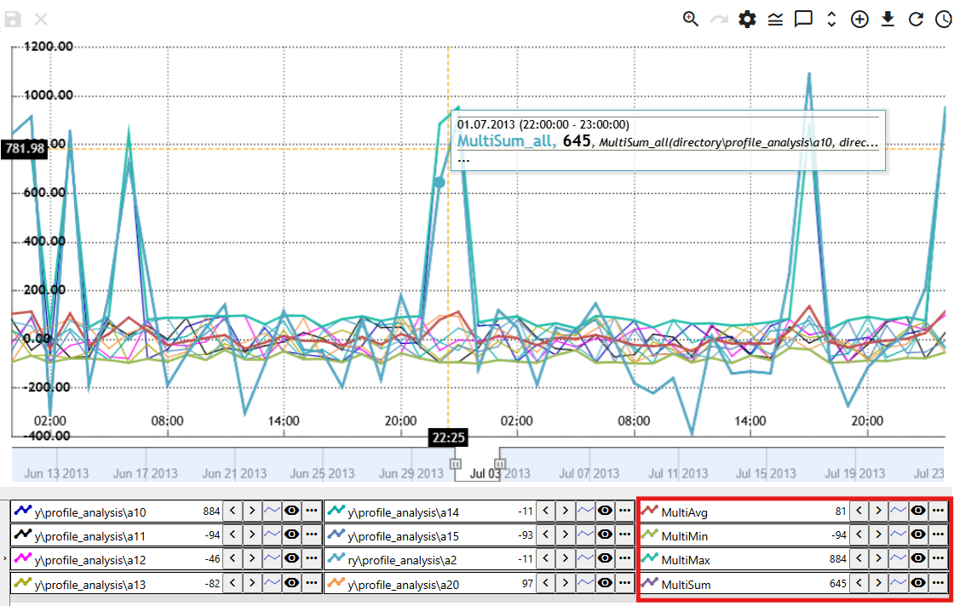

Figure 332: Statistical lines

### How to replace selected text

This function is used for bulk renaming of profiles. Proceed as follows:

1. Select the profiles whose text in the profile path you want to change.
2. Right-click on the profile name.
3. A menu will appear; select “Replace text with highlighted text” from it.

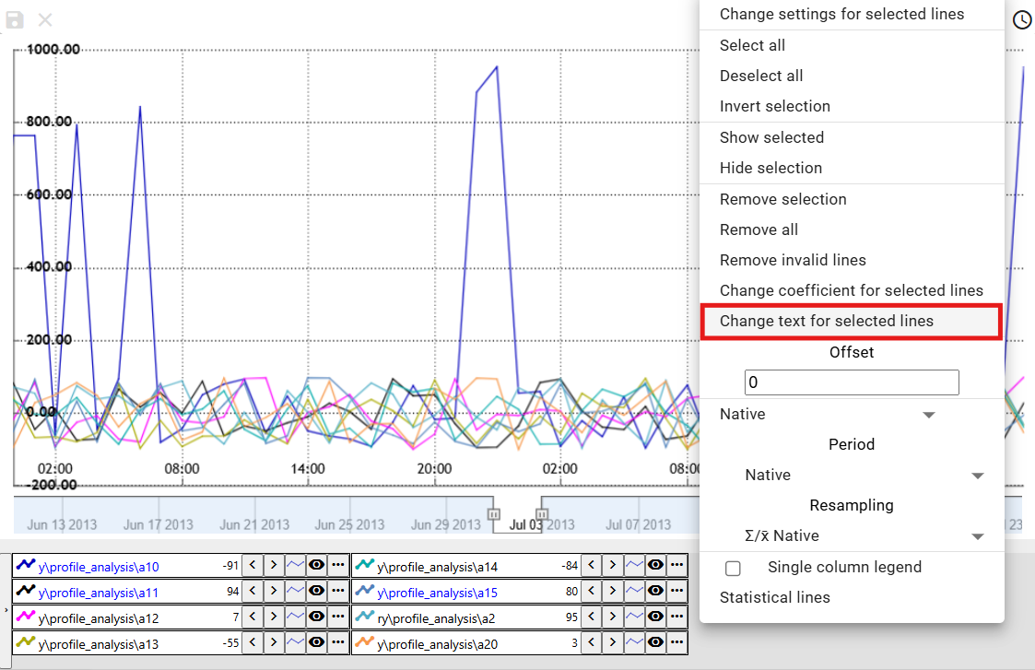

Figure 333: "Replace text with highlighted text" item

1. A window “Replace text in profile path” will appear.
2. In the “Find” field, enter the text you want to replace.
3. In the “Replace” field, enter the text you want to replace the text in the “Find” field.

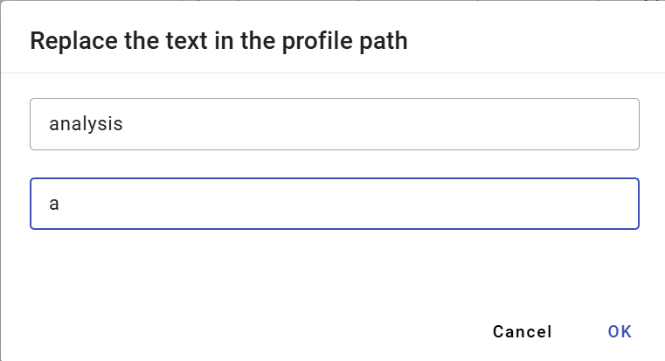

Figure 334: "Replace text in profile path" window

1. Confirm by clicking the “OK” button.
2. The entered text will be replaced with the new text.

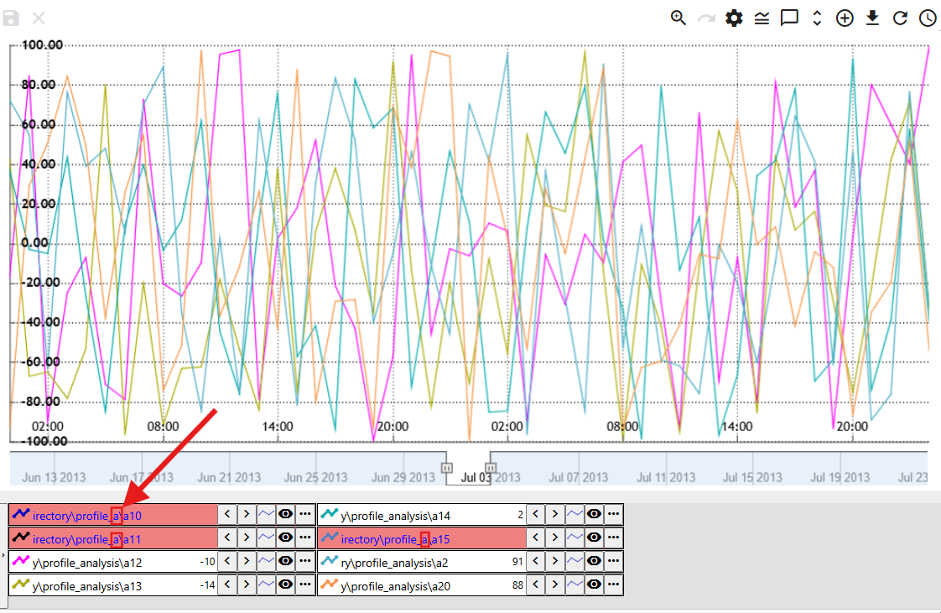

Figure 335: Replaced text

## Functions for working with a single profile

Each profile has a button next to its name, which is used to display functions. The functions are used to work with the selected profile.

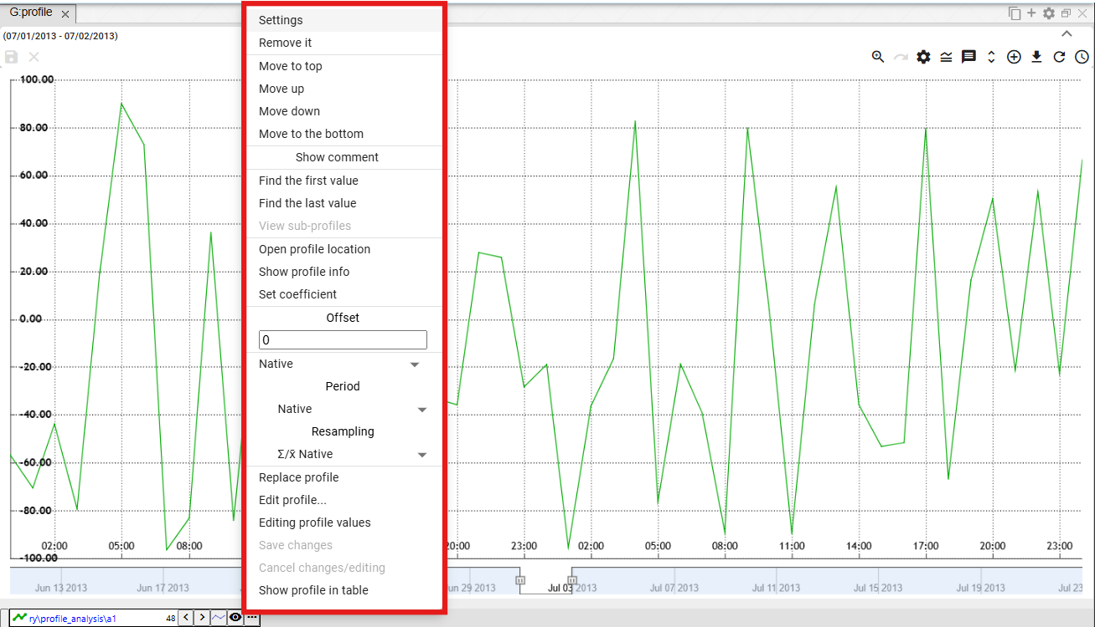

Figure 336: Functions for working with a profile

### How to edit settings

You can change the display of profile data in the graph in the settings window. For example, you can change the color in which the profile is displayed, the line style..

To change the settings, proceed as follows:

1. Click the button next to the name of the profile whose settings you want to change.
2. A window will appear, in which select the "Settings" item.

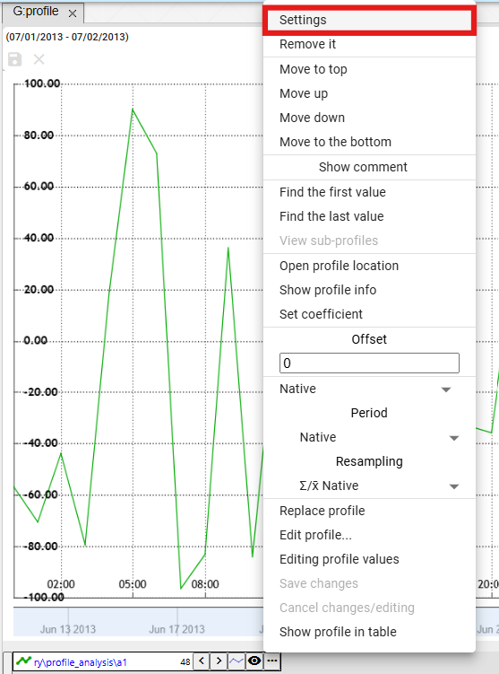

Figure 337: "Settings" item

1. In the window that appears, change the profile settings.
2. Save the changes by pressing the "OK" button.

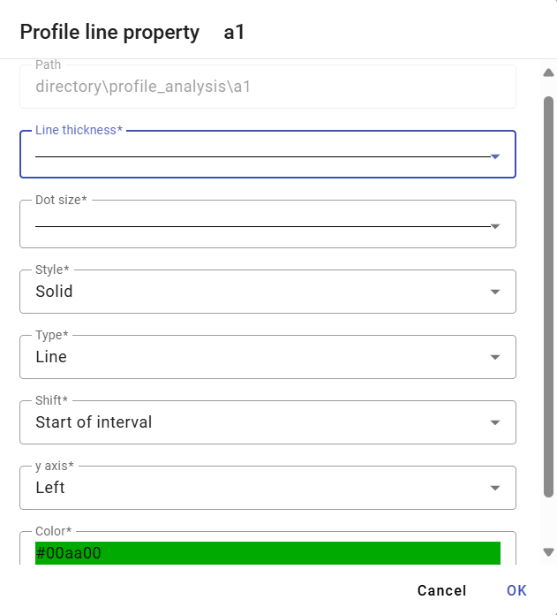

Figure 338: Profile Settings

### How to delete a profile

Delete profile:

1. Click the button next to the name of the profile you want to delete.
2. The profile will be removed from the list of profiles at the bottom of the Graph window and from the profile view.

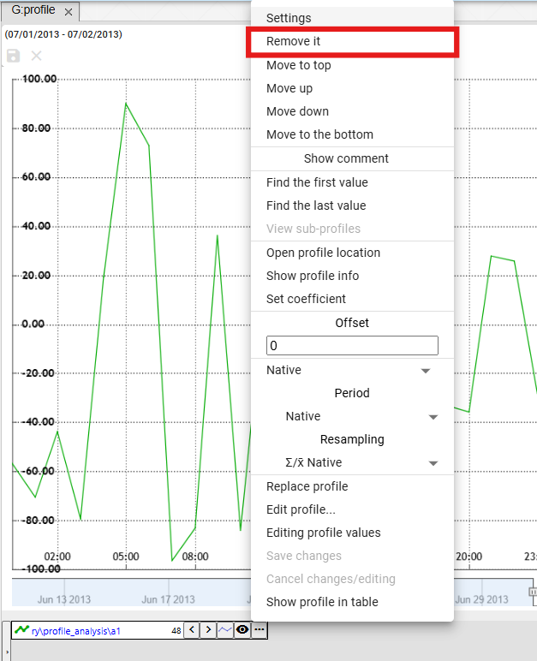

Figure 339: "Delete" item

### How to move a profile to the top

To move a profile to the top of the list of profiles, proceed as follows:

1. Click the button next to the name of the profile you want to move to the top.
2. Select the "Move to Top" item.
3. The selected profile will be moved to the top of the list.

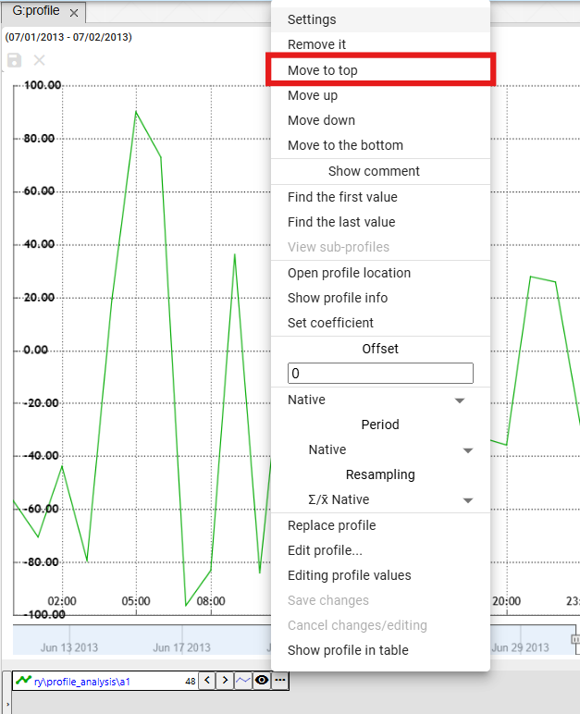

Figure 340: "Move to Top" item.

### How to move the profile to the top

The "Move Up" item is used to move the profile name one position higher in the profile list at the bottom of the "Graph" window, for example from the third position to the second position.

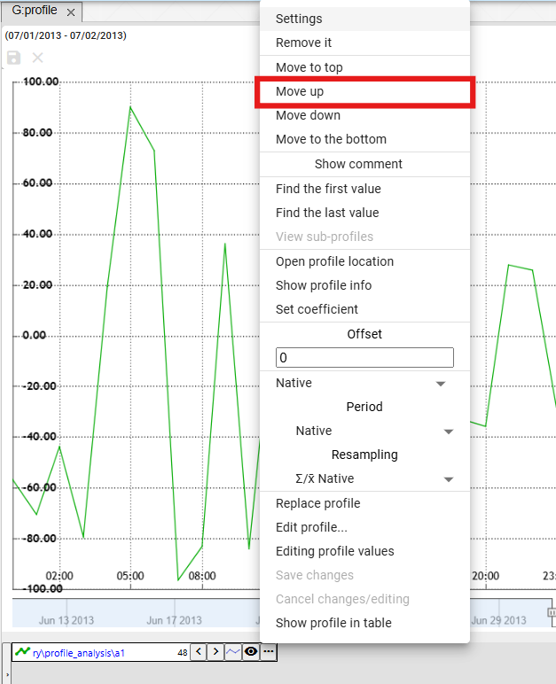

Figure 341: "Move Up" item

### How to move the profile down

The "Move Down" item is used to move the profile name one position lower in the profile list at the bottom of the "Graph" window, for example from the second position to the third position.

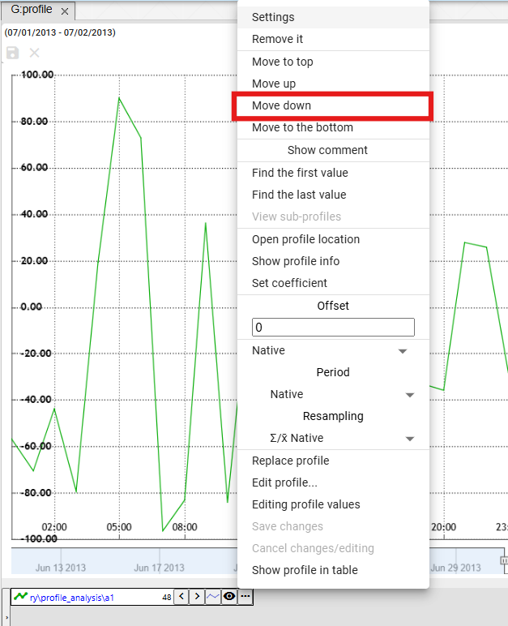

Figure 342: "Move Down" item

### How to move the profile to the end

The "Move to End" item is used to move the profile to the end of the profile list at the bottom of the "Graph" window.

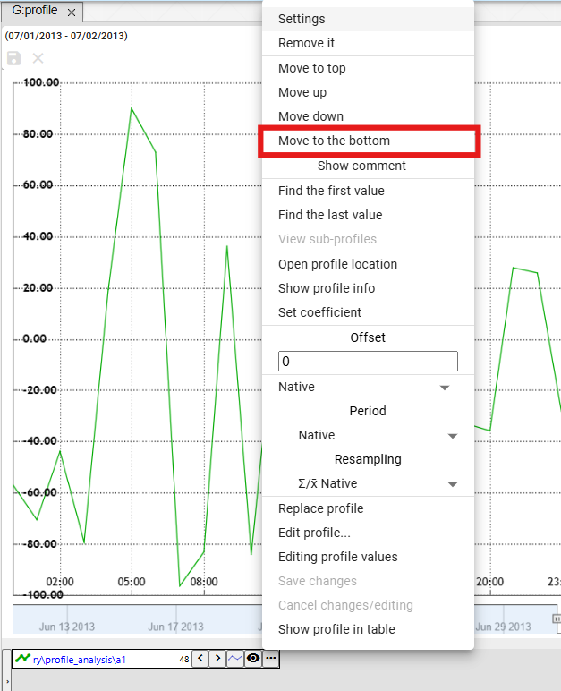

Figure 343: "Move to End" item

### How to display a comment

The "Show Comment" item determines the display of the profile name. After selecting "Show Comment", the comment is displayed instead of the profile name, Figure 345. To display the profile name, click "Show Comment" again.

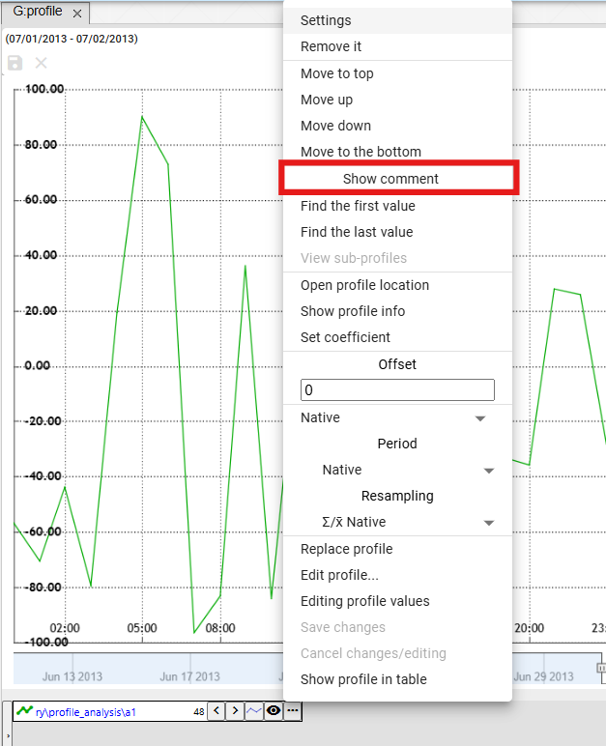

Figure 344: "Show Comment" item

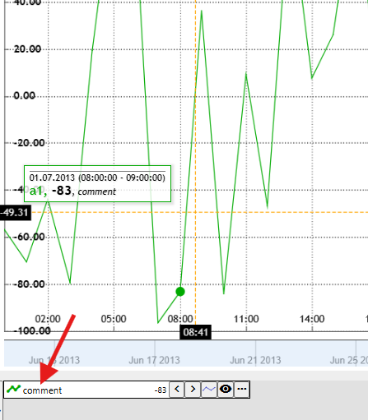

Figure 345: Profile comment displayed

### How to find the first value

The "Find First Value" item is used to find the first value in the profile graph.

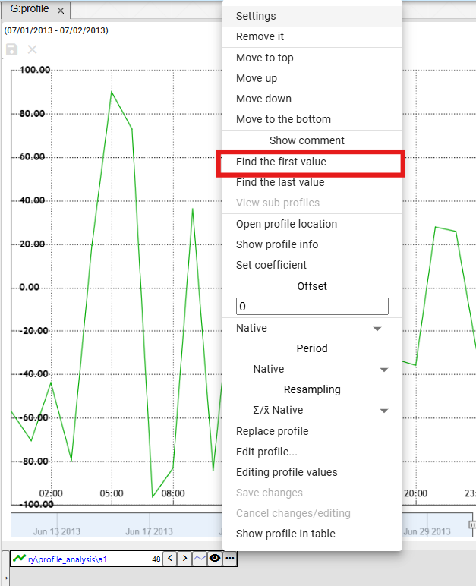

Figure 346: "Find First Value" item

### How to find the last value

The "Find Last Value" item is used to find the last value in the profile graph.

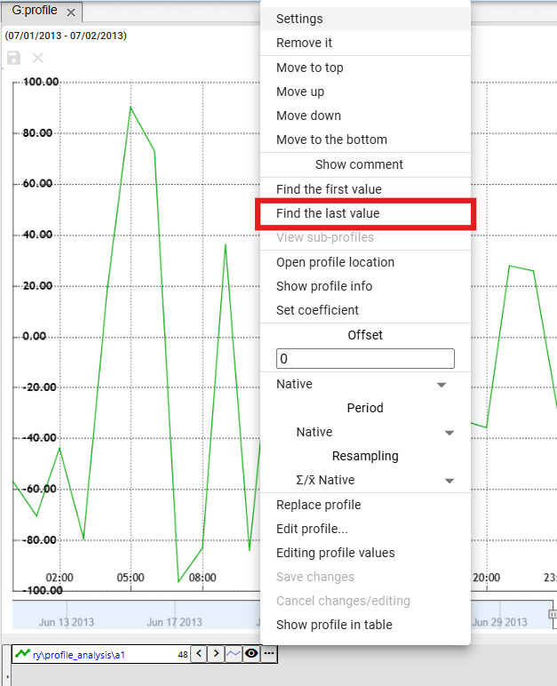

Figure 347: "Find Last Value" item

### How to display subprofiles

The calculated profile may use other profiles in its definition, so-called subprofiles. To display them, proceed as follows:

1. Click the button next to the name of the profile whose settings you want to change.
2. A window will appear in which select the "Show subprofiles" item.
3. All profiles used in the definition of the calculated profile will be displayed.

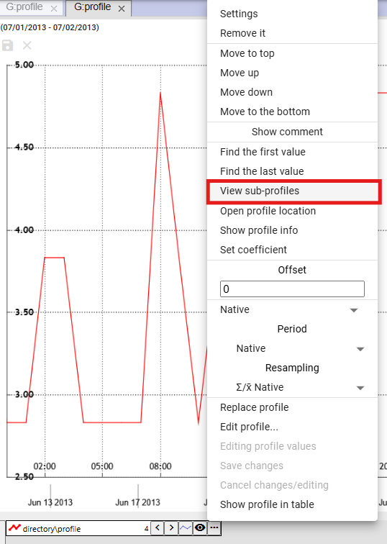

Figure 348: "Show subprofiles" item

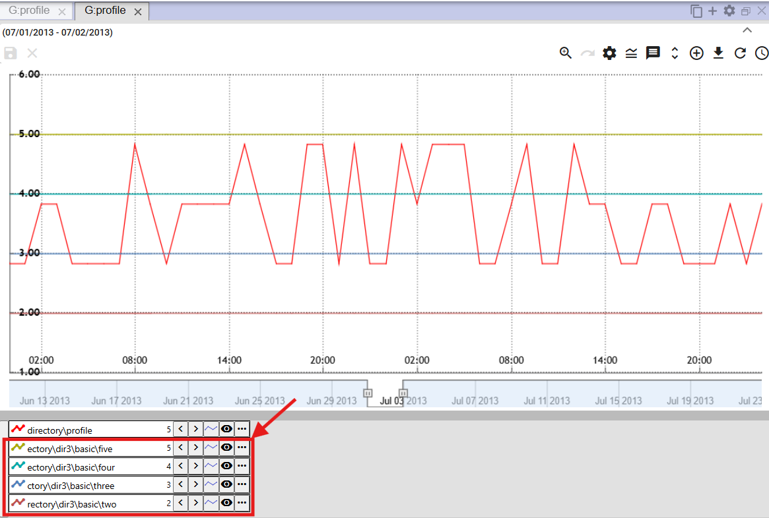

Figure 349: Displayed subprofiles

### How to open the profile location

You can display the profile location in the tree structure:

1. Click the button next to the name of the profile you want to open in the tree.
2. A window will appear, in which select the "Open profile location" item.

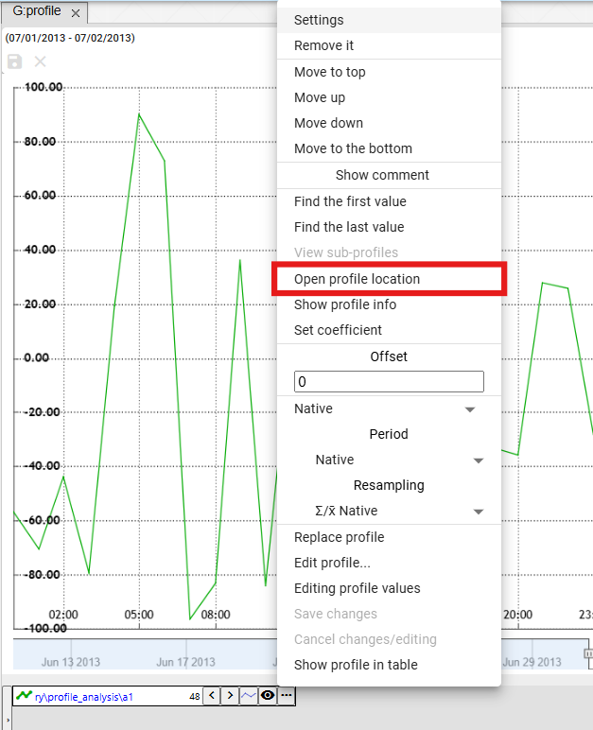

Figure 350: "Open profile location" item

1. A directory will open in the tree structure, containing the profile.

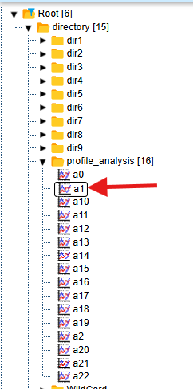

Figure 351: Profile location in the tree structure

### How to open the info window

You can open an info window for each profile, for example, the profile name, the profile path, and the profile type.

You open the info window:

1. Click the button with the three dots icon, which is located next to each profile.



Figure 352: Button for displaying functions

1. Select "Open Info Window".

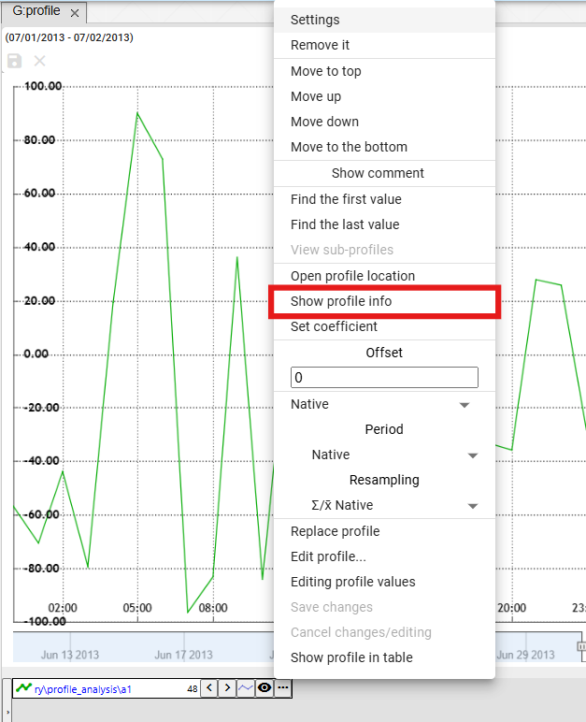

Figure 353: "Open Info Window" item

1. A directory containing the profile will open in the tree structure, Figure 351.
2. Subsequently, an information window for the profile will be displayed, which contains three tabs: “Info”, “ReadLog”, and “WriteLog”, Figure 354.
3. In the “Info” tab, you can copy the profile name and profile path by clicking the button.

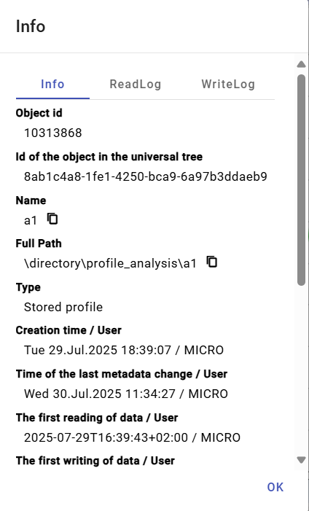

Figure 354: “Info” tab

### How to set the coefficient

To set the coefficient, proceed as follows:

1. Click the button next to the profile name you want to set the coefficient for.
2. Select "Set Coefficient".

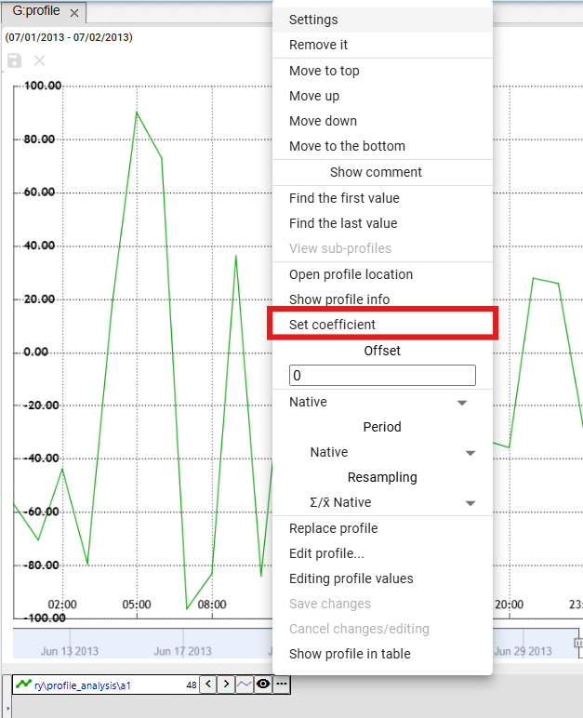

Figure 355: "Set Coefficient" item

1. A window will appear where you enter the coefficient.

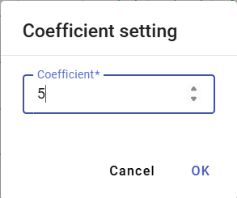

Figure 356: Setting Coefficient

1. Save by pressing the "OK" button.
2. Information about the set coefficient will be displayed next to the profile name.

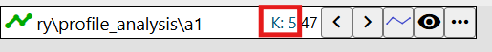

Figure 357: Set Coefficient

### How to enter offset

To enter the offset, proceed as follows:

1. You can enter the offset by clicking the arrows next to the profile name, or click the button and enter the value in the “Offset” section and press the “Enter” key.



Figure 358: Buttons for offset adjustment

1. The same value that you entered for the offset using the arrows next to the profile name will also be displayed after clicking the button in the “Offset” section.

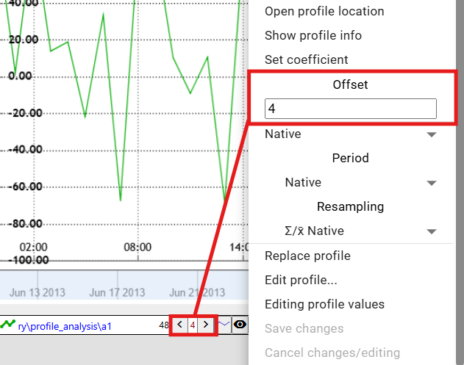

Figure 359: Set offset

1. Below the Offset field is a field for selecting the period for the offset, Figure 360. After clicking the field, a list of time periods for the offset will be displayed, Figure 361.

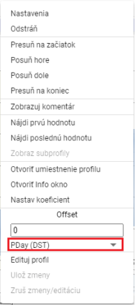

Figure 360: Field for selecting the period for the offset

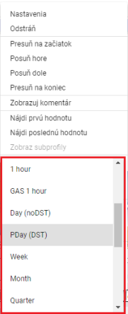

Figure 361: Selecting the time period for the offset

### How to change a profile

To change a profile to a different profile, proceed as follows:

1. Click the button next to the name of the profile you want to replace.
2. Select "Replace Profile".

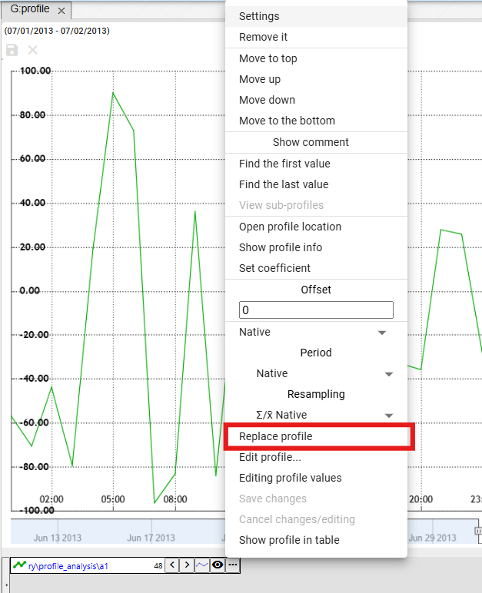

Figure 362: "Replace Profile" item

1. The "Replace Profile" window will appear.

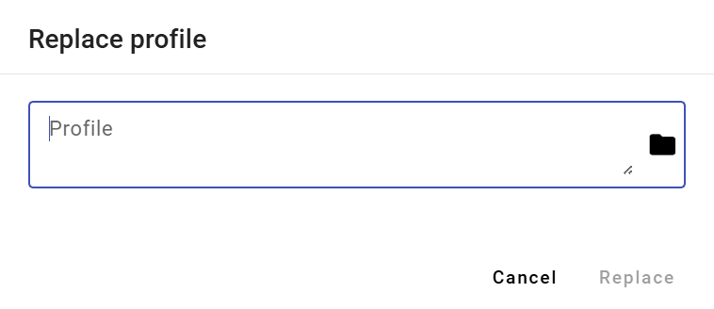

Figure 363: "Replace Profile" window

1. Enter the path to the profile or click the button.
2. To confirm, click the "Replace" button.

### How to Edit a Profile

To edit a profile, proceed as follows:

1. Click the button next to the name of the profile you want to edit.
2. Select "Edit Profile Values".

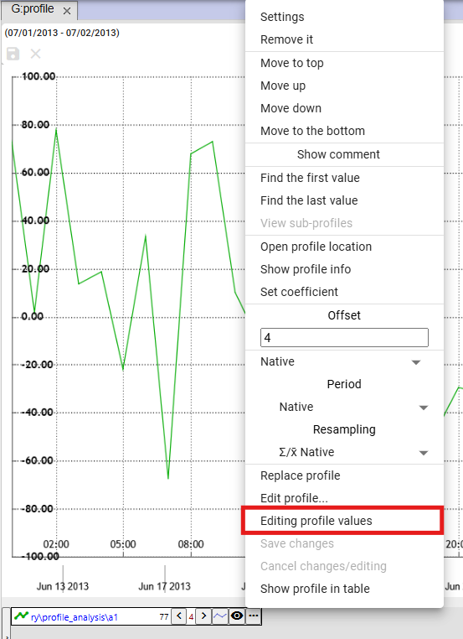

Figure 364: "Edit Profile Values" item

1. A copy of the profile will be created. The fields with the names of the original and copied profiles will be highlighted in green.

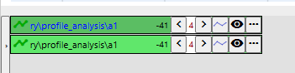

Figure 365: A copy of the profile will be created.

1. Edit the profile.
2. Save changes by clicking the button and selecting "Save Changes" or by pressing the button with the floppy disk icon located in the upper left corner of the chart.

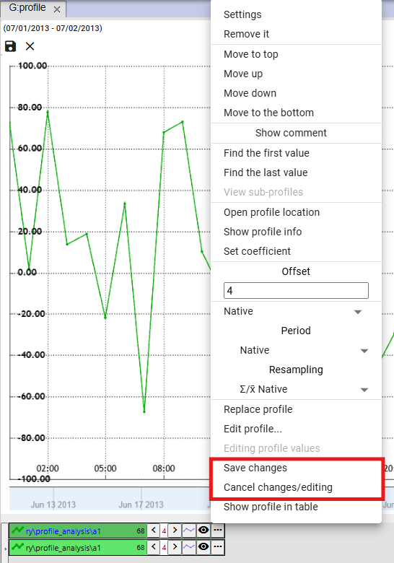

Figure 366: The "Save Changes" and "Discard Changes/Edit" items.

1. To discard changes, select the "Discard Changes/Edit" item or press the "x" button in the upper left corner of the chart.

### How to set the color for a profile

To set the color for a profile, proceed as follows:

1. Press the button next to the profile you want to set the color for.
2. Select "Settings" to display the "Profile Line Property" window.

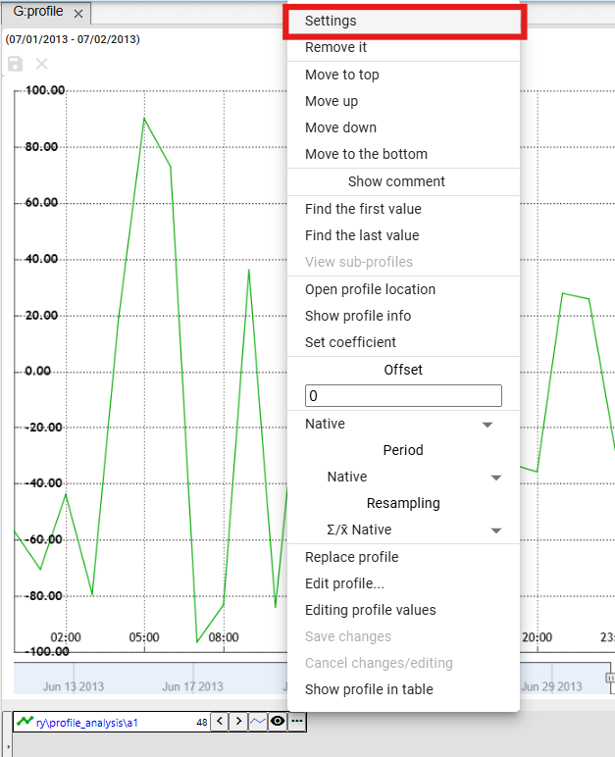

Figure 367: "Settings" item

1. In the "Profile Line Property" window, click in the "Color" field.
2. A color selection window appears. A color palette for quick color selection is located at the bottom.

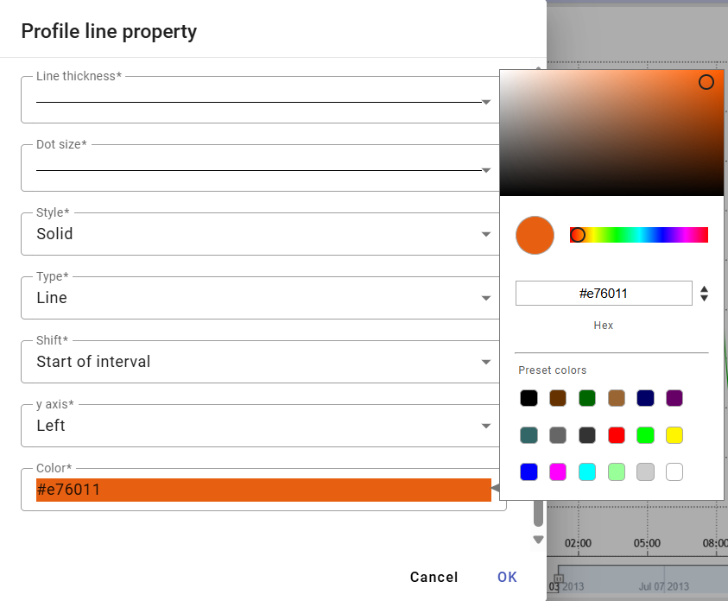

Figure 368: Color Selection

1. Click on the selected color.
2. You save the changes by pressing the "OK" button.

### How to set the point size

To set the point size, proceed as follows:

1. Press the button next to the profile name you want to set the point size for.
2. Select "Settings" to display the "Profile Line Property" window.



Figure 369: "Settings" item

1. Click in the "Point Size" field.

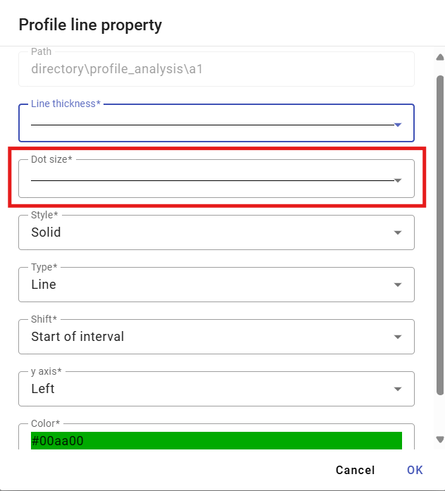

Figure 370: "Point Size" field

1. A window will appear where you can click to select the display size for the point.

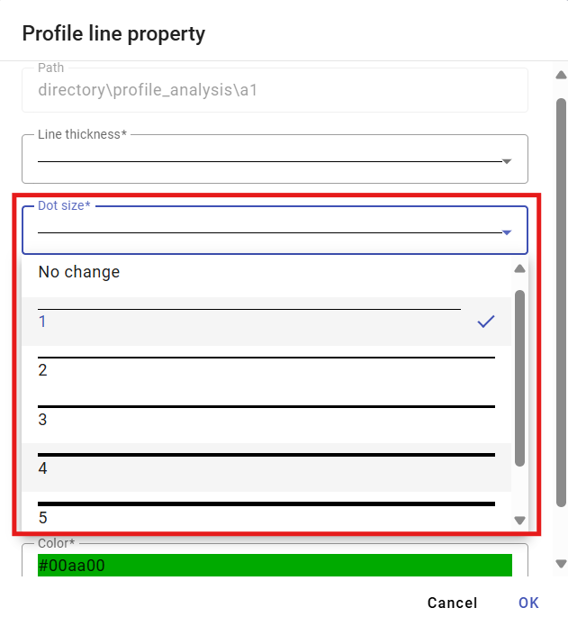

Figure 371: Selecting Point Size

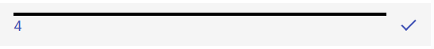

Figure 372: Selected Size

1. Save the changes by pressing the "OK" button.

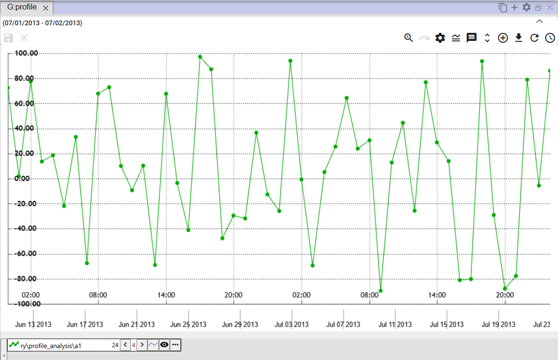

Figure 373: Set Point Size

### How to display the profile in the table

To display the profile in the Graph window in the table, follow these steps:

1. Click the button next to the profile name you want to display in the table.
2. Select "Display Profile in Table".

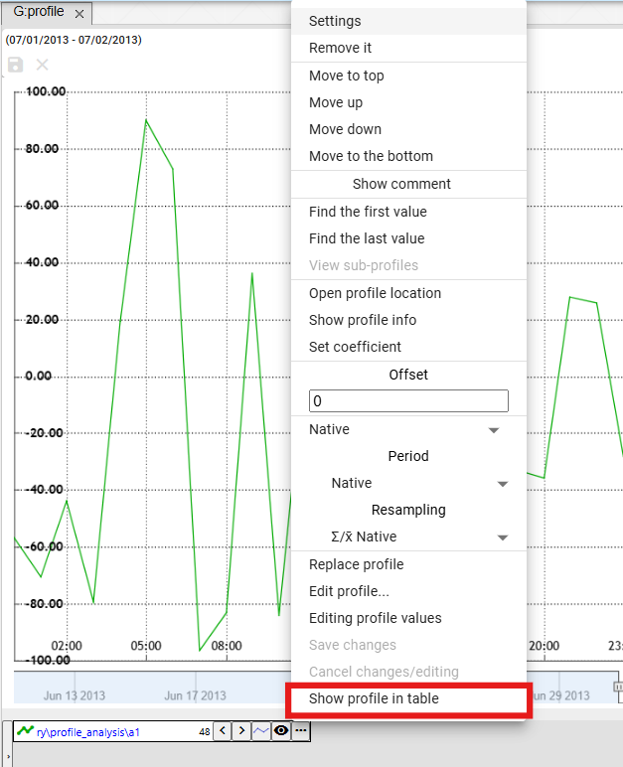

Figure 374: "Display Profile in Table" item

1. A new Table tab is added to the Chart window.

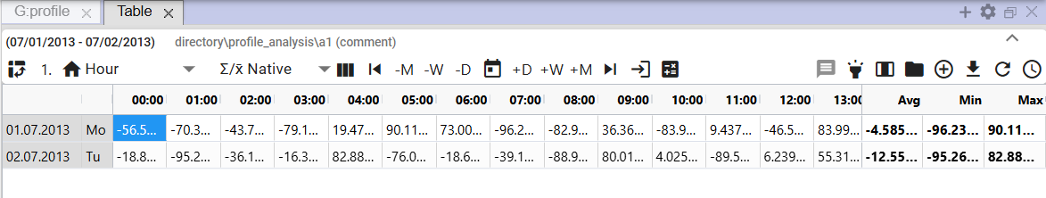

Figure 375: Display Profile in Table

## Quick chart type change

At the bottom of the Chart window, a button for quick chart type change is located next to the name of each profile. The button with a chart icon allows switching between StepLine, StepArea, and StackedColumn chart types. The chart type can also be switched through the "Type" field in the "Profile Properties" window, as described in Chapter 5.8.1.



Figure 376: Button for quick chart type change

By default, the chart type in the Chart window is set to “StepLine”, Figure 377. Pressing the button sets the chart type to “StepArea”, Figure 378, and the appearance of the quick chart type change button changes to . Pressing the button again sets the chart type to “StackedColumn”, Figure 379, and the button’s appearance changes to .

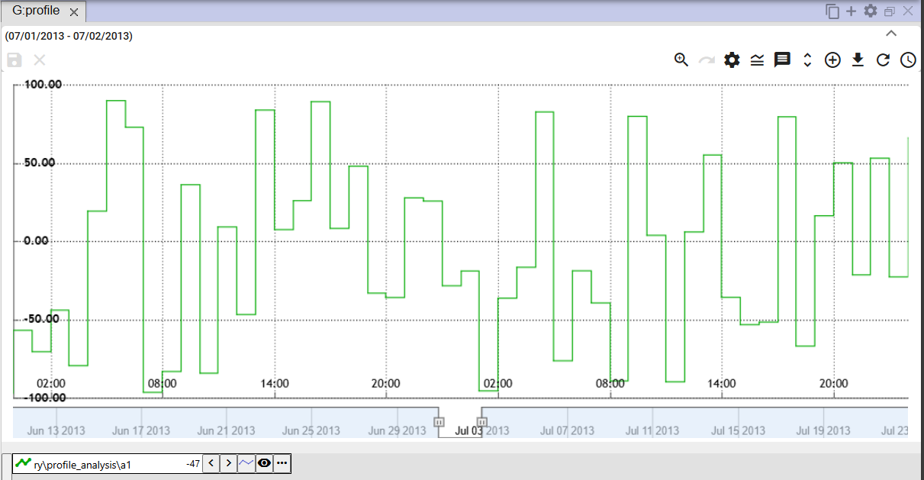

Figure 377: “StepLine” chart type

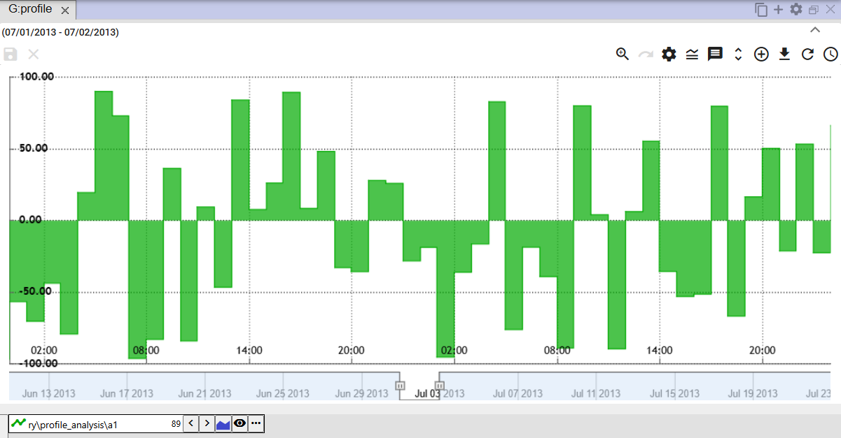

Figure 378: “StepArea” chart type

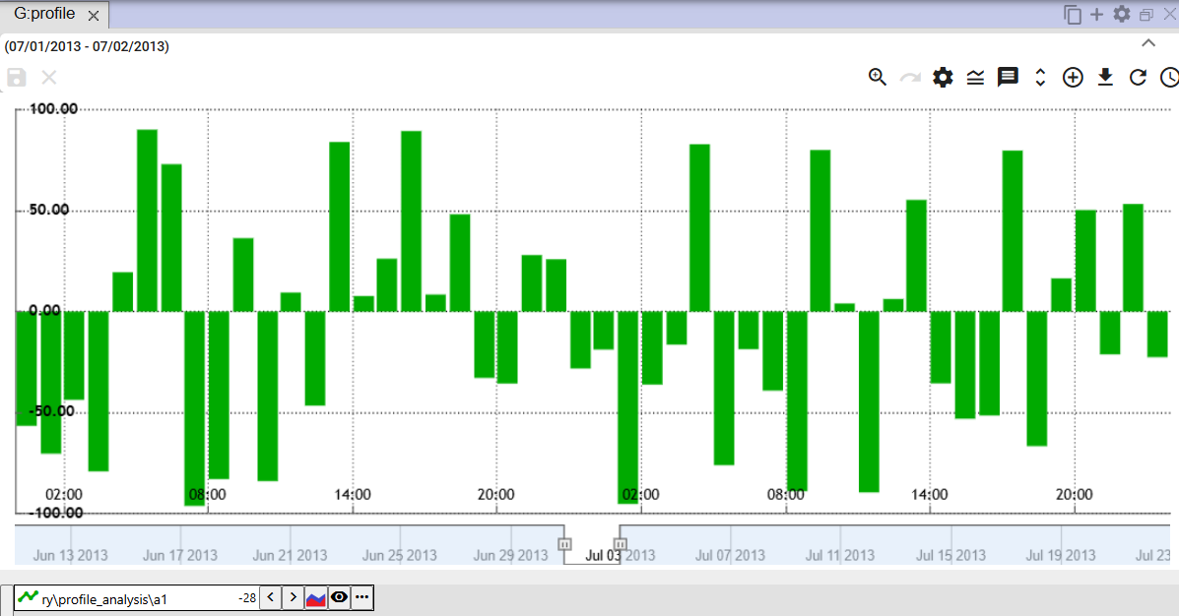

Figure 379: “StackedColumn” chart type

## How to zoom in on a selected part of the chart

To zoom in on a selected part of the chart:

1. Press the "Toggle Zoom" button, located in the top right corner of the chart.

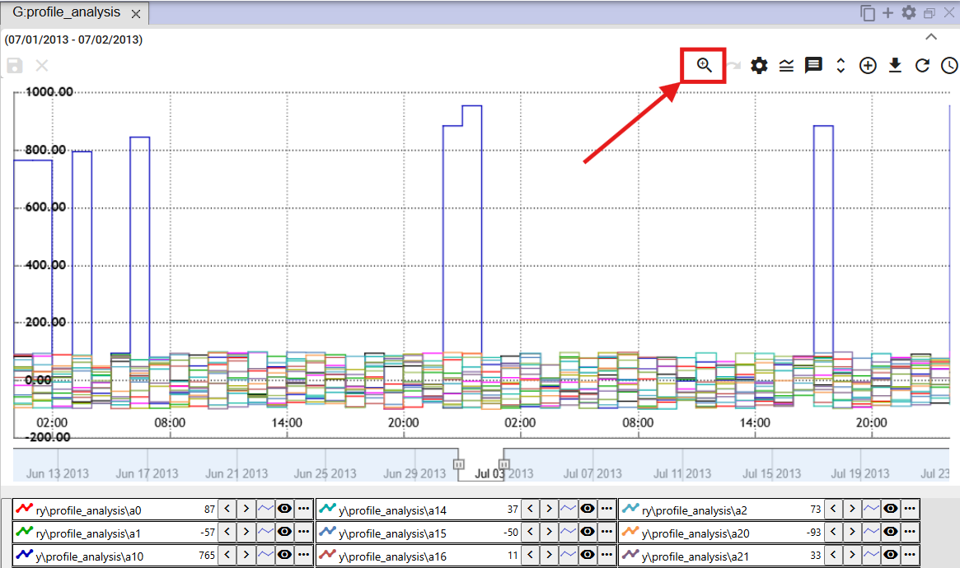

Figure 380: "Toggle Zoom" button

1. Press the left mouse button and select an area in the chart.

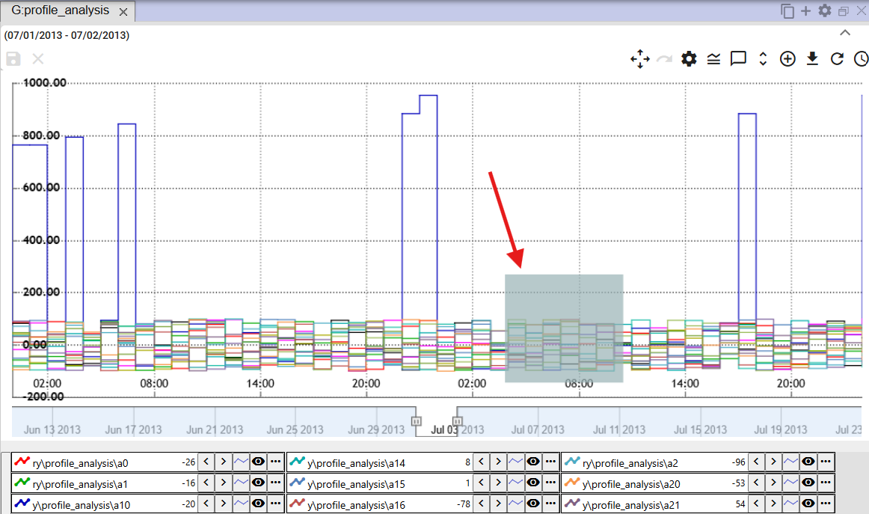

Figure 381: Selected area in the chart

1. Release the left mouse button.
2. The selected area will be zoomed in.

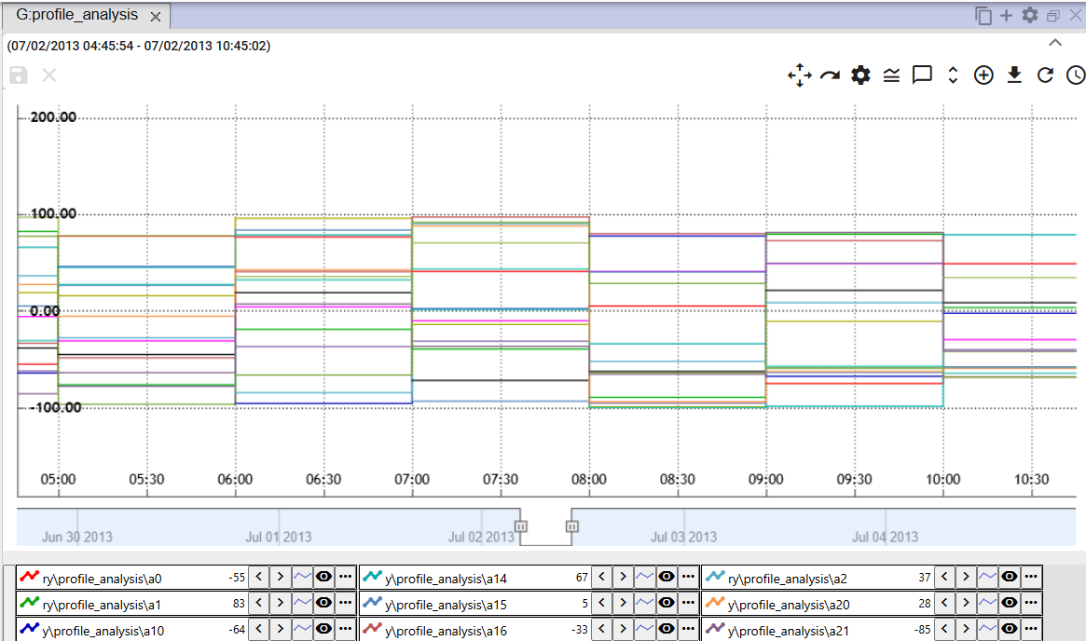

Figure 382: Zoomed area in the chart

1. To restore the y-axis, press the "Reset zoom" button, chapter 5.12.

## How to pan the chart

Clicking the "Toggle Zoom" button, Figure 380, changes the button from a magnifying glass to a "Toggle Pan" button, Figure 383. This allows you to move around in the chart. To pan in the chart, grab a location in the chart with the left mouse button and move the chart.

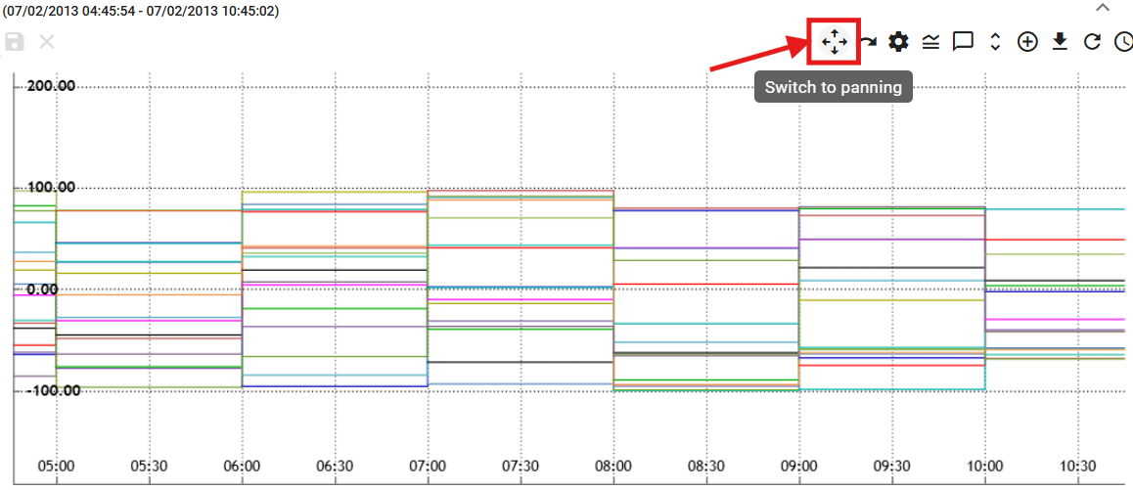

Figure 383: “Toggle Pan” button

## How to cancel zoom

After zooming in on a selected area in the chart using the zoom function, you restore the chart by pressing the "Reset zoom" button.

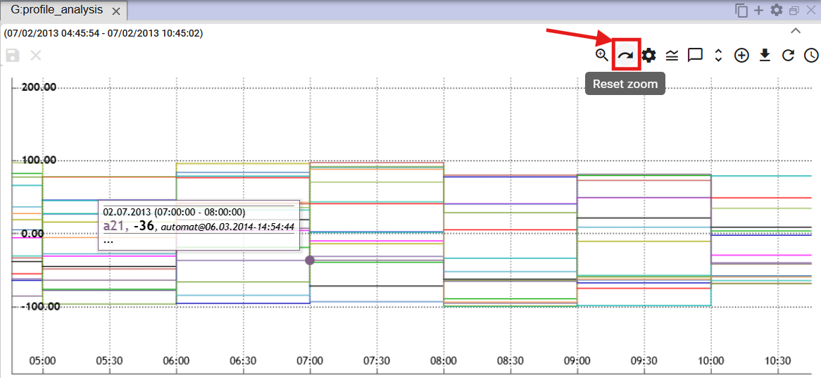

Figure 384: “Reset zoom” button

## How to show/hide the legend

At the bottom of the chart window, there is a list of displayed profiles, called the legend. To hide the list of profiles, press the “Show/hide legend” button, located in the upper right corner of the Chart window. To display the legend, press the “Show/hide legend” button again.



Figure 385: “Show/hide legend” button

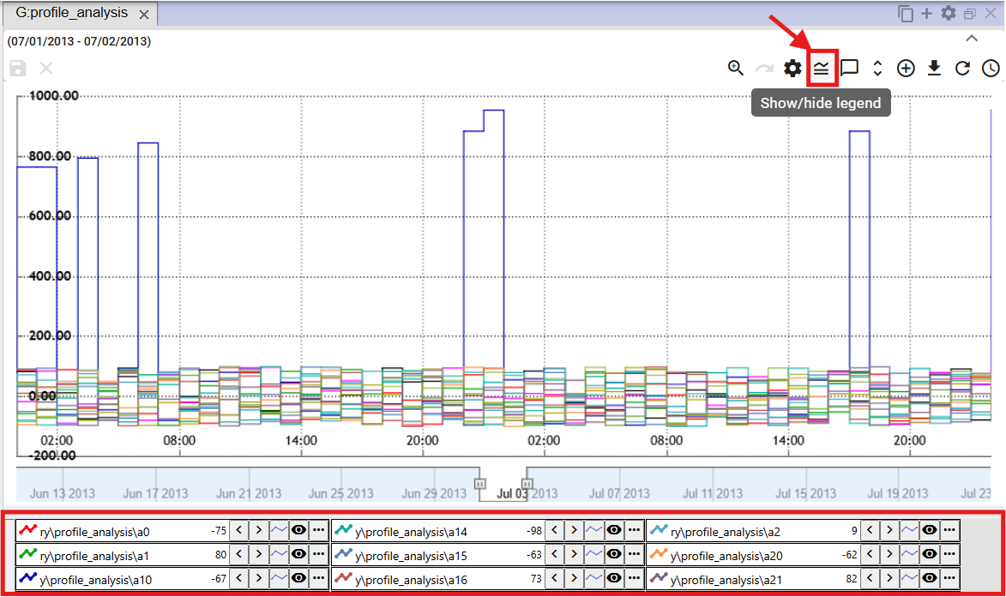

Figure 386: Legend displayed

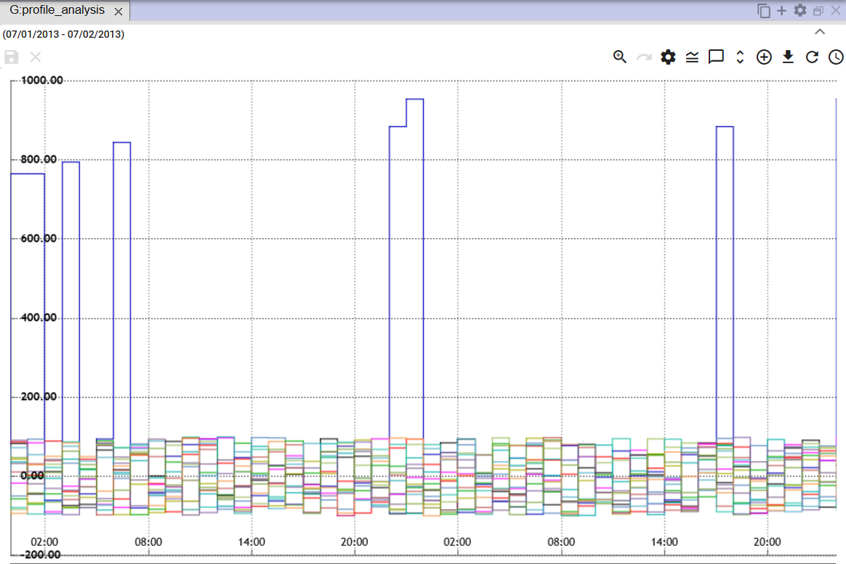

Figure 387: Hidden legend

## How to show/hide tooltip

To display values (tooltip) for a specific location in the graph, hover your mouse cursor over the selected location in the graph. You can hide the tooltip by clicking the "Show/Hide Tooltip" button, located in the top right corner of the Graph window. To display the tooltip again, click the "Show/Hide Tooltip" button again.



Figure 388: "Show/Hide Tooltip" Button

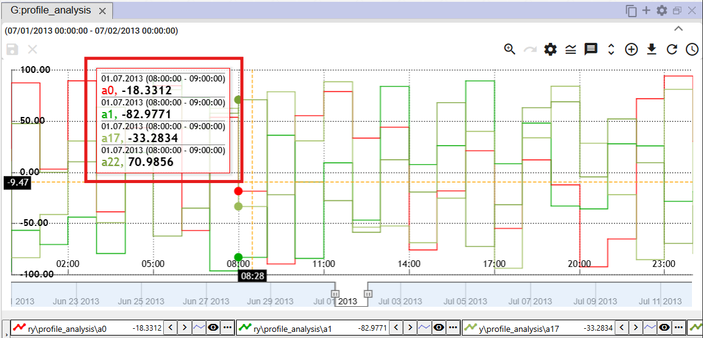

Figure 389: Tooltip Displayed

## How to set up the y-axis to display values

The "Set y-axis to display values" button is used to zoom out the y-axis if all values (all lines) are not clearly visible when zooming in. The y-axis will be zoomed out to ensure all values are visible. The x-axis remains unchanged.

Proceed:

1. Press the "Zoom" button, located in the upper right corner of the Chart window.



Figure 390: "Zoom" button

1. Select the location in the chart that you want to zoom in on.

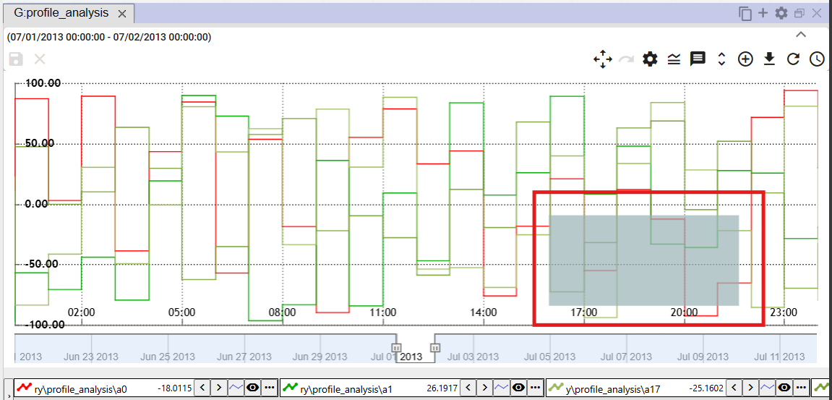

Figure 391: Select the location in the chart

1. The location in the chart will be zoomed in.

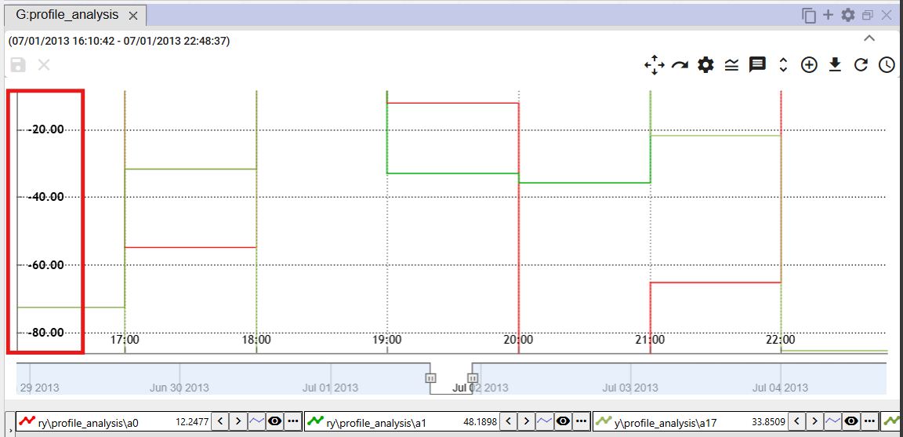

Figure 392: Zoomed area from the chart

1. Press the "Set y-axis to show values" button.



Figure 393: "Set y-axis to show values" button

1. The y-axis will zoom out.

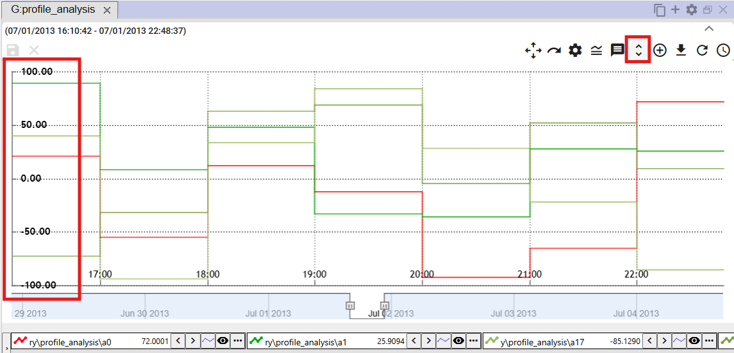

Figure 394: Changed y-axis

## How to change profile

To change the profile, proceed as follows:

1. Click the button next to the profile you want to change.
2. Select the "Change Profile" item.

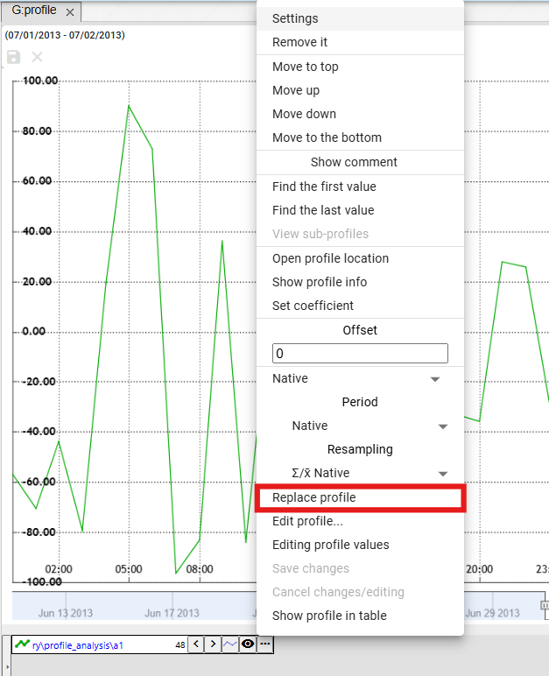

Figure 395: "Change Profile" item

1. A "Change Profile" window will appear.

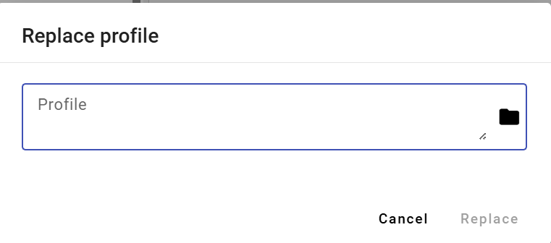

Figure 396: "Change Profile" window

1. Enter the profile path or click the button to browse for a profile.

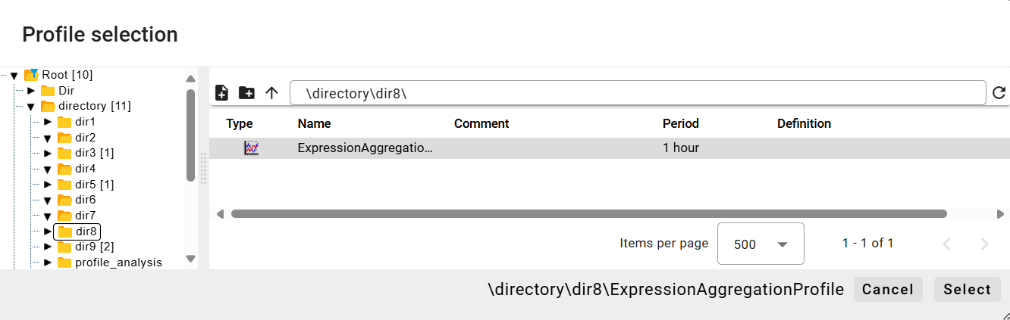

Figure 397: "Profile Selection" window

1. In the "Change Profile" window, click the "Change" button.

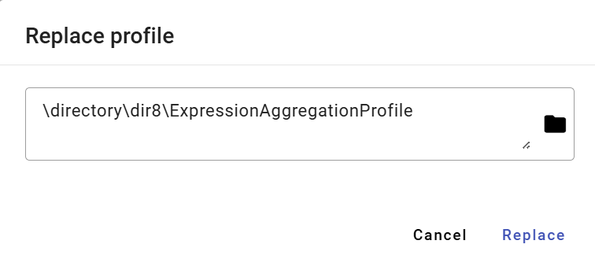

Figure 398: Selected Profile

1. The profile in the Graph window will be replaced with the selected profile.

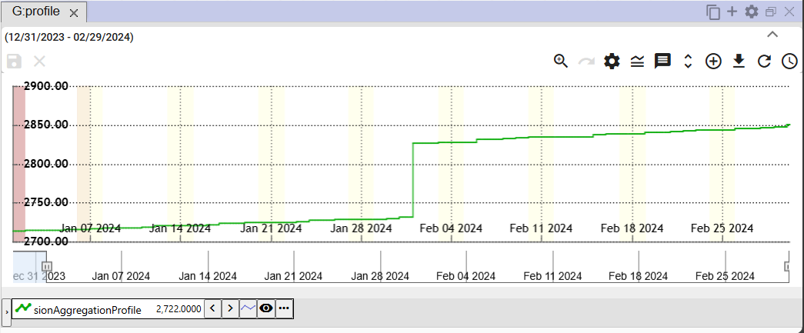

Figure 399: Replaced Profile

# Working with the Table

The "Profile Manager" application, in addition to working with the graph and explorer, also offers the ability to work with data in a table. Each table contains data from one profile and is created in a separate window.

If the user closes the table window with unsaved data, a window will appear - Figure 400.

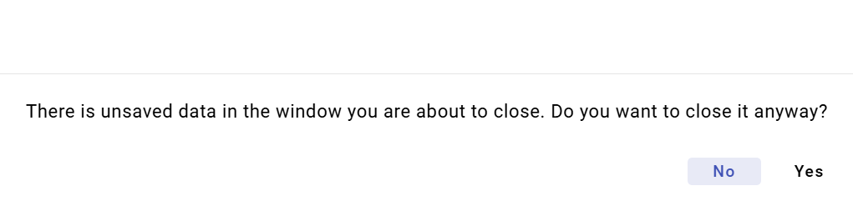

Figure 400: Notification about unsaved data

## How to display a profile in a table

You can display a profile in a table by transferring the profile from the explorer into the table (Chapter 4.8) or by transferring the profile from the profile tree into the table.

To display a profile from the profile tree in a table, proceed as follows:

1. By default, the table window is empty.

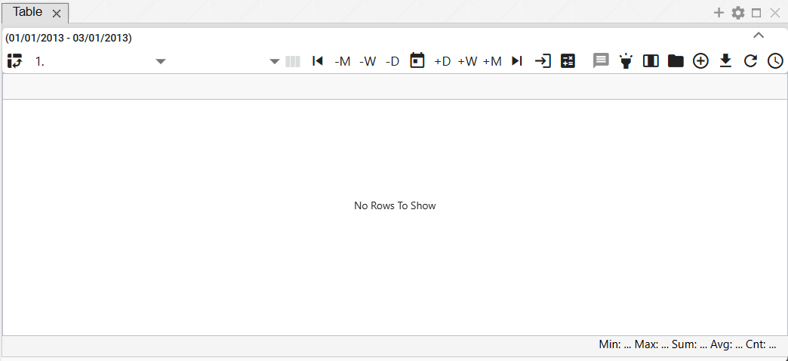

Figure 401: By default, the table window is empty.

1. In the profile tree, click with the left mouse button on the profile you want to display in the table.
2. Move the profile over the table window and release it.

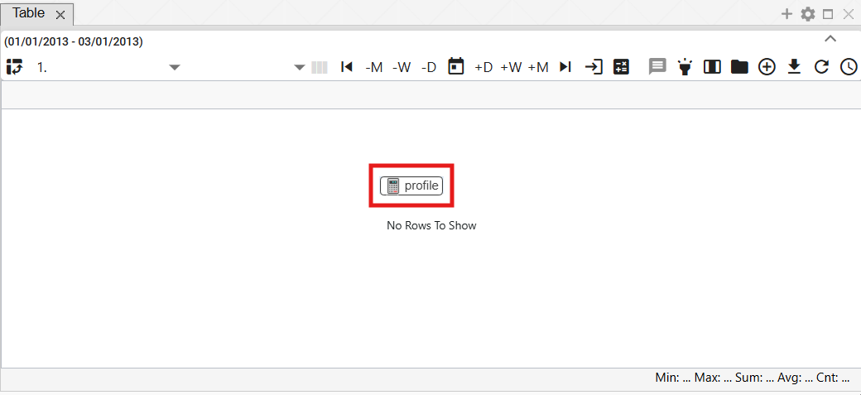

Figure 402: Adding a profile to the table

1. The profile values will be displayed in the table window.

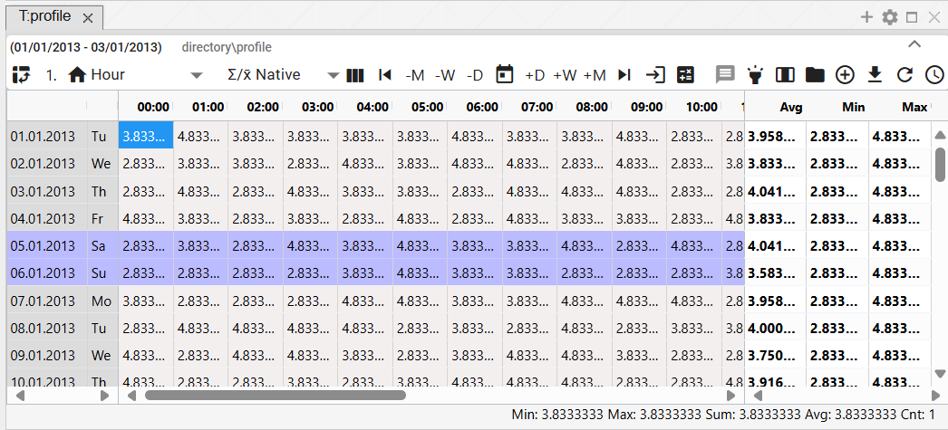

Figure 403: Displaying the profile in the table

## How to set up the column view

By default, the table is set to row view. To set column view, press the "Switch to Column View" button. To return to row view, press the "Switch to Column View" button again.

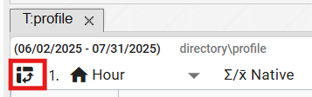

Figure 404: The "Switch to Column View" button

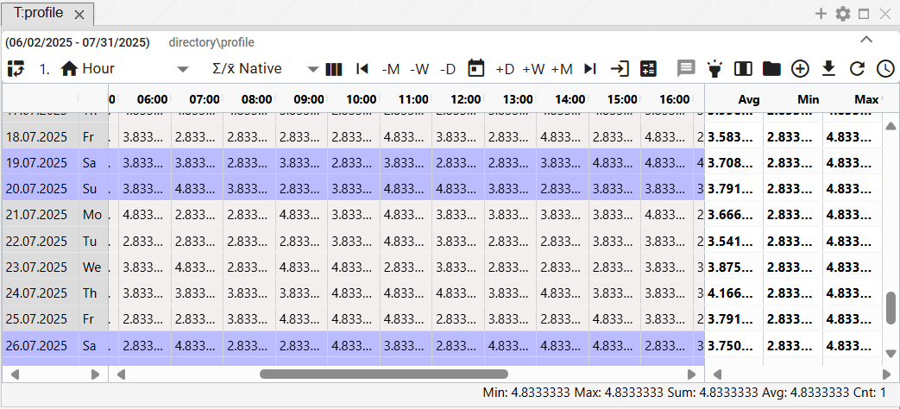

Figure 405: Row View

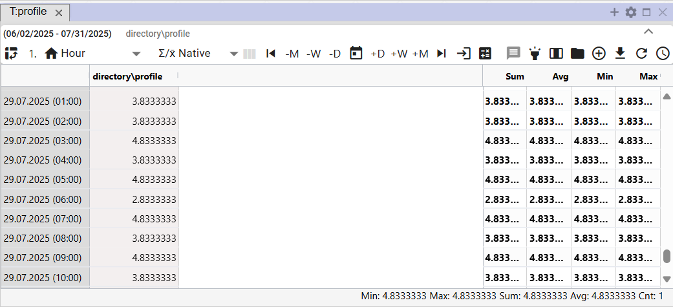

Figure 406: Column View

## How to switch to Single View

By default, the “Table” window is set to Single View, Figure 409. Pressing the button shown in Figure 407 switches the table to Multi View, Figure 410. Switching to Multi View changes the appearance of the button in Figure 407 to the button – Figure 408, which is used to switch the table back to Single View.



Figure 407: "Switch to Multi View" Button



Figure 408: "Switch to Single View" Button

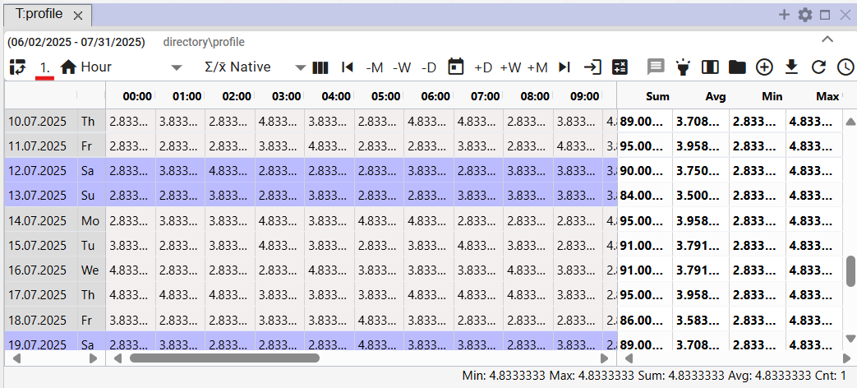

Figure 409: Single View

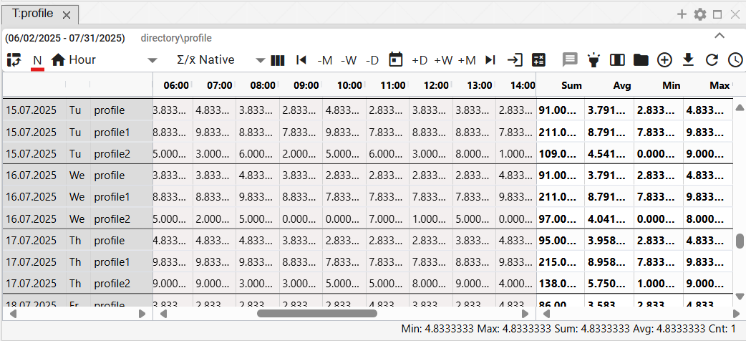

Figure 410: Multi-profile View

## How to change the time display format

Data is displayed in the table by default in the same period as the profile from which the data is displayed, always one day per row. This means that for an hourly profile, 24 columns will be displayed, for a 15-minute profile 96 columns will be displayed, for a 1-minute profile 1440 columns will be displayed, and for a 1-second profile 900 columns will be displayed.

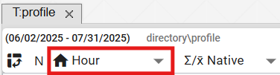

Figure 411: Button for changing the time format

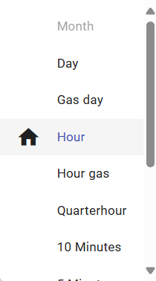

Figure 412: List of time formats in the table

Data can also be viewed in periods:

* Day – daily data overview
* Hour – hourly data overview
* Quarter hour – 15-minute data overview
* 10 Minutes – 10-minute data overview
* 5 Minutes – 5-minute data overview
* 3 Minutes – 3-minute data overview
* 1 Minute – 1-minute data overview
* 1 Second – 1-second data overview
* Unknown – displayed if the table does not recognize the profile period. In this case, the profile values will be pulled into a single column, and the time column will be populated based on the data.

## How to set the number of columns

In the Table window, you can set the number of columns to display. Proceed as follows:

1. Click the "Number of Columns" button, located at the top of the Table window.

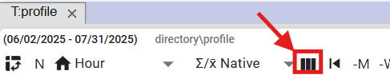

Figure 413: "Number of Columns" button

1. The "Number of Columns Settings" window will appear.

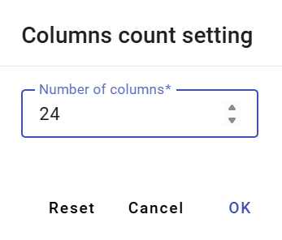

Figure 414: "Number of Columns Settings" window

1. Enter the number of columns to display.

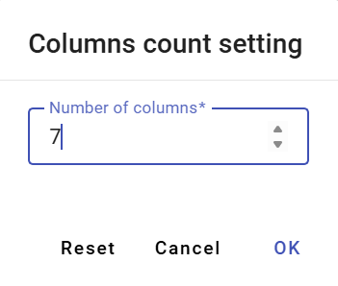

Figure 415: Modified Number of Columns

1. The number of columns will be modified. The set number of columns will be displayed above the "Number of Columns" button.

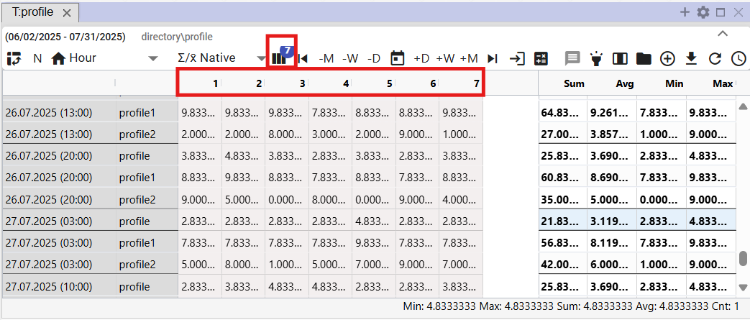

Figure 416: Set Number of Columns

1. To restore the number of columns, press the "Number of Columns" button and press the "Cancel" button in the "Set Number of Columns" window.
2. Subsequently, the original number of columns will be restored.

## How to select the resampling method

The resampling method determines how the profile will be resampled when displayed in periods other than its "natural" period.

With the "Quantity" resampling method, the underlying profile will be treated as a quantity (e.g., energy) and when displayed in smaller periods, the profile value will be divided by the corresponding ratio. In the case of the "Piebe's" resampling method, the underlying profile will be treated as a waveform (e.g., temperature) and when resampling to lower periods, the profile value will remain at the same level.

The "Native" method means that the profile's inherent characteristic is selected for the given profile. This means that a waveform characteristic is used for a waveform profile and a quantity characteristic is used for a quantity profile. This choice is especially important when displaying multiple profiles with different characteristics. In that case, each profile is displayed according to its definition.

This setting only affects the display of the profile in the table. The change does not affect the behavior of the underlying profile in the system, nor the behavior of profiles dependent on it.

You select the resampling method by pressing the "Resampling Method" button and choosing from the window that appears, Figure 418.

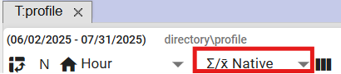

Figure 417: "Resampling Method" button

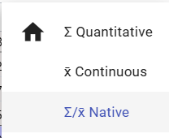

Figure 418: Resampling Method Selection

## How to display the first value

The "Go to First Value" button is used to display the first measured value of the profile.

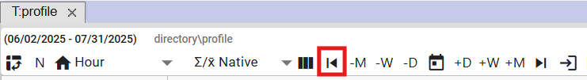

Figure 419: "Go to First Value" Button

## How to display the last value

The "Go to Last Value" button is used to display the last measured value of the profile.

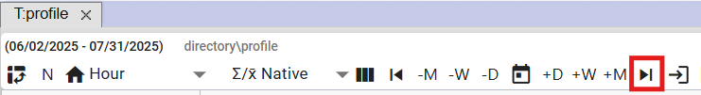

Figure 420: "Go to Last Value" Button

## How to display the current day

To display the current day, press the "Go to Current Day" button. The cell in the table representing the current date and current time will be highlighted.

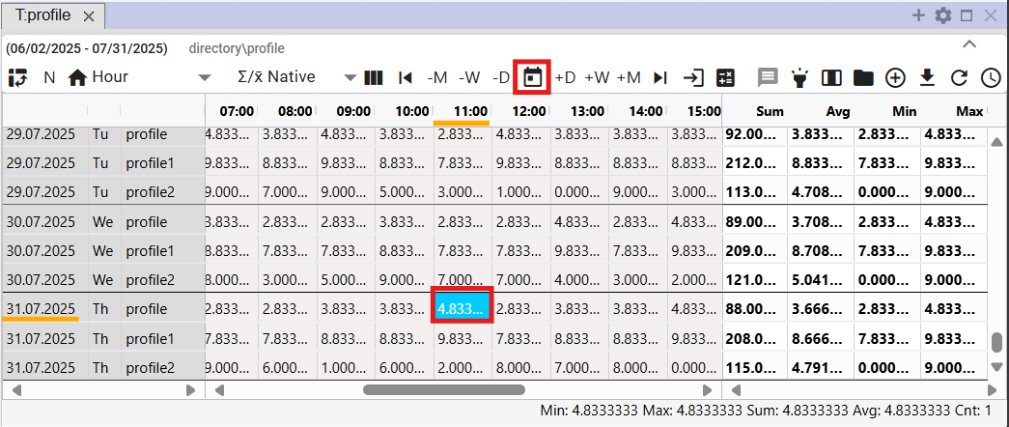

Figure 421: "Go to Current Date" Item

## How to display a specific date

You display a specific date in the table:

1. Press the "Go to Specific Date" button.

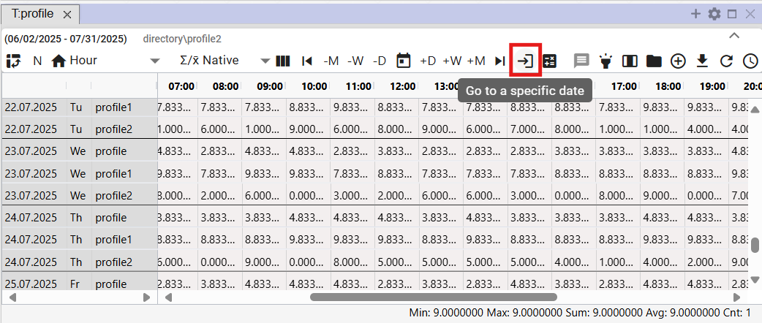

Figure 422: "Go to Specific Date" button

1. Select a date.

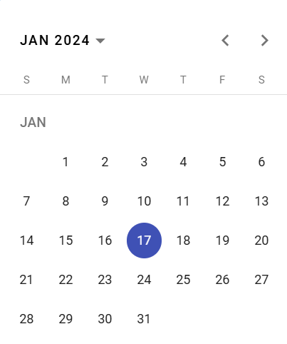

Figure 423: Date Entry

1. The selected date is displayed and the first cell in the selected date is highlighted in blue.

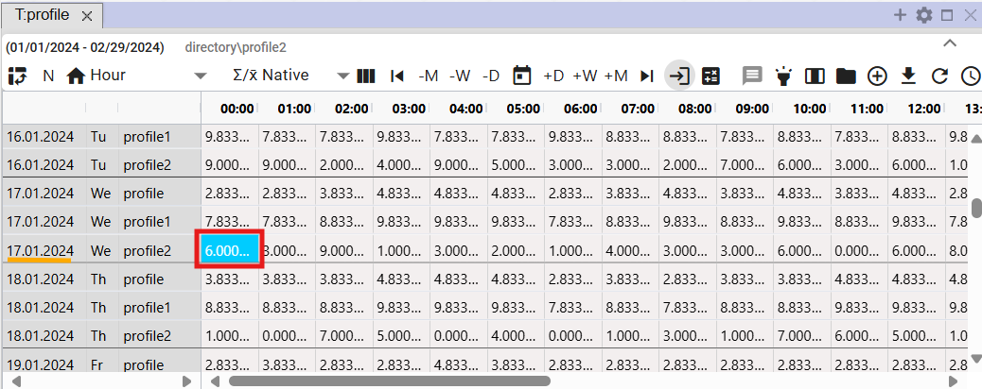

Figure 424: Display of Selected Date

## How to move the date by day, week, or month

You can move the date range for which data is displayed in the table using the buttons:

* "-M" - subtracts one month from the selected date.
* "-W" - subtracts one week from the selected date.
* "-D" - subtracts one day from the selected date.
* "+M" - adds one month to the selected date.
* "+W" - adds one week to the selected date.
* "+D" - adds one day to the selected date.

Proceed:

1. Click on the cell representing the date from which you want to add or subtract the selected date range. The cell is highlighted in blue.
2. Click on the selected button to shift the date.
3. The date display in the table will shift by the selected date range.

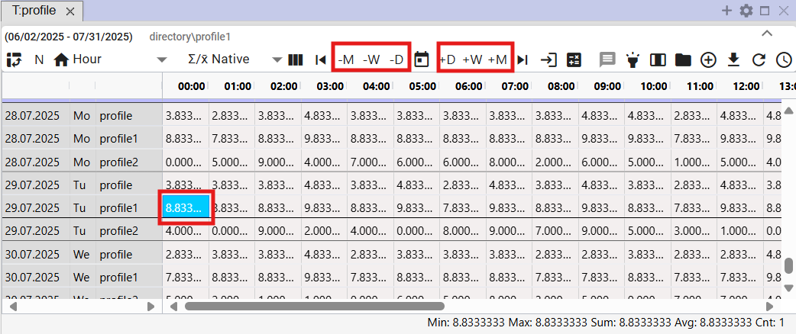

Figure 425: Buttons for shifting the date by day, week, month

## How to add a Sum, Average, Min, Max column

You can add columns:

* Sum – toggles daily sum calculation on/off in the table. A "Sum" column will be added to the table.
* Average – toggles daily average calculation on/off in the table. An "Average" column will be added to the table.
* Min – toggles display of the minimum value from the values for a given day on/off. A "Min" column will be added to the table.
* Max – toggles display of the maximum value from the values for a given day on/off. A "Max" column will be added to the table.

By default, the table does not contain Sum, Average, Min, and Max columns. To add them, proceed as follows:

1. Click the “Row Statistics” button at the top of the table window.
2. A window will appear, allowing you to select which columns to display.
3. You can pin columns to the right side of the table by checking the “Pinned to Right” box. If you do not select “Pinned to Right”, the Sum, Average, Min, and Max columns will be added to the end of the table. If you select the box, the selected columns will be pinned to the right side of the table.

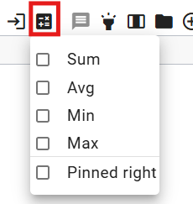

Figure 426: “Row Statistics” button

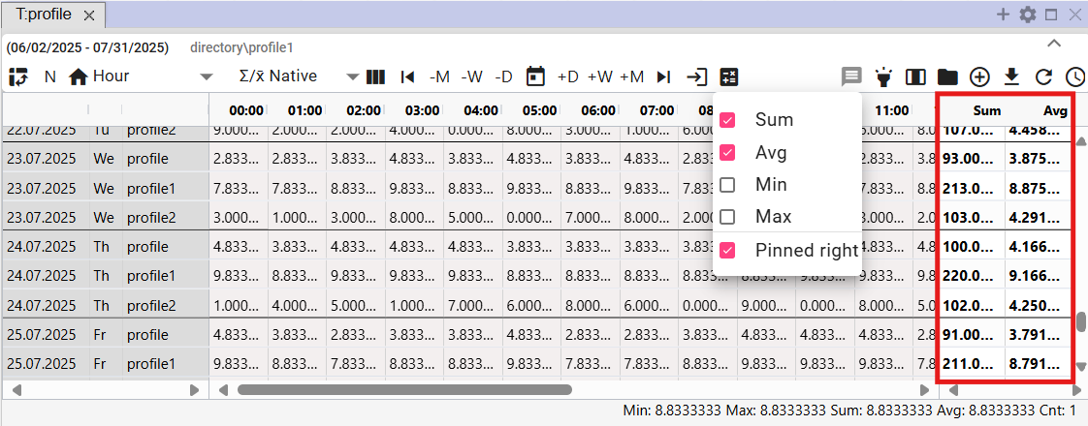

Figure 427: “Sum” and “Average” Pinned Columns

## How to turn tooltips on/off

By default, the tooltip display in the table is disabled. You can enable the tooltip by clicking the “Toggle Tooltip” button, which is located in the upper right corner of the Table window. To display values (tooltip) for a specific location in the table, hover over the selected location. To hide the tooltip, click the “Toggle Tooltip” button again.

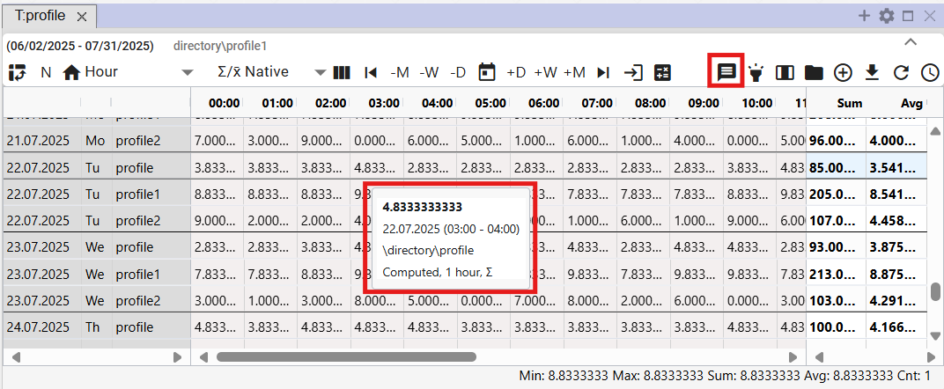

Figure 428: Tooltip Displayed in the Table

## How to turn row highlighting on/off

Row highlighting means that the row will be highlighted when you hover over it with the mouse cursor. If the “Toggle Row Highlighting” button is black, highlighting is enabled. The button is off when it is gray.

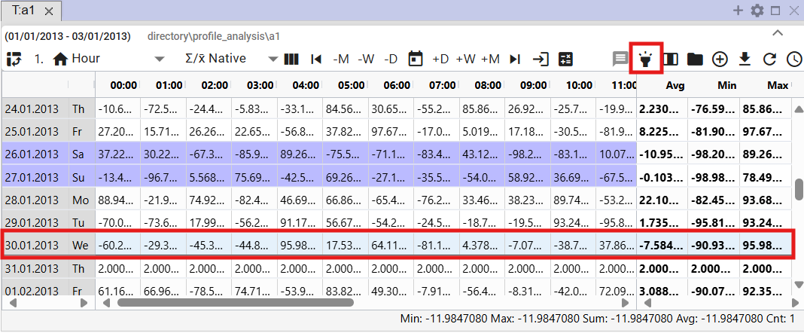

Figure 429: “Toggle Row Highlighting” Button and Highlighted Row

## How to edit a profile value in the table

You can edit the values of the saved profile in the Table window. The calculated profile cannot be edited.

Proceed:

1. Click to select a cell in the Table window.

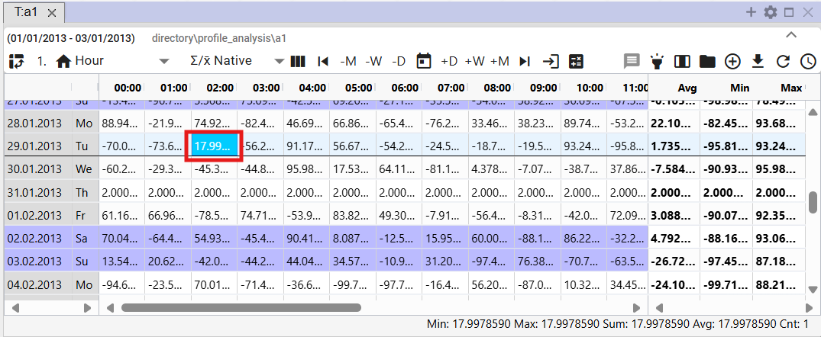

Figure 430: Cell Selection

1. Double-click the cell and enter a value.

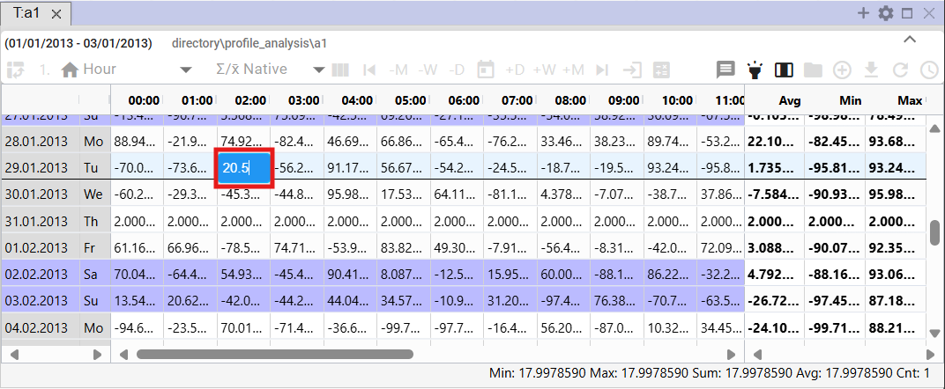

Figure 431: Entering a Value

1. After modifying the value, click into another cell in the table. The button with the floppy disk icon will become active.

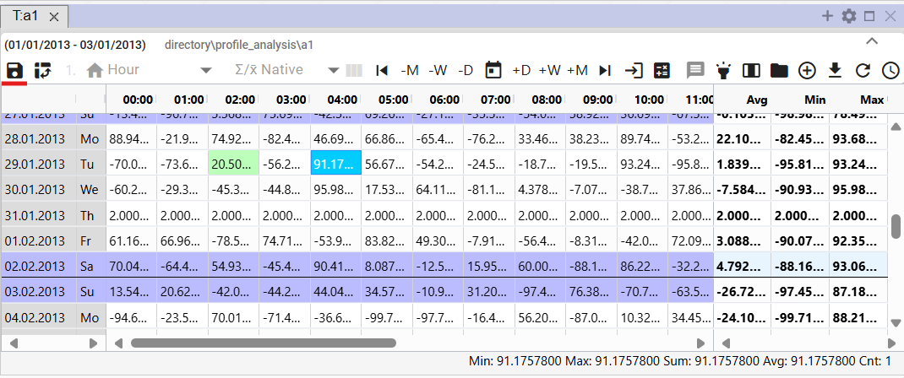

Figure 432: Modified Value in the Table

1. Save changes by clicking the "Save Modified Values" button, which is located at the top of the Table window.



Figure 433: "Save Modified Values" Button

## How to change a profile definition

You can modify the definition of the calculated profile in the Table window. Proceed as follows:

1. Right-click on the profile in the Table window.
2. A window will appear where you select the “Edit Definition” item.

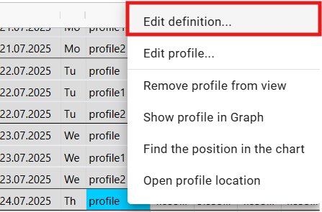

Figure 434: “Edit Definition” item

1. A window will appear where you select the “Change Profile Definition” item.

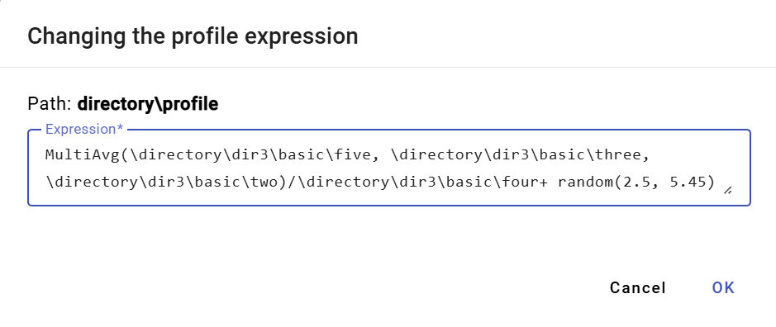

Figure 435: “Change Profile Definitions” window

1. Edit the definition and confirm by clicking the “OK” button.

## How to remove a profile from the table

To remove a profile, proceed as follows:

1. Right-click on the row of the profile you want to delete.
2. A window will appear where you select "Remove profile from view".

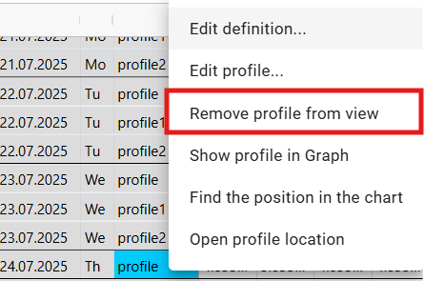

Figure 436: Remove profile from view

1. The profile will be removed from the "Table" window.

## How to enable automatic column width adjustment

By default, cells in the "Table" window have a fixed width. Using the "Automatic Column Width Adjustment" button, Figure 437, you can adjust the width to show the entire cell content, Figure 438.

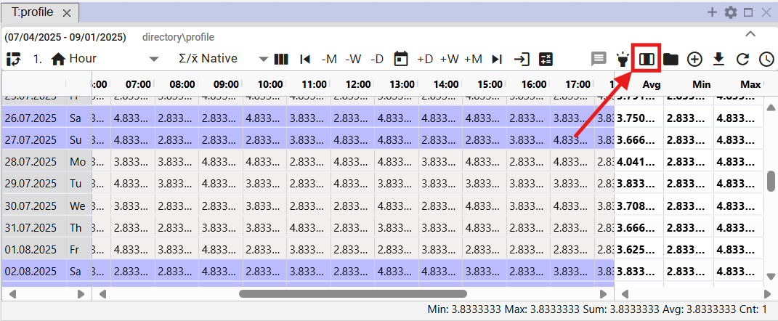

Figure 437: "Automatic Column Width Adjustment" Button

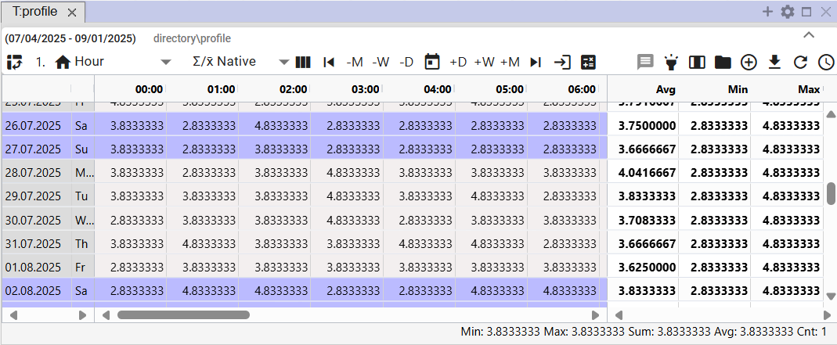

Figure 438: Automatic Column Width Adjustment Enabled

## How to open the profile location

The "Open Profile Location" Button, Figure 439, is used to open the profile from the Table window in tree structure, Figure 440.

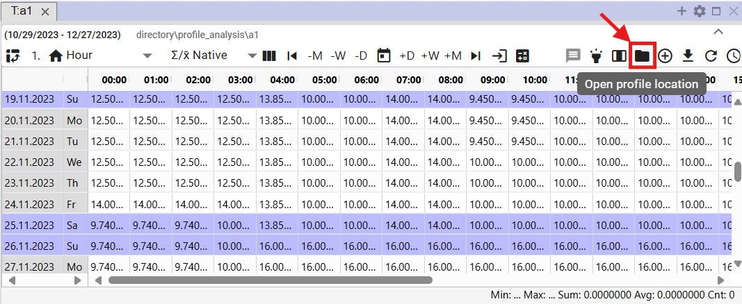

Figure 439: The "Open Profile Location" Button

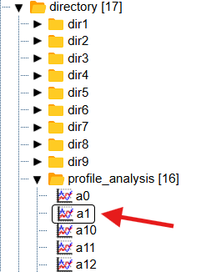

Figure 440: Opening the profile in tree structure

## How to add a profile

To add a profile to the "Table" window, proceed as follows:

1. Click the "Add Profile" button, which is located in the upper-right corner of the "Table" window.

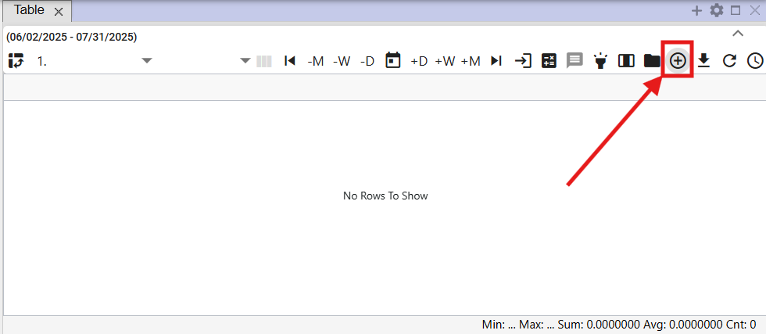

Figure 441: “Add Profile” Button

1. The "Add Profile" window will appear, where you enter the path to the profile in the tree structure or click the button to display the "Profile Selection" window.

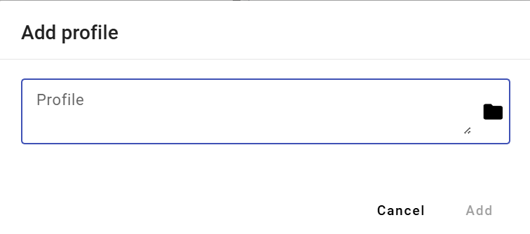

Figure 442: “Add Profile” Window

1. In the "Profile Selection" window, find the profile and click the "Select" button.

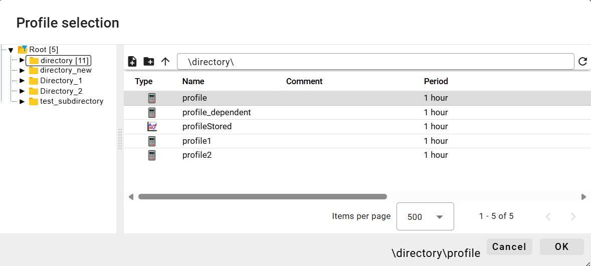

Figure 443: “Profile Selection” Window

1. The path to the profile is displayed in the “Add Profile” window.

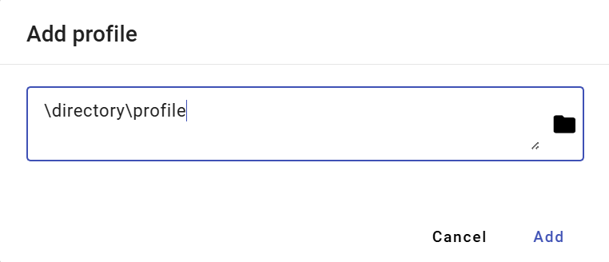

Figure 444: Entered Path to Profile

1. Confirm by clicking the "Add" button.
2. The added profile is displayed in the “Table” window.

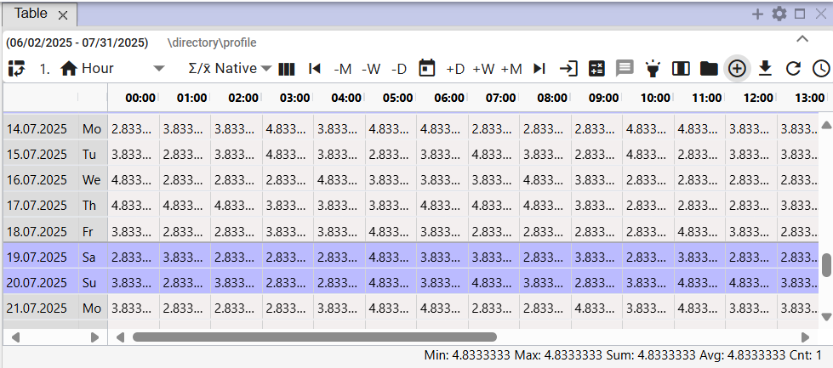

Figure 445: Added profile in the “Table” window

1. If a profile is displayed in the table and you add another profile, multiprofile view is automatically enabled.

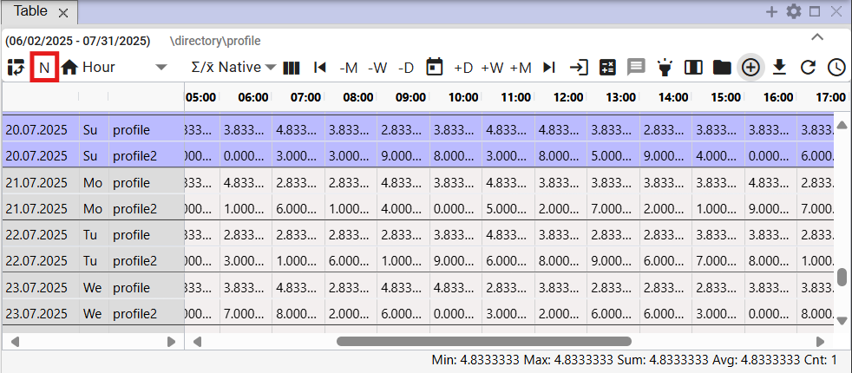

Figure 446: Multiprofile view

## How to export displayed data to CSV

You can download the data displayed in the “Table” window by clicking the “Export displayed data to CSV” button. A file will then be downloaded, Figure 448.

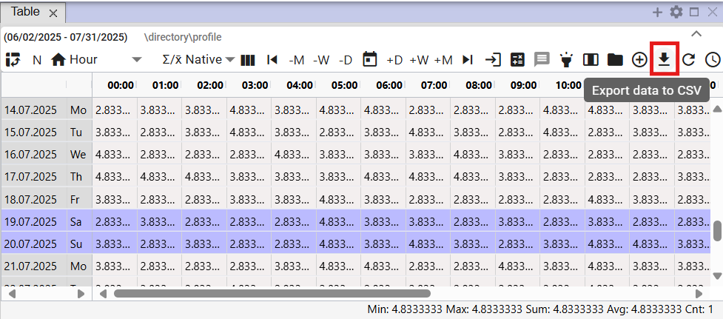

Figure 447: “Export displayed data to CSV” button



Figure 448: Downloaded export

## How to change the definition

You can edit the definition for the calculated profile:

1. Right-click any cell in the table.
2. A menu will appear, in which select “Change definition”.

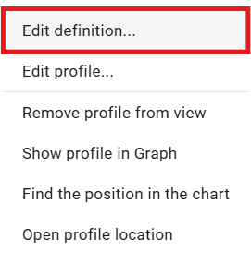

Figure 449: “Change definition” item

1. A window “Change profile expression” will appear, in which you can edit the definition of the calculated profile.

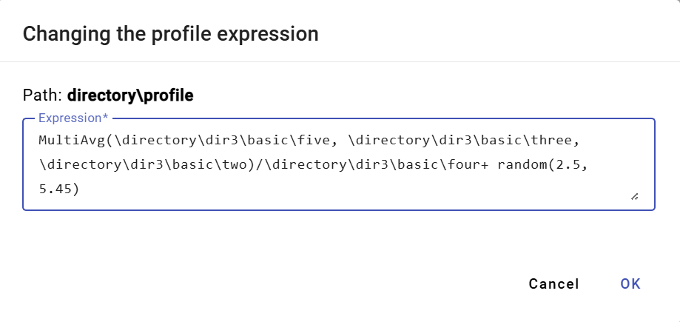

Figure 450: “Change profile expression” window

1. You save the changes by pressing the “OK” button.

## How to change profile metadata

Proceed:

1. Right-click on a cell in the table.
2. A menu will appear, in which click on "Edit Profile".

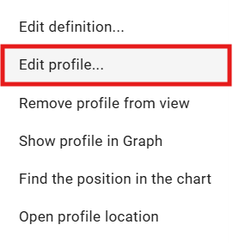

Figure 451: "Edit Profile" item

1. A window "Edit Profile" will appear.

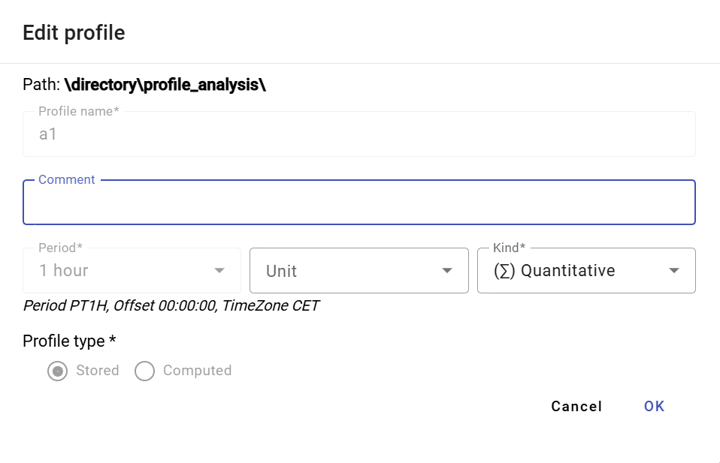

Figure 452: "Edit Profile" window for the saved profile

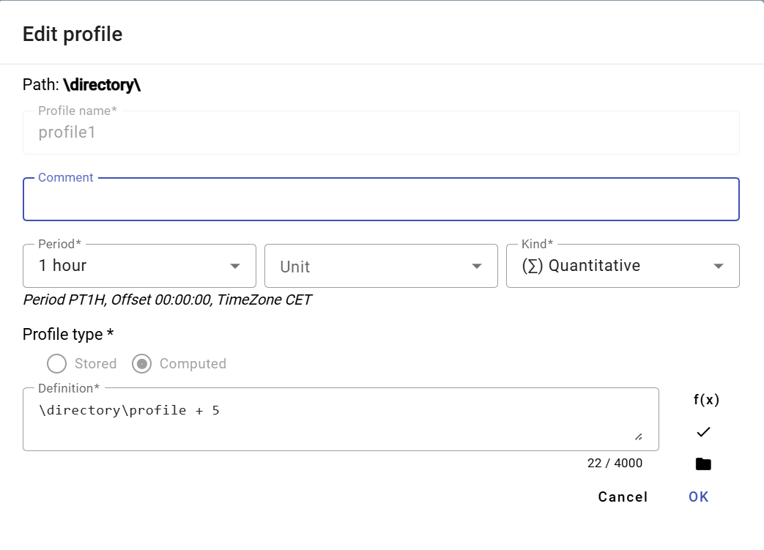

Figure 453: "Edit Profile" window for the calculated profile

1. For the saved profile, you can edit the fields: Comment, Unit, and Character. For the calculated profile, you can also edit the "Definition" field.
2. You save the changes by pressing the "OK" button.

## How to remove a profile from view

To remove a profile from the table:

1. Right-click on any cell in the table.
2. A menu will appear, in which select "Remove profile from view".

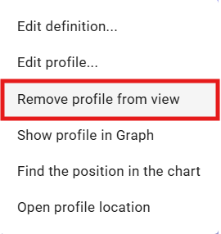

Figure 454: "Remove profile from view" item

1. The profile will be removed from the table.

## How to display a profile in the graph

To display a profile in the graph, proceed as follows:

1. Click on the header of the window where you want to display the graph. This will activate the window. If the active window is the table, the graph will be displayed in the table window.

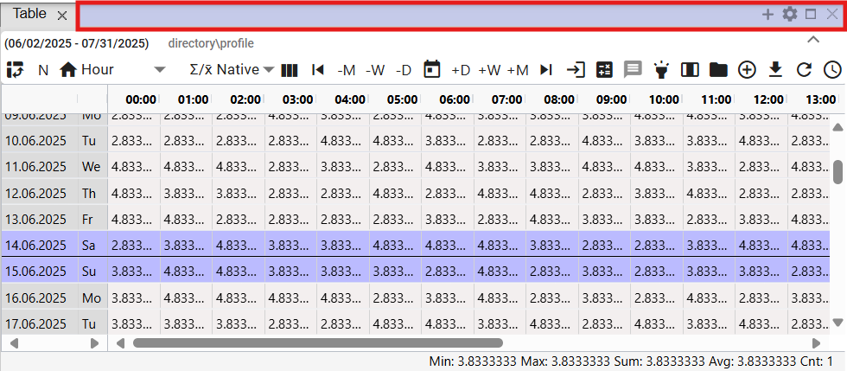

Figure 455: Active Window

1. Right-click on any cell in the table.
2. A menu will appear, from which select the "Display profile in graph" item.

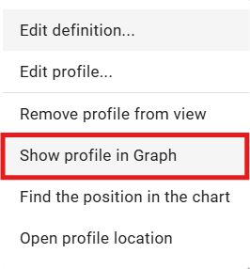

Figure 456: "Display profile in graph" item

1. A new tab will be added to the active window showing the graph.

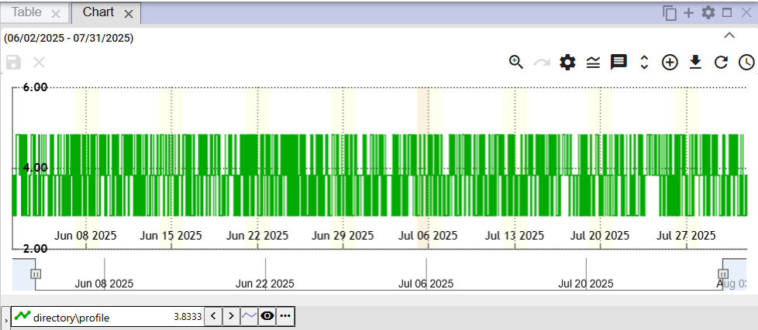

Figure 457: Display profile from table in graph

## How to find a position in the graph

Proceed:

1. Display the profile in the table and in the graph.
2. Right-click on the cell in the table/location you want to display in the graph.
3. A menu will appear; select the "Find Position in Graph" item.

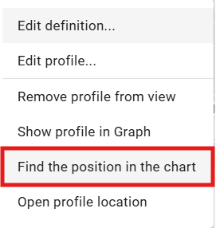

Figure 458: "Find Position in Graph" item

1. The location representing the cell from the table will be displayed in the graph. The graph will scroll so that the selected location is in the center of the graph. A line will be displayed in the center of the graph for one second.

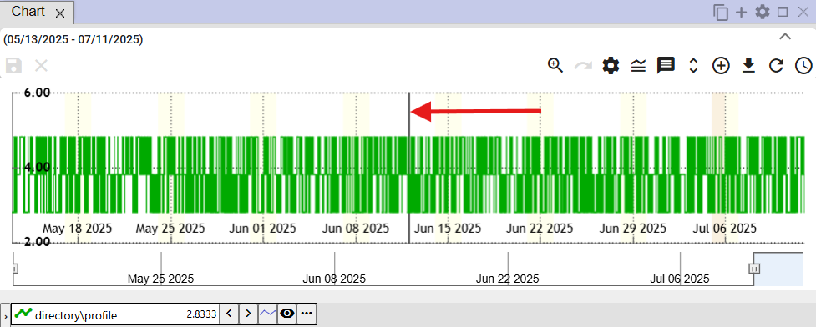

Figure 459: A line representing the selected cell from the table will be displayed in the center of the graph.

## How to open a profile in the tree

To open a profile in the tree:

1. Right-click on any cell in the table window.
2. A menu will open, in which select the item “Open in tree”.

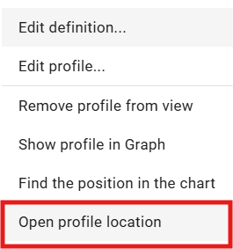

Figure 460: Item “Open in tree”

1. A directory will open in the tree view, containing the profile displayed in the table.

## Select the block using the left mouse button.

To select a block in the table, click the left mouse button on the selected cell in the table, hold down the left mouse button, and select the block.

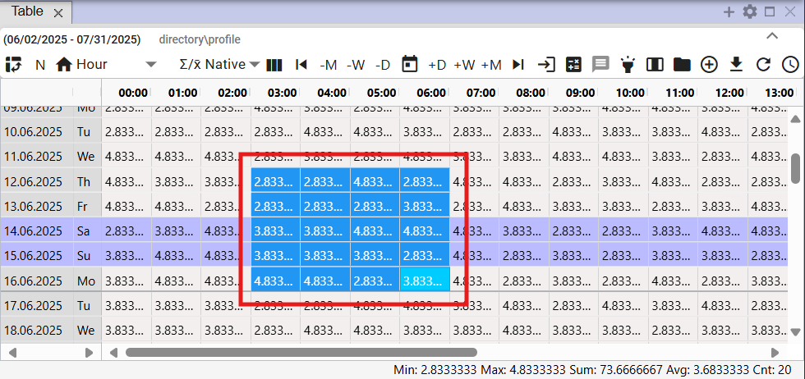

Figure 461: Selecting Cells in the Table

## How to set up scrolling in the table using the mouse wheel.

You can scroll in the table using the mouse cursor. Scrolling is done one day at a time. You can also scroll beyond the set range in the table. An active cell must be set in the table.

Proceed:

1. Press the "Settings" button, located in the top bar of the application.



Figure 462: "Settings" button

1. A "Settings" window will appear.
2. In the "Table" section, check the "Mouse wheel moves cursor" box.

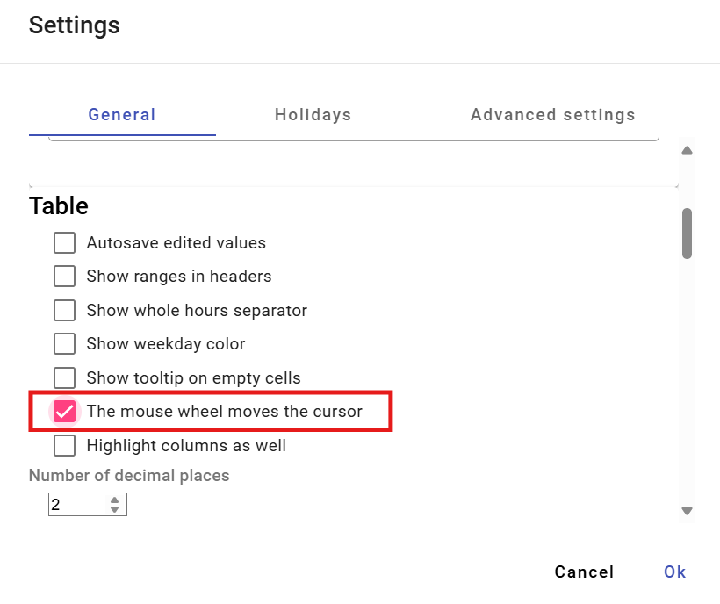

Figure 463: "Mouse wheel moves cursor" item

1. Save by clicking the "OK" button.
2. Next, in the table, move the cursor using the mouse wheel. The cursor is the active cell in the table. This cell is highlighted in blue.

If the "Mouse wheel moves cursor" item is not checked, scrolling with the mouse wheel will move rows in the table.

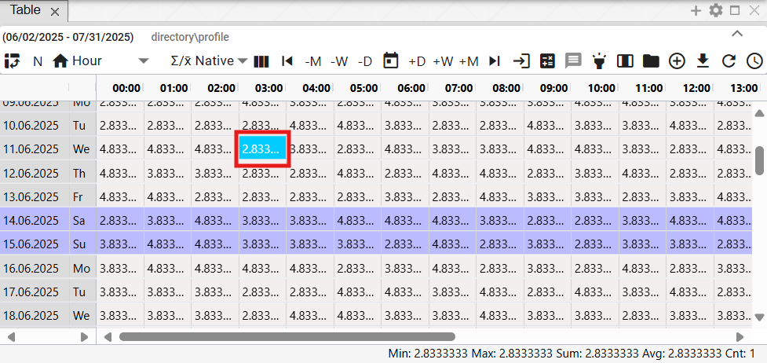

Figure 464: Active cell in the table

## How to change the order of profiles in the table

To change the order of profiles in the table, you need to switch the view to columns. Each profile represents one column. The order of columns can be changed. After changing the order of columns, you can re-enable the row view.

Proceed:

1. Display the desired profiles in the table.
2. Press the "Switch to column view" button.

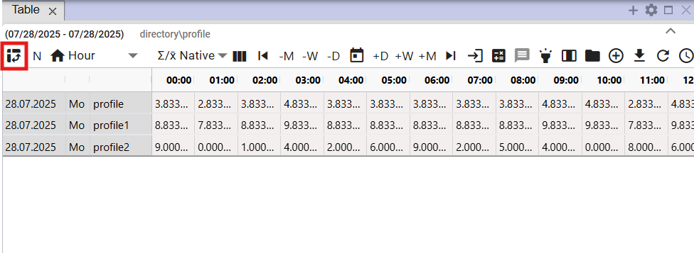

Figure 465: "Switch to column view" button

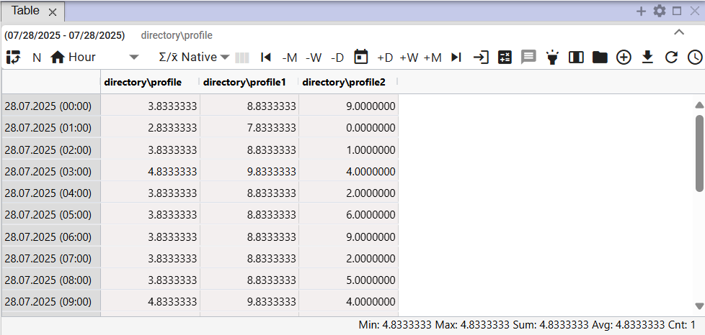

Figure 466: Column view in the table

1. Click and hold the left mouse button on the column header and drag the column to the desired location. Then release the mouse button.

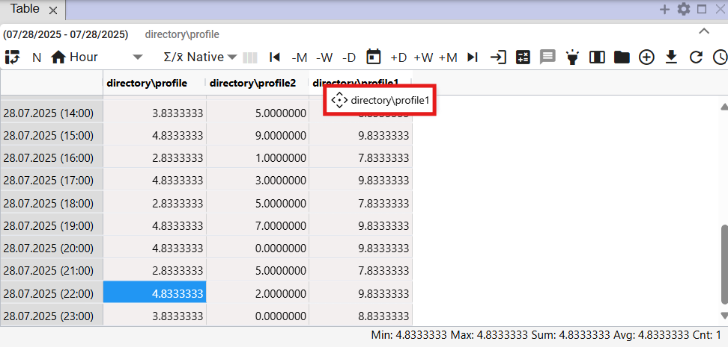

Figure 467: Moving a column

1. After moving the column, you can switch back to row view for profiles.

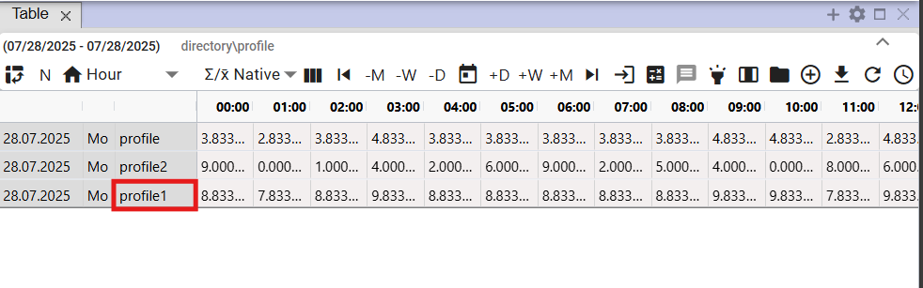

Figure 468: Changed profile order

# Arithmetic of calculated profiles

## Resampling Rules

When performing arithmetic operations with profiles that have different periods, resampling occurs during their calculation. This resampling has its own rules, which mainly depend on the established nature of the profiles entering the operation. The resampling rules are described in more detail in the following text.

### Resampling rules for the input profile to the output profile, taking into account its nature.

Example: Output profile := input profile1 + input profile2 * input profile3 ...

1. If the input profile is inside an aggregation function (avg, sum, min, max, count) or cp(), then its resampling is determined explicitly by its parameter and the following rules are not taken into account.
2. If not, then the input profile is resampled to the sampling of the output profile before applying the arithmetic, according to the following rules:
3. A profile without a character is taken as a continuous profile. This is the default character, and as such it was treated as such even before the introduction of characters.
4. If the periods of the input and output profile are the same, then no resampling takes place and no characters are considered at all. Values are copied 1:1.
   1. If the profiles have different characters and we want to perform a conversion between them, we must do it manually using a formula in the profile arithmetic. The most common conversion is from ¼ power to ¼ energy using input_profile/4.
5. If the periods of the input and output are different, then resampling will take place:
   1. Down-sampling: if resampling from finer to coarser sampling, then:
6. When down-sampling, aggregation using SUM is used.
7. When up-sampling, aggregation using AVG is used.
8. Up-sampling: if resampling from coarser to finer sampling, then:
9. When up-sampling, the input value divided by the ratio of the output and input period is multiplied into the output.
10. During up-sampling, the input value is multiplied (unchanged) by the ratio.
11. During up-sampling, only the character of the input profile is considered. The character of the output is not considered at all.

## Calculated profile

You create the profile according to the following procedure:

1. In the tree structure, right-click on the name of the directory where you want to create a new calculated profile. A window with items will appear; use your mouse cursor to select the “New” item and click to select “Profile”, Figure 469. The “New Profile” window will open, Figure 470.

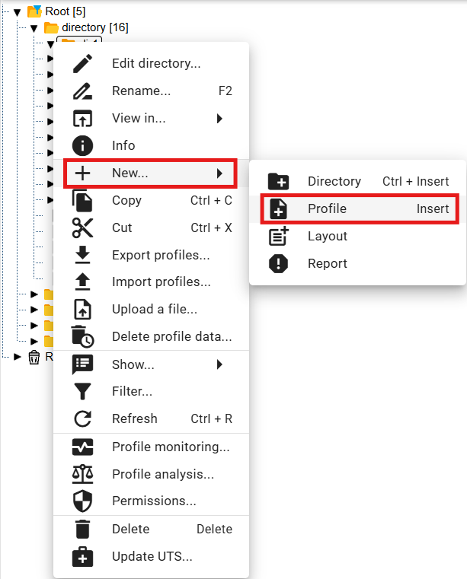

Figure 469: “Profile” item

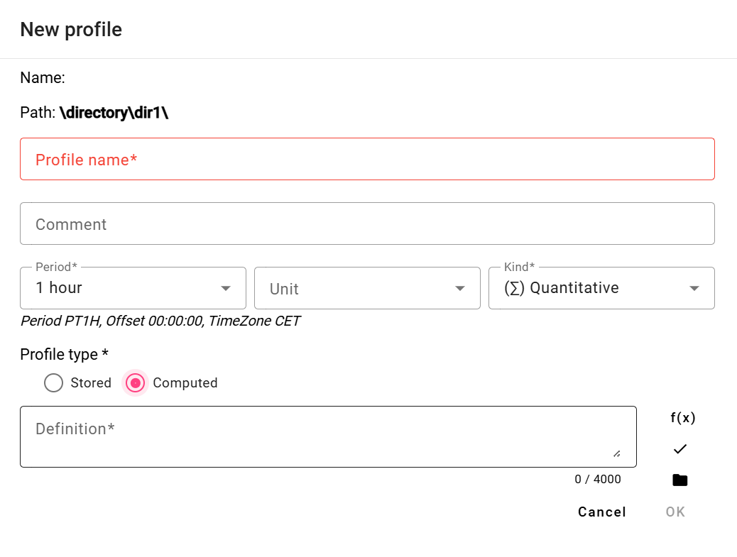

Figure 470: New Profile Window

1. In the “Profile Name” field, enter a name for the profile. The profile name must start with a letter, and can then also contain numbers and the underscore character “_”. The profile name can contain a maximum of 50 characters. A profile is identified by its name, or by specifying the path to the profile and its name (path\profile).
2. You can enter a comment.
3. Select the period, unit, and character.
4. In the “Profile Type” section, select “Calculated”.
5. When defining a calculated profile, we can use the following buttons:
6. if we want to work with standard functions for a calculated profile
7. if we want to use a different saved or calculated profile in the definition. For a calculated profile, we can also use another calculated profile in the definition.
8. You create a profile by pressing the "OK" button.

A profile is identified by its name, or by specifying the path to the profile and its name (path\profile).

* For a calculated profile, you can also use plugin functions in the definition (described later).

Warning

In Xenergie G2 version, creating Oracle profiles is not possible. Depending on the specifics of the particular Xenergie G2 implementation, their backward compatibility may be preserved.

### Expression writing method

We write the definition of the calculated field into the "Definition" window.

The profile name must start with a letter, and can then also contain digits and the underscore character “_”. The profile name can contain a maximum of 22 characters. The profile is identified by its name, or by specifying the path to the profile and its name (path\profile).

Case does not matter when creating definitions.

Examples:

**through**

link to profile via in the main directory

**through**

link to profile via in the directory one level up

**through the oprava directory**

link to profile via 2 levels up in the directory, in the "oprava" subdirectory

**100**

The profile will contain the value 100 for the entire time range.

The number format is [-]nnn.mmm[E[-]eee].

The expression may contain spaces, tabs, and newline characters. These will be ignored.

### Expression evaluation

The expression will be evaluated for the requested time period for each time (hour, minute) separately.

If the profile does not have a value at a calculated time, an invalid value is used.

If any of the values entering the +, -, *, /, >, <, >=, <=, =, <>, |, &, ! operation is invalid, the result is an invalid value.

Division by zero produces an invalid value.

The program always calculates all values, even if they are not necessarily needed, therefore for example alt(100.0, unknown_profile) is not a valid expression.

### Arithmetic operations:

* Addition + ++
* Subtraction - --
* Multiplication * **
* Division / //
* Parentheses ()

Operations are calculated from left to right. Parentheses ( ) have the highest priority, followed by "*", "**", and "/", "//".

Operations "++", "--", "**", "//" replace an invalid value with the value 0.

### Functions

Clicking the button opens a window where you can choose one of the standard functions. Functions are stored in categories:

* Aggregation functions
* Alternatively
* Composition functions
* Conditional
* Obsolete functions
* Other
* Rounding functions
* Character functions

After selecting a category, a list of functions with function help opens.

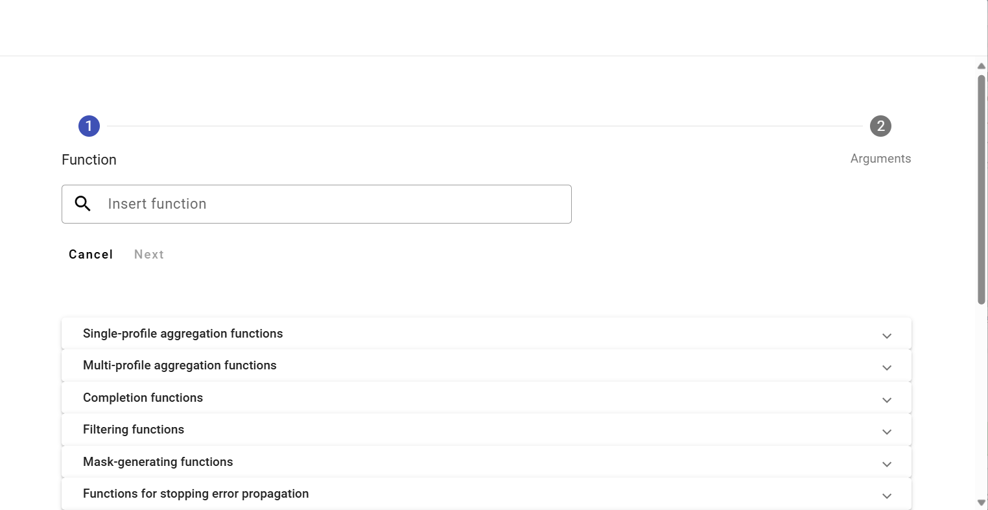

Figure 471: List of functions

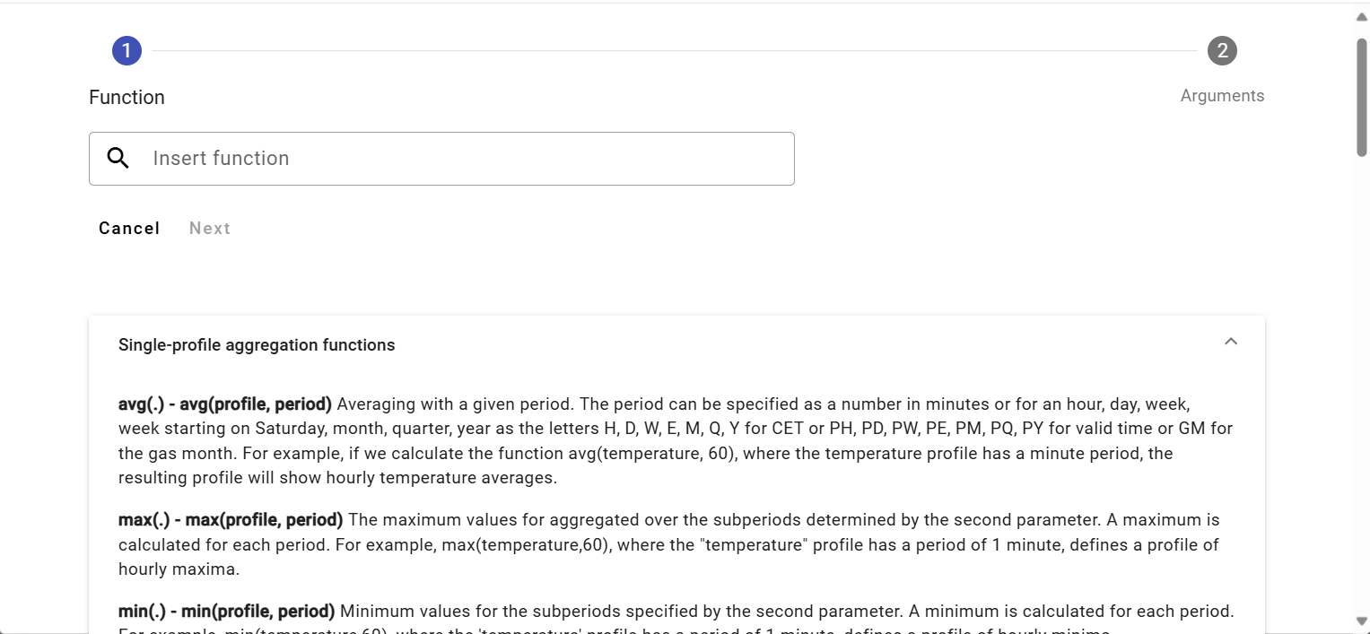

Figure 472: List of functions with function help

#### Aggregate functions

Aggregate functions have two parameters.

1. **profile - profile name,**
2. **period – the period with which the given function is to be calculated. The period is specified by the following constants (for calculating in valid time, constants starting with the letter "P" are used):**

Constants for specifying the period must always be specified in uppercase.

**D, PD – daily period (in CET and in valid time – in summer in CEST)**

**W, PW – weekly period /week starts on Monday and ends on Sunday/**

**E, PE – weekly period /week starts on Saturday and ends on Friday/**

**M, PM – monthly period**

**Q, PQ – quarterly period**

**Y, PY – annual period**

For calculated profiles, we can enter the period in minutes. It does not have to be entered using an abbreviation.

**sum(profile, period)**

Summation with the given period in CET.

(Periods: D, W, E, M, Q, Y, where the period can be entered in minutes for calculated profiles.)

For example, if we calculate the function sum(measurement, M) where the measurement profile has an hourly period, the resulting profile will contain the sum of the measurement profile values for that month in all values within the month.

**avg(profile, period)**

Averaging with the given period in CET

For example, if we calculate the function avg(temperature, 60), where the temperature profile has a minute period, the resulting profile will contain hourly temperature averages.

**min(profile, period)**

Minimum values within the period in CET.

The minimum value is calculated for each period.

**Maximum values within the period in CET.**

Maximum values within the period. The function operates in CET.

The maximum value is calculated for each period.

**csum(profile, period)**

Cumulative summation of profile values over time units defined by the period parameter. The output profile at a given time point provides a value that is the sum of all previous values of the input profile, from the beginning of the time interval (determined by the period parameter) up to the specific time point (inclusive).

For example, if the input profile has an hourly period, then the output profile with the definition “csum(profile_input, PD)” will have, in each day, in its last hour (in valid time), a value equal to the sum for the entire day.

**Average of profile values over time units defined by the period parameter.**

Averaging with a given period in valid time.

**Cumulative sum of profile values over time units defined by the period parameter.**

Summing with a given period. The function operates in valid time.

At each time t, the given period determines the sum of values from the beginning of the period to time t.

**max(profile, period)**

Maximum values within the period in valid time.

**min(profile, period)**

Minimum values within the period in valid time.

**sum(profile, period)**

Summation with the given period in valid time.

(Periods: D, W, E, M, Q, Y, with the period being able to be specified in minutes within the calculated profiles.)

Functions starting with P control the way time is divided into intervals to be aggregated.

P stands for Valid Time, which switches to UTC+1 to UTC+2 in summer.

The functions PSUM, PAVG, PMIN, PMAX are deprecated. (others, such as PHOUR, PDAY, PTDIV, ... are not.)

We recommend using functions without P in their names instead, and using P as a prefix for the time parameter.

Therefore, for example, instead of the expression PAVG(profile, X), we recommend using AVG(profile, PX).

By “deprecated,” we mean that we no longer recommend using these functions when creating new calculations.

These "deprecated" functions remain as they are in the system. However, we will no longer be modifying their behavior.

Functions without the P prefix, which we recommend as replacements, are more versatile and will be gradually expanded with new periods.

Old functions can still be used. However, for creating new formulas, we recommend using the new, more versatile versions.

#### Alternative

**alt(expression1, expression2)**

**alt3(expression1, expression2, expression3)**

**...**

**alt9(expression1, expression2,..., expression9)**

If expression1 does not have a valid value, the calculation continues with expression2, and if that does not have a valid value either, the next expression is used...

**alt(expression1, expression2)**

If expression1 does not have a valid value, expression2 is used.

alt(\Data\DGC2000\cez, 0)

If the “...\cez” profile does not contain a valid value, the function will use the value 0 during processing.

**alt3(expression1, expression2, expression3)**

If expression1 does not contain a valid value, expression2 will be used, and if that does not contain a valid value either, expression3 will be used.

We can sometimes suitably replace alternative functions with:

Example:

alt(supplier1,0)+alt(supplier2,0)

can be replaced

supplier1++supplier2

It adds two profiles, replacing invalid values with 0.

Example:

alt(through,alt(through2,0))

or

alt3(through,through2,0)

An invalid value in the “through” profile will be replaced with the value from the “through2” profile, or, if the “through2” profile also does not contain a valid value, the value 0 will be used. The second variant is, of course, more efficient.

#### Stopping error propagation / suppressing the error

**nv()**

A function that returns an empty (invalid) value. (NO_VALUE). All operations with an invalid value produce an invalid value.

Examples:

*nv()*

*nv() + 100*

The result will be a profile containing invalid values. (Containing no values.)

valid(profile)

If there is an error retrieving the profile values (e.g., it does not exist), the result will be invalid values. If the VALID function is not used and the specified profile does not exist, the program will display an error message (the computed profile definition is invalid) and the expression will not be executed.

Example:

*test*

or

*alt(test,0)*

If the "test" profile is invalid (or does not exist), the program will report an error when entering the following expressions.

If the "test" profile becomes invalid after entering this expression, an error message will be displayed in the info window of the resulting profile.

Example:

valid(test)

The resulting profile will be valid, but it will not contain a valid value.

alt(valid(test),0)

The resulting profile will be valid and will contain values of 0.

#### Simple condition

**cond(logical_expression,expression1,expression_false)**

If the logical_expression is true, expression1 is executed. If it is false or has an invalid value, expression_false is executed.

The logical_expression may contain

* expressions and numerical values
* comparison operators: ">", "<", ">=", "<=", "=", "<>"

logical expressions can be combined using logical operations:

* logical product (and also): &
* logical sum (or): |
* negation: !

The order of evaluation of logical operations is: ! & |, and we can modify it using ().

Example:

cond(cez<0, 0, cez)

All values in profile 'cez' less than 0 will be replaced with the value 0.

Example:

If the value of 'cez' is equal to 'cez', then 1, otherwise 0.

If the 'cez' profile contains a valid value, the result will be 1, otherwise the result will be 0.

Example:

if ((cez < 0) or (cez > 1000)), then nv, otherwise cez

if ((cez >= 0) and (cez <= 1000)), then cez, otherwise nv

The resulting profile in both cases will not contain values less than 0 and greater than 1000. Parentheses are not necessary in these cases.

#### Multiple condition

**cond2(logical_expression1, expression1, logical_expression2, expression2, false_expression)**

**This function allows for multiple conditions.**

**cond9(logical_expression1, expression1,…logical_expression9, expression9,…false_expression)**

If logical_expression1 is true, expression1 is executed, if logical_expression2 is true, expression2 is executed… if no logical_expression is true, false_expression is executed.

Example:

cond(real<zjed*1.02,1,cond(real<zjed*1.05,1.1,1.2))

cond2(real<zjed*1.02,1,real<zjed*1.05,1.1,1.2)

In both cases, if the profile value real is less than 102% of the zjed profile value, it returns a value of 1, if it is greater than 102% and less than 105%, it returns a value of 1.1, otherwise it returns 1.2.

#### Composite functions

*day(selection_days)*

The output is a profile containing ones and zeros. The function writes 1 for those days of the week that are listed in the argument. The function operates in CET. The day of the week is identified by a number in sequence: Sun(1), Mon(2), Tue(3), Wed(4), Thu(5), Fri(6), and Sat(7).

Writing :day(136) creates a 0-1 profile that will have ones in Mon(1), Wed(3), and Sat(6).

***hour(selection_hours)***

The output is a profile containing ones and zeros. The function returns 1 for those hours of the day that are listed in the argument. The function operates in CET.

Writing for a computed profile: hour(1, 5-10, 18, 24) writes a value of 1 for hours 1, 5, 6, 7, 8, 9, 10, 18 and 24.

***month(selection_days)***

The output is a profile containing ones and zeros. The function will write a 1 for those days of the month that are listed in the argument. The function operates in CET.

Writing: month(1, 3, 10 – 13, 30) returns a value of 1 for days 1, 3, 10, 11, 12, 13, and 30.

***day(selection_days)***

The output is a profile containing ones and zeros. The function will return a 1 for those days of the week that are listed in the argument. The function operates in valid time. The day of the week is identified by a number in sequence: Sun(1), Mon(2), Tue(3), Wed(4), Thu(5), Fri(6) and Sat(7).

Writing: pday(136) returns a 0-1 profile that will have ones in Mon(1), Wed(3) and Sat(6)

The function operates in valid time.

***phour(hour_selection)***

The output is a profile containing ones and zeros. The function will write 1 for those hours in the day that are specified in the argument. The function operates in valid time.

Recording: phour(1, 5-10, 18, 24) will return a value of 1 for hours 1, 5, 6, 7, 8, 9, 10, 18 and 24.

The function operates in valid time.

***pmonth(day_selection)***

The output is a profile containing ones and zeros. The function returns 1 for those days in the month that are specified in the argument. The function operates in valid time.

Entry: pmonth(1, 3, 10 – 13, 30) returns the value 1 for days 1, 3, 10, 11, 12, 13, 30.

The function operates in valid time.

*ptdiv(expression0, time1, expression1,...., timeX, expressionX)*

Profile stacking by time. Until time time1, it uses the values of profile expression0, from time1 (inclusive) to time2 it uses the values of profile expression2, ..., from timeX (inclusive) it uses the values of profile expressionX.

Time is entered in the format DD.MM.YY[YY] [HH:MM]. Year can be entered in full format (1990-2030) or abbreviated (00-30, 90-100).

The ptdiv function operates in valid time.

***tdiv(expression0, time1, expression1,...., timeX, expressionX)***

Profile stacking by time. Until time time1, the values of profile expression0 are used, from time1 (inclusive) to time2, the values of profile expression2 are used, ..., from timeX (inclusive) the values of profile expressionX are used.

Time is entered in the format DD.MM.YY[YY] [HH:MM]. The year can be entered in full format (1990-2030), or abbreviated (90-100, 00-30).

The tdiv function operates in CET.

***vdiv(input_expression, expression0, value1, expression1, ... valueX, expressionX)***

Profile stacking based on value. If the input expression is less than value1, it is replaced by expression0. If it is greater than or equal to value1 and less than value2, it is replaced by expression1, ... . If it is greater than or equal to valueX, it is replaced by expressionX.

For a calculated profile, the function assigns the value NO_VALUE to the value NO_VALUE.

#### Rounding functions

The parameter počet_desatinných_miest (number of decimal places) determines the position to which rounding occurs. If this number is positive, rounding occurs to units, tens, etc., and if negative, rounding occurs to tenths, hundredths…

If počet_desatinných_miest (number of decimal places) is 2, the rounding functions will round to the nearest tens.

***round(expression, number_of_decimal_places)***

Mathematical rounding (round from 5 upwards of the absolute value). If the parameter number_of_decimal_places = 0, the number 1.5 rounds to 2. The number -1.5 rounds to -2.

***roundup(expression, number_of_decimal_places)***

Rounding always upwards in absolute value. If the parameter number_of_decimal_places = 0, the number 1.1 rounds to 2. The number -1.1 rounds to -2.

*trunc( (expression, number_of_decimal_places) )*

Truncating the specified number of places. If the parameter number_of_decimal_places = 0, the number 1.1 truncates to 1 and the number -1.1 to -1.

#### Sign functions

***abs(expression)***

Absolute value of each value in the profile.

***minus(expression)***

Values greater than 0 will be replaced with 0.

***plus(expression)***

Values less than 0 will be replaced with 0.

Example:

if(odch<0,-1*odch,odch)

it is the same as abs(odch)

Example:

cond(odch<0, 0, odch)

it is the same as plus(odch)

Example:

cond(odch<0, odch, 0)

it is the same as minus(odch)

# Additional/optional features

Additional/optional features are not included as standard with “Profile Manager” delivery, but are ordered separately.

## Profile Monitoring

This feature is used to monitor profiles. The monitoring job is used to watch over the profiles. It checks, for example, that the value in the profile does not fall below zero, or exceed 100. The following chapters deal with the creation, modification, deletion and export of the monitoring job.

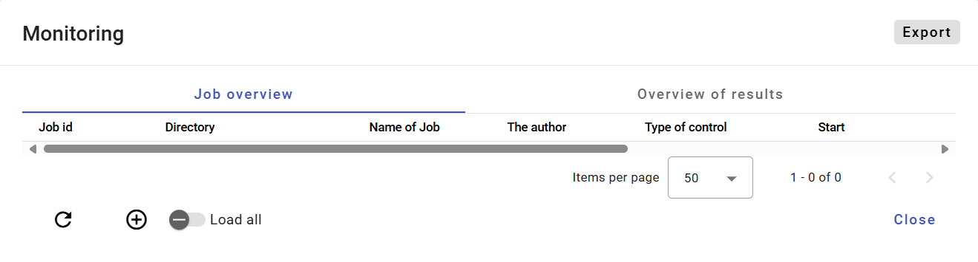

Figure 473: "Monitoring" Window

### How to create a new monitoring job

To create a new monitoring job, proceed as follows:

1. Right-click on the directory in the tree structure.
2. A menu will appear, in which select "Profile Monitoring".

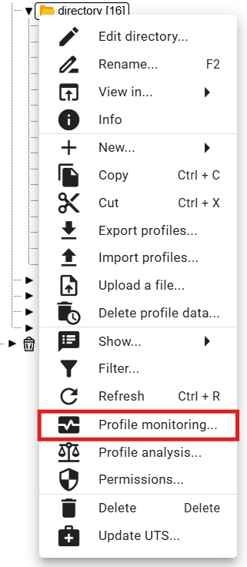

Figure 474: "Profile Monitoring" item

1. A "Monitoring" window will appear.
2. Press the button or right-click on an existing job and select "Create New Job".

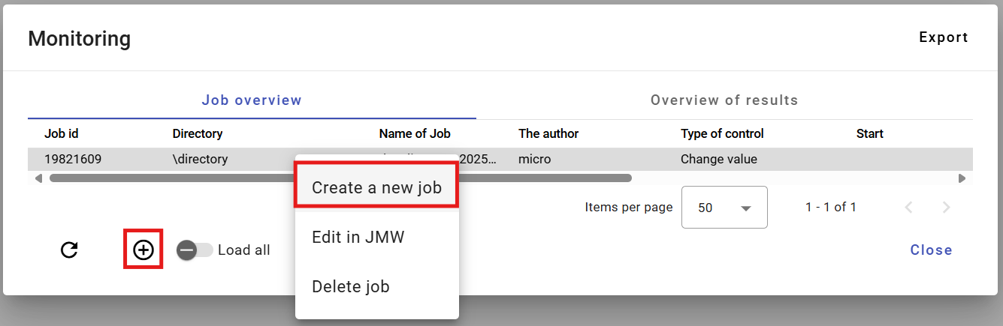

Figure 475: "Create New Job" item

1. A "New Monitoring Job" window will appear. Explanation of fields:

* “Criteria” - criteria according to which the profile is monitored,
* “Value Change” - a criterion checking for a value change in the monitored profile. The profile is monitored at a specified time interval, and if all values within the interval are the same, an error message is displayed. (Profile: “Profile Name” No change in value in interval 27.3.2017 1:00:00 - 27.3.2017 4:00:00,)
* “Monotonic” - a criterion checking for monotonicity of values in the monitored profile within a specified interval. If values violating increasing monotonicity are found within the time period, an error message is displayed. (Profile: “Profile Name” Monotonicity condition of the series is not fullfilled at time point 6.4.2017 11:00:00),
* “Increasing” - a criterion checking for increasing trend. The profile must consistently increase.
* “Maximum Value” - a criterion checking for reaching the maximum value in the monitored profile. If a value exceeding the selected maximum value is found within the values of the selected profile in the specified time interval, an error message is displayed. (Profile: “Profile Name” 1.1.2013 0:00:00 > 14 is larger than allowed max: 8)
* “Minimum Value” - a criterion checking for reaching the minimum value in the monitored profile. It functions analogously to the Maximum Value criterion.
* “Missing Value” - a criterion checking the number of missing values in the monitored profile within a specified interval. If the number of missing values within the specified interval exceeds the “Missing Value” parameter, an error message is displayed. (Profile: “Profile Name” Interval 1.1.2013 0:00:00 - 2.1.2013 0:00:00 contains 3 empty values.),
* “Different Value” - a criterion checking the difference between the maximum and minimum value in the monitored profile within a specified interval. If the difference between the max and min values within the specified interval exceeds the “Different Value” parameter, an error message is displayed. (Profile: “Profile Name” Difference in values was 12),
* “Interval Start (D:H:M:S)” - is the interval for the start of data monitoring in the profile. It relates to the action start time or to the specified absolute time.
* “Interval End (D:H:M:S)” - is the interval for the end of data monitoring. It relates to the action start time or to the specified absolute time,
* “Time Zone” - is the zone in which the server running JMW is located. The zone is taken into account when using the sliding time window, where it is used to determine the local action start time.
* “Alignment” - the Alignment option allows you to align the time window of the monitored profile data to the following time periods:
  + day in valid time
  + hour in valid time

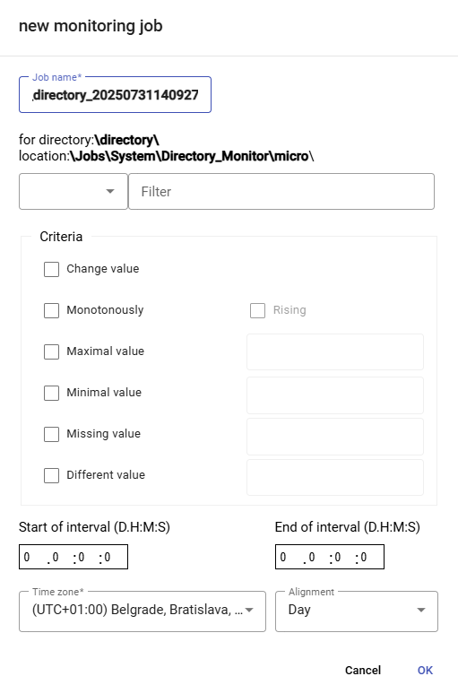

Figure 476: "New Monitoring Job" Window

1. By default, the job name is pre-filled. You can enter a name for the job in the "Job Name" field.
2. Click in the field to the left of the word "Filter" to display a window where you can select the condition for the filter.

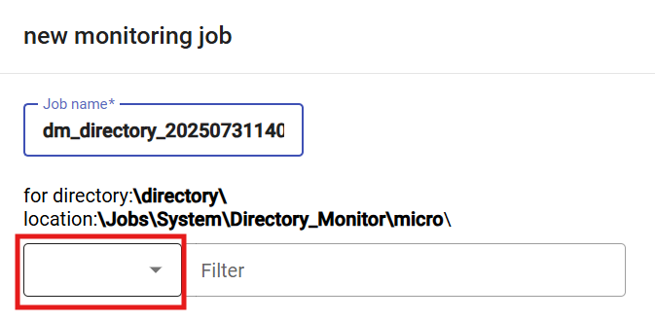

Figure 477: Filter Selection Field

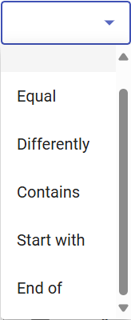

Figure 478: Window for Selecting Filter Condition

1. Click in the "Filter" field and enter a value for the filter. For example: Starts with letter A – this will only display profiles whose name starts with the letter A.

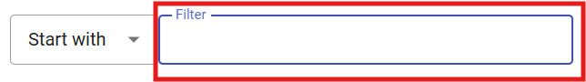

Figure 479: Field for Entering a Value for the Filter

1. In the "Criteria" block, enter the criteria for monitoring.

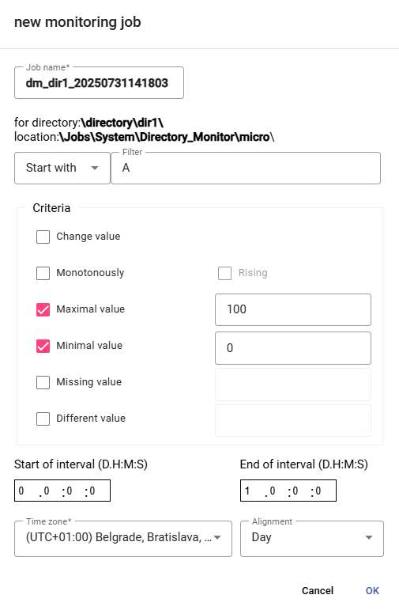

Figure 480: Job Submission

1. Enter the Start and End of the interval.
2. You can select the time zone and alignment.
3. To create a monitoring job, press the "Ok" button.
4. A new monitoring job will be displayed in the "Monitoring" window.

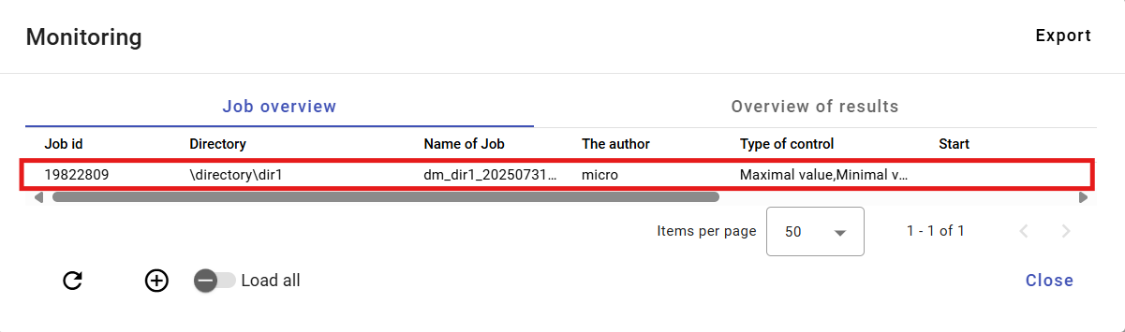

Figure 481: Created monitoring job

### How to edit a job in JMW

To edit a job, proceed as follows:

1. Right-click on the job and select "Edit in JMW".

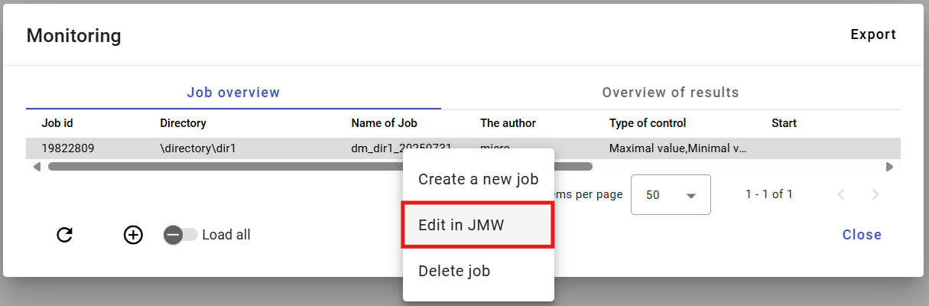

Figure 482: "Edit in JMW" item

1. A new tab will open in the browser, displaying the job in the “Job Manager” application.

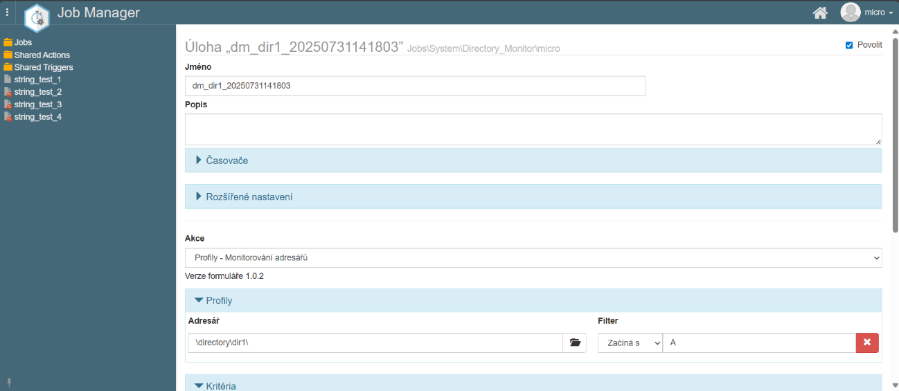

Figure 483: Editing the job in the “Job Manager” application

1. The procedure for editing a job can be found in the documentation for the “Job Manager” application.

### How to delete a job

To delete a job, proceed as follows:

1. Right-click on the job you want to delete in the “Monitoring” window.

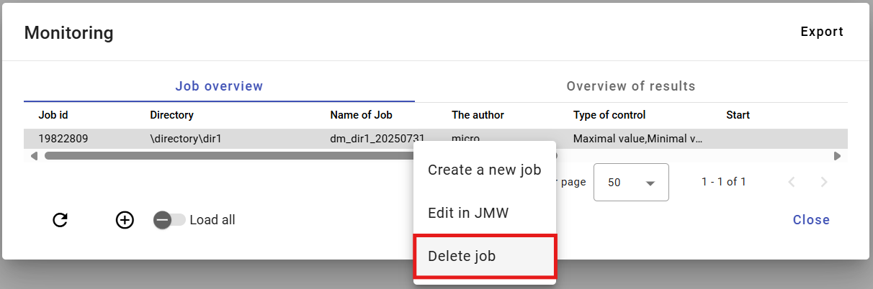

Figure 484: “Delete job” item

1. A confirmation window will appear, in which press the “Yes” button.

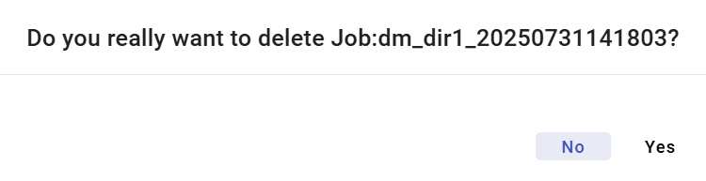

Figure 485: Job deletion confirmation window

### How to export monitoring jobs and job results

To export jobs in the “Job Overview” tab, press the “Export” button, located in the top right corner of the “Monitoring” window. To export job results, display the “Results Overview” tab and press the “Export” button. A CSV file will be downloaded.

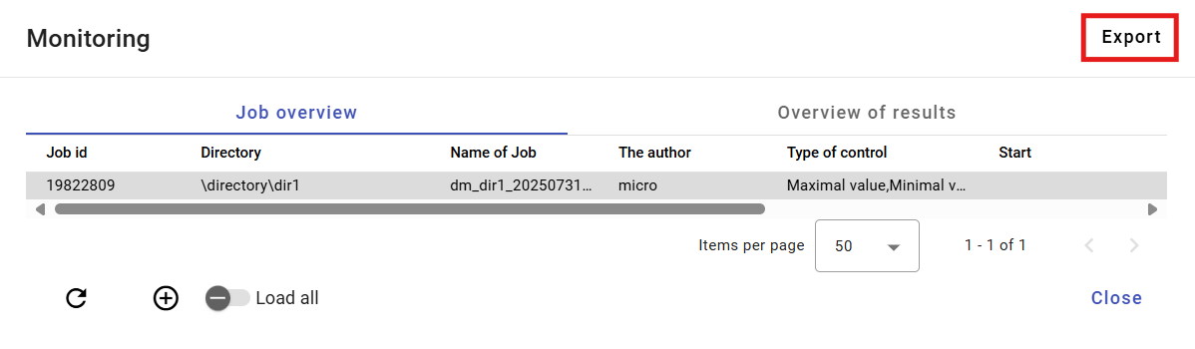

Figure 486: "Export" Button

### How to display all monitoring jobs

To display all monitoring jobs, press the “Load All” button. All monitoring jobs from the tree structure will be displayed in the “Monitoring” window.

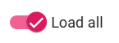

Figure 487: "Load All" Button

### How to refresh the job list in the “Monitoring” window.

To refresh the job list, press the button located in the lower-left corner of the “Monitoring” window.

### How to view the results overview of a monitoring job

In the “Monitoring” window, display the “Results Overview” tab. Here you will find a list of monitoring job runs. If the criteria according to which the profile is monitored were violated, the text “ERR” will be displayed in the “result” column and a description of the error will be found in the “detail” column. If the criteria were met, the result is “OK”.

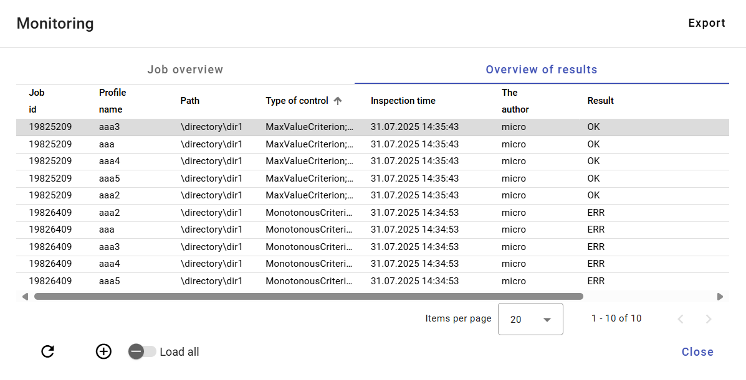

Figure 488: “Results Overview” tab

## Profile Analysis

Profile Analysis represents a static snapshot at a given point in time during the calculation. This means that if someone were to delete a profile, the Profile Analysis would remain preserved. Profile Analysis allows the user to filter and sort data. Creating a Profile Analysis is covered in chapter 8.2.1.

If you close a Profile Analysis, you can reopen it. Opening an existing Profile Analysis is described in chapter 8.2.2.

Profile Analysis is valid for 15 minutes after creation. You can extend the validity. The procedure can be found in chapter 8.2.3.

Exporting the displayed data in a Profile Analysis is covered in chapter 8.2.4.

### How to create a Profile Analysis

To create a Profile Analysis, proceed as follows:

1. In the tree structure, right-click on the directory containing the profiles for which you want to create a Profile Analysis.
2. A window will appear, in which click on the "Profile Analysis" item.

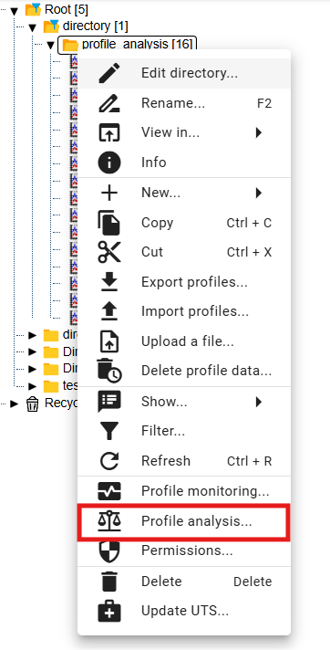

Figure 489: "Profile Analysis" item

1. Another option is to display the directory with profiles in the "Explorer" window and click the "Statistics" button, which is located in the upper-right corner of the "Explorer" window.



Figure 490: "Statistics" button

1. The "Profile Analysis" window will be displayed.
2. By default, the "Create new for period" option is selected.

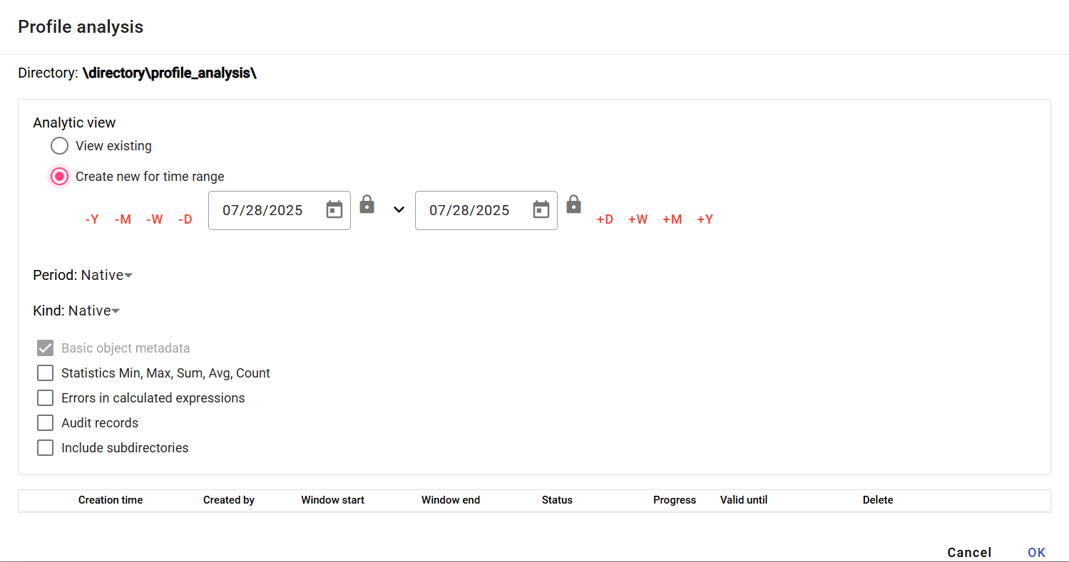

Figure 491: "Profile Analysis" window

1. Set the period for which the profile analysis should be performed. Click the button to display the default date range options.

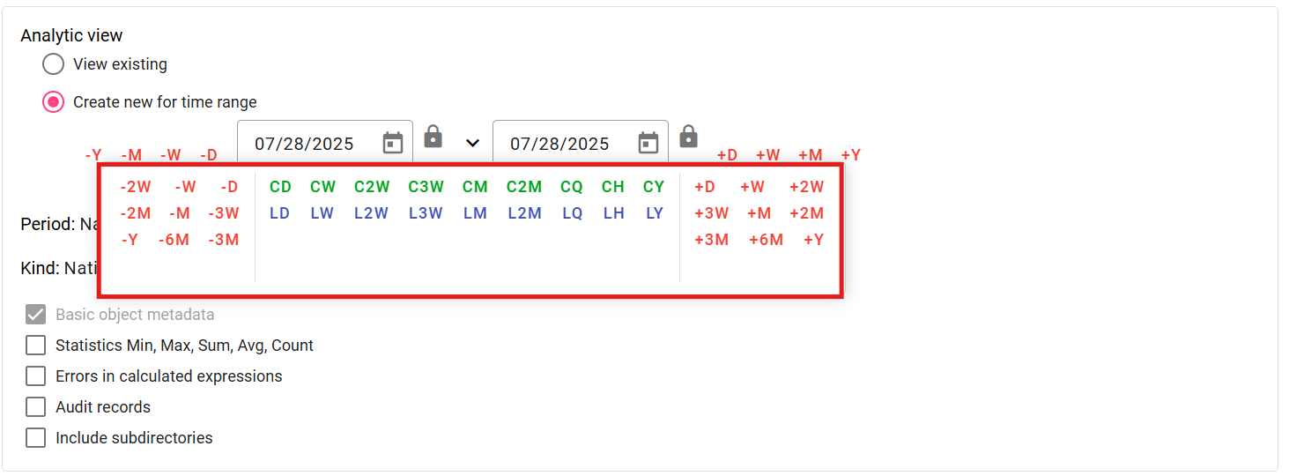

Figure 492: Date Selection

1. By default, the "Period" field contains "Native". To enter a different period, click in the "Period" field and select a period.

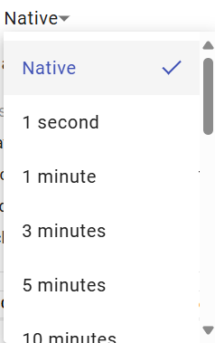

Figure 493: Period Selection

1. The profile character is used to identify how values in the profile should be resampled to finer or coarser sampling. By default, the "Character" field contains "Native". To select a character, click in the "Character" field and select "Quantity" or "Continuous".

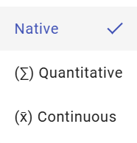

Figure 494: Character Selection

1. To calculate statistics in the analysis, check the "Min, Max, Sum, Avg, Count Statistics" checkbox.

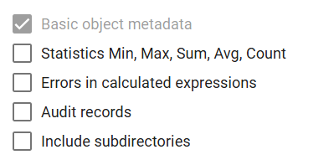

Figure 495: Optional Items in the Analysis

1. To display errors if they occur, check the "Calculated Expression Errors" checkbox.
2. Check the "Audit Records" checkbox if you want to list the following data: First Read, Last Read, First Write, and Last Write.
3. To include subfolders in the analysis, check the "Analyze Subfolders" checkbox.
4. To create the profile analysis, press the "OK" button.
5. A new tab named "A directory name" will be created in the "Explorer" window. Profile analysis represents a static snapshot in time during the calculation.

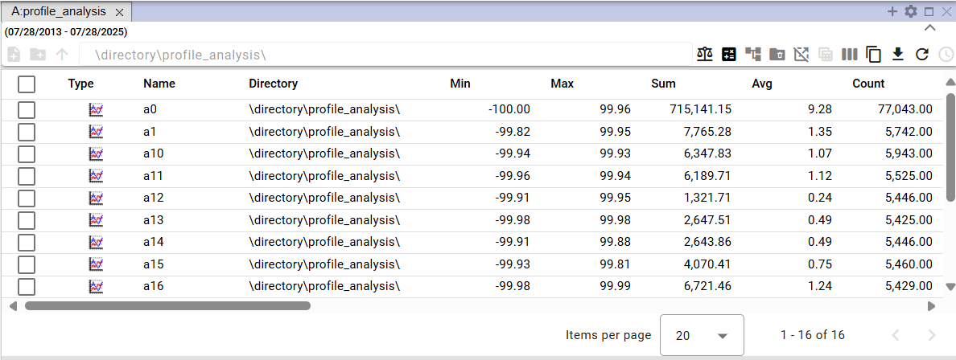

Figure 496: Created profile analysis

1. In the profile analysis window, you can filter the data. Position the mouse cursor on the column name where you want to enter a filter. A button for entering a filter will appear.



Figure 497: Button for entering a filter

1. To sort the data in a column, position the mouse cursor on the column name. An arrow will appear. Click the button with the arrow icon to sort the data in the column.



Figure 498: Button for sorting data in columns

### How to display an existing profile analysis

If you have closed a profile analysis and want to reopen it, you can do so during the validity period of the profile analysis. A profile analysis is valid for 15 minutes after creation. This validity period can be extended.

To open an existing profile analysis, proceed as follows:

1. In the "Profile Analysis" window, click "Show Existing".
2. Click to select the analysis you want to view.

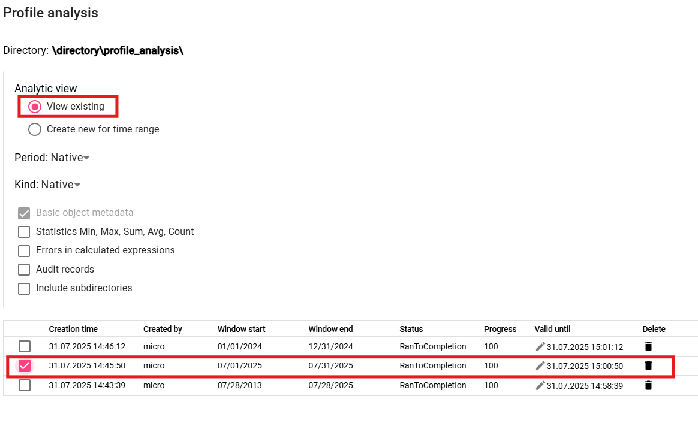

Figure 499: Viewing an Existing Profile Analysis

1. Click the "OK" button.
2. The profile analysis will be displayed in the "Explorer" window.

### How to change the validity of a created profile analysis

The validity of the profile analysis is standardly 15 minutes, but you can extend it.

To extend the validity of the profile analysis, proceed as follows:

1. In the "Profile Analysis" window, in the row of the analysis whose validity you want to extend, click the button with the pencil icon.

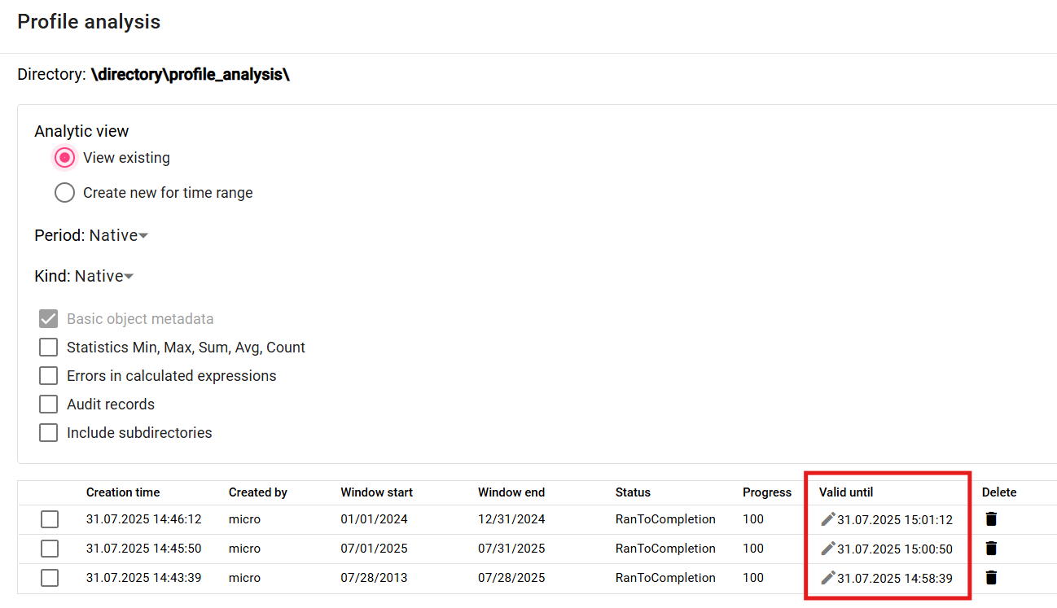

Figure 500: "Valid Until" field

1. The "Valid Until" field will become editable.

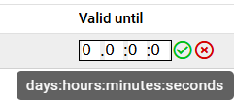

Figure 501: Extending the validity of profile analysis

1. The first field represents days, the second field hours, the third represents minutes, and the fourth field seconds. If you want to extend the validity by 2 days, enter the value "2" in the first field. If you want to extend the validity by 6 hours, enter the value "6" in the second field.
2. Save by pressing the button.
3. The validity of the profile analysis will be extended.

### How to export the displayed data in the profile analysis

To export data in the profile analysis, proceed as follows:

1. Click the button located in the upper right corner of the “Explorer” window.

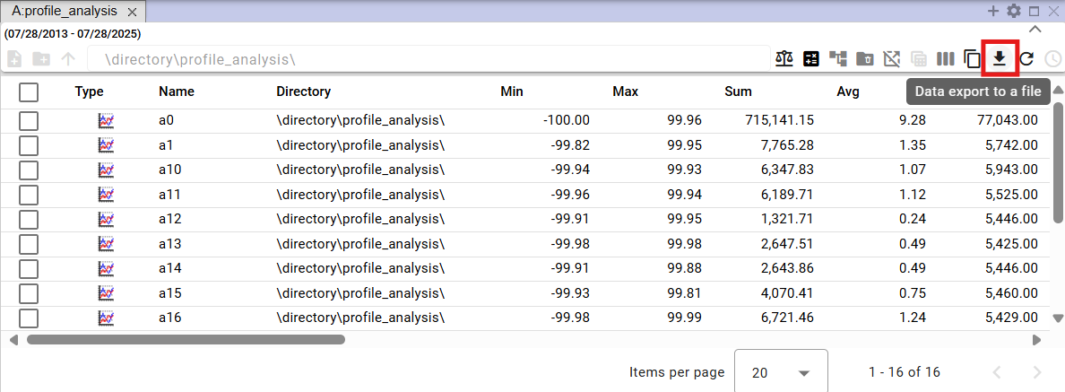

Figure 502: Button for exporting profile analysis

1. A "Export" window will appear.

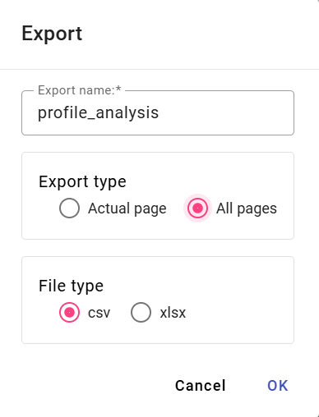

Figure 503: “Export” window

1. In the "Export Type" section, the default setting is "All Pages". All data is exported. If you select "Current Page", only the displayed data is exported.
2. In the "File Type" section, select the file type for export.
3. To confirm the export, press the "OK" button.

## Report Manager

### How to create a new report

To create a report, proceed as follows:

* 1. In the tree structure, right-click on the directory where you want to add a new report.
  2. A menu will appear, in which you position the mouse cursor over the "New" item and then select the "Report" item.

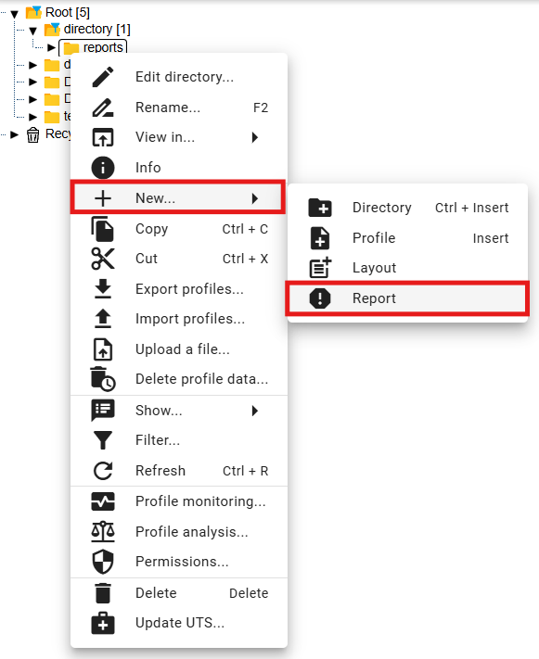

Figure 504: "Report" item

* 1. A "Report Manager" tab will appear, where you enter the data for the new report.

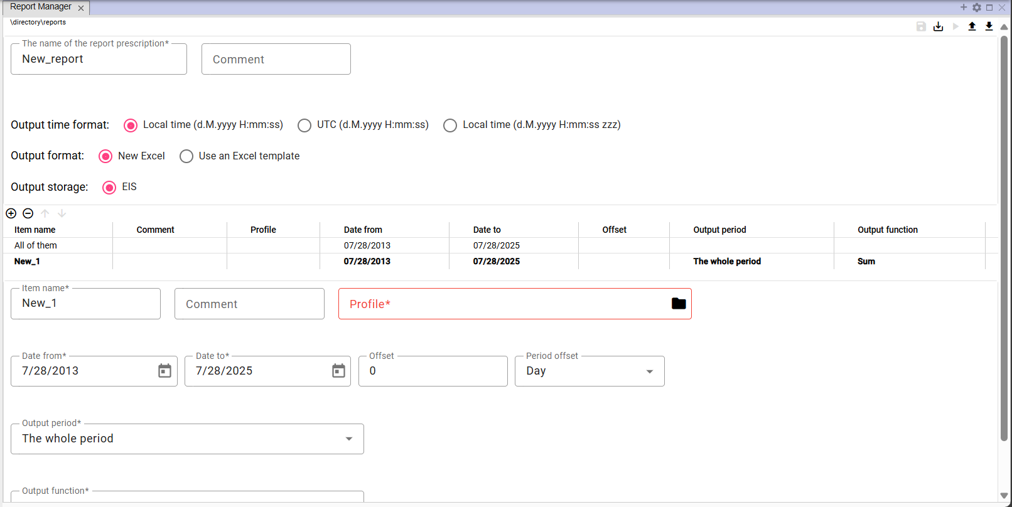

Figure 505: "Report Manager" tab

* 1. In the "Report Name" field, the text "New_report" is automatically entered. You can change the name.

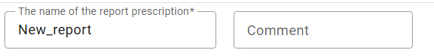

Figure 506: "Report Name" and "Comment" fields

* 1. In the "Comment" field, you can enter a comment.
  2. Select the output time format. "Local Time (d.M.yyyy H:mm:ss)" is selected by default.



Figure 507: "Output Time Format" field

* 1. In the "Output Format" field, select the output format for the report. "New Excel" is selected by default.

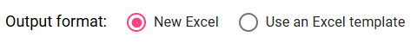

Figure 508: "Output Format" field

* 1. If you select "Use Excel Template", the "Excel Name" and "Sheet Name in Excel" fields will be displayed.

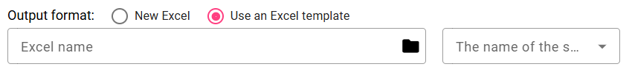

Figure 509: Fields for entering Excel details

* 1. In the "Excel Name" field, click the button to display the "Select xlsx" window, where you can search for the Excel file in the tree structure.

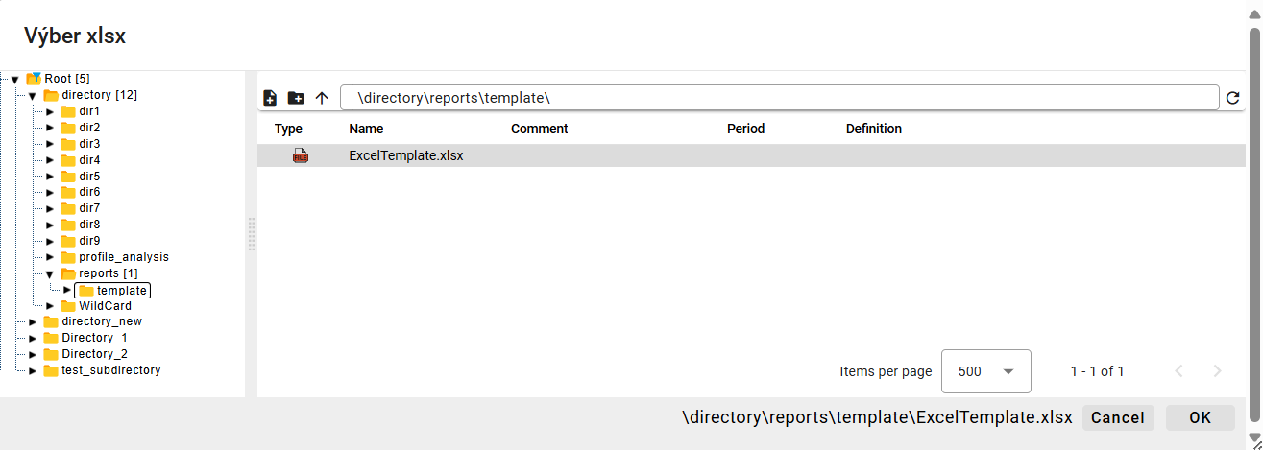

Figure 510: "Select xlsx" window

* 1. In the "Select xlsx" window, after finding the Excel file, click the "Select" button. The path to the Excel file will be automatically filled in the "Excel Name" field, Figure 511.
  2. Click in the "Excel Sheet Name" field and select the sheet name.

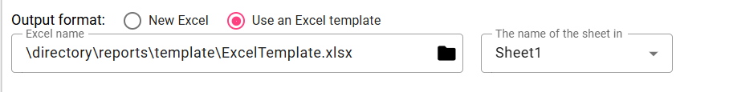

Figure 511: "Excel Name" and "Excel Sheet Name" fields filled in.

* 1. Fill in the details for items.

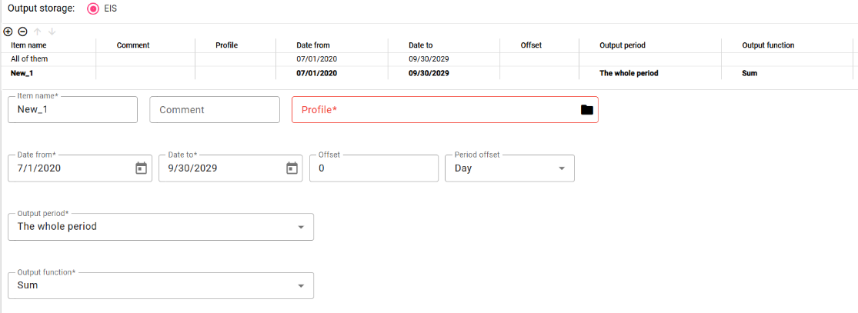

Figure 512: Entering data for items

* 1. To enter the same data for all items at once, click on "All". The data you enter will be filled in for all profiles.
  2. To enter data for each profile separately, click on the item in the table for which you want to enter the data.

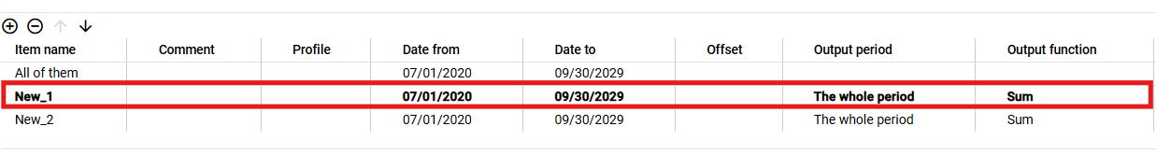

Figure 513: Selected item in the table

* 1. Fill in the data below the table. The data will be automatically filled in to the table.
  2. The "Item Name" field is automatically filled with "New_1". You can change the name.
  3. You can write a comment in the "Comment" field.
  4. In the "Profile" field, write the path to the profile or click the button to display the "Profile Selection" window.
  5. In the "Profile Selection" window, find the profile and click the "Select" button.

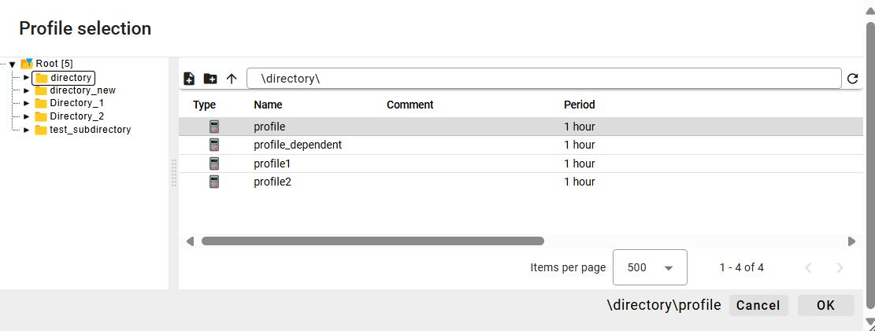

Figure 514: "Profile Selection" Window

* 1. Select the "From Date" and "To Date" dates.
  2. You can enter an offset in the "Offset" field.
  3. Select the period in the "Offset Period" field.
  4. Click in the "Output Period" field and select a period from the displayed menu.
  5. Click in the "Output Function" field and select a function.

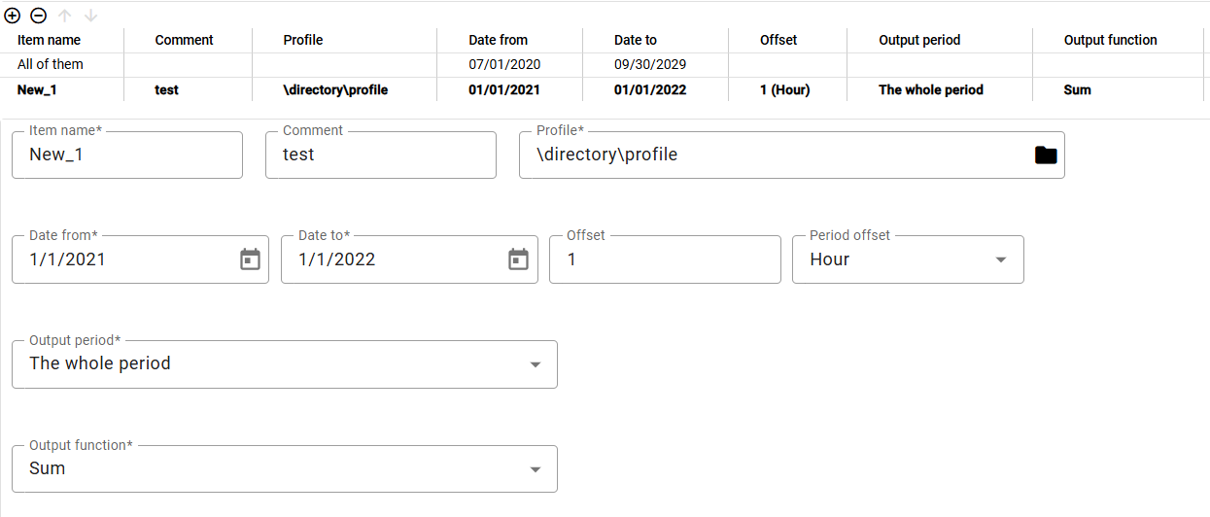

Figure 515: Filled data for the item

* 1. You can also add a profile by transferring it from the tree structure to the table in the "Report Manager" tab. In the tree structure, click and hold the left mouse button on the profile and move the profile over the table. Release the profile to add it as a new item to the table.

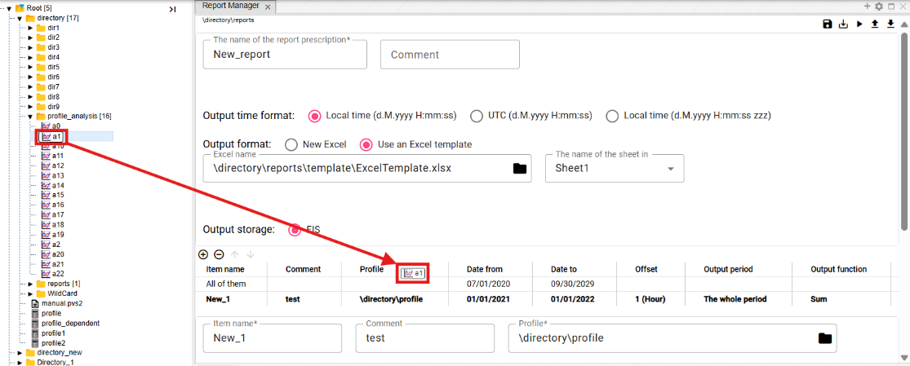

Figure 516: Transferring a profile from the tree structure to the table

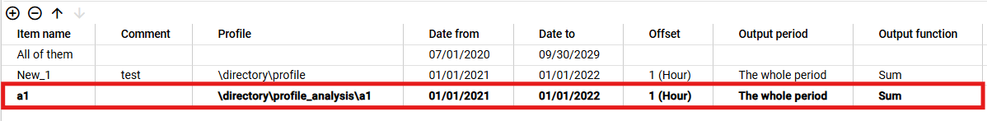

Figure 517: Profile added from the tree structure

* 1. You can also add a profile to the "Report Manager" tab from the tree structure. In the tree structure window, click the profiles you want to transfer to the table in the "Report Manager" tab. Grab the profiles with the left mouse button in the tree structure window and move them over the table in the "Report Manager" tab. Release the profiles. The profiles will be added to the table in the "Report Manager" tab.

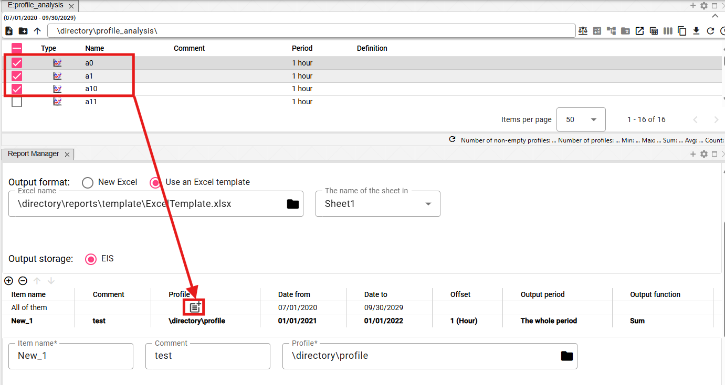

Figure 518: Transferring profiles from the table to the Report Manager using Drag and Drop functionality

* 1. You can add another item by clicking the button.
  2. To remove an item, click the item in the table and press the button. The item will be removed from the table.
  3. You can change the order of profiles in the table using the buttons.
  4. You save the report by clicking the "Save" button, located in the upper right corner of the "Report Manager" screen. The report will be saved to the directory in the tree structure where you created it.



Figure 519: "Save" button

* 1. To save the report to a different directory, click the "Save As" button.
  2. The "New Report" window will appear.
  3. In the "Path" field, enter the path to the new directory or browse for a directory using the button.

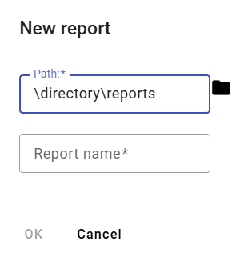

Figure 520: "New Report" Window

* 1. In the "Report Name" field, enter a name for the report.
  2. You save the report by clicking the "OK" button.
  3. You generate the report by clicking the "Generate Report" button, which is located in the upper right corner of the "Report Manager" screen.



Figure 521: "Generate Report" button

* 1. A "Time Range Settings" window will appear, in which you select the time range.

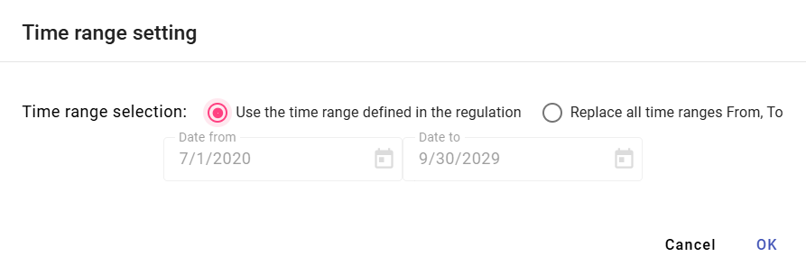

Figure 522: "Time Range Settings" window

* 1. To generate the report, click the "OK" button.
  2. To download the generated report, click the "Export" button in the top toolbar, which will display the "Export" window.
  3. In the "Export" window, click the "Download" button, which is located in the row of the generated report.

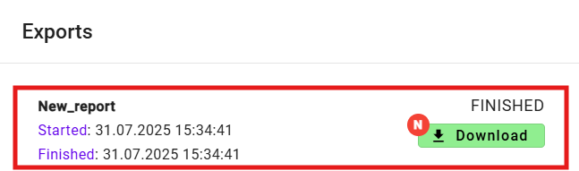

Figure 523: Generated report

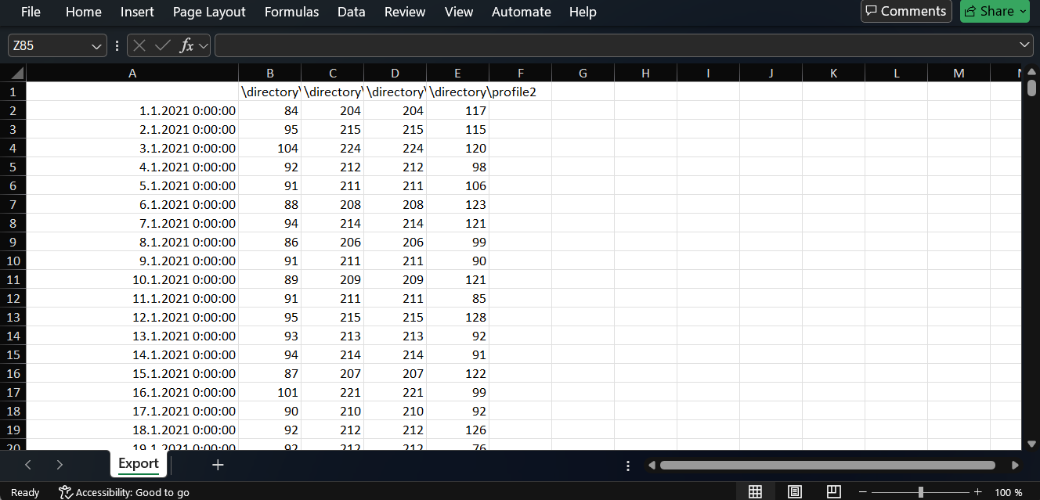

Figure 524: Downloaded report

* 1. You can save the report to disk in "CSV" or "PGZ2" format. To download the report, click the "Save report to disk..." button and select the format in which to download the report. The report will be saved among the downloaded files on your computer.

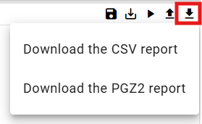

Figure 525: Save report to disk... button menu

### Rights for Report Manager

Rights can be set for "Report Manager":

* Read - if a user does not have "Read" rights, they cannot open the form or pgz or pgz2.
* Create - if a user does not have "Create" rights, the "Save as..." button will not be enabled, nor will the option to create a "Report" appear in the "New..." menu.
* Write - if a user does not have "Write" rights, the "Save" button will not be enabled, only the "Save as..." button will be enabled, and they will be able to save to disk.
* Execute - if a user does not have "Execute" rights, the "Generate Report" button will not be enabled.

## How to restore deleted items from the Recycle Bin

You restore items from the Recycle Bin:

1. Display the contents of the Recycle Bin in a tree structure or in Explorer window, 4.14.



Figure 526: Recycle Bin in tree structure

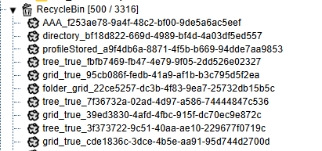

Figure 527: Displaying the Recycle Bin contents in a tree structure

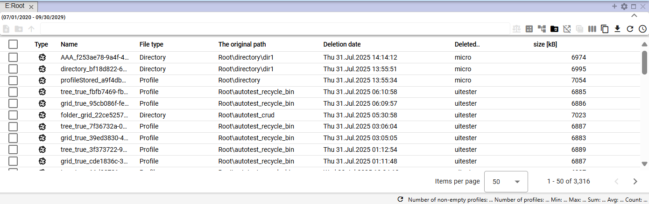

Figure 528: Recycle Bin contents displayed in Explorer window

1. Right-click the item in the Recycle Bin that you want to restore.
2. A menu will appear, in which select "Restore from Recycle Bin".

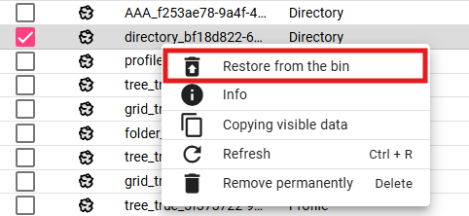

Figure 529: "Restore from Recycle Bin" item

1. A "Restore File" window will appear.

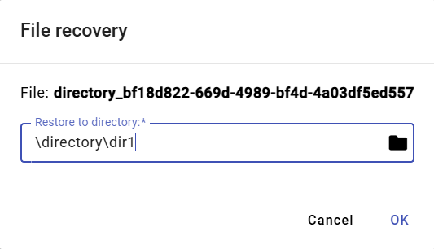

Figure 530: "Restore File" window

1. In the "Restore to folder" field, you will find the path to the folder from which the file was deleted. If you want to restore the file to a different folder, enter the folder path or browse for a folder using the button.
2. To confirm the file restore, press the "OK" button.



© 2025 MicroStep – HDO spol. s r.o.

MicroStep and MicroStep-HDO are registered trademarks. This document is the intellectual property of MicroStep-HDO s.r.o. and may only be used for the purposes for which it was provided.

*MicroStep-HDO s.r.o., Vajnorská 158, 831 04  Bratislava*

*www.microstep-hdo.com, e-mail: info@microstep-hdo.sk*